Annex I

To obtain the actual canopy temperature (Tc) from FLIR sensor temperature (Ts), it is necessary to conduct the atmospheric correction to remove the longwave radiation reflected by the land surface and the upwelling longwave radiation to the sensor from the atmosphere. As shown in Eq. (2), $σT_{s}^{4}$ indicates the at-sensor thermal radiation recorded by FLIR Eq.(1)
${LW}_{sensor}=σT_{s}^{4}$ (equation 1)
$σT_{s}^{4}=ε_{s}σT_{s}^{4}+\left(1-ε_{s}\right){LW}_{in}+{LW}_{atm}$(equation 2)
where $σ$ is the Stefan-Boltzmann constant (5.67×10−8 W·m⁻²·K⁻⁴). $T_{s}$ is the brightness temperature from FLIR sensor (K). $σT_{s}^{4}$ Convert $T_{s}$ of sensor to longwave radiation sensor ${LW}_{sensor}$ (W·m⁻²). $ε_{s}σT_{s}^{4}$ is the thermal radiation emitted from the surface, in our case, from the canopy. ${LW}_{in}$ is incoming longwave radiation (W·m⁻²). ${LW}_{atm}$ is the upwelling longwave radiation from the atmosphere to the sensor(W·m−2). Due to the low flight altitude and simplicity, this study neglected the influence of ${LW}_{atm}$ as other UAS studies (e.g. Hoffmann et al., 2016; Ortega-Farías et al., 2016; Brenner et al., 2017., Wang et al., 2018). Under our continental conditions of summer with low water vapour content and a flying altitude of 120 meters, atmospheric transmission can be expected to be in the range of 0.8 to-0.9 (Vlassova et al. 2014) Additionally, the effect of not correcting for atmospheric transmission up to 120 m will affect equally to all pixels in the image, as atmospheric conditions are the same for the vineyard, so it will be a constant bias in the retrieval of Tc, scaling equally the resulting CWSI values. We are working towards having a good indicator to detect significant differences in SWP based on thermal emission rather than having an absolute accurate value of transpiration in mm/day or stomatal conductance. Therefore, in our study we have given priority to minimize sources of variation in Tc across the scene unrelated to plant water status.
Finally, we solve for Ts in equation 3.
$T_{s}=\frac{{LW}_{sensor}-\left(1-ε_{s}\right)*{LW}_{in}}{{ε_{s}σ}^{0.25}}$(equation 3)
Tc= $T_{s}$-273.15, is the corrected land surface temperature (ºC).
The surface emissivity ($ε_{s}$) can be calculated based on the relation with NDVI (Van de Griend and M. Owe, 1993).
$ε_{s}=1.0094+0.047ln*(NDVI)$(equation 4)

To estimate the emissivity of the air ($εa$) that reaches the surface from the atmosphere (aerosols, gases, etc.) that they emit, there are several equations, we are going to use Prata et al., 1998, a function of air temperature and the water vapor content of the atmosphere:
$εa= 1-(1+w) \exp^{–\sqrt{(1.2 +3.0 w)}}$ (equation 5)
$w= (\frac{46.5}{T_{a}+273.15})*ea$ (equation 6)
$ea$ = water vapor pressure saturation (calculated using the portable weather station in hpa)
Local atmospheric conditions such as air temperature, relative humidity, and barometric pressure were measured at the time of flight with a portable weather station.

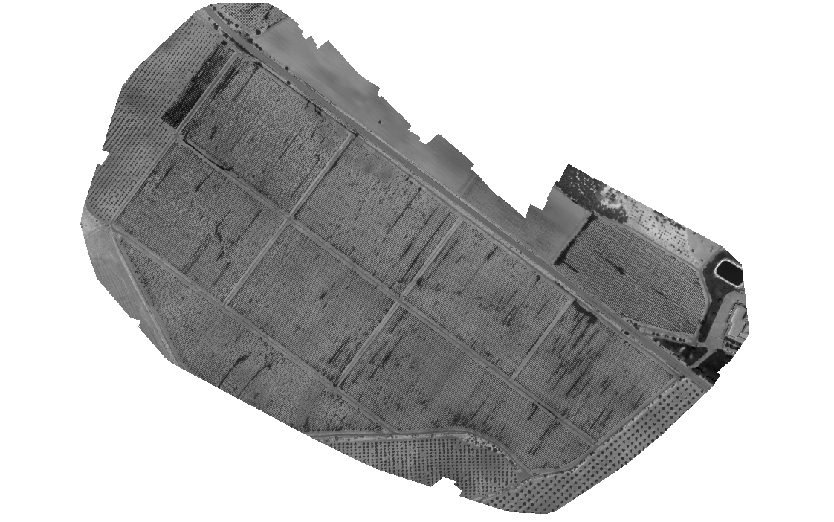
Fig A1: Thermal mosaic obtained after photogrammetry process. The camera provides an automated way to recalibrate the intensity, usually by taking a picture with the shutter closed.

