Table 1 Rt₀ values for each replication
Replication | 5-2 mm | <2 mm | > 5 mm | Total
I | 29.46 | 108.09 | 13.2 | 150.75
I | 25.88 | 83.13 | 18.25 | 127.26
II | 15.02 | 63.6 | 11.75 | 90.37
II | 20.4 | 54.28 | 6.61 | 81.29
III | 14.6 | 48.38 | 3.12 | 66.1
III | 12.26 | 39.42 | 5.09 | 56.77
IV | 15.72 | 39.12 | 7.85 | 62.69
IV | 13.87 | 37.43 | 7.85 | 59.15

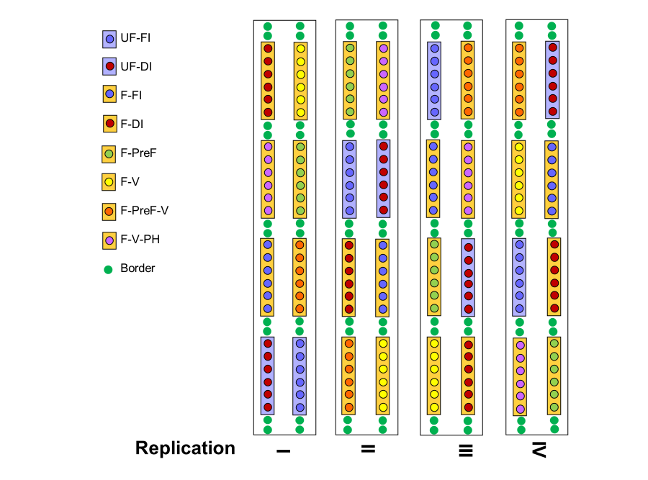
Fig. 1 Scheme of the experimental design used in the experiment. Each spot means an individual vine. UF = unforced vines; F = forced vines; FI = fully irrigated; DI = sustained deficit irrigation; PreF = pre-forcing deficit irrigation; V = post-veraison deficit irrigation; PH = post-harvest irrigation suppression.

