Fig. S1. The biases in average annual precipitation (a), maximum (b), minimum (c), and average temperature (d) simulated by five CMIP6 models. The line and cross within the box mark the median and average, respectively, while the whiskers below and above the box indicate the minimum and maximum values. The red diamonds indicate the correlation coefficient. The average annual precipitation and temperatures were computed using the 1981-2010 historical data.
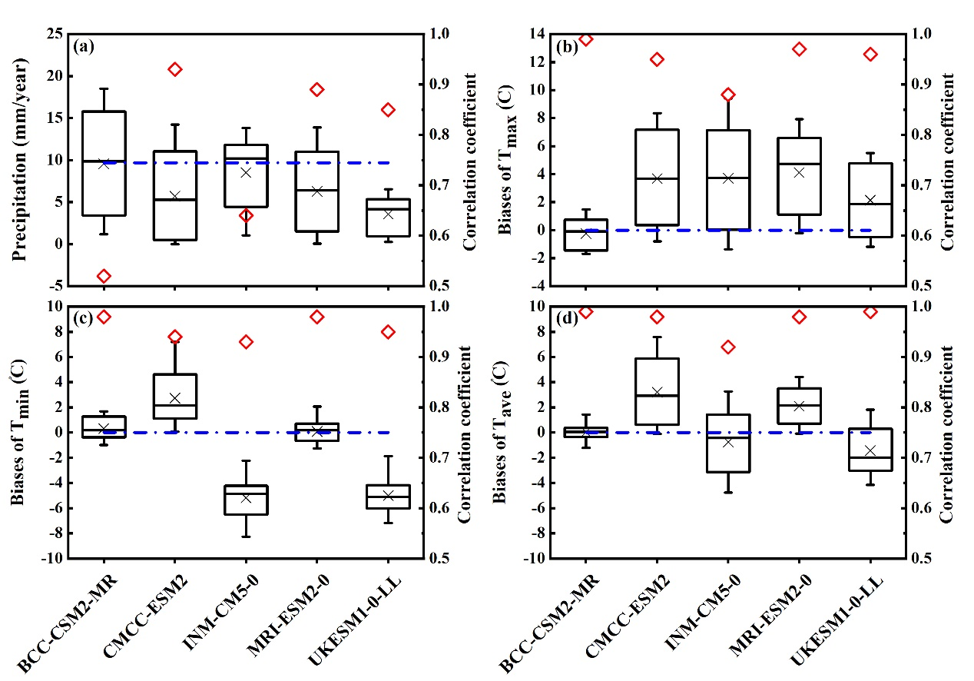

Fig. S2. Projected average rice yield (Y, t·ha⁻¹) and % change over Damietta under the 3-day irrigation frequency regime, the SSP2-4.5 (a, b), and SSP5-8.5 (c, d) emission scenarios during 2021–2099 with respect to the 2001–2010 yields. The crosses and lines within the boxes in figures b and d mark the averages and medians of projected rice yields, while the whiskers above and below the boxes represent the maximum and minimum yields, respectively.
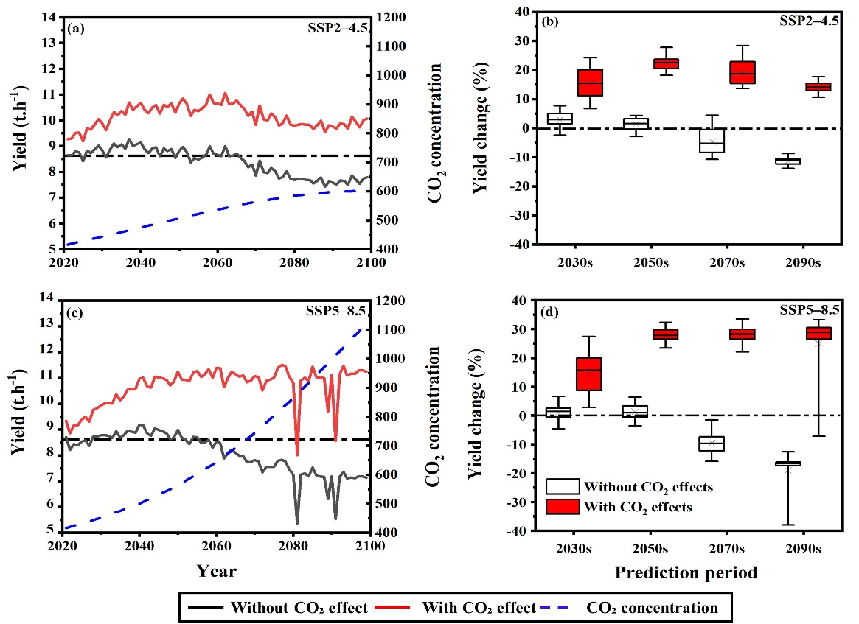

Fig. S3. Changes in evapotranspiration (ET, %) over Damietta under the 3-day irrigation frequency regime, the two SSP scenarios during 2021–2099 compared with the 2001–2010 baseline. The crosses and lines within the boxes in figures a and b mark the averages and medians of projected rice ET, while the whiskers above and below the boxes represent the maximum and minimum ET, respectively.
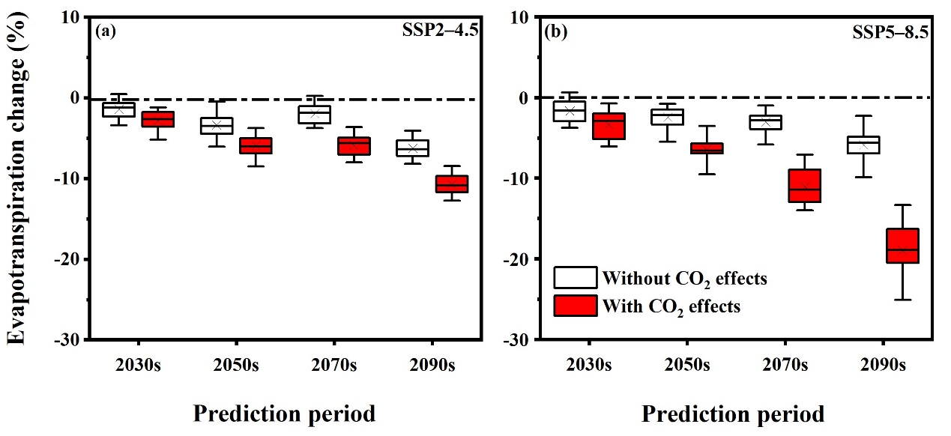

Table S1: List of the CMIP6 best-performing models over the study area.
No. | Originating | Model | Country | Resolution scale (long. x Lat.)
1 | Beijing Climate Center | BCC-CSM2-MR | China | 1.1 x 1.1
2 | Centro Euro-Mediterraneo sui Cambiamenti Climatici | CMCC-ESM2 | Italy | 1.25 x 0.9
3 | Russian Academy of Sciences,  Institute of Numerical Mathematics | INM-CM5-0 | Russia | 2 x 1.5
4 | Meteorological Research Institute | MRI-ESM2-0 | Japan | 1.1 x 1.1
5 | Met Office Hadley Centre | UKESM1-0-LL | UK | 1.875 x 1.25
Notes: Long. and lat. refer to longitude and latitude resolutions, respectively.

