Supplement Table 1. Expression of KIAA0125 in various AML risk groups
Risk groups | No. | Mean | Standard deviation | 95% confidence interval
 |  |  |  | Lower Bound | Upper Bound
t(8;21) | 24 | 5.803 | 0.146 | 5.741 | 5.864
t(15;17) | 27 | 6.117 | 0.757 | 5.818 | 6.417
inv(16) | 9 | 7.873 | 0.993 | 7.110 | 8.637
CEBPA^{double} | 27 | 7.164 | 0.606 | 6.924 | 7.404
NPM1+/FLT3-ITD- | 57 | 7.092 | 1.025 | 6.820 | 7.364
NPM1-/FLT3-ITD+ | 19 | 8.676 | 1.458 | 7.974 | 9.379
RUNX1 | 47 | 8.085 | 1.456 | 7.657 | 8.512
ASXL1 | 22 | 8.164 | 1.482 | 7.508 | 8.821
Unfavorable karyotypes* | 32 | 7.685 | 1.547 | 7.127 | 8.243
*Based on the refined Medical research Council (MRC) classification.

Supplement Table 2. Comparison of KIAA0125 expression in various AML risk groups
Reference (I) | Comparator (J) | Mean Difference (I-J) | Std. Error | Sig. | 95% Confidence Interval
 |  |  |  |  | Lower Bound | Upper Bound
t(8;21) | t(15;17) | -.3145194 | .3276042 | .999 | -1.616661 | .987622
t(8;21) | inv(16) | -2.0703417* | .4564382 | .010 | -3.884564 | -.256119
t(8;21) | CEBPA^{doouble} | -1.3610083* | .3276042 | .031 | -2.663149 | -.058867
t(8;21) | NPM1+/FLT3-ITD- | -1.2887434* | .2841524 | .010 | -2.418175 | -.159312
t(8;21) | NPM1-/FLT3-ITD+ | -2.8734680* | .3585946 | .000 | -4.298788 | -1.448148
t(8;21) | RUNX1 | -2.2818587* | .2929723 | .000 | -3.446347 | -1.117371
t(8;21) | ASXL1 | -2.3615189* | .3446782 | .000 | -3.731525 | -.991513
t(8;21) | Unfavorable karyotypes* | -1.8820823* | .3153300 | .000 | -3.135437 | -.628728
t(15;17) | t(8;21) | .3145194 | .3276042 | .999 | -.987622 | 1.616661
t(15;17) | inv(16) | -1.7558222 | .4494693 | .059 | -3.542345 | .030701
t(15;17) | CEBPA^{doouble} | -1.0464889 | .3178228 | .217 | -2.309751 | .216773
t(15;17) | NPM1+/FLT3-ITD- | -.9742240 | .2728175 | .127 | -2.058602 | .110154
t(15;17) | NPM1-/FLT3-ITD+ | -2.5589485* | .3496811 | .000 | -3.948839 | -1.169058
t(15;17) | RUNX1 | -1.9673392* | .2819921 | .000 | -3.088184 | -.846494
t(15;17) | ASXL1 | -2.0469995* | .3353951 | .000 | -3.380107 | -.713892
t(15;17) | Unfavorable karyotypes* | -1.5675628* | .3051554 | .001 | -2.780476 | -.354650
inv(16) | t(8;21) | 2.0703417* | .4564382 | .010 | .256119 | 3.884564
inv(16) | t(15;17) | 1.7558222 | .4494693 | .059 | -.030701 | 3.542345
inv(16) | CEBPA^{doouble} | .7093333 | .4494693 | .961 | -1.077189 | 2.495856
inv(16) | NPM1+/FLT3-ITD- | .7815982 | .4188564 | .899 | -.883246 | 2.446443
inv(16) | NPM1-/FLT3-ITD+ | -.8031263 | .4725338 | .940 | -2.681324 | 1.075072
inv(16) | RUNX1 | -.2115170 | .4248892 | 1.000 | -1.900341 | 1.477307
inv(16) | ASXL1 | -.2911773 | .4620619 | 1.000 | -2.127752 | 1.545398
inv(16) | Unfavorable karyotypes* | .1882594 | .4406031 | 1.000 | -1.563023 | 1.939542
CEBPA^{doouble} | t(8;21) | 1.3610083* | .3276042 | .031 | .058867 | 2.663149
CEBPA^{doouble} | t(15;17) | 1.0464889 | .3178228 | .217 | -.216773 | 2.309751
CEBPA^{doouble} | inv(16) | -.7093333 | .4494693 | .961 | -2.495856 | 1.077189
CEBPA^{doouble} | NPM1+/FLT3-ITD- | .0722649 | .2728175 | 1.000 | -1.012113 | 1.156643
CEBPA^{doouble} | NPM1-/FLT3-ITD+ | -1.5124596* | .3496811 | .019 | -2.902350 | -.122569
CEBPA^{doouble} | RUNX1 | -.9208504 | .2819921 | .227 | -2.041695 | .199994
CEBPA^{doouble} | ASXL1 | -1.0005106 | .3353951 | .355 | -2.333618 | .332597
CEBPA^{doouble} | Unfavorable karyotypes* | -.5210740 | .3051554 | .938 | -1.733987 | .691839
NPM1+/FLT3-ITD- | t(8;21) | 1.2887434* | .2841524 | .010 | .159312 | 2.418175
NPM1+/FLT3-ITD- | t(15;17) | .9742240 | .2728175 | .127 | -.110154 | 2.058602
NPM1+/FLT3-ITD- | inv(16) | -.7815982 | .4188564 | .899 | -2.446443 | .883246
NPM1+/FLT3-ITD- | CEBPA^{doouble} | -.0722649 | .2728175 | 1.000 | -1.156643 | 1.012113
NPM1+/FLT3-ITD- | NPM1-/FLT3-ITD+ | -1.5847246* | .3093460 | .001 | -2.814294 | -.355155
NPM1+/FLT3-ITD- | RUNX1 | -.9931153* | .2300818 | .020 | -1.907630 | -.078600
NPM1+/FLT3-ITD- | ASXL1 | -1.0727755 | .2931006 | .105 | -2.237774 | .092223
NPM1+/FLT3-ITD- | Unfavorable karyotypes* | -.5933389 | .2579494 | .725 | -1.618620 | .431942
NPM1-/FLT3-ITD+ | t(8;21) | 2.8734680* | .3585946 | .000 | 1.448148 | 4.298788
NPM1-/FLT3-ITD+ | t(15;17) | 2.5589485* | .3496811 | .000 | 1.169058 | 3.948839
NPM1-/FLT3-ITD+ | inv(16) | .8031263 | .4725338 | .940 | -1.075072 | 2.681324
NPM1-/FLT3-ITD+ | CEBPA^{doouble} | 1.5124596* | .3496811 | .019 | .122569 | 2.902350
NPM1-/FLT3-ITD+ | NPM1+/FLT3-ITD- | 1.5847246* | .3093460 | .001 | .355155 | 2.814294
NPM1-/FLT3-ITD+ | RUNX1 | .5916093 | .3174667 | .900 | -.670238 | 1.853456
NPM1-/FLT3-ITD+ | ASXL1 | .5119490 | .3657259 | .982 | -.941716 | 1.965614
NPM1-/FLT3-ITD+ | Unfavorable karyotypes* | .9913857 | .3382090 | .382 | -.352907 | 2.335678
RUNX1 | t(8;21) | 2.2818587* | .2929723 | .000 | 1.117371 | 3.446347
RUNX1 | t(15;17) | 1.9673392* | .2819921 | .000 | .846494 | 3.088184
RUNX1 | inv(16) | .2115170 | .4248892 | 1.000 | -1.477307 | 1.900341
RUNX1 | CEBPA^{doouble} | .9208504 | .2819921 | .227 | -.199994 | 2.041695
RUNX1 | NPM1+/FLT3-ITD- | .9931153* | .2300818 | .020 | .078600 | 1.907630
RUNX1 | NPM1-/FLT3-ITD+ | -.5916093 | .3174667 | .900 | -1.853456 | .670238
RUNX1 | ASXL1 | -.0796603 | .3016589 | 1.000 | -1.278676 | 1.119355
RUNX1 | Unfavorable karyotypes* | .3997764 | .2676341 | .972 | -.663999 | 1.463552
ASXL1 | t(8;21) | 2.3615189* | .3446782 | .000 | .991513 | 3.731525
ASXL1 | t(15;17) | 2.0469995* | .3353951 | .000 | .713892 | 3.380107
ASXL1 | inv(16) | .2911773 | .4620619 | 1.000 | -1.545398 | 2.127752
ASXL1 | CEBPA^{doouble} | 1.0005106 | .3353951 | .355 | -.332597 | 2.333618
ASXL1 | NPM1+/FLT3-ITD- | 1.0727755 | .2931006 | .105 | -.092223 | 2.237774
ASXL1 | NPM1-/FLT3-ITD+ | -.5119490 | .3657259 | .982 | -1.965614 | .941716
ASXL1 | RUNX1 | .0796603 | .3016589 | 1.000 | -1.119355 | 1.278676
ASXL1 | Unfavorable karyotypes* | .4794366 | .3234167 | .974 | -.806060 | 1.764933
Unfavorable karyotypes* | t(8;21) | 1.8820823* | .3153300 | .000 | .628728 | 3.135437
Unfavorable karyotypes* | t(15;17) | 1.5675628* | .3051554 | .001 | .354650 | 2.780476
Unfavorable karyotypes* | inv(16) | -.1882594 | .4406031 | 1.000 | -1.939542 | 1.563023
Unfavorable karyotypes* | CEBPA^{doouble} | .5210740 | .3051554 | .938 | -.691839 | 1.733987
Unfavorable karyotypes* | NPM1+/FLT3-ITD- | .5933389 | .2579494 | .725 | -.431942 | 1.618620
Unfavorable karyotypes* | NPM1-/FLT3-ITD+ | -.9913857 | .3382090 | .382 | -2.335678 | .352907
Unfavorable karyotypes* | RUNX1 | -.3997764 | .2676341 | .972 | -1.463552 | .663999
Unfavorable karyotypes* | ASXL1 | -.4794366 | .3234167 | .974 | -1.764933 | .806060

*Based on the refined Medical research Council (MRC) classification.

Supplement Table 3. Comparison of cytogenetic changes between patients with lower and higher KIAA0125 expression among 331 patients in the NTUH cohort and 135 patients in the TCGA cohort

Karyotype | NTUH cohort |  |  |  | TCGA cohort
Karyotype | Total* (n=331) | High (n=164) | Low (n=168) | P value | Total  (n=135) | High  (n=68) | Low  (n=67) | P value
Normal | 166 | 92 (56.1%) | 74 (44%) | 0.022 | 69 | 40 (59%) | 29 (43.3%) | 0.086
t (8;21) | 24 | 0 (0%) | 24 (14.3%) | <0.001 | 7 | 0 (0%) | 7 (10.5%) | 0.006
t (15;17) | 27 | 3 (1.8%) | 24 (14.3%) | <0.001 | 14 | 0 (0%) | 14 (21%) | <0.001
Inv (16) | 9 | 6 (3.7%) | 3 (1.8%) | 0.332 | 8 | 3 (4.4%) | 5 (7.5%) | 0.490
Complex† | 33 | 20 (12.2%) | 13 (7.7%) | 0.201 | 19 | 13 (19%) | 6 (9%) | 0.140
Poor risk‡ | 49 | 30 (18.3%) | 19 (11.3) | 0.089
*Cytogenetic data at diagnosis were available in 332 patients, including 168 with lower KIAA0125 expression and 164 with higher KIAA0125 expression.
†≥ 3 abnormalities
‡Based on the refined Medical research Council (MRC) classification.

Supplement Table 4. Comparison of genetic alterations between AML patients with lower and higher BM KIAA0125 expression in the NTUH cohort

Genes | Total | Number of patients with the mutation (%) |  |  | P value
Genes | Total | High KIAA0125 | Low KIAA0125 |  | P value
FLT3-ITD | 84 | 50 (59.5) |  | 34 (40.5) | 0.048
FLT3-TKD | 32 | 13 (40.6) |  | 19 (59.4) | 0.258
N-RAS | 59 | 31 (52.5) |  | 28 (47.5) | 0.686
K-RAS | 15 | 6 (40) |  | 9 (60) | 0.422
PTPN11 | 22 | 13 (59.1) |  | 9 (40.9) | 0.386
KIT | 15 | 6 (40) |  | 9 (60) | 0.422
WT1 | 26 | 17 (65.4) |  | 9 (34.6) | 0.106
NPM1 | 99 | 53 (53.5) |  | 46 (46.5) | 0.425
CEBPA^{double} | 27 | 13 (48.1) |  | 14 (51.9) | 0.829
RUNX1 | 50 | 32 (64) |  | 18 (36) | 0.034
MLL/PTD | 13 | 8 (61.5) |  | 5 (38.5) | 0.429
ASXL1 | 52 | 26 (50) |  | 26 (50) | 0.982
IDH1 | 20 | 14 (70) |  | 6 (30) | 0.067
IDH2 | 51 | 26 (51.0) |  | 25 (49.0) | 0.897
TET2 | 56 | 25 (44.6) |  | 31 (55.4) | 0.369
DNMT3A | 66 | 42 (63.6) |  | 24 (36.4) | 0.015
TP53 | 16 | 8 (50) |  | 8 (50) | >0.999

Supplement Table 5. Comparison of genetic alterations between AML patients with lower and higher BM KIAA0125 expression in the TCGA cohort

Genes | Total | Number of patients with the mutation (%) |  |  | P value
Genes | Total | High KIAA0125 | Low KIAA0125 |  | P value
DNMT3A | 26 | 21 (80.8) |  | 5 (19.2) | <0.001
RUNX1 | 13 | 11 (84.6) |  | 2 (15.4) | 0.017
PTPN11 | 5 | 5 (100) |  | 0 (0) | 0.058
TP53 | 10 | 8 (80) |  | 2 (20) | 0.098
PCLO | 5 | 1 (20) |  | 4 (80) | 0.209
ASXL1 | 3 | 3 (100) |  | 0 (0) | 0.245
KIT | 9 | 3 (33.3) |  | 6 (66.7) | 0.327
BCORL1 | 5 | 4 (80) |  | 1 (20) | 0.367
CMYA5 | 4 | 1 (25) |  | 3 (75) | 0.367
FLT3-ITD/TKD | 16 | 10 (62.5) |  | 6 (37.5) | 0.429
NRAS | 6 | 2 (33.3) |  | 4 (66.7) | 0.442
KRAS | 6 | 2 (33.3) |  | 4 (66.7) | 0.442
IDH1 | 9 | 6 (66.7) |  | 3 (33.3) | 0.494
WT1 | 11 | 7 (63.6) |  | 4 (36.4) | 0.533
MUC16 | 12 | 5 (41.7) |  | 7 (58.3) | 0.564
SMC3 | 8 | 5 (62.5) |  | 3 (37.5) | 0.719
IDH2 | 10 | 6 (60) |  | 4 (40) | 0.745
NPM1 | 16 | 9 (56.3) |  | 7 (43.7) | 0.792
NF1 | 6 | 3 (50) |  | 3 (50) | >0.999
TET2 | 5 | 3 (60) |  | 2 (40) | >0.999

Supplement Table 6. Univariate analysis (Cox regression) of the impact of different variables on the overall survival in the 227 AML patients who received standard treatment

Variable | HR | Lower 95% CI | Upper 95% CI | P value
WBC* | 1.000 | 1.000 | 1.000 | 0.394
Karyotype† | 1.443 | 1.111 | 1.874 | 0.006
FLT3-ITD | 2.134 | 1.342 | 3.394 | 0.001
FLT3-TKD | 1.324 | 0.680 | 2.578 | 0.409
N-RAS | 0.908 | 0.478 | 1.723 | 0.767
K-RAS | 1.770 | 0.646 | 4.855 | 0.267
PTPN11 | 1.910 | 0.828 | 4.405 | 0.129
KIT | 0.914 | 0.333 | 2.510 | 0.862
WT1 | 1.902 | 0.939 | 3.850 | 0.074
NPM1 | 1.262 | 0.776 | 2.051 | 0.348
CEBPA^{double} | 0.312 | 0.098 | 0.992 | 0.048
RUNX1 | 2.292 | 1.300 | 4.041 | 0.004
MLL/PTD | 3.769 | 1.490 | 9.533 | 0.005
ASXL1 | 1.289 | 0.592 | 2.808 | 0.523
IDH1 | 1.385 | 0.601 | 3.190 | 0.445
IDH2 | 0.771 | 0.354 | 1.679 | 0.512
TET2 | 1.428 | 0.785 | 2.598 | 0.243
DNMT3A | 1.599 | 0.918 | 2.785 | 0.098
TP53 | 6.628 | 2.378 | 18.469 | <0.001
KIAA0125 | 2.181 | 1.362 | 3.493 | 0.001
P values < .05 are considered statistically significant.
Abbreviations: HR, hazard ratios; CI, confidence interval.
*As continuous variable.
†Unfavorable cytogenetics versus others. The classification of favorable, intermediate and unfavorable cytogenetics is based on the refined Medical Research Council (MRC) classification. Favorable: t(15;17)(q22;q21), t(8;21)(q22;q22), and inv(16)(p13q22)/t(16;16)(p13;q22); unfavorable: abn(3q) (excluding t(3;5)(q25;q34)), inv(3)(q21q26)/t(3;3)(q21;q26), add(5q)/del(5q), -5, -7, add(7q)/del(7q), t(6;11)(q27;q23), t(10;11)(p1113;q23), other t(11q23) (excluding t(9;11)(p21~22;q23) and t(11;19)(q23;p13)), t(9;22)(q34;q11), -17, and abn(17p); and intermediate: entities not classified as favorable or adverse. Seven patients without chromosome data were not included in the analysis.
Supplement Table 7. Multivariable analysis for DFS and OS in 227 AML patients who received standard treatment

 | DFS |  |  |  | OS
 | 95% CI |  |  |  | 95% CI
Variable | HR | Lower | Upper | P | HR | Lower | Upper | P
Age* | 1.008 | 0.996 | 1.019 | 0.198 | 1.031 | 1.014 | 1.047 | <0.001
WBC* | 1.004 | 1.001 | 1.007 | 0.002 | 1.004 | 1.001 | 1.008 | 0.016
Karyotype† | 1.711 | 1.270 | 2.304 | <0.001 | 1.868 | 1.258 | 2.773 | 0.002
NPM1/FLT3-ITD‡ | 0.580 | 0.320 | 1.050 | 0.072 | 0.878 | 0.436 | 1.770 | 0.716
CEBPA^{double} | 0.531 | 0.273 | 1.035 | 0.063 | 0.314 | 0.096 | 1.028 | 0.056
RUNX1 | 1.409 | 0.805 | 2.468 | 0.230 | 1.351 | 0.689 | 2.648 | 0.381
MLL-PTD | 2.189 | 0.997 | 4.803 | 0.051 | 2.597 | 0.960 | 7.030 | 0.060
TP53 | 1.955 | 0.708 | 5.399 | 0.196 | 3.048 | 0.959 | 9.692 | 0.059
Higher KIAA0125 expression* | 1.345 | 1.188 | 1.524 | <0.001 | 1.332 | 1.127 | 1.573 | 0.001
P values < .05 are considered statistically significant.
Abbreviations: HR, hazard ratios; CI, confidence interval.
*As continuous variable.
†Unfavorable cytogenetics versus others. The classification of favorable, intermediate and unfavorable cytogenetics is based on the refined Medical Research Council (MRC) classification. Favorable: t(15;17)(q22;q21), t(8;21)(q22;q22), and inv(16)(p13q22)/t(16;16)(p13;q22); unfavorable: abn(3q) (excluding t(3;5)(q25;q34)), inv(3)(q21q26)/t(3;3)(q21;q26), add(5q)/del(5q), -5, -7, add(7q)/del(7q), t(6;11)(q27;q23), t(10;11)(p1113;q23), other t(11q23) (excluding t(9;11)(p21~22;q23) and t(11;19)(q23;p13)), t(9;22)(q34;q11), -17, and abn(17p); and intermediate: entities not classified as favorable or adverse. Seven patients without chromosome data were not included in the analysis.
‡NPM1+/FLT3-ITD- versus other subtypes.

Supplement Table 8. The 3000bp upstream sequence of KIAA0125.
Several occurrences of TGTGG motif sequence (highlighted in yellow), which might be the potential binding sites of RUNX1, were found in the 3000bp upstream sequence of KIAA0125.
AGTCAGGTGAGGCCGAGCTCAGGTGAAGCCCAGAGGTGAGGTCTAGGCCA
GGTGAGGTCCAGGCCAGGTGAGGTCCAGGTCAGGTGAGGCCCAGGTCAGG
CAAGGCTGAGGTAGATGTATGAGACTTCTGTAATTTTCAGTTGGTGCCAA
CCCTGCCTGGTGTCCCTGCCCCTCCTCCCAGCCCATGCTCTGTGCCTGCC
AGATGGCGGCCCCTGCACAGGTGCTGCTGGCTGTGGAGGAGCTGGGCTCT
GCCTCCCTGTGCATGGGCGTCCCTCTCGGGCTCTGGCCTGGGAGTGTGGC
TGAGTTGCTTGTCTCCGGAATGTACCAACTGTGCCGTCCTTGGGGGTATA
TGTCCTCGGGGGGATACGGCTCTGTGCCTGCTCCACATCAGGCCCCAGGA
GCTGCCAGCAGGTACCAGCCTGCCCTGCCACACAGTGTGCCTGCAGCCTG
TCCGGGGATGCCCAGGGAGGTGAGTGCCACCACATATCAGGCCTTTTCTC
TTTAAAGTCATTTCTTTGGGGATACATCATCAATGTCTCATATACTGAAT
GTATGTCTGTATCATTGTGCAATTGCCTGTGTCATCGTTTATTTATCCAA
CCTGGGTTAATGTCTTTGCTATTATGAACAGTGCTGGACTGAGAATTTTC
TAAACACAGCTGTGTGCATTTTCCTCTTCTTGCAATTTAGAATTTTAACT
GCTGTTTTCAAGGTACTGTAATGTATTTGTTCTCTTCTTGTTAGGAGACT
TGCCAACCCTGTGTGTCTCAGTTCATACCCTCTTCCTTCCCCAGTAGAAG
TAACGACCACTGTGTTTATGTGATCATCCTTTTCTTGATTTTCCTTATAG
TTTTCCTAGTGGAAAGTTTATCCCTTAAGAAGATAGTTCATTTTGCCGGC
TGTAAATTTTATTTAGAAGAAATCACATTGAAAGTATTTTTTGGACTTTC
CTTTGTTACTCCAATTACTCAGCATTGTCATGAACTCAACCACAGAGTCA
CCTGTAACCCTCACTGTTGTCCTTCTGGCTGTCTGGGTTTGCATTTCATG
AACCTGCCATCGTTTATTTGCCTGTTTTCCTTCAGATGGCTGTTTGCTTC
ATTCTCAGTTTGGGGCTATGACAAACATATGTTCTGCACATCTTTGCCCA
TGAGGCTCTCAGGGAGGGCTCTGGAGCTGGCATTGCCTGCAGGGCTCTGC
TTTGTTGCAGGGAGTTCCTGCCAAGGCTTTTCAGAGTGTCTGTGCCCAGC
CTGAAGGTACACACTGTACTTTGCCCTTGCATCAGGCACTTTCCTTGTGC
TTGCTTCTGTGTGGCTCCACATTCTGGAGAATTTATTCAGATCTGTGCTG
CAAATCCATTTCACTGATTCTCTCTTTAGCTGTGTCTACATCAGCTGTTA
AGCATCCCATGATGCAGCATTGTGGGCACAGGGCAAACTCTTGAAAGATG
ACAGTGTAGGATAGCGGCTGCTTCTCCTTCCCTGTGCCCTTCCCACACTG
TCCTCCTGGGCTCACTCCCAGCCATCGATCTTGAACACCAGTTTATGGAA
CTATCTGCACAGGAAAGCAGAAACAGCAAAAGGCCCTGCTCAGGCTCTGC
CCGCATCCCCTCTTGCACACCCGCCAAAGCTCTTTCCTTGGGGCCTGTGC
AAGCTTCCCAGCTGCTTCTCATTTTCTGTTTACTCTGCTCACTGGCCAGT
GGGGTGATGTCTGGGGGGGAGTCTGGTGCGTTTTGGGCATTGATGGCCAC
CCCTAGGCCCTACTTCCCAGACGCTCCCCCCAGCCCCTCAGCTCCAGAAG
TGGAAGCGTTTACAGCAGGGCTTTGGGAATGGGGCTGTGTCACTGTGGGC
ATAGCAGCTGGTACTACTACAATATCCTCACAGTGACACGAGCCCCCACA
AAATCCTCCTGTCCCCGCGGGAGTCACTGAGTCCCCTCTTGCTGTCTCTG
GCTAGTTCTCCTGCTGATACTATGATTTCCAGGGGGTTTTTGTCTGAAAC
TCAGGGTGTGTTGGAGAGGACTCTGAGCCCAGTGCTGTACAGGGGGCTCC
TCCTTTGTCCTGGGGGAGTTGCGTGGACCCTGTTTTTGGTCAAGGGAAGT
ACTTGCTGGTGAAGGAGACCTCCCCTCCTTTCTTTCTCAGGAGCCCCCTC
TGATGCCGTTGCCTGGTGTTTCTCAGGGCTGGTGCTGGGGGCTCAGCAGT
GTCTGCCCTGTTCCAGGTGGGAATGTGGGTCTGTTCTGTTTCCACGCGGT
GTTCTGGGGCCGCCAGTGAGGGGCTCGGGATGTCAGCGGCTGGTCTCTGT
CCCTATGGTCTGGGCTCCGGTTCACTGCTCCCCTGCCCTCCAGGTCGGTC
ACTGACTCAGTTACTATCCAGCGGGCTCCGTGGCTGTTCAGTGGTGGCTG
CAGGTCTCTTCCCAGGAGAGGCCTGCGAGAGGGCTGGGCTGTCTGGGAGC
CCTGCATTCTCCCATGATGTTGCTGCCTGGATCCCTCGTCTTTACAGGGA
GTGCCGAGCCTCCCTGCAGGTGCGGGCAGTGAGAGACACAGGCGGACGTG
CATCAGGGTGCTGGAGGCCGATTTCTTTCAGTGCCTTCTGCCTGTGGAAG
GGCTGAGCTCCCTGCTTCTGTGCACAGGAGGCTGCCGTGTAACCGGGCAG
TGAGGGCAAGGGCCTGCATGGGGAAGACTTGGGTGAGCCTTTGTCCTGGA
AATACCAGGGCTGGGTCCAAGAGGGGAGCAGGGTCAGAGTGTCCAGGAGG
AAGGTGAGGGCATGGGCAGTGTGGGGGTGGGAGTGCACGGTCAGTGCCAT
GGCTCAGGGGCCCCAGGAGAGGAAGAGCTCGAGTTGTGGGCAGGAGGAGG
CAGGGGGTAGGCACAGAGGGTAGAAACTGAGGCTCTGGCAGCAGAAAAGG
GGAGGGCCTGCATGTGCAGGGTTGGCCTGGGAGGGGTGTCTGGAGGGAGA
GACAGGGGTCTGGGTGGAGACCAGGGTGTAGGCTGCAGGGATGGGACCCC

Supplement Figure 1. Dot plots depicting distribution of KIAA0125 expression in 347 AML patients.
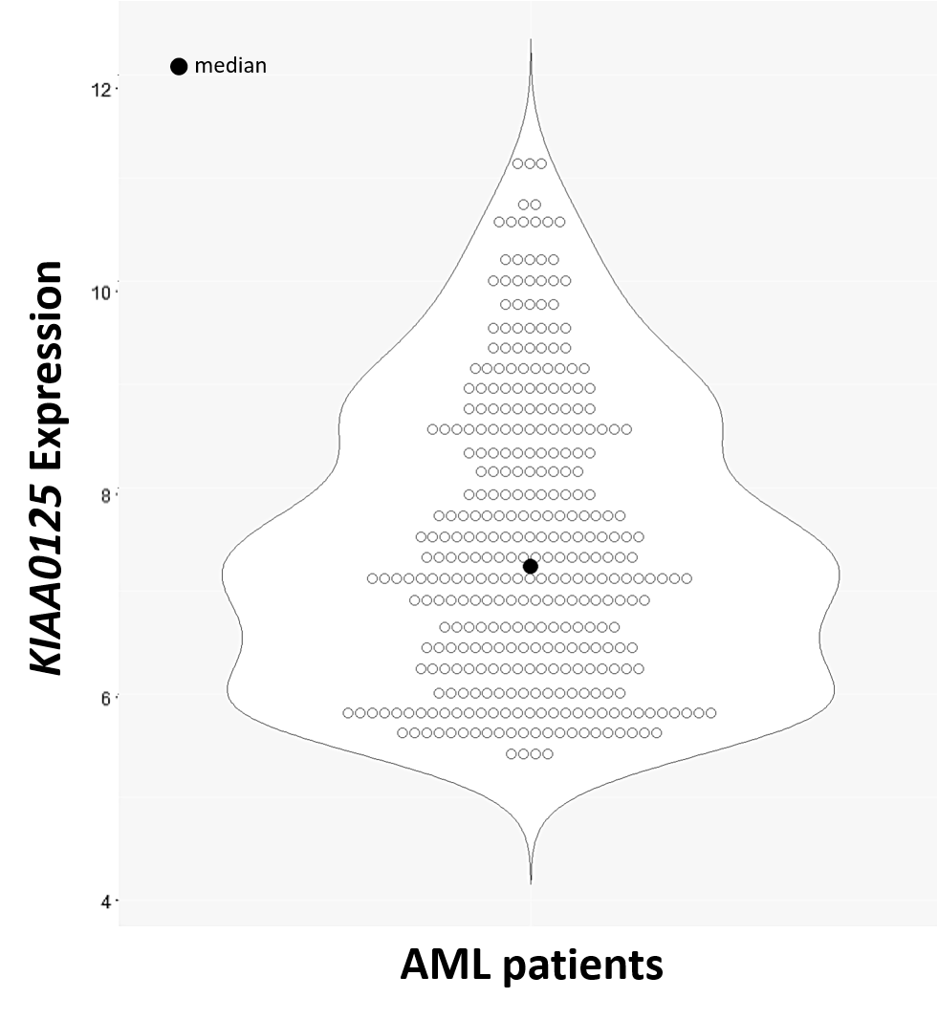

Supplement Figure 2. Box plots depicting expression of KIAA0125 in AML patients with different genotypes.
Among 166 cytogenetically normal AML patients, those with FLT3-ITD (a) or RUNX1 mutation (b) had higher KIAA0125 expression in the bone marrow than others. Patients with DNMT3A mutation (c) had a trend of higher KIAA0125 expression than those without the mutation.
a | b
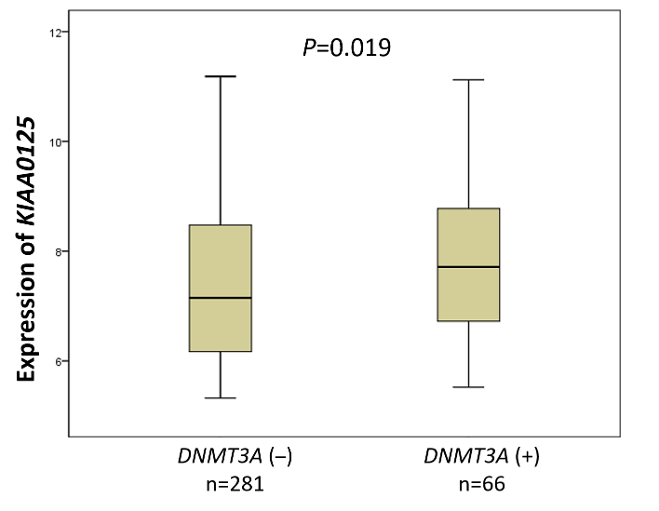 | 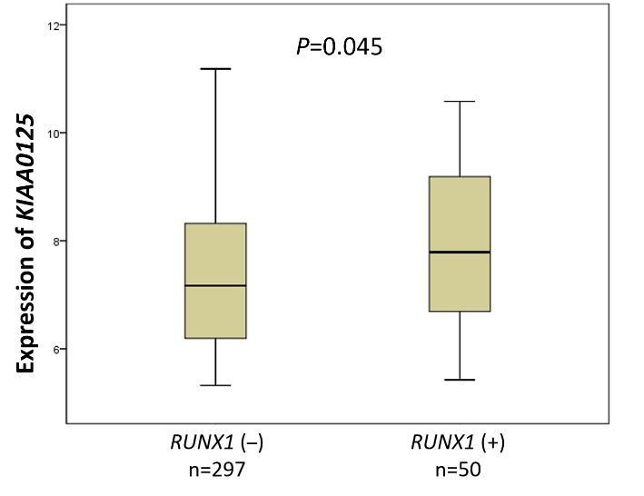
c
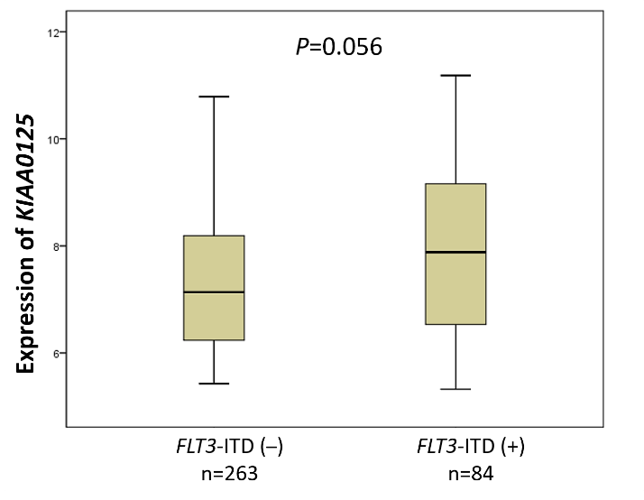

Supplement Figure 3. Distribution and maximally selected rank statistics of KIAA0125 expression in the NTUH cohort, TCGA, and GSE12417.

NTUH | TCGA | GSE12417
Optimal cut point: 7.72 | Optimal cut point: 8.56 | Optimal cut point: 9.71
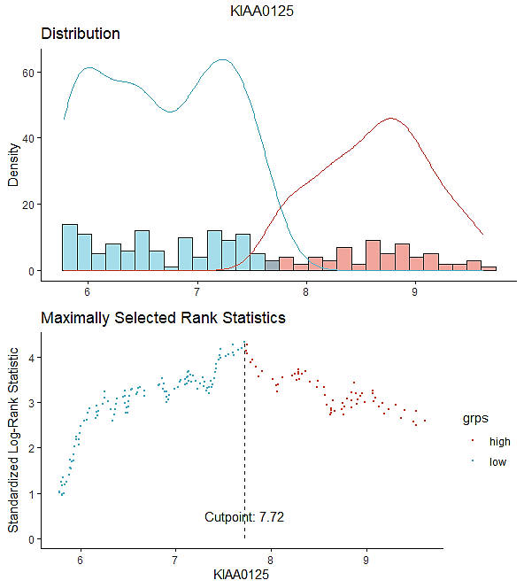 | 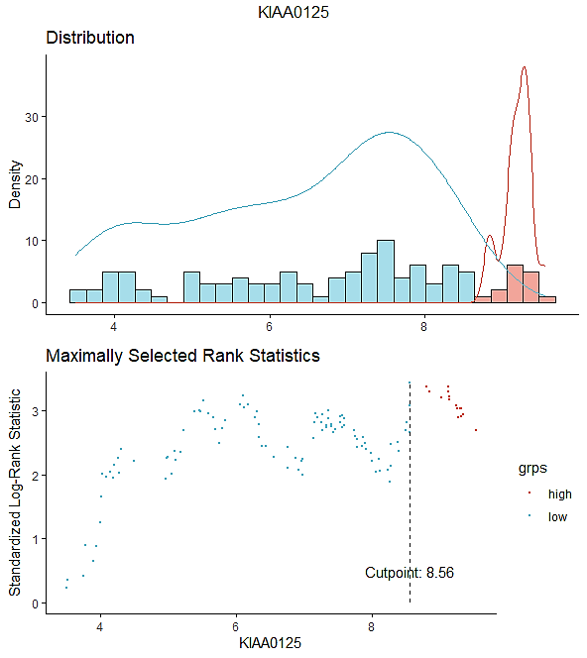 | 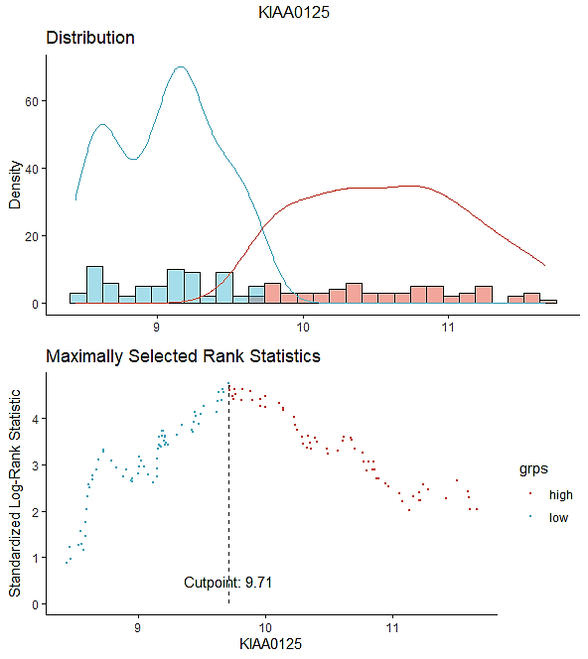

Supplement Figure 4. Kaplan-Meier plots stratified by expression of KIAA0125.
DFS (a) and OS (b), not censored at HSCT, of the 227 AML patients receiving standard induction chemotherapy in NTUH cohort. Patients with higher KIAA0125 expression had worse clinical outcomes than those with lower expression.
a |  | b
 | 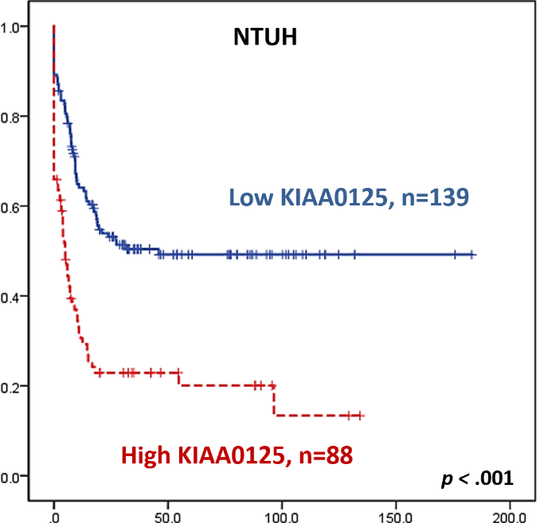 |  | 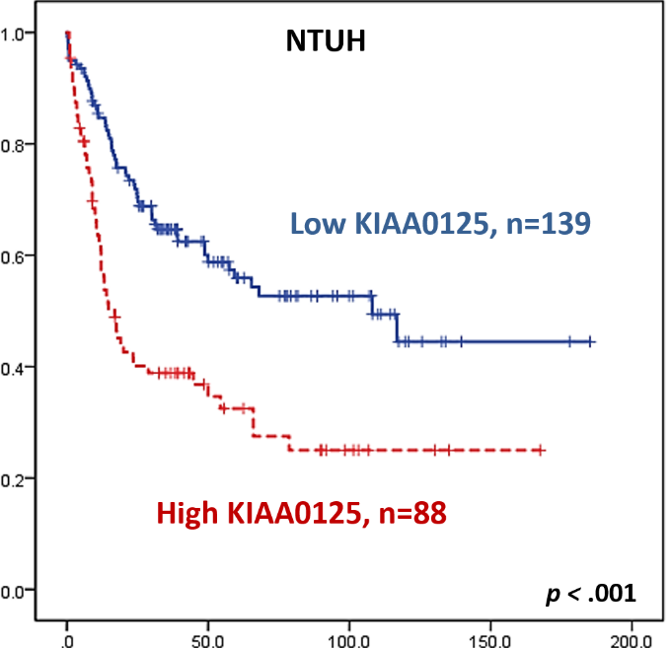
 | 