Suppl. Table 1: Risk factors for achieving CR2 in patients with AML in first relapse (uni- and multivariate analyses)
 | CR2  all patients |  | CR2  ≤60 years | CR2  >60 years
 | uni-  variate | multi-  variate | multi-  variate | multi-  variate
age  continuous  18 - 50 / 51 - 60 / 61 - 70 / 71 - 86 years | < .0001  < .0001 | * | < .05 | *
gender | n.s. |  | n.s. | n.s.
type of AML de novo / prior MDS / t-AML | < .001 | * | n.s. | n.s.
Cytogenetic risk favorable/intermediate/adverse  monosomal/non-monosomal | < .01  < .0001 | *  * | < .05 | < .05
NPM1 wt/mut  FLT3 wt/ITD  FLT3/NPM1 wt/wt vs. ITD/wt vs. wt/mut vs. ITD/mut  FLT3/NPM1 wt/wt; wt/mut; ITD/mut vs. ITD/wt | n.s.  n.s.  n.s.  n.s. | n.d. | n.d. | n.d.
intervall CR -> relapse ≤ 6 / 7 - 18 / ≥ 18 months | < .0001 | < .0001 | < .01 | n.s.
alloSCT in CR1 | < .05 | * | < .01 | n.s.
Treatment ICT vs. HCT vs. DLI vs. palliative vs. BSC | < .0001 | < .0001 |  | < .0001
* significant interaction between age and AML subtype, cytogenetic risk, HCT in CR1

 | OS  intensive chemotherapy  n=368 |  | OS  palliative/supportive therapy  (n=155)
 | univariate | multivariate | univariate | multivariate
age  continuous  18 - 50 / 51 - 60 / 61 - 70 / 71 - 86 years | <.01  <.05 | ** | n.s.  n.s.
gender | n.s. |  | n.s.
type of AML de novo / prior MDS / t-AML | < .05 | ** | n.s.
Cytogenetic risk favorable/intermediate/adverse  monosomal/non-monosomal | <.01  <.01 | <.05  n.s. | <.05  < .0001 | n.s.  <.001
NPM1 wt vs. mut  FLT3 wt vs.ITD  FLT3/NPM1 wt/wt vs. ITD/wt vs. wt/mut vs. ITD/mut  FLT3/NPM1 wt/wt; wt/mut; ITD/mut vs. ITD/wt | n.s.  n.s.  n.s.  n.s. |  | n.s.  n.s.  n.s.  n.s.
CR - Relapse time interval ≤ 6 / 7 - 18 / ≥ 18 months | < .0001 | < .0001 | <.05 | <.05
allogeneic HCT in CR1 | <.05 | ** | n.s.
allogeneic HCT as consolidation in CR2  palliative/supportive  HMA vs. low dose chemotherapy/palliative | < .0001 | < .0001 | n.d.  < .0001  < .0001 | n.d.  n.s.  < .0001
Suppl. Table 2: Uni- and multivariate analysis for OS after relapsed AML according to treatment
** significant interaction between age and AML subtype and HCT In CR1. Intensive treatment (intensive chemotherapy ± hematopoietic cell transplantation; donor lymphocyte infusion with chemotherapy); BSC, best supportive care; HMA, hypomethylating agents

Suppl. Figure 1: Relapse Free Survival according to FLT3 status in patients ≤ 60 years
0
2
4
6
8
10
12
14
years after CR/CRi
0
.2
.4
.6
.8
1
Relapse-free survival (probability)
FLT3 wt
FLT3-ITD
p < .02

 | n | RFS % at 10 years | median (months)
FLT3 wt | 324 | 45.9 (40.0 - 52.6) | 57.6
FLT3 ITD | 92 | 31.1 (22.0 - 43.9) | 15.6

Suppl. Figure 2: OS of AML patients according to age decades (18 – 50; 51 – 60; 61 – 70; 71 – 86 years)
0
2
4
6
8
10
12
14
years after first relapse
0
.2
.4
.6
.8
1
OS (probability)
18 - 50 years
51 - 60 years
61 - 70 years
71 - 86 years
p < .0001

Age (years) | n | OS % at 5 years | median (months)
18 - 50 | 128 | 25.1 (18.3 - 34.4) | 10.8
51 - 60 | 118 | 21.8 (15.0 - 31.7) | 6.0
60 - 70 | 213 | 7.5 ( 4.4 - 13.0) | 4.8
71 - 86 | 123 | 2.4 ( 2.1 - 12.6) | 4.8

Suppl. Figure 3: OS according to monosomal vs. non-monosomal
0
2
4
6
8
10
12
14
years after first relapse
0
.2
.4
.6
.8
1
OS (probability)
non-monosomal
monosomal
p < .0001

cytogenetics | n | OS % at 5 years | median (months)
non-monosomal | 448 | 15.4 (12.0 - 19.8) | 8.4
monosomal | 76 | 2.2 ( 0.3 - 14.2) | 2.4

Suppl. Figure 4: OS according to allogeneic HCT in CR1
0
2
4
6
8
10
12
14
years after first relapse
0
.2
.4
.6
.8
1
OS (probability)
no allogeneic HCT in CR1
allogeneic HCT in CR1
p = .003

 | n | OS % at 5 years | median OS (months)
no allogeneic HCT in CR1 | 454 | 15.3 (12.1 - 19.4) | 7.2
allogeneic HCT in CR1 | 128 | 9.0 ( 4.9 - 16.6) | 3.6

Suppl. Figure 5: OS according to FLT3/NPM1 mutation status
0
2
4
6
8
10
12
14
years after first relapse
0
.2
.4
.6
.8
1
OS (probability)
p = n.s.
FLT3 / NPM1-wt
FLT3-ITD / NPM1-wt
FLT3 / NPM1-mut
FLT3-ITD / NPM1-mut

FLT3 / NPM1 | n | OS % at 5 years | median (months)
wt / wt | 233 | 11.1 ( 7.5 - 16.6) | 6.0
ITD / wt | 52 | 18.4 ( 9.3 - 36.2) | 7.2
wt / mut | 89 | 16.7 ( 9.9 - 28.0) | 6.0
ITD / mut | 36 | 23.5 (12.9 - 43.2) | 4.8

Suppl. Figure 6: OS according to treatment (allogeneic HCT; ICT, intensive chemotherapy; DLI, Donor Lymphocyte Infusion; HMA, hypomethylating agents; mod. CT, modified non-intensive chemotherapy)
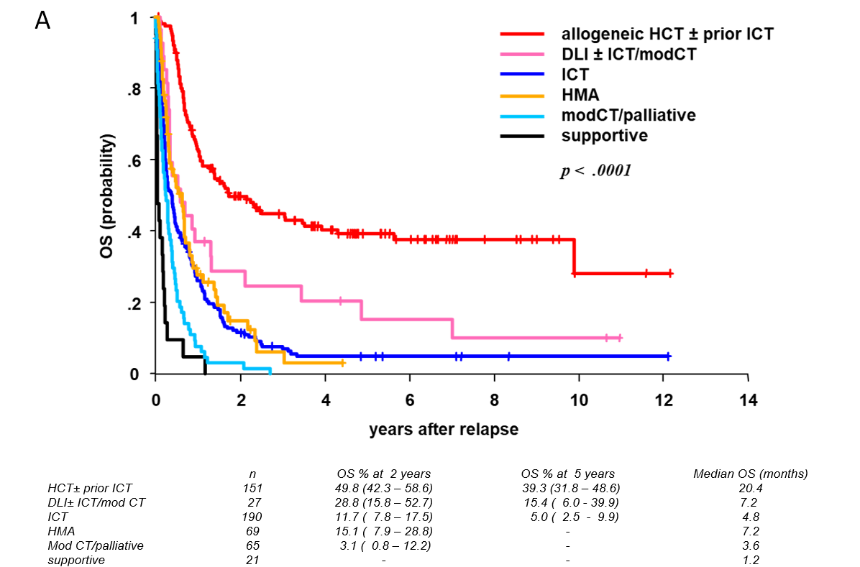
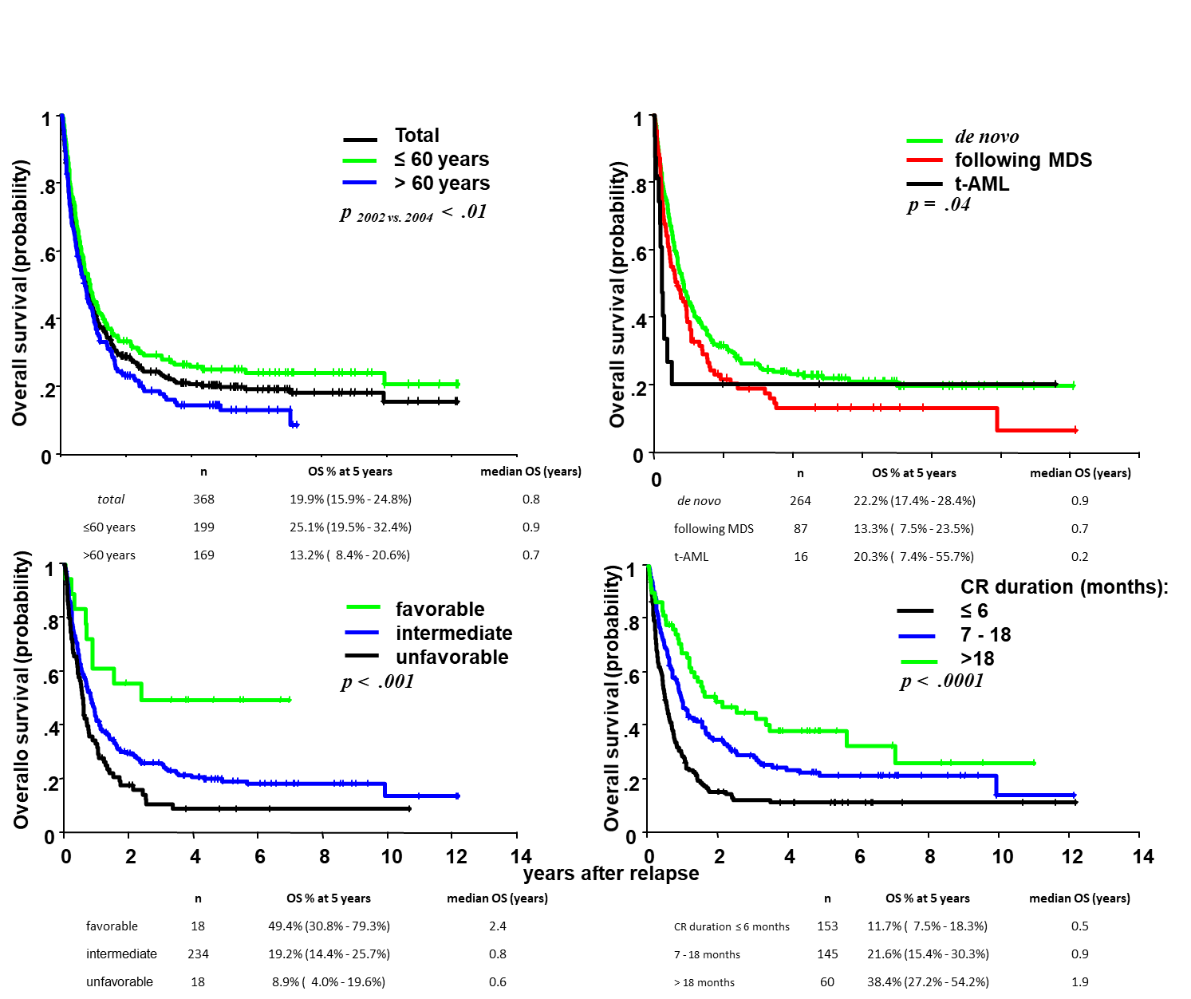
Suppl. Figure 7: OS in patients with intensive chemotherapy according to age, AML type, cytogenetic risk and CR – relapse interval
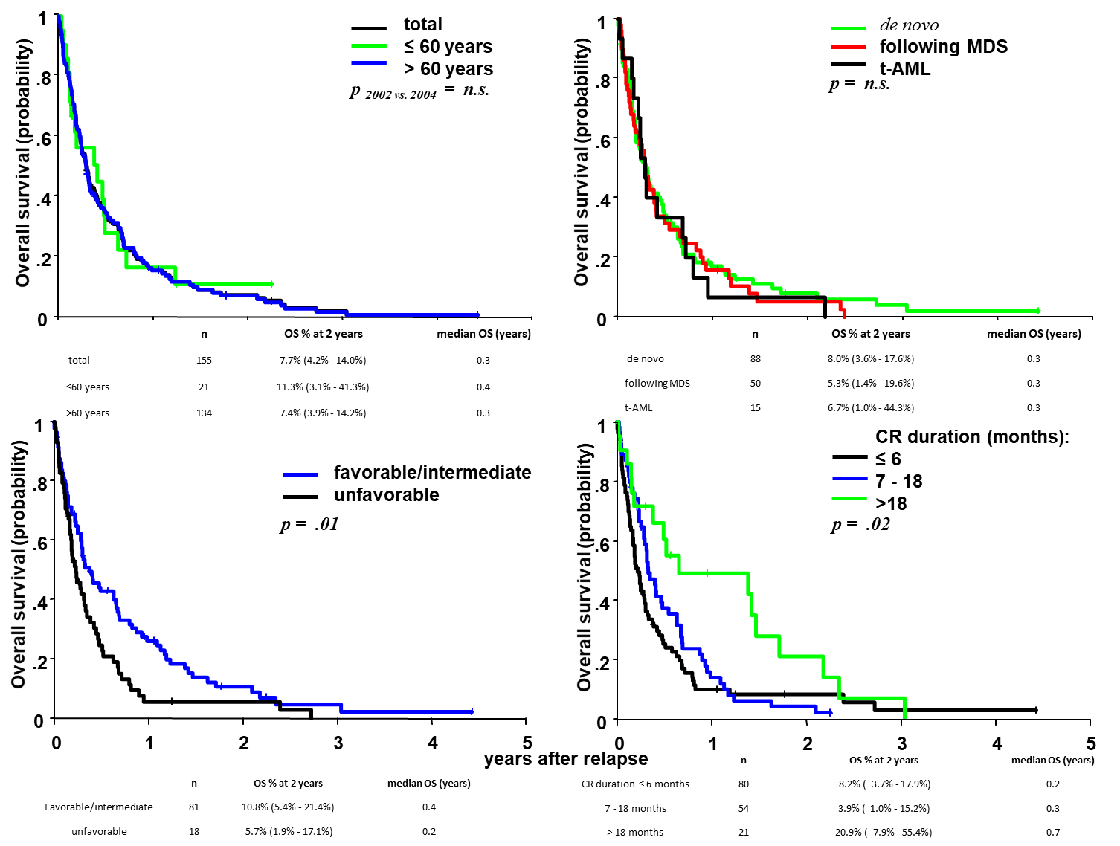
Suppl. Figure 8: OS in patients with palliative/supportive treatment according to age, AML type, cytogenetic risk and CR – relapse interval

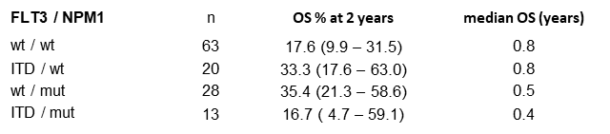
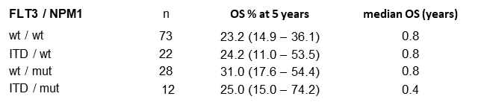
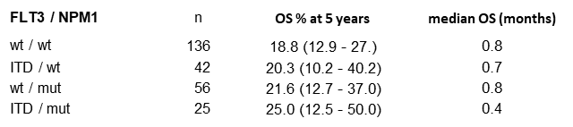
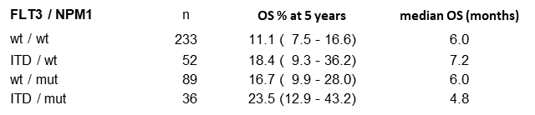
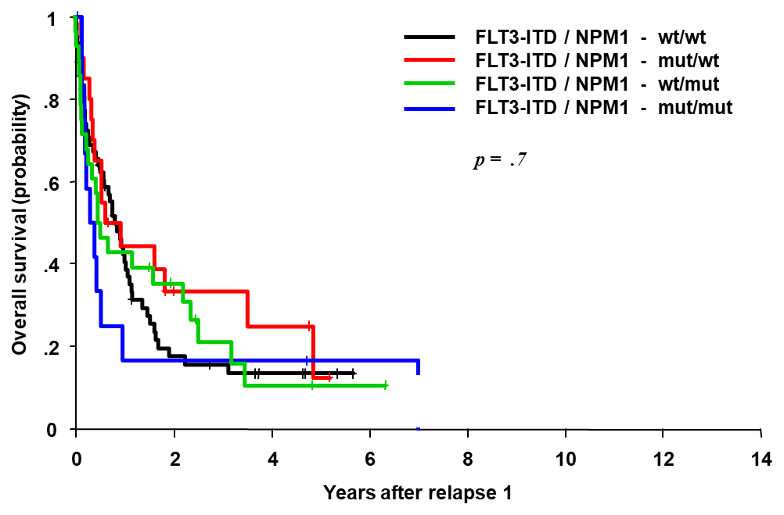
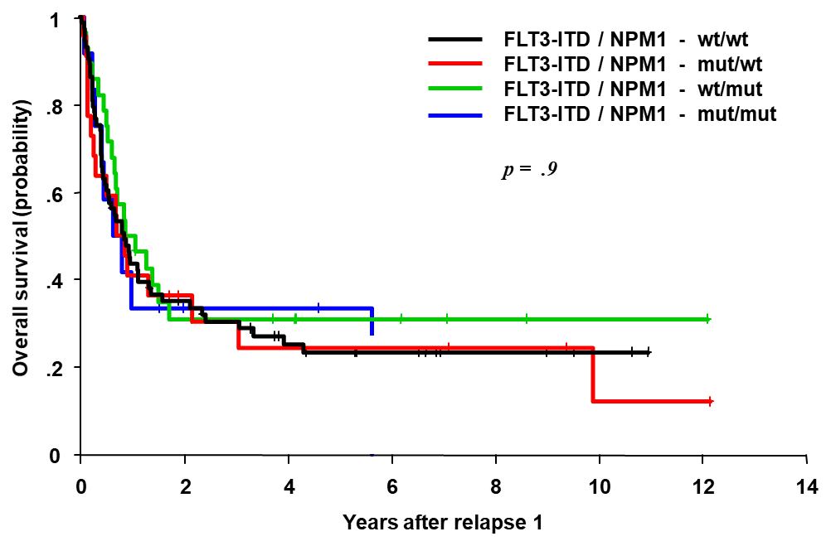
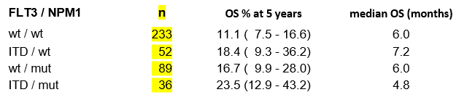
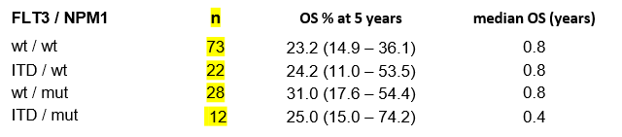
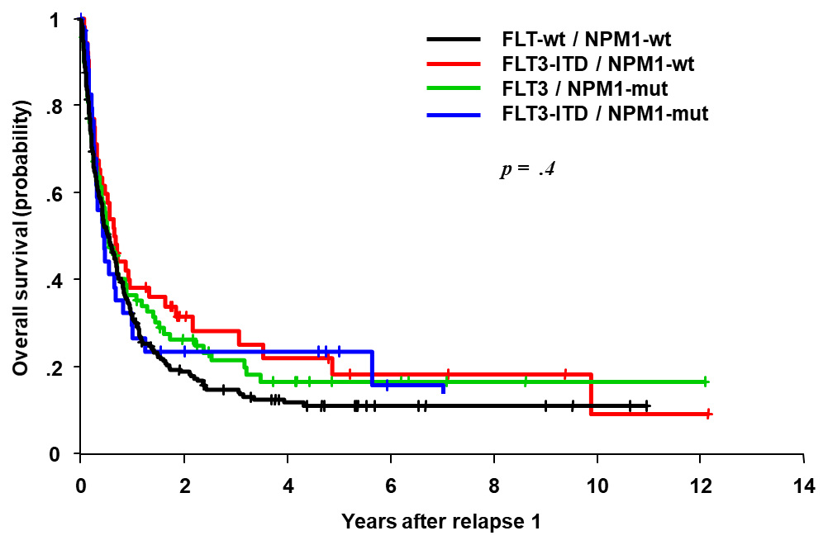
OS intensive chemotherapy all ages (n=259)
OS intensive chemotherapy >60 years(n=124)
OS intensive chemotherapy <60 years (n=135)
FLT3 / NPM1-wt
FLT3-ITD / NPM1-wt
FLT3 / NPM1-mut
FLT3-ITD / NPM1-mut
p = n.s.
Suppl. Figure 9: OS after intensive chemotherapy according to molecular risk factors and age
D
C
B
A
years after relapse
p = n.s.
p = n.s.
p = n.s.
0
2
4
6
8
10
12
14
Years after relapse 1
0
.2
.4
.6
.8
1
p = .7
OS all treatments (n= 410)

0
2
4
6
8
10
12
14
years after CR2
0
.2
.4
.6
.8
1
LFS (probability)
Total
≤ 60 years
> 60 years
p _{≤ 60} _{vs. >60} = .008

Suppl. Figure 10: LFS of patients with relapsed AML according to age

 | n | LFS % at 5 years | median LFS (months)
total | 227 | 24.9 (19.5-31.7) | 9.6
AML02, ≤60 years | 128 | 33.7 (26.2-43.5) | 10.8
AML04, >60 years | 99 | 13.8 (8.1-23.4) | 7.2

p = .5
0
2
4
6
8
10
12
14
Years after relapse 1
0
.2
.4
.6
.8
1
Leukemia free survival (probability)
Suppl. Figure 11: LFS of patients with relapsed AML according to molecular marker
FLT3 / NPM1-wt
FLT3-ITD / NPM1-wt
FLT3 / NPM1-mut
FLT3-ITD / NPM1-mut

FLT3 / NPM1 | n | OS % at 5 years | median (months)
wt / wt | 82 | 20.0% (12.7 - 31.5) | 8.4
ITD / wt | 25 | 20.3% ( 8.8 - 46.8) | 9.6
wt / mut | 36 | 30.3% (17.6 - 52.0) | 14.4
ITD / mut | 11 |  | 13.2
FLT3-ITD / NPM1 = wt / wt 20.0% (12.7 - 31.5) @5y, median 0.7y
FLT3-ITD / MPN1 = mut / wt 20.3% ( 8.8 - 46.8) @5y, median 0.8y
FLT3-ITD / MPN1 = wt / mut 30.3% (17.6 - 52.0) @5y, median 1.2y
FLT3-ITD / MPN1 = mut / mut median 1.1y

