Supplements

Legend to the suppl. Table
Suppl. Table S1: Multivariate logistic regression for CR/CRi

Legend to the suppl. Figures

Suppl. Figure S1: Design of the studies and treatment characteristics
Suppl. Figure S2 : Standardized event-free survival (EFS) of the three arms: common standard arm (CSA), study group A and study group B

Suppl. Figure S3 : Standardized Overall survival (OS) of the three arms: common standard arm (CSA), study group A and study group B

Suppl. Figure S4 : Standardized relapsed-free survival (RFS) of the three arms: common standard arm (CSA), study group A and study group B

suppl. Table 1: Multivariate logistic regression for CR/CRi
 | CR/CRi
Variable | n | events | Estimated Coeff. ± SD | Estimated  OR 95% CI | p-value
Treatment group
CSA | 98 | 54 | Baseline
Study group A | 183 | 101 | 0.002 ± 0.26 | 1.00 (0.60-1.67) | .99
Study group B | 650 | 393 | 0.24 ± 0.23 | 1.27 (0.81-1.97) | .29
Significant variables in the final model
Age, years / 10 | 931 | 548 | -0.48 ± 0.14 | 0.62 (0.48-0.81) | .0004
Type of disease
De novo AML | 564 | 360 | Baseline
Secondary AML | 367 | 188 | -0.59 ± 0.14 | 0.55 (0.42-0.73) | <.0001
Cytogenetic risk group
Favorable | 115 | 87 | Baseline
Intermediate | 587 | 341 | -0.91 ± 0.24 | 0.40 (0.25-0.65) | .0002
Adverse | 229 | 120 | -1.21 ± 0.27 | 0.29 (0.17-0.50) | <.0001
Log [(WBC in 10⁹/L) / 10] | 931 | 548 | -0.19 ± 0.04 | 0.82 (0.75-0.89) | <.0001
CSA, common standard arm; CR/CRi, Complete or incomplete remission; Coeff., coefficient; SD, standard deviation; OR, odds ratio; EFS, event free survival; OS, overall survival; RFS, relapse free survival. For age and WBC, the same variable transformations as identified in Büchner et al. (2012) were chosen.

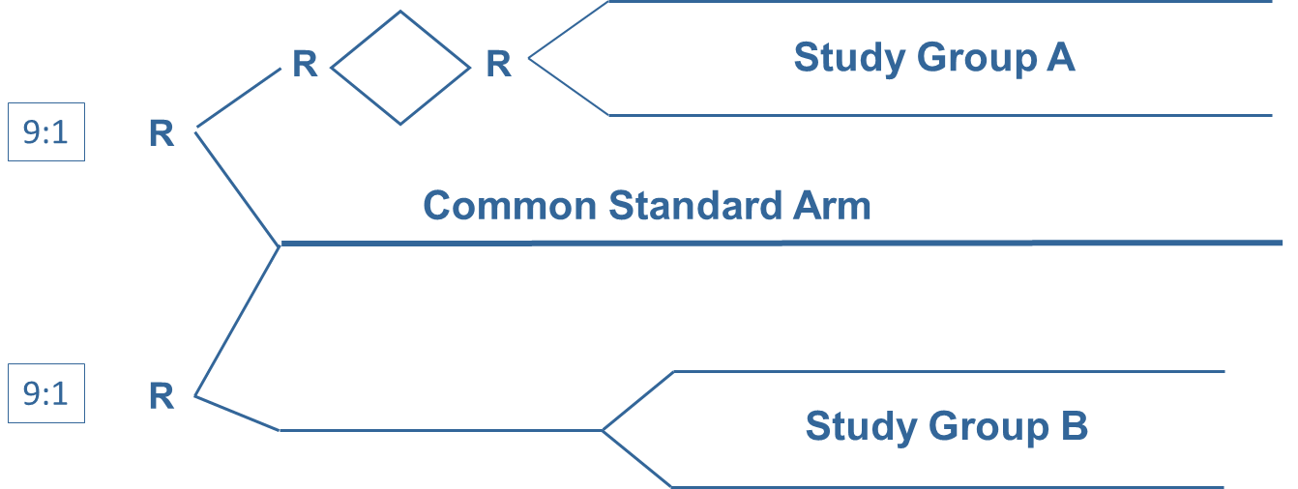
suppl. Figure 1: Design of the study including common standard arm, study group A and study group B and treatment characteristics

Common standard arm (CSA): 1-2 x araC 100 mg/m2/d C.I. d 1-7 + daunorubicin (dauno) 60 mg/m2/d IV d 3-5; 2 consolidations araC 1 g/m2/d BID IV d 1, 3 and 5 (Mayer RJ et al, NEJM 1994).
Group A: TAD (HAM) – HAM vs. HAM (HAM) - HAM ± G-CSF. TAD were given as consolidation followed by maintenance AD-AT-AC-AT over 3 a.
Group B: 1-(2) x araC 1 g/m²/d BID IV d 1 + 3 + 5 + 7 and mitoxantrone (mito) 10 mg/m2/d IV d 1 – 3; 2 x ara-C 500 mg/m² BID 1h IV d 1 + 3 + 5 in combination with mito 10 mg/m2/d IV d 1 + 2 Pegfilgrastim 6 mg s.c. on day 10 of induction and on d 8 of consolidation.
Abbreviations: TAD (araC 100 mg/m2/d C.I. d1-2, BID d 3-8 + daunorubicin 60 mg/m2/d IV d 3-5 + 6-thioguanine 100 mg/m2/d po BID d 3-9); HAM (araC 1 g/m2/d IV BID d 1-3 and mitoxantrone 10 mg/m2/d IV d 3-5)

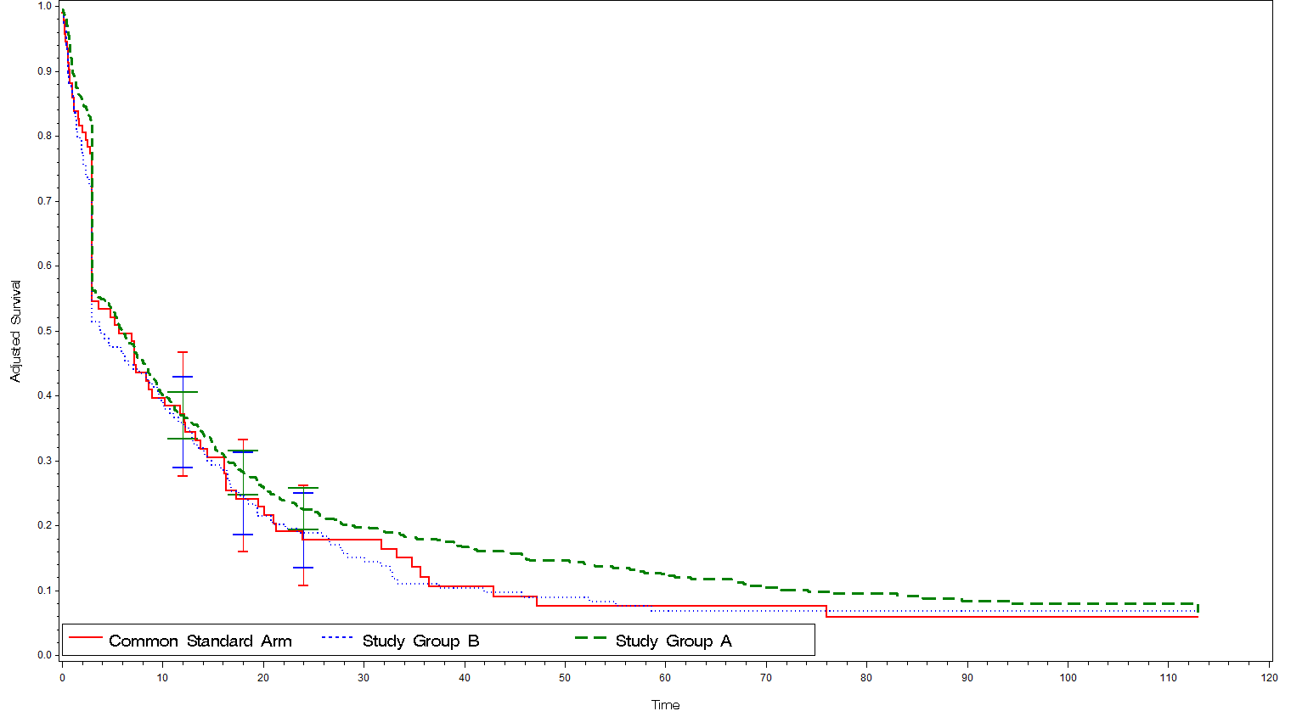
suppl. Figure S2: EFS adjusted
Months from Treatment

suppl. Figure S3: OS adjusted
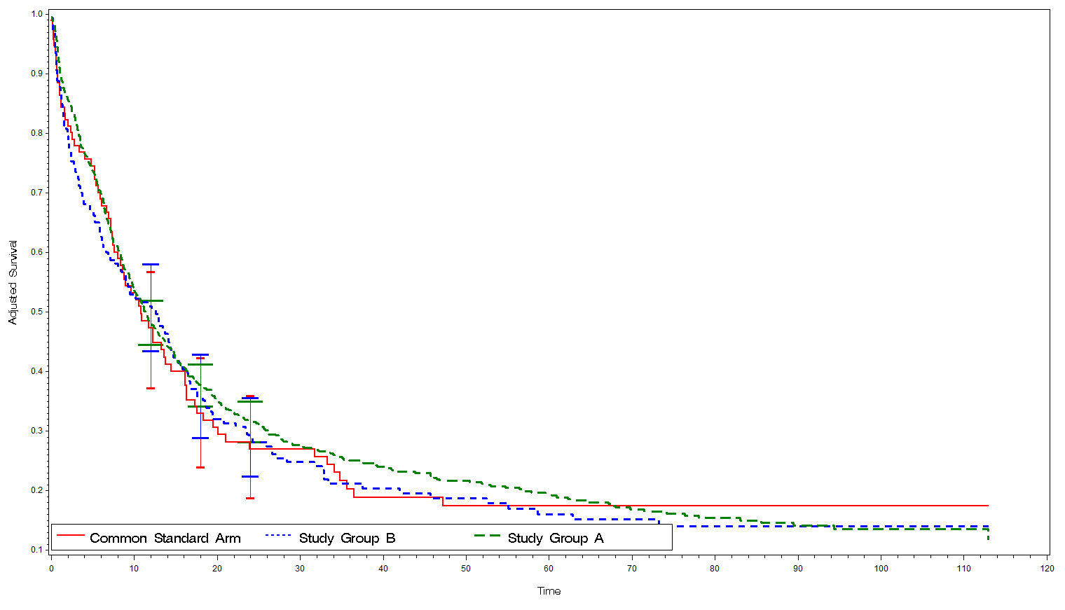
Months from Treatment
suppl. Figure S4: RFS adjusted
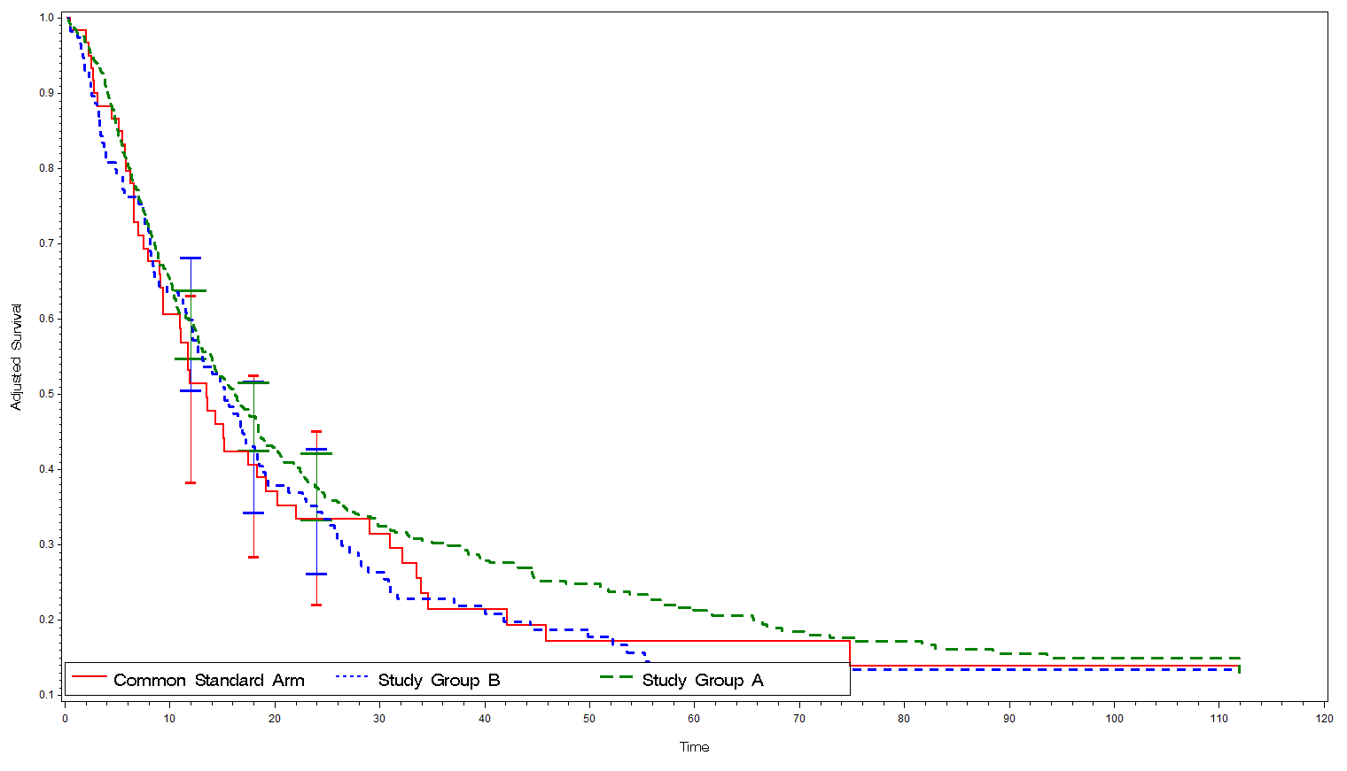
Months from CR/CRi
Months from CR/CRi

