Supplementary information

Comorbidities and survival of multiple myeloma patients diagnosed in Finland between 2000-2021
Kai Kysenius^{1*}, Anna Anttalainen¹, Iiro Toppila¹, Tatu Miettinen^{1,2}, Mariann Lassenius¹, Juha Lievonen³, Anu Partanen⁴, Raija Silvennoinen³, Mervi Putkonen⁵

¹ Medaffcon Oy, Espoo, Finland
² Takeda Oy, Helsinki, Finland
³ University of Helsinki and Helsinki University Hospital, Department of Hematology, Helsinki, Finland
⁴ Kuopio University Hospital, Department of Medicine, Kuopio, Finland
⁵ Turku University Hospital, Department of Hematology, Turku, Finland
* Corresponding author: kai.kysenius@medaffcon.fi

Supplementary methods

Patient selection
The cohort was identified as patients with at least four records for MM in the HILMO during 2000-2021 with the International Classification of Diseases 10th Revision (ICD-10) diagnosis code C90.0; MM diagnosis date was set as the date of the first of these records. Prevalent patients with the initial C90.0 recorded before 1.1.2000 were excluded from the cohort. All patients were over 18 years at diagnosis. In order to include only true MM patients and not erroneously recorded, additional exclusion criteria were used: patients with less than 4 MM records were excluded, unless the patient died within two weeks from the first MM record. Additionally, the MM patient had to be treated for MM during the first year from initial diagnosis.
Data extraction included specialty care diagnoses, procedures, and visits from the corresponding time-window. The cohort was linked with Statistics Finland to obtain the time and cause of death (until end of 2021). Data on reimbursed drug purchases and specialty reimbursement decisions were collected from the Social Insurance Institution (SII). Date of MM treatment initiation was defined as the first record of specialty reimbursement decision codes for blood malignancies (117), ixazomib (1505, 329), pomalidomide (1507, 393) and lenalidomide (153, 329) earliest 6 months before MM diagnosis and latest at the end of 2021. Records of hospital medications were not available in this study. The cohort formation process along with the number of excluded patients for each criterion is shown in Figure 1. Similar cohort formation was used in Toppila et al. (1).

Control group
Non-MM control group individuals were age-, sex- and region-matched to MM patients in a 3:1 ratio. However, there were 29 MM patients in the final cohort who had less than 3 region-matched controls, hence these patients were age- and sex-matched without region-matching. Any individual with a record of ICD-10 C90.0 between 1997-2021 was excluded from the control cohort.

Statistical analysis
The cohort was described at diagnosis by age (years), sex, mortality during follow-up, socioeconomic status during follow-up and most recently reported educational level, the proportion of patients treated for MM, the proportion of patients receiving ASCT during follow-up, distribution of index years divided into four groups (2000-2004, 2005-2010, 2011-2016 and 2017-2021; the patients in the second and third group correspond to the patients studied in Toppila et al. (1,2) and most prevalent comorbidities (>5%) and Charlson comorbidity index (CCI) (3) three years prior to diagnosis (=at baseline) using ICD-10 diagnosis codes. ASCT status was identified as having a record with one of the following NOMESCO classification of surgical procedure codes (NCSP): codes associated with the collection, modulation and storage of stem cells for transplantation (YNB10, YNB12, YNB40, YNB42) or autologous or allogenic stem cell transplantation (WW300, WW302, WW304, WW306. ASCT was assessed at any time after diagnosis, however, the analyses describing time trends of ASCT proportion were restricted to include data from patients diagnosed between 2000-2021, to ensure completed ASCT treatments after diagnosis within our follow-up period. The differences between groups were tested using Chi-squared for categorical variables and Kruskal-Wallis Rank-Sum test for continuous variables. A level of statistical significance of α = 0.05 was used for all statistical testing.
The annual incidence of MM was estimated by dividing the number of new incident patients by the total Finnish population at any given year. Incidence was further evaluated, utilizing also the age-standardized world standard population as reference [WHO World standard population (2000-2025)]. Incidence per age-group (5-year gaps) is also reported. Mann-Kendall trend test was used to test the time-trend where applicable.
Overall survival (OS) was analyzed using the Kaplan-Meier estimate; the difference in median survival by different strata was tested using the Log-rank test. Association of available MM patient characteristics with OS was analyzed in Cox-proportional hazards models. The following predictors of survival were included as covariates models: age at MM diagnosis, sex, ASCT (time-varying covariate), CCI, and diagnosis year (continuous variable to assess the improvement in survival over time). As CCI showed violations of proportional hazards assumption, the covariate was included by fitting a model stratified by CCI group (scores 0, 1-2, and ≥3, with higher scores indicating increased comorbidity load), allowing for different baseline hazards for each group.
The cohort was described at MM diagnosis by the proportion of each reported ICD-10 diagnosis code (prevalence ≥5% in the cohort) up to 3 years before MM index date (date of study entry) and with cut-off at 1 month before MM diagnosis. The differences between cases and controls were tested with z-test from binomial logistic regression model between the paired (case-control) data.
The effect of baseline comorbidities included in the Charlson comorbidity index (3) on OS was studied by univariate Cox proportional hazard models, stratified by ASCT. Because the ASCT patients were alive at least until the transplantation, their follow-up shows some immortality survival bias at the beginning, but it was accepted in order to keep the ASCT and nASCT model results comparable.
Healthcare resource utilization (HCRU) was assessed based on the inpatient visits, hospital outpatient clinic contacts, and emergency room (ER) visits recorded at THL registries (specialty care only, since primary care data was not available until 2011). An event was defined as a recorded healthcare contact (longer hospitalizations were also counted as single events). HCRU was also stratified by main diagnoses of interest CVD (I1-I7), other malignancies (C0-C6, C70-C76, C8, C91-C97) and infections (A, B, J0, J1, J20-J22, N10, N30). HCRU was analyzed annually from index (1 - 6+ years) as the visits per patient year (PPY; total number of visits divided by the corresponding patient years). 95% confidence intervals (CI) were estimated using bootstrapping over the patients.

1. Toppila I, Miettinen T, Lassenius MI, Lievonen J, Bauer M, Anttila P. Characteristics and survival trends in Finnish multiple myeloma patients—a nationwide real-world evidence study. Ann Hematol [Internet]. 2021 Mar 12 [cited 2021 Mar 18]; Available from: http://link.springer.com/10.1007/s00277-021-04481-4
2. Toppila I, Kysenius K, Miettinen T, Lassenius MI, Lievonen J, Anttila P. Comorbidity characteristics of multiple myeloma patients diagnosed in Finland 2005-2016. Ann Hematol. 2022 Nov;101(11):2485–95.
3. Quan H, Li B, Couris CM, Fushimi K, Graham P, Hider P, et al. Updating and Validating the Charlson Comorbidity Index and Score for Risk Adjustment in Hospital Discharge Abstracts Using Data From 6 Countries. American Journal of Epidemiology. 2011 Mar 15;173(6):676–82.

Supplementary Figures
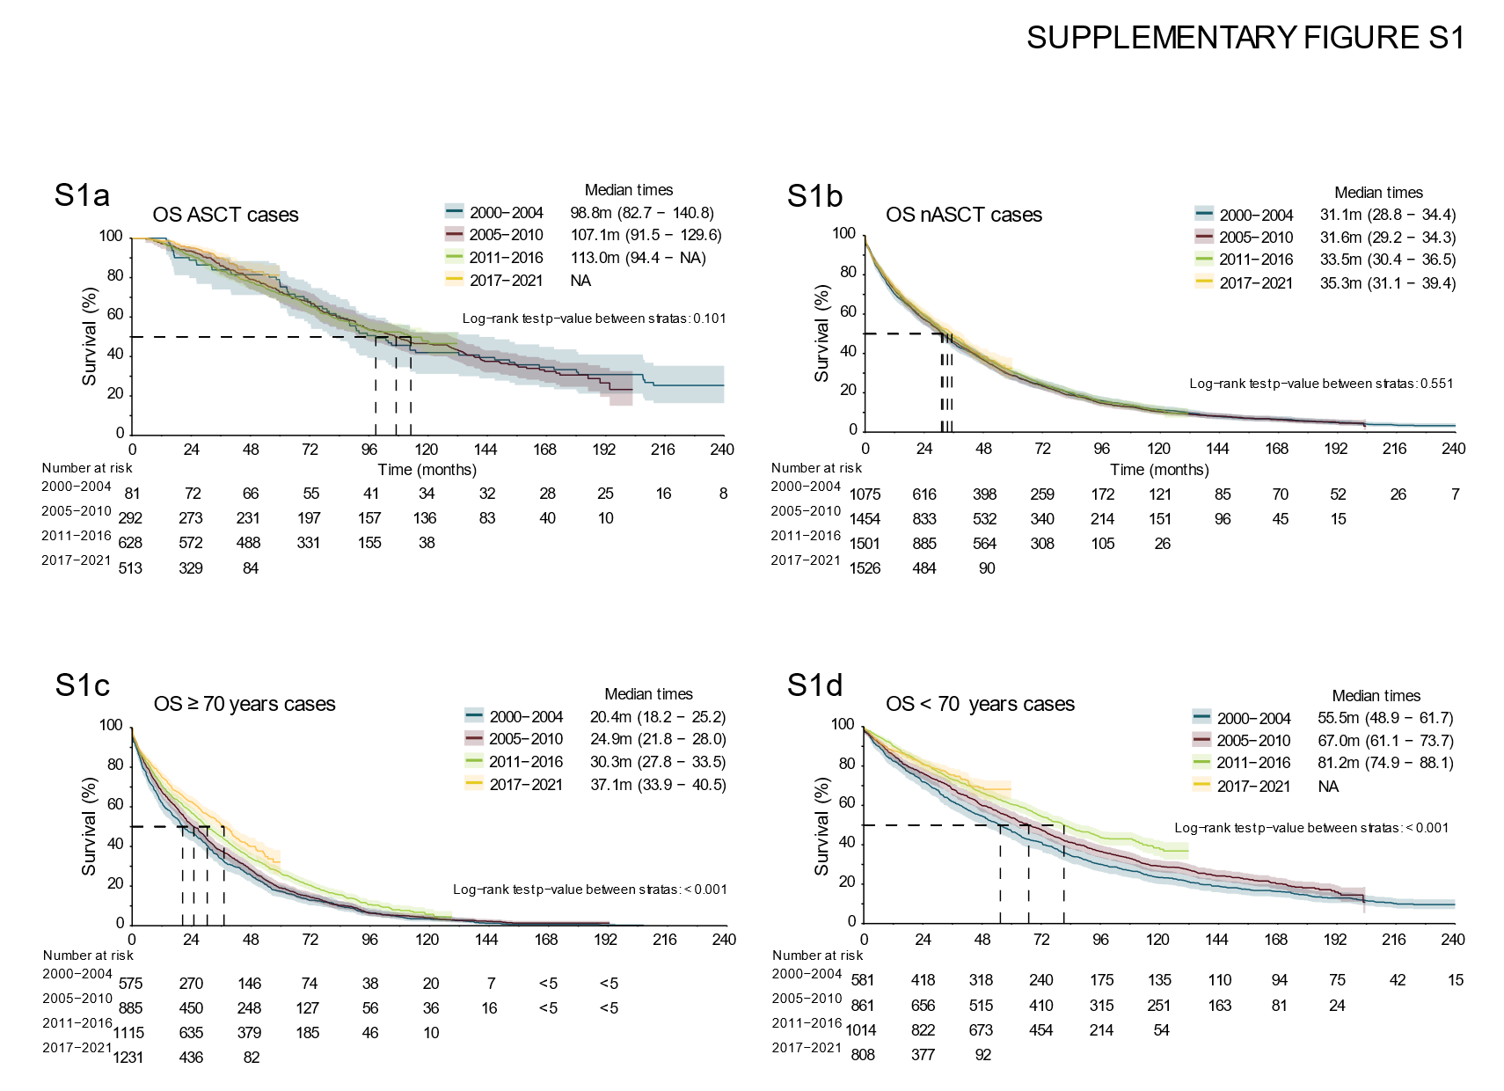

Supplementary Fig. S1 The development in the overall survival of ASCT vs. nASCT, and elderly MM patients in Finland during 2000-2021
The mOS of ASCT (a) and nASCT (b) patients during 2000-2004, 2005-2010, 2011-2016 and 2017-2021. The mOS of MM patients ≥ 70 years old (c) and < 70 years old (d) during 2000-2004, 2005-2010, 2011-2016 and 2017-2021.

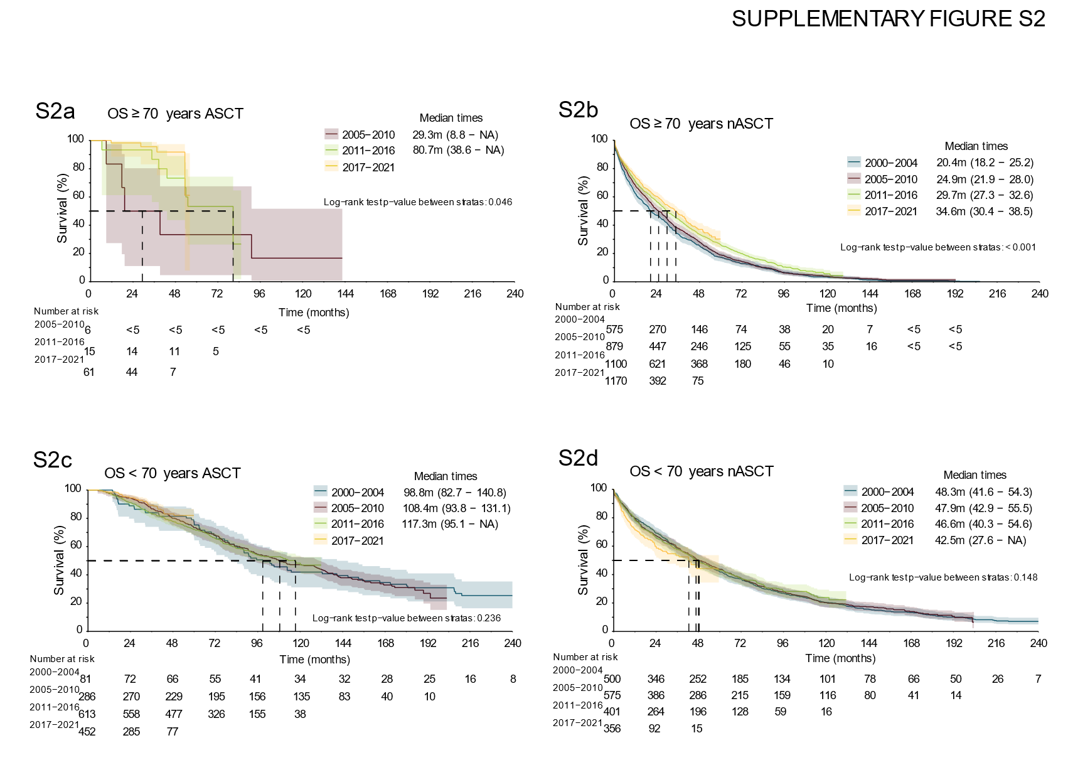

Supplementary Fig. S2 The development in the overall survival of MM patients in Finland during 2000-2021 stratified by age and ASCT-status
The mOS of ≥ 70 years old ASCT (a) and nASCT (b) patients during 2000-2004, 2005-2010, 2011-2016 and 2017-2021. The mOS of < 70 years old ASCT (c) and nASCT (d) patients during 2000-2004, 2005-2010, 2011-2016 and 2017-2021.
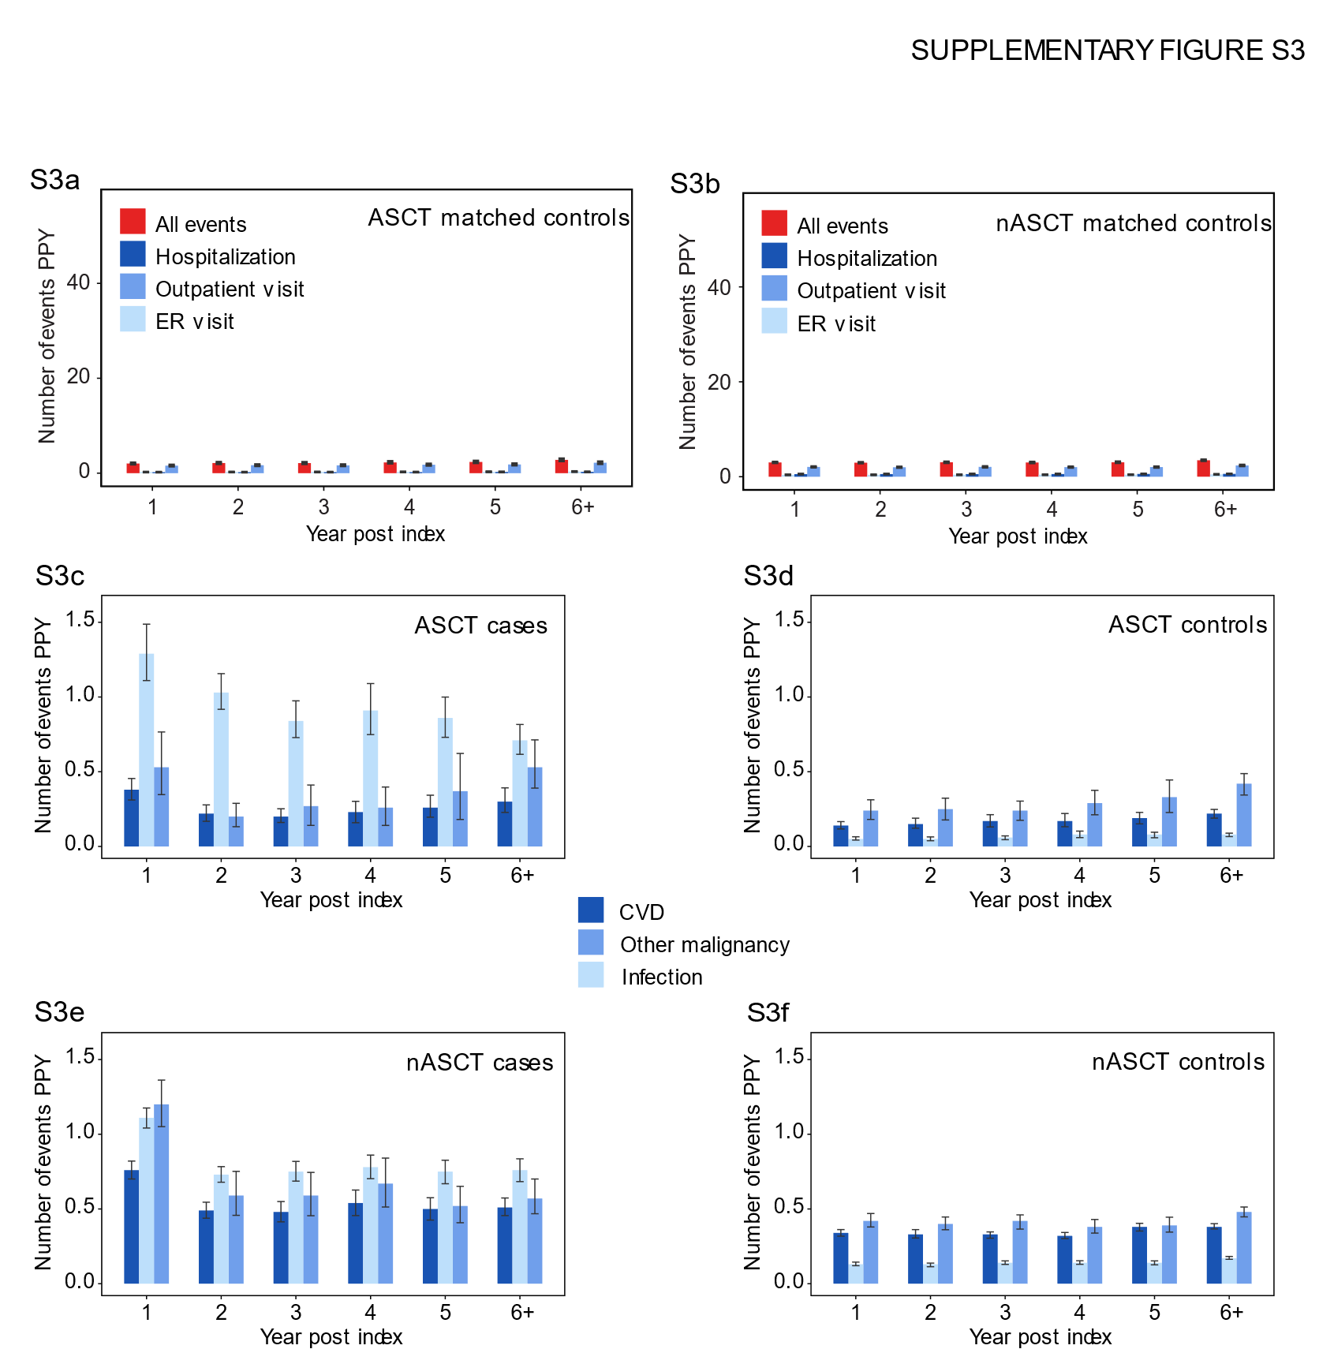
Supplementary Fig. S3 HCRU of ASCT and nASCT matched controls
HCRU by total number of events PPY in (a) ASCT matched controls and (b) nASCT matched controls. HCRU of (c) ASCT patients and (d) their matched controls, and (e) nASCT patients and (f) their matched controls, due to cardiovascular disease (CVD), other malignancies and infections.

Supplementary Tables
Supplementary Tables are provided in a separate excel file.

Supplementary Table S1 Clinical characteristics of the MM patients (socioeconomic status and education level)
Supplementary Table S2 Clinical characteristics of ASCT and nASCT MM patients (socioeconomic status and education level)
Supplementary Table S3 Annual and age-standardized incidence, overall and time-stratified incidences by age group
Supplementary Table S4 Clinical characteristics of MM patients and their matched controls stratified by time
Supplementary Table S5 Median age of ASCT and nASCT patients over time
Supplementary Table S6 Clinical characteristics of ≥ and <70 years old MM patients and their matched controls
Supplementary Table S7 Co-occurring diagnoses in MM patients and their matched controls in Finland during 2000-2021
Supplementary Table S8 Comorbidities of ASCT and nASCT patients and their matched controls

