Supplementary Appendix

Daratumumab, Bortezomib, Melphalan, and Prednisone Versus Bortezomib, Melphalan, and Prednisone Alone in Transplant-ineligible Asian Patients With Newly Diagnosed Multiple Myeloma: Final Analysis of the Phase 3 OCTANS Study

Annals of Hematology

Weijun Fu, Soo-Mee Bang, Honghui Huang, Kihyun Kim, Wei Li, Gang An, Je-Jung Lee, Zhen Cai, Jie Jin, Yafei Wang, Chor Sang Chim, Robin Carson, Rui Liu, Lingling Wang, Man Zhao, Xi Chen, Canchan Cui, Jian Hou, Jianxiang Wang

Corresponding authors:
Prof. Jianxiang Wang
Chinese Academy of Medical Sciences & Peking Union Medical College, Tianjin, China
Email: wangjx@ihcams.ac.cn

Prof. Jian Hou
Renji Hospital, Shanghai Jiao Tong University School of Medicine, Shanghai, China
Email: houjian@medmail.com.cn
Supplementary Methods

Pre- and post-dose medications
In an effort to mitigate the incidence of infusion-related reactions, patients in the daratumumab plus bortezomib/melphalan/prednisone (D-VMP) group were provided with the following medications 1 to 3 hours prior to each study drug administration:
- An antipyretic, such as paracetamol/acetaminophen 650 to 1000 mg intravenously (IV) or orally (PO)
- An antihistamine, such as diphenhydramine 25 to 50 mg IV or PO, or equivalent. Patients were to avoid IV use of promethazine
- Dexamethasone 20 mg IV or PO, or equivalent. On days when patients received this dose of dexamethasone in the clinic, prednisone was not permitted to be self-administered at home
- A leukotriene inhibitor, such as montelukast 10 mg PO or equivalent, was optional on Cycle 1 Day 1 and could be administered up to 24 hours before study treatment administration as per investigator discretion
If it was deemed necessary, all oral pre-dose medications could be administered outside of the clinic on the day of the infusion, provided they were taken within 3 hours before the study treatment administration.

For patients who presented with a high risk of respiratory complications, such as those with mild asthma or with chronic obstructive pulmonary disorders and an forced expiratory volume in 1 second of <80% at screening, the following post-dose medications were to be considered:
- Antihistamine, such as diphenhydramine or equivalent
- Leukotriene inhibitor, such as montelukast or equivalent
- Short-acting β₂ adrenergic receptor agonist, such as salbutamol aerosol
- Control medications for lung disease, such as inhaled corticosteroids ± long-acting β₂ adrenergic receptor agonists for patients with asthma and long-acting bronchodilators (eg, tiotropium or salmeterol) ± inhaled corticosteroids for patients with chronic obstructive pulmonary disorder
Any post-dose medication was administered after the study treatment administration had been completed. For patients previously treated with daratumumab IV who switched to daratumumab subcutaneous (SC) on Day 1 of any cycle, post-dose medications were offered after ≥1 doses of daratumumab SC per investigator discretion.

Overview of ALCYONE study design
Complete study design has been published previously (Mateos MV, et al. Lancet. 2020;395(10218):132-141). Briefly, ALCYONE (ClinicalTrials.gov identifier: NCT02195479) was a phase 3, multicenter, randomized, open-label clinical trial that enrolled patients between February 9, 2015, and July 14, 2016, across 162 sites in 25 countries (North America, South America, Europe, and the Asia-Pacific regions). Eligible patients were aged ≥18 years with newly diagnosed multiple myeloma who were ineligible for high-dose chemotherapy with autologous stem cell transplant due to age ≥65 years or due to the presence of substantial comorbidities. Patients were randomized 1:1 to receive D-VMP or bortezomib/melphalan/prednisone (VMP), stratified by International Staging System (I, II, or III), geographical region (Europe or other), and age (<75 or ≥75 years). All patients received up to nine 6-week cycles of bortezomib (1.3 mg/m² SC on Days 1, 4, 8, 11, 22, 29, and 32 of Cycle 1 and Days 1, 8, 22, and 29 of Cycles 2–9) and melphalan (9 mg/m² PO once daily on Days 1–4 of each cycle) and prednisone (60 mg/m² PO once daily on Days 1–4 of each cycle). Patients allocated to the D-VMP group also received daratumumab (16 mg/kg IV once weekly during Cycle 1, once every 3 weeks in Cycles 2‒9, and once every 4 weeks thereafter [Cycles ≥10]) until disease progression or unacceptable toxicity. To mitigate the incidence of infusion-related reactions in the D-VMP group, dexamethasone 20 mg was substituted for prednisone on Day 1 of Cycles 1 through 9 as pre-infusion therapy.

The primary endpoint of ALCYONE was progression-free survival. Minimal residual disease (MRD) negativity was a secondary endpoint. MRD was assessed in bone marrow aspirate via next-generation sequencing at a sensitivity threshold of 10^{–5}, measured at confirmation or complete response or stringent complete response and at 12, 18, 24, and 30 months after the first dose of study treatment to assess the durability of MRD negativity in patients who maintained complete response/stringent complete response.

Exploratory subgroup analyses of the OCTANS and ALCYONE studies
A total of 220 Asian patients (D-VMP, n = 146; VMP, n = 74) were randomized in the OCTANS study and 706 global patients (D-VMP, n = 350; VMP, n = 356) were randomized in the ALCYONE study. The OCTANS and ALCYONE studies enrolled similar patient populations, except that OCTANS enrolled patients from sites specifically within the Asia-Pacific region whereas ALCYONE enrolled patients from sites across North America, South America, Europe, and the Asia-Pacific region. Study treatment regimens were similar between studies. The data cutoff date for the OCTANS analyses was December 23, 2022 (median [range] follow-up of 41.2 [0–59.9] months), and the data cutoff date for the ALCYONE analyses was June 24, 2019 (median [range] follow-up of 40.1 [0–52.1] months).

MRD negativity was measured at a sensitivity threshold of 10^{–5} and assessed by multiparameter flow cytometry in OCTANS and next-generation sequencing in ALCYONE; due to differences in the study methodology, no pooling of ALCYONE and OCTANS MRD data was performed. Sustained MRD negativity was defined as MRD negative and confirmed 12 months or 18 months later without an MRD-positive result in between. P values for MRD status were calculated via Fisher’s exact test. In both studies, cytogenetic risk was assessed by fluorescence in situ hybridization or karyotype testing, with high cytogenetic risk defined by the presence of del(17p), t(4;14), and/or t(14;16) abnormalities. For progression-free survival analyses, hazard ratios and 95% confidence intervals were calculated using a stratified Cox proportional hazards model with treatment as the sole explanatory variable; P values were calculated via a stratified log-rank test.

Supplemental Table S1 Patient Enrollment in OCTANS by Study Site
 | D-VMP  (n = 146) | VMP  (n = 74) | Total  (n = 220)

Country/region site, n (%)

China
CN10001 | 16 (11.0) | 8 (10.8) | 24 (10.9)
CN10003 | 5 (3.4) | 2 (2.7) | 7 (3.2)
CN10004 | 5 (3.4) | 2 (2.7) | 7 (3.2)
CN10005 | 2 (1.4) | 0 | 2 (0.9)
CN10006 | 2 (1.4) | 2 (2.7) | 4 (1.8)
CN10007 | 6 (4.1) | 5 (6.8) | 11 (5.0)
CN10008 | 3 (2.1) | 5 (6.8) | 8 (3.6)
CN10009 | 4 (2.7) | 1 (1.4) | 5 (2.3)
CN10010 | 3 (2.1) | 3 (4.1) | 6 (2.7)
CN10011 | 5 (3.4) | 1 (1.4) | 6 (2.7)
CN10012 | 2 (1.4) | 0 | 2 (0.9)
CN10013 | 6 (4.1) | 2 (2.7) | 8 (3.6)
CN10014 | 8 (5.5) | 2 (2.7) | 10 (4.5)
CN10016 | 3 (2.1) | 0 | 3 (1.4)
CN10017 | 1 (0.7) | 2 (2.7) | 3 (1.4)
CN10018 | 1 (0.7) | 1 (1.4) | 2 (0.9)
CN10019 | 0 | 1 (1.4) | 1 (0.5)
CN10020 | 2 (1.4) | 2 (2.7) | 4 (1.8)
CN10021 | 4 (2.7) | 3 (4.1) | 7 (3.2)
CN10024 | 0 | 1 (1.4) | 1 (0.5)
CN10025 | 10 (6.8) | 3 (4.1) | 13 (5.9)
CN10027 | 2 (1.4) | 0 | 2 (0.9)
CN10028 | 11 (7.5) | 3 (4.1) | 14 (6.4)
CN10029 | 1 (0.7) | 1 (1.4) | 2 (0.9)
CN10030 | 2 (1.4) | 0 | 2 (0.9)
CN10031 | 2 (1.4) | 0 | 2 (0.9)

Taiwan
TW10001 | 1 (0.7) | 1 (1.4) | 2 (0.9)
TW10002 | 3 (2.1) | 1 (1.4) | 4 (1.8)
TW10003 | 2 (1.4) | 1 (1.4) | 3 (1.4)

Hong Kong SAR
HK10001 | 2 (1.4) | 0 | 2 (0.9)

Korea
KR10001 | 9 (6.2) | 7 (9.5) | 16 (7.3)
KR10002 | 5 (3.4) | 5 (6.8) | 10 (4.5)
KR10003 | 4 (2.7) | 1 (1.4) | 5 (2.3)
KR10004 | 10 (6.8) | 3 (4.1) | 13 (5.9)
KR10005 | 2 (1.4) | 2 (2.7) | 4 (1.8)
KR10006 | 0 | 2 (2.7) | 2 (0.9)
KR10007 | 1 (0.7) | 0 | 1 (0.5)

Malaysia
MY10003 | 1 (0.7) | 0 | 1 (0.5)
MY10004 | 0 | 1 (1.4) | 1 (0.5)
D-VMP, daratumumab plus bortezomib/melphalan/prednisone; VMP, bortezomib/melphalan/prednisone.

Supplemental Table S2 Duration of Study Treatment and Treatment Exposureª
 | D-VMP  (n = 144) | VMP  (n = 71)
Duration of study treatment, months
Median (range) | 33.8 (0.3–57.7) | 12.0 (0.4–17.3)
Bortezomib dose intensity,^{b} mg/m²/cycle
Median (range) | 5.3 (2.9–10.3) | 5.3 (3.5–9.3)
Melphalan dose intensity,^{c} mg/m²/cycle
Median (range) | 33.6 (18.0–45.6) | 34.2 (13.0–38.9)
Prednisone equivalent dose intensity,^{d,e} mg/m²/cycle
Median (range) | 257.4  (151.9–315.3) | 238.0  (148.5–262.1)
Daratumumab IV dose intensity,^{f} mg/kg/cycle
Median (range) | 28.0 (1.2–96.0) | -
D-VMP, daratumumab plus bortezomib/melphalan/prednisone; VMP, bortezomib/melphalan/prednisone; IV, intravenous
ªIn the safety population
^{b}Dose intensity (mg/m²/cycle) was calculated as the sum of total doses (mg/m²) received in all cycles divided by the number of treatment cycles on bortezomib
^{c}Dose intensity (mg/m²/cycle) was calculated as the sum of total doses (mg/m²) received in all cycles divided by the number of treatment cycles on melphalan
^{d}Dose intensity (mg/m²/cycle) was calculated as the sum of total doses (mg/m²) received in all cycles divided by the number of treatment cycles on steroid
^{e}For D-VMP group, other corticosteroids may have been used as substitutes, which were converted to prednisone equivalent doses with the following conversion factor: 1 mg of dexamethasone = 6.67 mg of prednisone; 1 mg of methylprednisolone = 1.25 mg of prednisone; 1 mg of triamcinolone = 0.8 mg of prednisone; 1 mg of betamethasone = 8.33 mg of prednisone
^{f}Dose intensity (mg/kg/cycle) was calculated as the sum of total doses (mg/kg) received in all cycles divided by the number of treatment cycles on daratumumab

Supplemental Table S3 MRD-negativity Rates and Sustained MRD-negativity Rates in the OCTANS and ALCYONE Studies
 | OCTANS |  |  | ALCYONE
 | D-VMP | VMP | P valueª | D-VMP | VMP | P valueª
ITT analysis set | 146 | 74 |  | 350 | 356
MRD-negativity rate (10^{–5}), n (%) | 59 (40.4) | 8 (10.8) | <0.0001 | 99 (28.3) | 25 (7.0) | <0.0001
Sustained MRD-negativity rate (10^{–5}), n (%)^{b}
≥12 months | 36 (24.7) | 1 (1.4) | <0.0001 | 49 (14.0) | 10 (2.8) | <0.0001
≥18 months | 22 (15.1) | 1 (1.4) | 0.0008 | 31 (8.9) | 6 (1.7) | <0.0001
MRD, minimal residual disease; D-VMP, daratumumab plus bortezomib/melphalan/prednisone; VMP, bortezomib/melphalan/prednisone; ITT, intent-to-treat
ªP values were calculated using Fisher’s exact test
^{b}Sustained MRD negativity was defined as 2 confirmed MRD-negative assessments ≥12 months or ≥18 months apart and without any MRD-positive assessments in between
Supplemental Fig. S1 PFS by MRD (10^{–5}) status* in the ITT populations of the a) OCTANS study and b) ALCYONE study.
PFS, progression-free survival; MRD, minimal residual disease; ITT, intent-to-treat; D-VMP, daratumumab plus bortezomib/melphalan/prednisone; VMP, bortezomib/melphalan/prednisone
*MRD-positive subgroup included patients in the ITT population who were not tested and assumed positive or tested and found positive or indeterminate
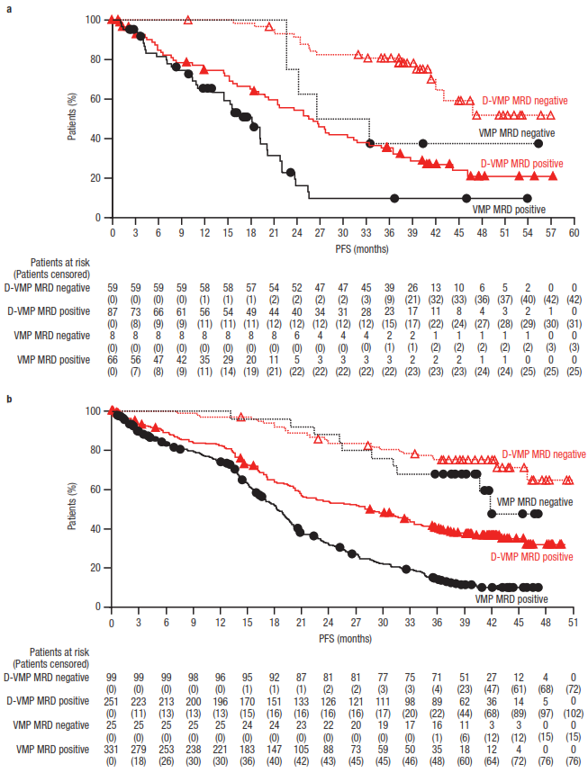
Supplemental Fig. S2 PFS by sustained MRD (10^{–5}; for ≥12 months) status* in ITT populations of the a) OCTANS study and b) ALCYONE study.
PFS, progression-free survival; MRD, minimal residual disease; ITT, intent-to-treat; D-VMP, daratumumab plus bortezomib/melphalan/prednisone; VMP, bortezomib/melphalan/prednisone
*MRD-positive subgroup included patients in the intent-to-treat population who were not tested and assumed positive or tested and found positive or indeterminate
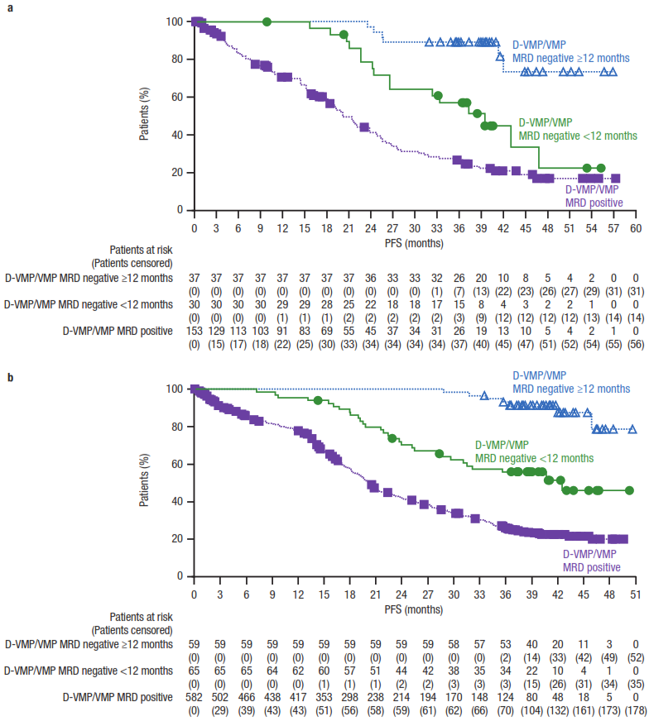

Supplemental Fig. S3 Pooled cytogenetic subgroup analysis of PFS in the ITT population of the OCTANS and ALCYONE studies.

PFS, progression-free survival; ITT, intent-to-treat; D-VMP, daratumumab plus bortezomib/melphalan/prednisone; VMP, bortezomib/melphalan/prednisone; HR, hazard ratio; CI, confidence interval; ISS, International Staging System; HRCA, high-risk cytogenetic abnormality
*Renal insufficiency defined as baseline creatinine clearance ≤60 mL/min
†Standard cytogenetic risk defined as none of the following HRCAs: t(4;14), t(14;16), and del(17p)
‡High cytogenetic risk defined as ≥1 of the following HRCAs: t(4;14), t(14;16), and/or del(17p)
§Revised standard cytogenetic risk defined as none of the following HRCAs: t(4;14), t(14;16), del(17p), t(14;20), gain(1q21), and amp(1q21)
¶Revised high cytogenetic risk defined as ≥1 of the following HRCAs: t(4;14), t(14;16), del(17p), t(14;20), gain(1q21), and/or amp(1q21)
#Gain(1q21) defined as 3 copies of chromosome 1q21, with or without other HRCAs
^{ǁ}Amp(1q21) defined as ≥4 copies of chromosome 1q21, with or without other HRCAs
**Gain(1q21) or amp(1q21) defined as ≥3 copies of chromosome 1q21, with or without other HRCAs
††1 HRCA defined as only 1 of the following HRCAs: t(4;14), t(14;16), del(17p), t(14;20), gain(1q21), or amp(1q21)
‡‡≥2 HRCAs defined as ≥2 of the following HRCAs t(4;14), t(14;16), del(17p), t(14;20), gain(1q21), and/or amp(1q21)
§§Isolated gain(1q21) defined as 3 copies of chromosome 1q21 without any other HRCAs
¶¶Isolated amp(1q21) defined as ≥4 copies of chromosome 1q21 without any other HRCAs
##Isolated gain(1q21) or amp(1q21) defined as ≥3 copies of chromosome 1q21 without any other HRCAs
^{ǁǁ}Gain(1q21) or amp1q21 plus ≥1 HRCA defined as ≥3 copies of chromosome 1q21 plus ≥1 of the following HRCAs: t(4;14), t(14;16), del(17p), and/or t(14;20)
