Characteristics, outcomes and treatment patterns in acute myeloid leukemia patients 60 Years or older in Colombia: a RENEHOC-PETHEMA study

Claudia Sossa-Melo
Faculty of Health Sciences, Universidad Autónoma de Bucaramanga, Floridablanca, Colombia, Hematology and Hematopoietic Stem Cell Transplantation Unit, Fundación Oftalmológica de Santander (FOSCAL).
Corresponding Author:
Email: claudiasossa@gmail.com
Virginia Abello Polo
Clinical Funcional Unit Leukemia, Lymphoma, Myeloma. Centro de Tratamiento e Investigación sobre Cáncer Luis Carlos Sarmiento Angulo (CTIC), Bogotá, Colombia.

Luis A. Salazar
Faculty of Health Sciences, Universidad Autónoma de Bucaramanga, Floridablanca, Colombia, Hematology and Hematopoietic Stem Cell Transplantation Unit, Fundación Oftalmológica de Santander (FOSCAL).
Angela M. Peña
Hematology and Hematopoietic Stem Cell Transplantation Unit, Fundación Oftalmológica de Santander (FOSCAL).
María Luna-González
Faculty of Health Sciences, Universidad Autónoma de Bucaramanga, Bucaramanga, Colombia.
Programa para el tratamiento de las enfermedades hemato-oncológicas de Santander, Floridablanca, Colombia.
Diana Cuervo-Lozada
Hematology Unit, Hospital San José - Fundación Universitaria de Ciencias de la Salud (FUCS), Bogotá, Colombia.
Guillermo E. Quintero-Vega
Hematology Unit, Fundación Santa Fe de Bogotá, Bogotá, Colombia.
Faculty of Medicine, Universidad de Los Andes, Bogotá, Colombia.
Jorge Daza
Hematology Unit, Centro de Tratamiento e Investigación sobre Cáncer Luis Carlos Sarmiento Angulo (CTIC), Bogotá, Colombia.
Olga Paola Omaña-Orduz
Functional Unit of Leukemia, Lymphoma, and Myeloma, Centro de Tratamiento e Investigación sobre Cáncer Luis Carlos Sarmiento Angulo (CTIC), Bogotá, Colombia.
Research Group GIGA, CTIC.
William Mantilla
Breast Cancer Unit, Centro de Tratamiento e Investigación sobre Cáncer Luis Carlos Sarmiento Angulo (CTIC).
Fundación Cardioinfantil - Instituto de Cardiología. Bogotá, Colombia.
Iván Perdomo
Hematology Unit, Clínica Los Nogales, Bogotá, Colombia.

Kenny Galvez
Hematology Unit, Hospital Pablo Tobón Uribe, Medellín, Colombia.
Laura María Díaz Correa
Hematology Unit, Hospital Pablo Tobón Uribe, Medellín, Colombia.
Paola Andrea Guerrero-Burbano
Hematologist, Cancer Unit, Clínica Imbanaco - Quirónsalud, Cali, Colombia.
Juan Manuel Herrera
Hematologist, Cancer Unit, Clínica Imbanaco - Quirónsalud, Cali, Colombia.

Henry Idrobo
Hematology Unit, Centro Médico Julián Coronel, Cali, Colombia.
Faculty of Health Sciences, Universidad del Valle, Cali, Colombia.

LM Gaviria
Hematology Unit, Hospital Universitario San Vicente Fundación, Medellín, Colombia.
Faculty of Medicine, Universidad de Antioquia, Medellín, Colombia.

Mario Ernesto Correa Correa
Hematology Unit, Clínica Nuestra Señora de los Remedios, Cali, Colombia.
Faculty of Health Sciences, Pontificia Universidad Javeriana, Cali, Colombia.

José Lobatón
Hematology Unit, Centro IMAT Oncomedica, Montería, Colombia.

Carlos Daniel Bermúdez
Hematology Department, Centro de Investigaciones Oncológicas, Clínica San Diego, Bogotá, Colombia.

Julian Eduardo Pedraza Morales
Hematology Service, Clínica Colsubsidio 127, Bogotá, Colombia.

Juan Carlos Serrano Casas
Hematology Service, Clínica de Cancerología del Norte de Santander, Cúcuta, Colombia.
Francisco Jaramillo
Hematology Unit, Fundación Valle del Lili, Cali, Colombia.
Rigoberto Gómez
Hematology Service, IDC Hematooncólogos S.A., Cali, Colombia.

Carmen Rosales
Hematology Unit, Sociedad de Oncología y Hematología del Cesar (SOHEC), Valledupar, Colombia.

María Helena Solano
Hematology Service, Hospital de San José, Bogotá, Colombia.

Carlos Varón
Hematology service, Unidad Hematológica Especializada, Cúcuta, Colombia
Rebeca Rodríguez Veiga
Hematology Unit, Hospital Universitari i Politècnic La Fe, Valencia, España.
David Martínez-Cuadrón
Hematology Unit, Hospital Universitari i Politècnic La Fe, Valencia, España.
Pau Montesinos
Hematology Unit, Hospital Universitari i Politècnic La Fe, Valencia, España.
Faculty of Medicine, Universitat de València, Valencia, España.

Supplementary Table 1. Induction Chemotherapy Regimens for Intensive and Non-Intensive Treatment
Therapeutic Approach | Treatment Regimen | n = 269 (100%) | Dose
Intensive Chemotherapy (IC)  n=99 | IDA + Ara-C (3+7) | 71 (26.4) | IDA 10–12 mg/m²/daily D1–3 + Ara-C 100–200 mg/m²/daily D1–7
Intensive Chemotherapy (IC)  n=99 | DNR + Ara-C (3+7) | 13 (4.8) | DNR 60 mg/m²/daily D1–3 + Ara-C 200 mg/m²/daily D1–7
Intensive Chemotherapy (IC)  n=99 | IDA + Ara-C (2+5) | 6 (2.2) | IDA 10–12 mg/m²/daily D1–2 + Ara-C 100–200 mg/m²/daily D1–5
Intensive Chemotherapy (IC)  n=99 | IDA+Ara-C (3+7) + FLT3 Inhibitor | 2 (0.7) | IDA 10–12 mg/m²/daily D1–3 + Ara-C 100–200 mg/m²/daily D1–7 midostaurin 50 mg /12hr D 8-21
Intensive Chemotherapy (IC)  n=99 | Ara-C 1g/m² | 2 (0.7) | 1000 mg/m² D1,3 and 5
Intensive Chemotherapy (IC)  n=99 | Ara-C 100 mg/m² x 5 | 2 (0.7) | Ara-C 100 mg/m²/daily D1–5
Intensive Chemotherapy (IC)  n=99 | MTX+Ara-C (LA FE OLD) | 1 (0.4) | MTX 10 mg/m²/daily D1-3 + Ara-C 150 mg/m²/daily D1-7
Intensive Chemotherapy (IC)  n=99 | Other (intensive) | 2 (0.7) | Not available
Non-Intensive Chemotherapy  (Non-IC)  n=129 | FLUGA | 24 (8.9) | FLU 40 mg/m²/daily orally or 25 mg/m²/daily IV D2–5 or 6 + Ara-C 75 mg / m²/ daily D2–5 + G-CSF  5 μg/kg/daily D1,3
Non-Intensive Chemotherapy  (Non-IC)  n=129 | Low-Dose Ara-C | 10 (3.7) | Ara-C, 20 mg/12hr D1–10
Non-Intensive Chemotherapy  (Non-IC)  n=129 | Azacitidine | 66 (24.5) | AZA 75 mg/m²/daily D1–7 or on a 5-on/2-off [weekend] /2-on schedule Q28D
Non-Intensive Chemotherapy  (Non-IC)  n=129 | Decitabine | 4 (1.5) | DEC 20 mg/m²/daily D1–5 Q28D
Non-Intensive Chemotherapy  (Non-IC)  n=129 | Venetoclax + Azacitidine | 25 (9.3) | Venetoclax 400 mg/daily D1-28 + AZA 75 mg/m²/daily D1-7 Q28D
Supportive Care (SC)  n=41 | Other (describe) | 41(15.2) | Oral treatment: hydroxyurea (4), mercaptopurine (1).
Abbreviations: Ara-C: Cytarabine; D: day; DNR: Daunorubicin; FDR: Fludarabine; hr: hour; IDA: Idarubicin; IV: Intravenous; MTX: Mitoxantrone; G-CSF:
Granulocyte colony stimulating factor

Supplementary Fig.1 Therapeutic approach distribution according to age
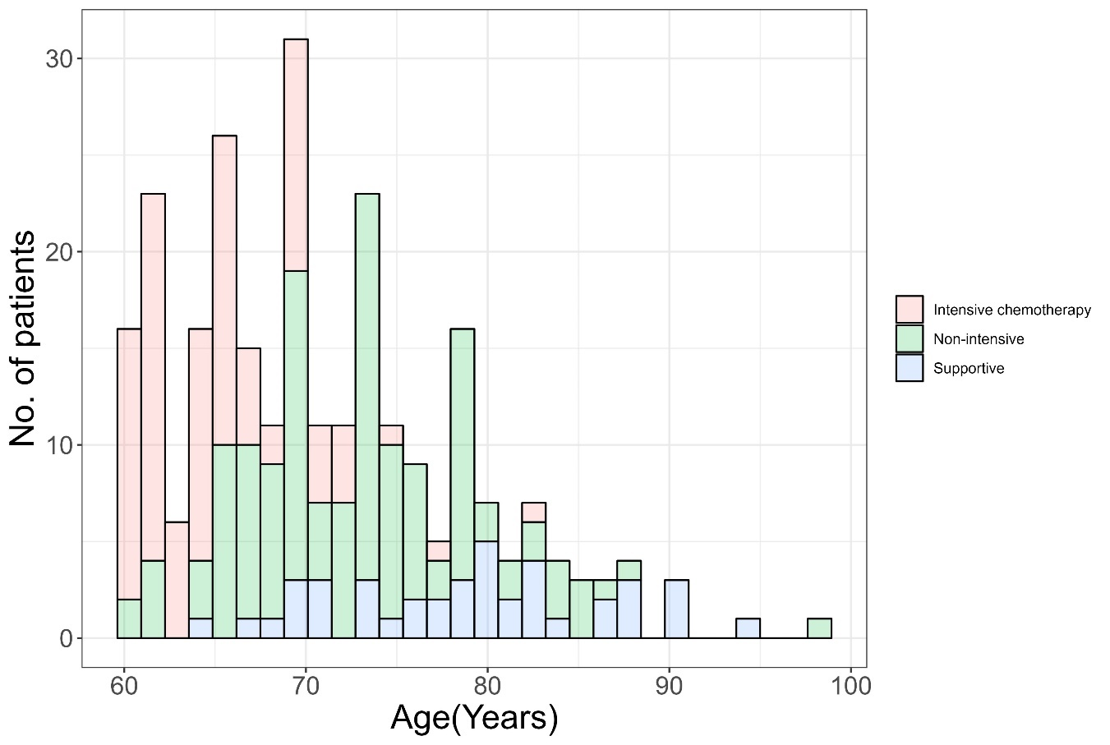

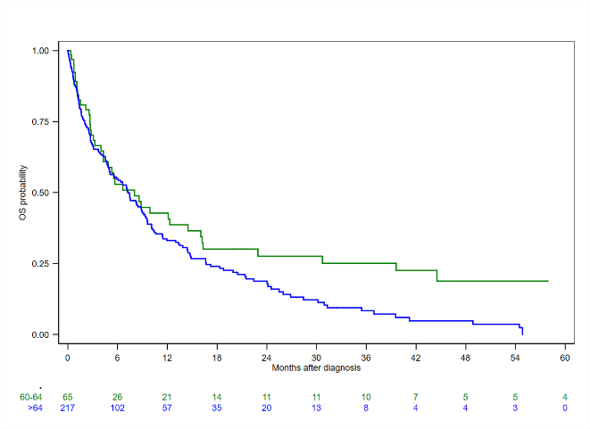
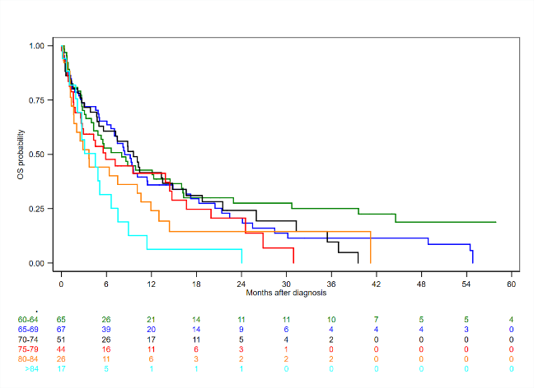
Supplementary Fig 2. OS, graph of age groups by five-year intervals (left) and classified

