`APPENDIX
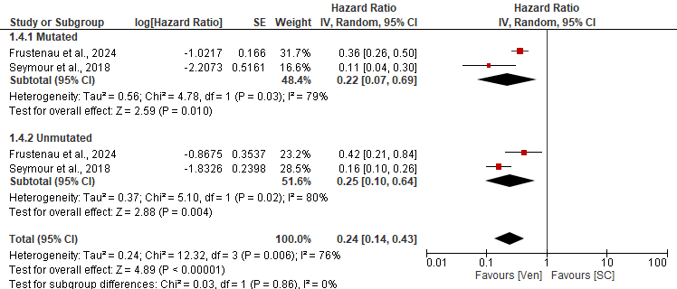
Suplementary Fig 1 A subgroup analysis of the PFS according to the IGHV mutational status.
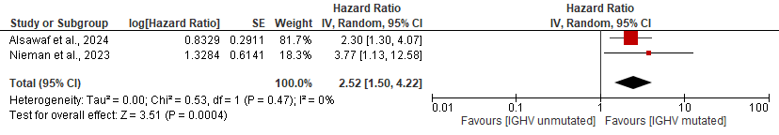
Suplementary Fig 2 The PFS of IGHV unmutated versus mutated patients on venetoclax based regimens.

