Clinical features and outcomes in large granular lymphocyte leukemia−associated pure red cell aplasia with STAT3 mutation
Xiaoqing Liu^{1,#}, Xingxing Chai^{2,#}, Qingling Yu^{3,#}, Wei Wang¹, Qiqiang Long¹, Yuemin Gong⁴, Yawen Zhang⁴, Chun Qiao⁴, Jianping Hao^{5,*}, and Guangsheng He^{4,*}
¹ Department of Hematology, The Second Hospital of Nanjing, Nanjing University of Chinese Medicine, Nanjing 210000, China
² Department of Hematology, The Second Lianyungang People's Hospital affiliated to Kangda College of Nanjing Medical University, Lianyungang 230601, China
³ Department of Hematology, Affiliated Jianhu Hospital of Nantong University Xinglin College,Yancheng 224000, China
⁴ Department of Hematology, The First Affiliated Hospital of Nanjing Medical University, Jiangsu Province Hospital, Nanjing 210000, China
⁵ Hematology Center, The First Affiliated Hospital of Xinjiang Medical University, Xinjiang Institute of Hematology, Urumqi 830000, China
#These authors contributed equally: Xiaoqing Liu, Xingxing Chai, Qingling Yu
*Correspondence:
Jianping Hao, E-mail: 13579876416@163.com
Guangsheng He, E-mail: heguangsheng1972@sina.com
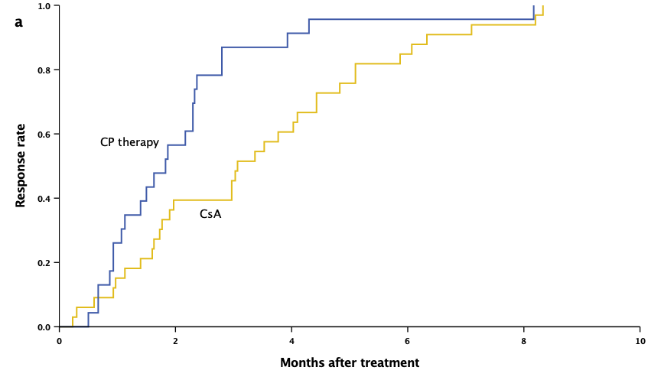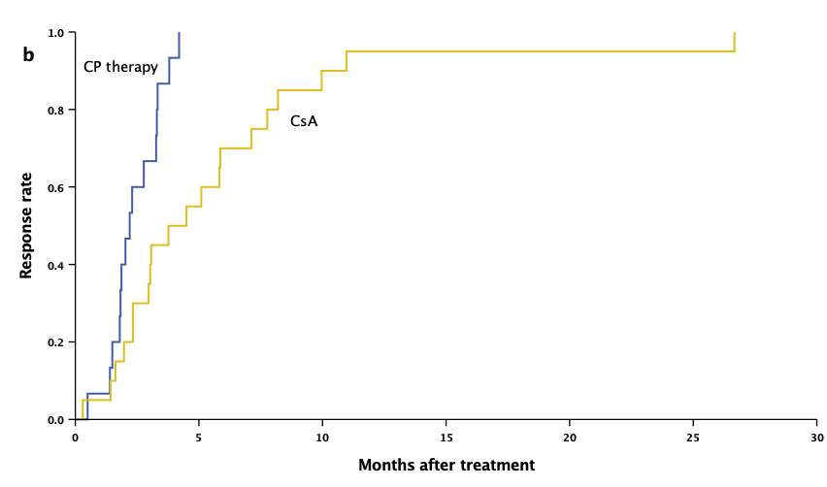
Supplementary Figure 1 Kinetics of hematologic response after immunosuppressive therapy. (a) showed the time to initial response after CsA and CP therapy (P=0.009); (b) showed the time to complete response after CsA and CP therapy (P=0.002).

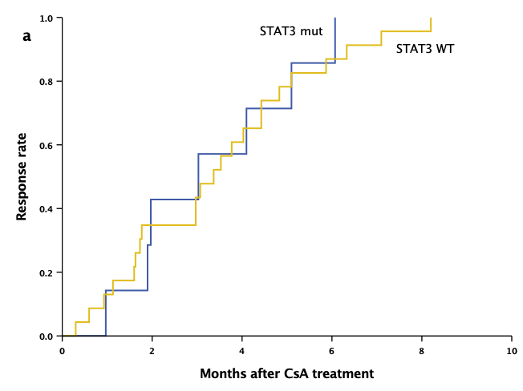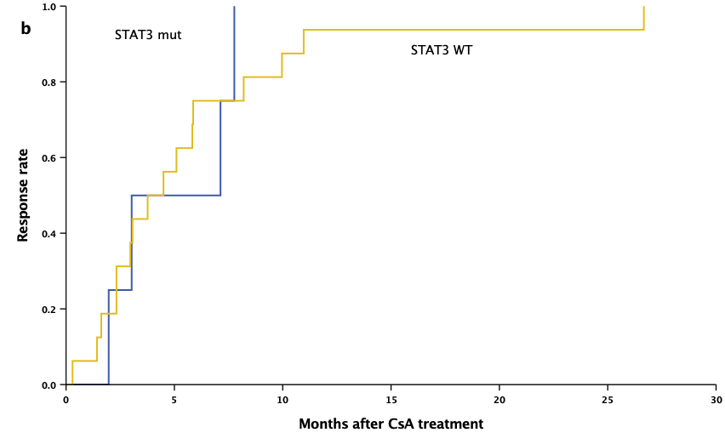
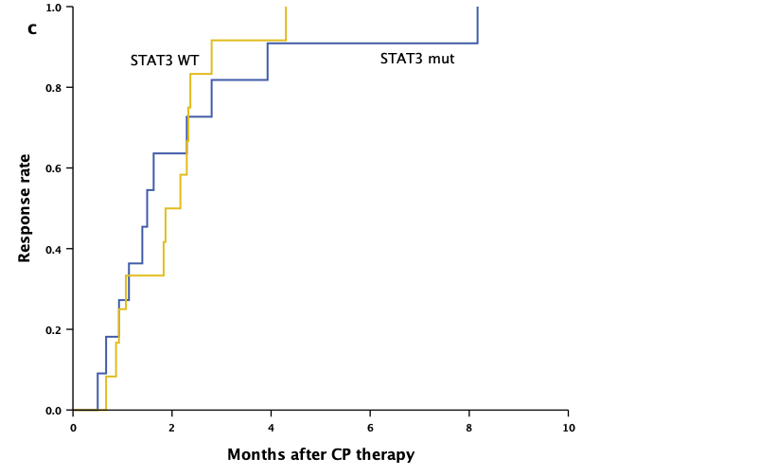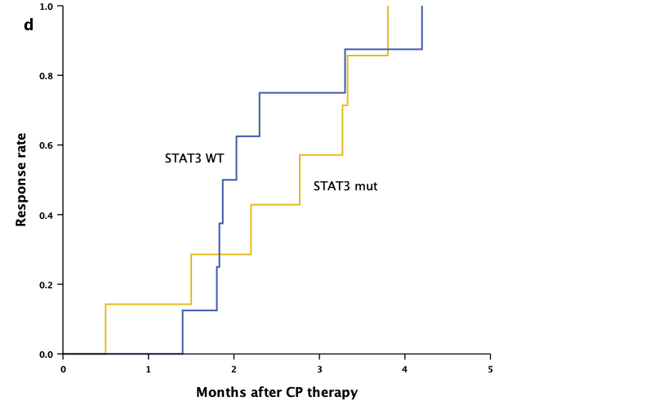
Supplementary Figure 2 Kinetics of hematologic response after CsA or CP treatment in terms of STAT3 mutations. (a) time to initial response after CsA treatment (P=0.804); (b) time to complete response after CsA treatment (P=0.774); (c) time to initial response after CP therapy (P=0.889); (d). time to complete response after CP therapy (P=0.822).

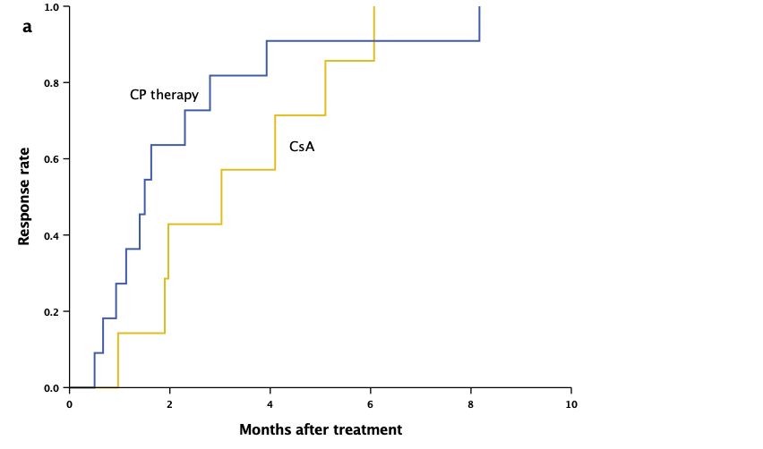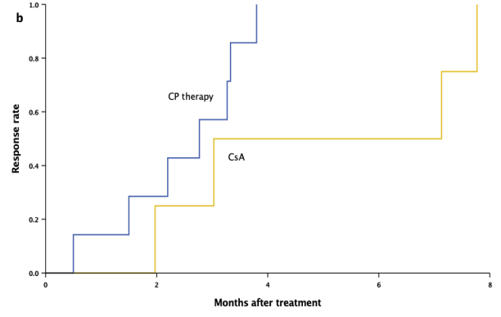
Supplementary Figure 3 Kinetics of hematologic response after CsA and CP therapy in the STAT3 mutant patients. (a) time to initial response (P=0.309); (b) time to complete response (P=0.157).

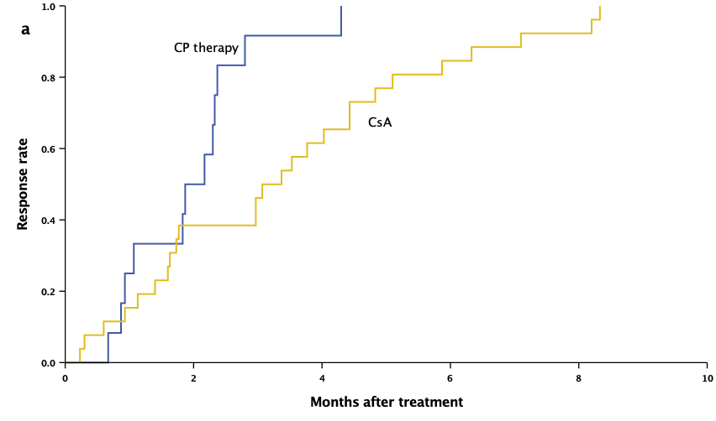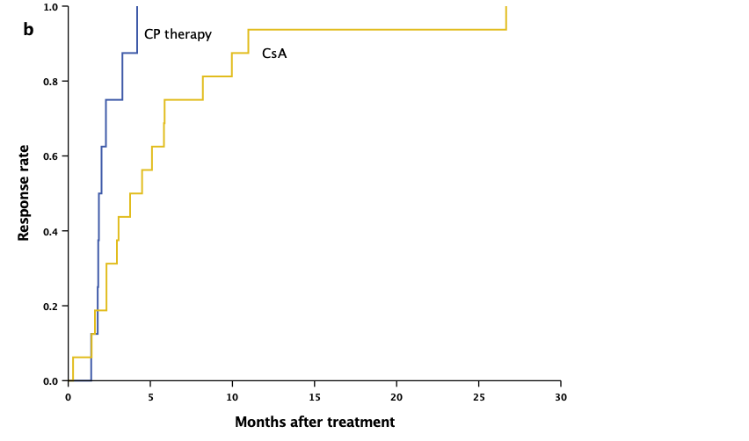
Supplementary Figure 4 Kinetics of hematologic response after CsA and CP therapy in the STAT3 wild−type patients. (a)time to initial response (P=0.011); (b) time to complete response (P=0.008).

