Supplementary tables

Table S1. Docking scores (shown in brackets) and binding energy (MMGBSA dG Bind) for complexes of native (WT) and mutated protein with inhibitors. Docking to WT protein was verified by superposition to crystallographic model (PDB ID 3oxz, 3cs9, 2hyy, 4xey, 3ue4). Docking score was evaluated based on Glide docking XP mode. MMGBSA dG Bind was obtained from Prime module in Schrödinger Suite
Inhibitor | AL | Native (WT) | Lys404Glu (K404E)
ponatinib, PON | DFG-out | -100.6 (-14.36) | -105.66 (-14.73)
nilotinib, NILO | DFG-out | -112.90 (-14.71) | -112.46 (-15.22)
imatinib, IM | DFG-out | -100.67 (-13.65) | -96.86 (-14.69)
dasatinib, DAS | DFG-in | -81.78 (-11.92) | -82.33 (-11.68)
bosutinib, BOS | DFG-in | -70.68 (-9.57) | -70.88 (-9.78)

Table S2. Docking scores (shown in brackets) and binding energy (MMGBSA dG Bind) for complexes of native (WT) and mutated protein with myristic acid (MYR). Docking to WT protein was verified by superposition to crystallographic model (PDB ID 1opl). Docking score was evaluated based on Glide docking XP mode. MMGBSA dG Bind was obtained from Prime module in Schrödinger Suite.
compound | AL | Native (WT) | Lys404Glu (K404E)
Myristic acid | DFG-out | -77.72 (-2.64) | -77.56 (-2.28)
Myristic acid | DFG-in | -78.54 (-3.33) | -77.73 (-3.03)

Supplementary figures

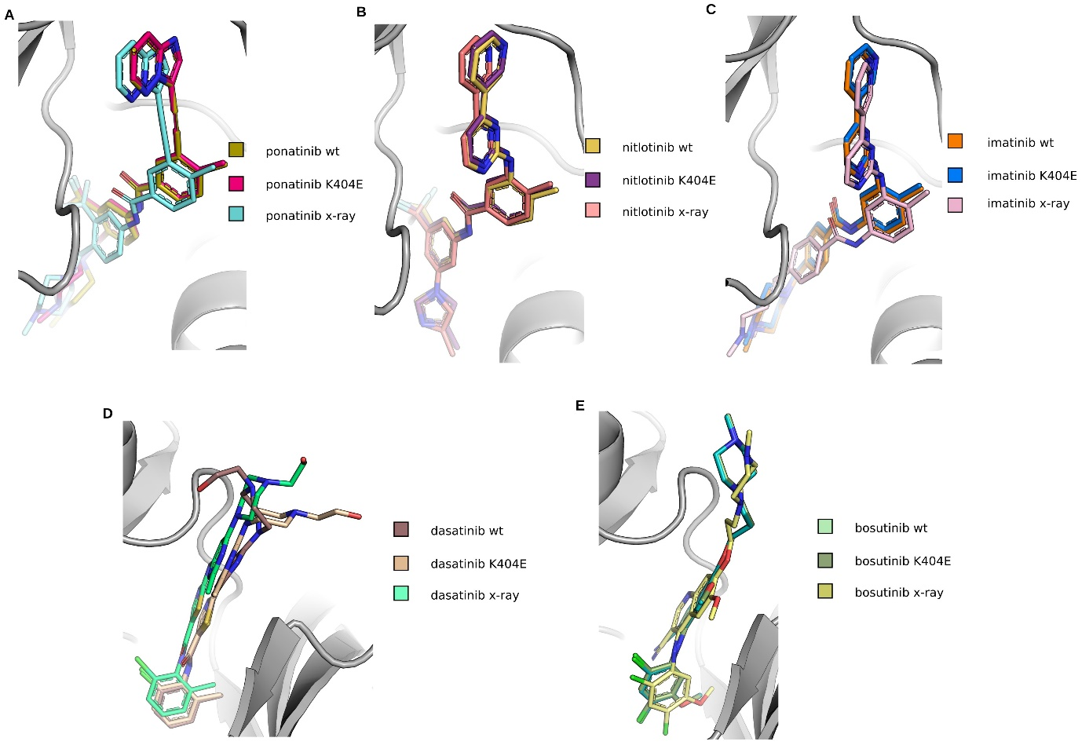
Fig. S1. Top binding poses of each BCR-ABL1 inhibitor obtained from molecular docking using Glide and rescoring using MM-GBSA approximation in comparison with experimental binding pose from crystallography.

Fig. S2. Data obtained from MD simulation using Desmond package. Diagram representing positional fluctuations of all amino acids for the BCR-ABL1 kinase domain; RMSF is the root fluctuation calculated for the side chain of a given residue (side chain) or only from the trace Cɑ. Panels A, E, C represents fluctuations for WT protein, while B, D and F for mutant K404E. Calculations were performed for inactive conformation of BCR-ABL1 possessing activation loop in conformation DGF-in (A, B) and activation loop in conformation DGF-out (C, D). Additionally, rmsf was calculated for active conformation of BCR-ABL1 with activation loop in DGF-in conformation. Fat pink strips mark loops made of residues 382-402 and 432-450 located close to the mutation site, while violet fat strips mark region of myristate binding pocket. Green strip marks αC helix. Data exported using Desmond tool, calculated from single MD simulation.

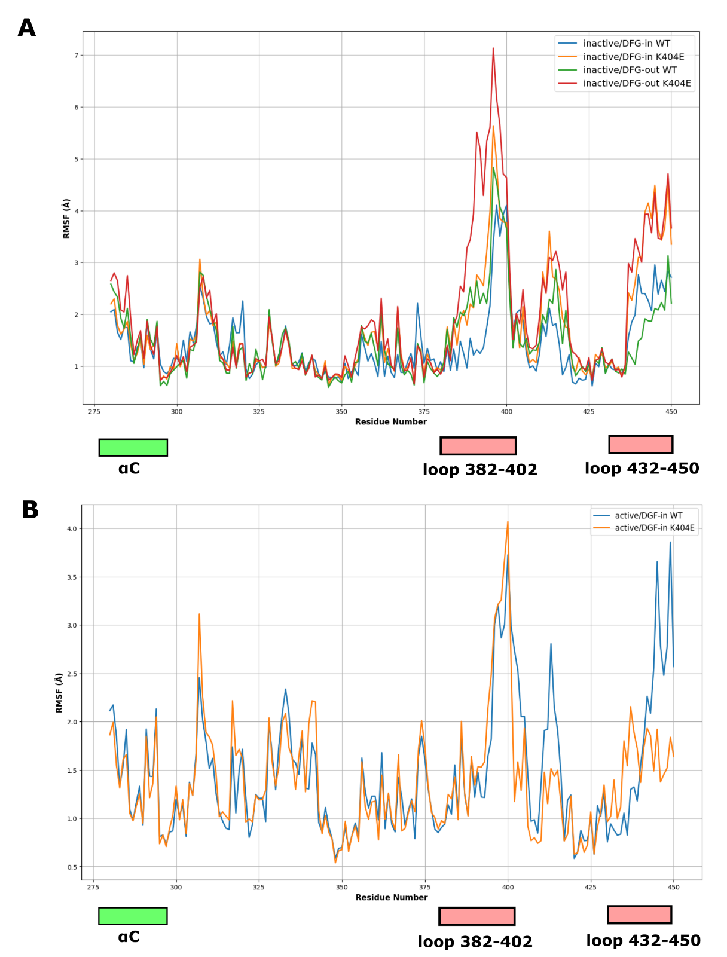
Fig. S3. Data obtained from MD simulation using Desmond package. Diagram representing positional fluctuations of selected residues (275-450) for the BCR-ABL1 kinase domain; Panel A representing rmsf calculations for inactive conformation of BCR-ABL1 possessing activation loop in conformation DGF-in and activation loop in conformation DGF-out. Panel B representing rmsf values calculated for active conformation of BCR-ABL1 with activation loop in DGF-in conformation. The potential hot spots regions of BCAR-ABL1 were marked. Two loops (382-402 and 432-450) are located close to the mutation site of BCAR-ABL1. Data were calculated based on triplicate MD simulation for each system.

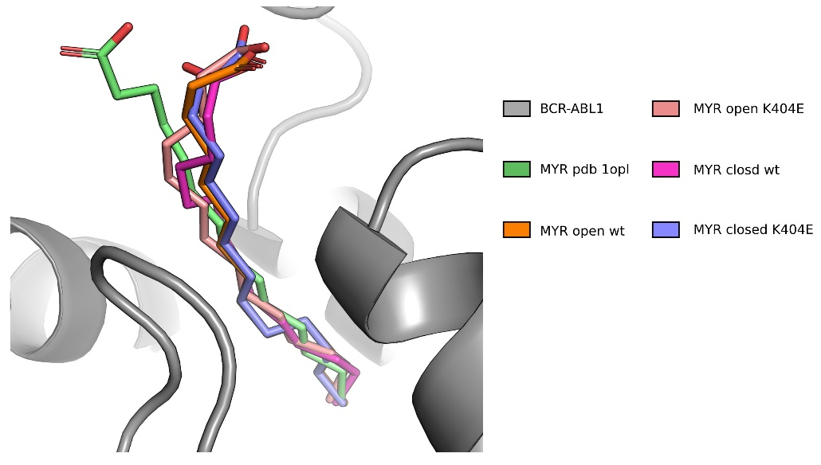
Fig. S4. Top binding poses of myristic acid (MYR) from molecular docking using Glide and rescoring using MM-GBSA approximation in comparison with experimental binding pose from crystallography (1opl).

>NP_005148.2 tyrosine-protein kinase ABL1 isoform a [Homo sapiens]

10 20 30 40 50 60 70
MLEICLKLVG CKSKKGLSSS SSCYLEEALQ RPVASDFEPQ GLSEAARWNS KENLLAGPSE NDPNLFVALY
80 90 100 110 120 130 140
DFVASGDNTL SITKGEKLRV LGYNHNGEWC EAQTKNGQGW VPSNYITPVN SLEKHSWYHG PVSRNAAEYL
150 160 170 180 190 200 210
LSSGINGSFL VRESESSPGQ RSISLRYEGR VYHYRINTAS DGKLYVSSES RFNTLAELVH HHSTVADGLI
220 230 240 250 260 270 280
TTLHYPAPKR NKPTVYGVSP NYDKWEMERT DITMKHKLGG GQYGEVYEGV WKKYSLTVAV KTLKEDTMEV
290 300 310 320 330 340 350
EEFLKEAAVM KEIKHPNLVQ LLGVCTREPP FYIITEFMTY GNLLDYLREC NRQEVNAVVL LYMATQISSA
360 370 380 390 400 410 420
MEYLEKKNFI HRDLAARNCL VGENHLVKVA DFGLSRLMTG DTYTAHAGAK FPIKWTAPES LAYNKFSIKS
430 440 450 460 470 480 490
DVWAFGVLLW EIATYGMSPY PGIDLSQVYE LLEKDYRMER PEGCPEKVYE LMRACWQWNP SDRPSFAEIH
500 510 520 530 540 550 560
QAFETMFQES SISDEVEKEL GKQGVRGAVS TLLQAPELPT KTRTSRRAAE HRDTTDVPEM PHSKGQGESD
570 580 590 600 610 620 630
PLDHEPAVSP LLPRKERGPP EGGLNEDERL LPKDKKTNLF SALIKKKKKT APTPPKRSSS FREMDGQPER
640 650 660 670 680 690 700
RGAGEEEGRD ISNGALAFTP LDTADPAKSP KPSNGAGVPN GALRESGGSG FRSPHLWKKS STLTSSRLAT
710 720 730 740 750 760 770
GEEEGGGSSS KRFLRSCSAS CVPHGAKDTE WRSVTLPRDL QSTGRQFDSS TFGGHKSEKP ALPRKRAGEN
780 790 800 810 820 830 840
RSDQVTRGTV TPPPRLVKKN EEAADEVFKD IMESSPGSSP PNLTPKPLRR QVTVAPASGL PHKEEAGKGS
850 860 870 880 890 900 910
ALGTPAAAEP VTPTSKAGSG APGGTSKGPA EESRVRRHKH SSESPGRDKG KLSRLKPAPP PPPAASAGKA
920 930 940 950 960 970 980
GGKPSQSPSQ EAAGEAVLGA KTKATSLVDA VNSDAAKPSQ PGEGLKKPVL PATPKPQSAK PSGTPISPAP
990 1000 1010 1020 1030 1040 1050
VPSTLPSASS ALAGDQPSST AFIPLISTRV SLRKTRQPPE RIASGAITKG VVLDSTEALC LAISRNSEQM
1060 1070 1080 1090 1100 1110 1120
ASHSAVLEAG KNLYTFCVSY VDSIQQMRNK FAFREAINKL ENNLRELQIC PATAGSGPAA TQDFSKLLSS
1130
VKEISDIVQR

Fig. S5. Sequence of BCR-ABL1 protein with mutation site (Lys404) marked by cyan box.

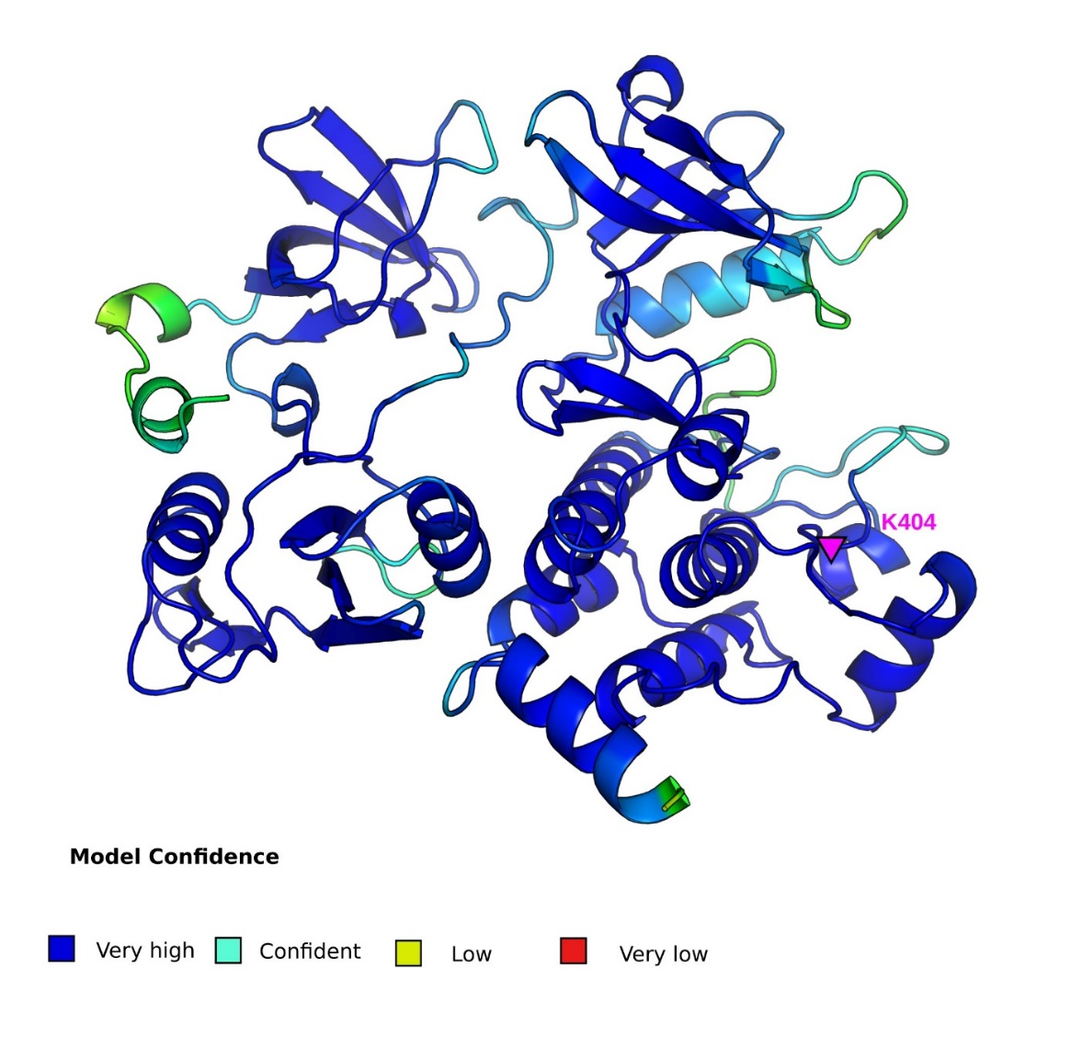
Fig. S6. The fragment of BCR-ABL1 kinase protein obtained using AF2 code. Structure was colored by model confidence score, Lys404 was labeled as pink triangle.
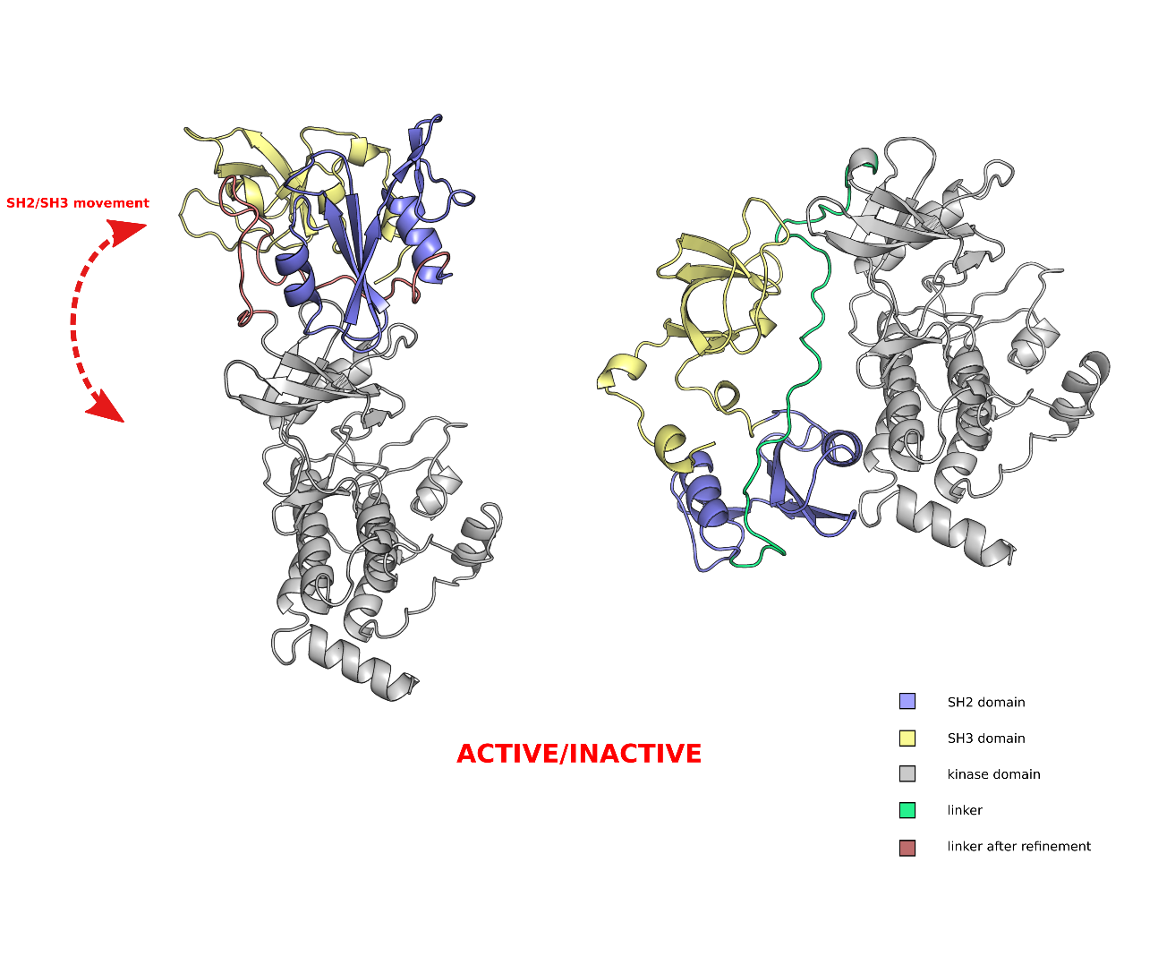
Fig. S7. The fragment of BCR-ABL1 kinase protein in both active and inactive conformation. Each domain was labeled. Displacement of SH2/SH3 domain was modelled according to pdb data (4xey). Flexible linker was modelled using loop refinement tool from Prime module.

Materials and methods
Protein modelling and preparation
The BCR-ABL1 and its K404E mutant (fragment including KD, SH2 and SH3) were obtained
by using standalone version of the AlphaFold2 (AF2) software (1) (Fig. S4, S5). The top-ranked structures of BCR-ABL1 and its K404E mutant were supplemented by manually adding open and closed activation loop (AL) conformation. The coordinates of AL were taken from pdb deposited structures of BCR-ABL1 (PDB: 4xey DFG-in and PDB: 2hyy DFG-out). In this case, two different starting structures of BCR-ABL1 and the mutated version were obtained. Evaluated protein structures were prepared using the Protein Preparation Wizard (2) and used for further analysis. The resulting structure models were energy minimized using the Prime module with the OPLS4 force field set (3) to default convergence criteria (rms gradient value of 0.3). Obtained structures with open and closed AL conformation were used for molecular docking of ATP competitors and for MD simulation in the next stage of bioinformatic analysis (4).
Molecular docking
For docking studies, the Glide software was used with the BCR-ABL1 protein target and the ligands flexible. The OPLS2005 (4) force field parameters were applied while performing all steps of the docking calculations. Before docking simulation, all BCR-ABL1 kinase inhibitors were prepared by using LigPrep. Tautomeric ionisation states were added using the Epik module (5). The grid for molecular docking was placed over the ATP binding pocket of BCR-
ABL1 kinase. The calculated receptor-ligand structures were scored and ranked according to the docking score of the Glide standard precision (XP) mode. For each ligand, at least ten alternative poses were generated. All poses were re-scored using MM-GBSA estimation using Prime module (6). The value of binding energy was calculated as the difference between the energy of the protein/ligand complex and the energy of the unbound protein and ligand. The entropy term was neglected. The VSGB (7) solvation model was used in the OPLS4 (3) force field with a minimized sampling method.
Molecular dynamics
The Desmond package (Desmond 2022) was used for molecular dynamics simulations. Each system was simulated at 310 K and a constant pressure of 1 bar using the NPT ensemble class; a Nose-Hoover thermostat and a Martyna-Tobias-Klein barostat were used. The integration time step was 2 fs. The SHAKE algorithm was used to keep the hydrogen-heavy atomic bonds rigid. A smooth-particle Ewald mesh was used for long-range interactions and a 9 Å cut-off was set for short-range Coulomb interactions. Prior to simulation, the structures were prepared and minimised. Each system was solvated in an orthorhombic box using the TIP3P water model, charges were neutralised, and 0.15 M NaCl was added. The OPLS4 force field parameters were used in all simulations. Data analysis was carried performed using the Desmond tools implemented in Maestro of the Schrödinger Suite, mainly to investigate protein-protein interactions and complex stability by monitoring RMSD and RMSF values. Simulation time of BCR-ABL1 in open and closed AL conformation was set on 1000 ns. For BCR-ABL1 with ATP competitive inhibitors evaluated after docking studies the time of MD simulation was set to 500 ns. All systems were simulated in triplicate.

1. Jumper J, Evans R, Pritzel A, Green T, Figurnov M, Ronneberger O, et al. Highly accurate protein structure prediction with AlphaFold. Nat 2021 5967873 [Internet]. 2021 Jul 15 [cited 2024 Oct 4];596(7873):583–9. Available from: https://www.nature.com/articles/s41586-021-03819-2
2. Madhavi Sastry G, Adzhigirey M, Day T, Annabhimoju R, Sherman W. Protein and ligand preparation: parameters, protocols, and influence on virtual screening enrichments. J Comput Aided Mol Des [Internet]. 2013 [cited 2024 Oct 4];27(3):221–34. Available from: https://pubmed.ncbi.nlm.nih.gov/23579614/
3. Lu C, Wu C, Ghoreishi D, Chen W, Wang L, Damm W, et al. OPLS4: Improving Force Field Accuracy on Challenging Regimes of Chemical Space. J Chem Theory Comput [Internet]. 2021 Jul 13 [cited 2024 Oct 4];17(7):4291–300. Available from: https://pubmed.ncbi.nlm.nih.gov/34096718/
4. Greenwood JR, Calkins D, Sullivan AP, Shelley JC. Towards the comprehensive, rapid, and accurate prediction of the favorable tautomeric states of drug-like molecules in aqueous solution. J Comput Aided Mol Des [Internet]. 2010 [cited 2024 Oct 4];24(6–7):591–604. Available from: https://pubmed.ncbi.nlm.nih.gov/20354892/
5. Banks JL, Beard HS, Cao Y, Cho AE, Damm W, Farid R, et al. Integrated Modeling Program, Applied Chemical Theory (IMPACT). J Comput Chem [Internet]. 2005 Dec [cited 2024 Oct 4];26(16):1752–80. Available from: https://pubmed.ncbi.nlm.nih.gov/16211539/
6. Jacobson MP, Pincus DL, Rapp CS, Day TJF, Honig B, Shaw DE, et al. A hierarchical approach to all-atom protein loop prediction. Proteins [Internet]. 2004 May 1 [cited 2024 Oct 4];55(2):351–67. Available from: https://pubmed.ncbi.nlm.nih.gov/15048827/
7. Li J, Abel R, Zhu K, Cao Y, Zhao S, Friesner RA. The VSGB 2.0 model: a next generation energy model for high resolution protein structure modeling. Proteins [Internet]. 2011 Oct [cited 2024 Oct 4];79(10):2794–812. Available from:

