Literature review and consensus meeting procedure
The 7-member panel specialising in haematology (all from public healthcare settings) was led by a 2-member steering committee (totalling a 9-member panel).
The panel established core recommendations comprising global and regional recommendations and clinical practice guidelines from medical societies and neighbouring Asian regions. These were supplemented with evidence from studies published post-2017, sourced through literature searches conducted, and summarized by an external agency (MIMS Ltd) according to clinical direction from the steering committee.
The panel drafted provisional statements, which were then reviewed and refined by the 2-member steering committee. Revised statements underwent a formal review session involving roundtable discussion and voting on a 5-point Likert scale (Supplementary Figure 1). Consensus required ≥75% agreement, with disagreements resolved by modification or exclusion.
Final statements and the summarized discussion were circulated among the full panel post-meeting.
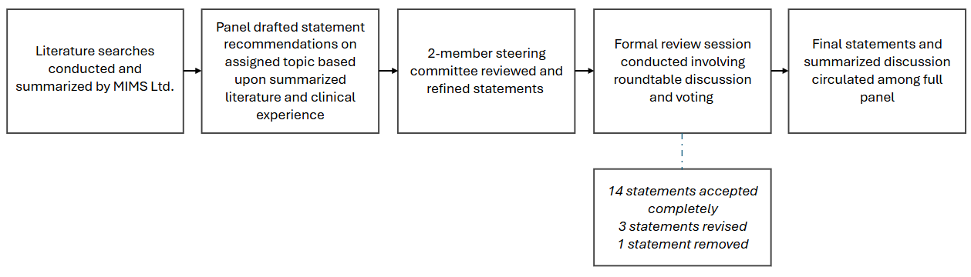
Supplementary Figure 1. Literature review and consensus meetings procedure.
Statement voting results
Definition of TKI failure
1 | 9
2 | 8 |  | 1
3 | 9
Prioritization of treatment goals in later lines
4 | 9
5 | 8 |  | 1
Clinical considerations
6 | 9
7 | 9
8 (removed) | (Statement was deleted*)
Treatment recommendations in later lines
8 (renumbered) | 9
9 | 9
10 | 9
11 | 9
12 | 9
13 | 9
14 | 9
The role of clinical trial agents and allo-HSCT
15 | 9
16 | 8 | 1
17 | 9

 | Accept completely |  | Accept with some reservation |  | Accept with major reservation |  | Reject with reservation |  | Reject completely

Supplementary Figure 2. Final consensus voting for each statement, showing the original (18) and final (17) number of statements and the aggregate vote results for all statements. Votes were on a 5-point Likert scale; consensus was considered as ≥75% of the votes.
*Statement 8 (‘Switching therapy after efficacy failure of a second-generation TKI has not been well defined due to an absence of comparison studies for patients who fail two or more lines, until recently’) was deleted and integrated into broader discussions. The panel acknowledged the lack of well-defined switching therapy options after 2G TKI failure due to a lack of comparison studies. However, the statement was considered unnecessary since it did not provide a direct recommendation, and thus, was removed.

