Supplementary materials
The expression patterns and prognostic significance of PD-1 and TIM-3 on T cells and the differentiated subsets in acute myeloid leukemia
Kai Sun¹, Zong-Yan Shi¹, Ya-Zhe Wang¹, Dai-Hong Xie¹, Yan-Rong Liu¹, Qian Jiang,¹, Hao Jiang¹, Xiao-Jun Huang¹, Ya-Zhen Qin²*
¹ Peking University People's Hospital, Peking University Institute of Hematology, National Clinical Research Center for Hematologic Disease, Beijing 100044, PR China
² Peking University People's Hospital, Peking University Institute of Hematology, National Clinical Research Center for Hematologic Disease, Beijing 100044, PR China, qin2000@aliyun.com
Corresponding author: Ya-Zhen Qin, E-mail: qin2000@aliyun.com, ORCIDs: 0000-0002-1548-0946

Fig. S1 The gating strategy of muti-parameter flow cytometry. For CD4⁺ and CD8⁺T cells and T-cell differentiated sub-populations (A), for PD-1⁺, TIM-3⁺ and PD-1⁺TIM-3⁺ levels in CD4⁺ and CD8⁺T cells and T-cell differentiated sub-populations (B).

Table S1. Distribution of PD-1 and TIM-3 expression in CD4 and CD8 T-cell compartments in AML patients and healthy donors (HDs). Represented by median (range).
 | AML | HD | P value
PD-1⁺ (%) | n = 143 for total  n = 103 for differentiated subsets | n = 12
Total CD4⁺T | 29.5 (1.6-77.5) | 23.5 (10.8-35.5) | 0.034
CD4⁺Tn | 0.8 (0.03-13.5) | 0.3 (0.07-1.1) | 0.019
CD4⁺Tscm | 7.1 (0-24.1) | 5.7 (2.6-11.9) | 0.31
CD4⁺Tcm | 33.0 (1.3-60.4) | 24.3 (11.8-38.7) | 0.028
CD4⁺Tem | 61.1 (5.0-88.4) | 50.2 (27.0-68.3) | 0.0092
CD4⁺Teff | 33.3 (0.4-79.8) | 21.9 (5.4-77.9) | 0.47
Total CD8⁺T | 38.7 (6.3-89.6) | 36.2 (16.7-52.3) | 0.24
CD8⁺Tn | 2.1 (0-26.3) | 2.4 (0.5-6.9) | 0.31
CD8⁺Tscm | 16.7 (0-55.2) | 17.2 (3.9-43.7) | 0.64
CD8⁺Tcm | 55.4 (6.2-83.5) | 42.7 (33.1-72.6) | 0.29
CD8⁺Tem | 67.8 (22.2-95.6) | 60.2 (30.0-81.2) | 0.19
CD8⁺Teff | 32.0 (5.0-76.7) | 27.3 (6.2-56.1) | 0.24
TIM-3⁺ (%) | n = 164 for total  n = 102 for differentiated subsets | n = 12
Total CD4⁺T | 4.3 (0.8-20.1) | 1.4 (0.6-3.4) | <0.0010
CD4⁺Tn | 0.8 (0-11.2) | 0.1 (0-1.5) | <0.0010
CD4⁺Tscm | 3.4 (0-15.5) | 0.6 (0-2.7) | <0.0010
CD4⁺Tcm | 3.4 (0.8-27.3) | 1.2 (0.6-2.9) | <0.0010
CD4⁺Tem | 6.5 (0.6-32.4) | 2.8 (1.5-6.5) | 0.0018
CD4⁺Teff | 5.3 (0-61.6) | 3.1 (1.1-18.5) | 0.048
Total CD8⁺T | 4.9 (0.7-35.1) | 0.9 (0.3-1.7) | <0.0010
CD8⁺Tn | 1.8 (0-30.3) | 0.2 (0-0.8) | <0.0010
CD8⁺Tscm | 5.2 (0-26.0) | 1.4 (0-3.3) | <0.0010
CD8⁺Tcm | 4.7 (0.9-28.8) | 1.5 (0.7-3.0) | <0.0010
CD8⁺Tem | 5.4 (1.1-36.0) | 1.1 (0.7-2.8) | <0.0010
CD8⁺Teff | 2.6 (0.1-29.6) | 0.5 (0.09-2.0) | <0.0010
PD-1⁺TIM-3⁺ (%) | n = 142 for total  n = 102 for differentiated subsets | n = 12
Total CD4⁺T | 2.0 (0.1-17.0) | 0.8 (0.2-2.0) | <0.0010
CD4⁺Tn | 0.02 (0-0.7) | 0.005 (0-0.3) | 0.35
CD4⁺Tscm | 0.4 (0-6.0) | 0.2 (0-0.9) | 0.088
CD4⁺Tcm | 1.7 (0.1-6.7) | 0.5 (0.1-1.2) | <0.0010
CD4⁺Tem | 4.3 (0.07-20.7) | 2.0 (0.6-4.4) | 0.0017
CD4⁺Teff | 1.3 (0-7.9) | 0.4 (0-3.8) | 0.24
Total CD8⁺T | 1.9 (0.1-29.4) | 0.4 (0.1-0.8) | <0.0010
CD8⁺Tn | 0.1 (0-2.7) | 0.02 (0-0.6) | 0.024
CD8⁺Tscm | 0.8 (0-8.3) | 0.3 (0-1.3) | 0.073
CD8⁺Tcm | 3.1 (0-20.1) | 0.9 (0.4-2.4) | <0.0010
CD8⁺Tem | 3.5 (0.1-34.6) | 0.7 (0.2-1.9) | <0.0010
CD8⁺Teff | 0.7 (0.04-6.7) | 0.07 (0-0.4) | <0.0010

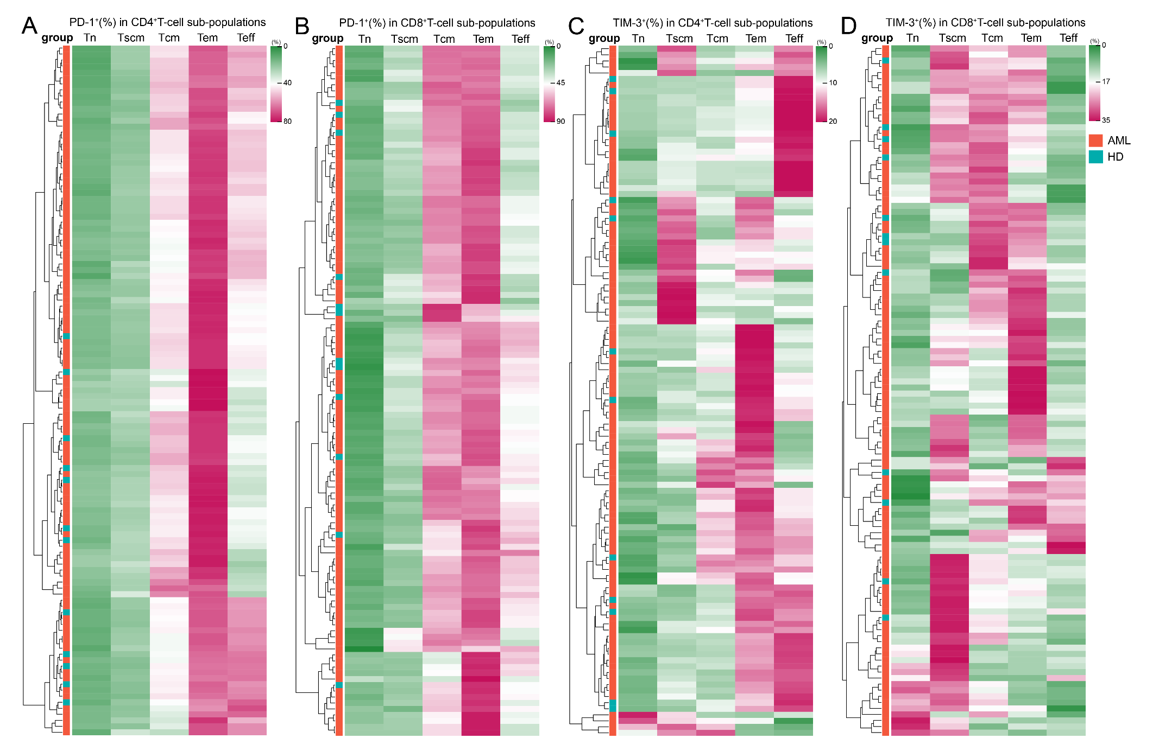
Fig. S2 PD-1 and TIM-3 expression levels on T-cell differentiated sub-populations in each AML patient and HD. PD-1 expression on CD4 T-cell sub-populations (A), PD-1 expression on CD8 T-cell sub-populations (B), TIM-3 expression on CD4 T-cell sub-populations (C), and TIM-3 expression on CD8 T-cell sub-populations (D).

Table S2. The relationship between PD-1 and TIM-3 expression on CD4⁺T and CD8⁺T cells and patients’ baseline clinical characteristics.
Variable | TIM-3/CD4⁺T | P value | TIM-3/CD8⁺T | P value | PD-1/CD4⁺T | P value | PD-1/CD8⁺T | P value | TIM-3⁺PD-1⁺/CD4⁺T | P value | TIM-3⁺PD-1⁺/CD8⁺T | P value
Age (y) |  | 0.84 |  | 0.41 |  | 0.40 |  | 0.016 |  | 0.36 |  | 0.86
15-45 | 4.2 (0.8-20.1) |  | 5.2 (0.7-32.4) |  | 28.0 (3.0-77.5) |  | 35.4 (6.3-67.5) |  | 1.8 (0.3-17.0) |  | 2.0 (0.3-28.4)
46-65 | 4.3 (0.9-14.6) |  | 4.5 (0.7-32.1) |  | 30.1 (1.6-57.6) |  | 40.5 (12.2-89.6) |  | 2.1 (0.1-8.8) |  | 1.9 (0.1-29.4)
Gender |  | 0.61 |  | 0.8 |  | 0.72 |  | 0.030 |  | 1.0 |  | 0.54
Male | 4.1 (0.8-20.1) |  | 4.6 (0.7-35.1) |  | 30.1 (1.6-77.5) |  | 42.0 (6.3-89.6) |  | 2.0 (0.2-17.0) |  | 1.9 (0.3-29.4)
Female | 4.5 (0.9-14.3) |  | 5.4 (0.7-18.8) |  | 28.4 (8.2-56.5) |  | 35.2 (13.8-75.3) |  | 1.9 (0.1-8.8) |  | 1.9 (0-7.9)
WBC count (×10⁹/L) |  | 0.68 |  | 0.56 |  | 0.41 |  | 0.17 |  | 0.30 |  | 0.43
≤20 | 4.3 (1.1-20.1) |  | 4.7 (0.7-32.4) |  | 28.6 (3.0-77.5) |  | 42.5 (12.2-89.6) |  | 1.8 (0.1-17.0) |  | 1.7 (0.1-28.4)
>20 | 4.1 (0.8-12.3) |  | 5.1 (1.0-35.1) |  | 30.0 (1.6-56.5) |  | 37.6 (6.3-78.6) |  | 2.1 (0.2-7.9) |  | 2.1 (0.3-29.4)
Hemoglobin (g/L) |  | 0.13 |  | 0.83 |  | 0.68 |  | 0.86 |  | 0.28 |  | 0.98
≤90 | 4.5 (1.1-14.6) |  | 4.9 (0.7-35.1) |  | 29.6 (1.6-77.5) |  | 39.0 (6.3-78.6) |  | 2.1 (0.2-8.0) |  | 2.0 (0.3-29.4)
>90 | 4.0 (0.8-20.1) |  | 5.0 (0.8-32.4) |  | 28.0 (8.2-57.6) |  | 39.3 (16.4-89.6) |  | 1.9 (0.1-17.0) |  | 1.9 (0.1-28.4)
Platelet count (× 10⁹/L) |  | 0.74 |  | 0.81 |  | 0.6 |  | 0.36 |  | 0.23 |  | 0.87
≤40 | 4.1 (1.0-12.3) |  | 4.5 (0.7-35.1) |  | 28.7 (3.0-56.5) |  | 38.5 (14.3-78.6) |  | 2.1 (0.2-7.9) |  | 1.9 (0.3-29.4)
>40 | 4.3 (0.8-20.1) |  | 5.3 (0.7-32.4) |  | 29.5 (1.6-77.5) |  | 40.1 (6.3-89.6) |  | 1.8 (0.1-17.0) |  | 2.0 (0.1-28.4)
BM blast percentage (%) |  | 0.42 |  | 0.037 |  | 0.52 |  | 0.66 |  | 0.19 |  | 0.034
≤60 | 4.2 (0.9-14.3) |  | 4.4 (0.7-27.1) |  | 28.6 (3.0-77.5) |  | 38.7 (6.3-89.6) |  | 1.9 (0.1-8.8) |  | 1.7 (0.1-27.1)
>60 | 4.5 (0.8-20.1) |  | 5.8 (1.1-35.1) |  | 30.1 (1.6-54.6) |  | 38.6 (12.2-78.6) |  | 2.0 (0.2-17.0) |  | 2.2 (0.6-29.4)
Karyotyping type |  | 0.16 |  | 0.099 |  | 0.52 |  | 0.74 |  | 0.18 |  | 0.20
Favorable | 3.8 (1.1-10.1) |  | 4.3 (0.7-14.4) |  | 26.7 (5.0-77.5) |  | 36.4 (6.3-75.3) |  | 1.6 (0.2-7.9) |  | 1.5 (0.4-8.5)
Intermediate | 4.4 (0.8-20.1) |  | 5.3 (1.0-32.4) |  | 29.7 (1.6-56.5) |  | 41.0 (12.2-75.5) |  | 2.1 (0.2-17.0) |  | 2.0 (0.3-28.4)
Adverse | 4.9 (1.5-14.6) |  | 4.8 (0.7-35.1) |  | 31.1 (13.4-57.6) |  | 39.3 (13.8-89.6) |  | 2.2 (0.1-7.3) |  | 3.0 (0.1-29.4)
NGS mutations
FLT3-ITD |  | 0.72 |  | 0.83 |  | 0.83 |  | 0.56 |  | 0.74 |  | 0.39
(-) | 4.3 (0.9-20.1) |  | 4.7 (0.7-35.1) |  | 28.7 (3.0-77.5) |  | 39.7 (6.3-89.6) |  | 2.1 (0.1-17.0) |  | 1.9 (0.1-29.4)
(+) | 4.1 (0.8-14.6) |  | 5.5 (0.7-18.8) |  | 30.2 (1.6-51.9) |  | 35.7 (12.7-75.5) |  | 1.8 (0.2-8.8) |  | 2.1 (0.5-10.0)
NPM1 |  | 0.11 |  | 0.31 |  | 0.84 |  | 0.47 |  | 0.78 |  | 0.69
(-) | 4.3 (0.8-20.1) |  | 4.6 (0.7-35.1) |  | 28.8 (1.6-77.5) |  | 39.3 (6.3-89.6) |  | 1.9 (0.1-17.0) |  | 1.9 (0.1-29.4)
(+) | 4.5 (0.9-14.3) |  | 5.9 (1.0-18.8) |  | 33.4 (8.2-51.9) |  | 38.3 (19.6-75.5) |  | 2.6 (0.5-8.8) |  | 2.3 (0.6-12.2)
CEBPA |  | 0.62 |  | 0.12 |  | 0.10 |  | 0.81 |  | 0.88 |  | 0.50
(-) | 4.1 (0.9-20.1) |  | 5.0 (0.7-35.1) |  | 28.5 (1.6-77.5) |  | 36.4 (12.2-78.6) |  | 1.9 (0.1-17.0) |  | 1.9 (0.1-29.4)
(+) | 3.7 (0.8-9.8) |  | 4.0 (1.1-10.6) |  | 32.4 (15.7-56.5) |  | 42.0 (15.6-62.4) |  | 1.8 (0.3-5.3) |  | 1.9 (0.3-9.2)
ASXL1 |  | 0.27 |  | 1.0 |  | 0.15 |  | 0.34 |  | 0.13 |  | 0.20
(-) | 4.2 (0.8-20.1) |  | 4.9 (0.7-35.1) |  | 29.6 (1.6-77.5) |  | 40.0 (12.2-78.6) |  | 1.9 (0.1-17.0) |  | 1.9 (0.1-29.4)
(+) | 3.1 (1.6-9.8) |  | 5.0 (0.7-12.0) |  | 24.4 (17.6-30.9) |  | 34.7 (13.8-44.6) |  | 1.4 (0.5-2.2) |  | 1.2 (0.3-6.6)
DNMT3A |  | 0.86 |  | 0.48 |  | 0.96 |  | 0.11 |  | 0.57 |  | 0.39
(-) | 4.1 (0.8-20.1) |  | 4.7 (0.7-32.4) |  | 28.7 (3.0-77.5) |  | 35.4 (13.8-70.9) |  | 1.9 (0.1-17.0) |  | 1.9 (0.1-28.4)
(+) | 4.2 (0.9-13.8) |  | 5.4 (1.0-35.1) |  | 29.6 (1.6-44.5) |  | 43.0 (12.2-78.6) |  | 1.4 (0.2-8.0) |  | 2.2 (0.6-29.4)
TET2 |  | 0.81 |  | 0.38 |  | 0.17 |  | 0.64 |  | 0.49 |  | 0.87
(-) | 4.1 (0.8-20.1) |  | 4.7 (0.7-35.1) |  | 28.6 (1.6-77.5) |  | 37.3 (12.7-78.6) |  | 1.8 (0.1-17.0) |  | 1.9 (0.1-29.4)
(+) | 3.7 (1.4-8.7) |  | 5.9 (2.6-10.6) |  | 34.5 (24.4-54.6) |  | 44.4 (12.2-58.1) |  | 1.9 (0.9-4.8） |  | 2.2 (0.6-9.2)
RUNX1 |  | 0.41 |  | 0.83 |  | 0.66 |  | 0.68 |  | 0.83 |  | 0.71
(-) | 4.1 (0.8-20.1) |  | 4.9 (0.7-35.1) |  | 29.6 (1.6-77.5) |  | 38.7 (12.2-78.6) |  | 1.9 (0.1-17.0) |  | 1.9 (0.1-29.4)
(+) | 4.9 (2.0-7.3) |  | 5.0 (3.2-6.6) |  | 27.3 (18.5-44.9) |  | 29.4 (20.1-69.1) |  | 2.1 (0.5-3.2) |  | 1.9 (1.2-2.6)
ELN genetic risk category |  | 0.042 |  | 0.0058 |  | 0.81 |  | 0.93 |  | 0.68 |  | 0.13
Favorable | 3.7 (0.9-10.1) |  | 3.9 (0.7-14.4) |  | 28.6 (5.0-77.5) |  | 38.5 (6.3-75.3) |  | 1.7 (0.2-8.0) |  | 1.6 (0.3-12.2)
Intermediate | 4.6 (0.8-20.1) |  | 5.5 (2.0-35.1) |  | 27.5 (1.6-47.7) |  | 41.8 (12.2-78.6) |  | 2.0 (0.2-17.0) |  | 2.1 (0.6-29.4)
Adverse | 4.8 (1.5-14.6) |  | 5.2 (0.7-27.1) |  | 31.1 (13.4-57.6) |  | 40.5 (13.8-89.6) |  | 2.2 (0.1-7.6) |  | 2.0 (0.1-27.1)

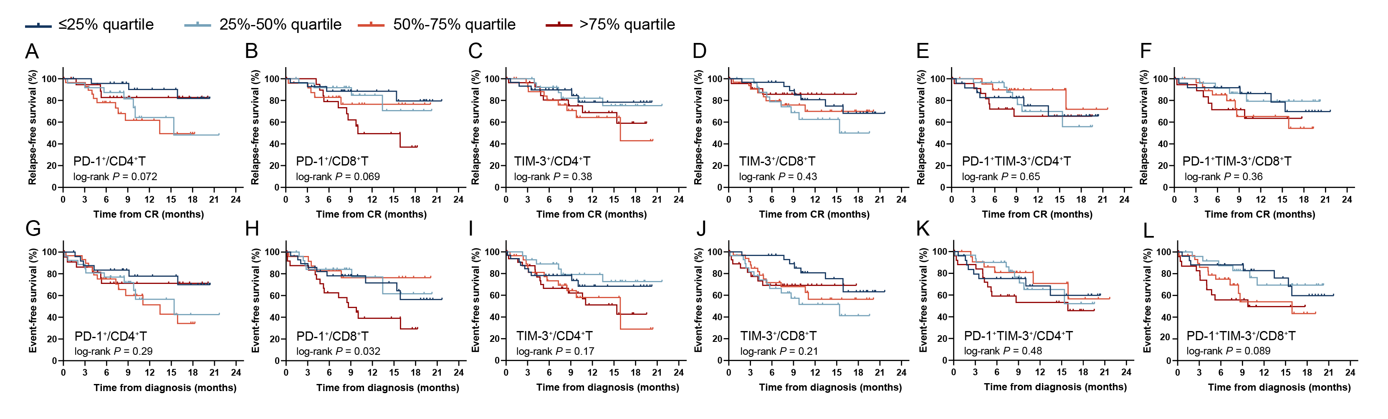
Fig. S3 The prognostic impact of the quartile indicators of PD-1 and TIM-3 expression. On CD4⁺ and CD8⁺T cells on RFS (A-F) and EFS rates (G-L).

Fig.S4 ROC curves of PD-1 and TIM-3 expression with relapse and event occurrence as outcome variables. On CD4⁺ and CD8⁺T cells on RFS (A-F) and EFS rates (G-L).

Table S3. The quartiles and P values of the prognostic impact of PD-1 and TIM-3 expression on T-cell differentiated sub-populations on RFS and EFS rates.
Variables | lower quartile | median | upper quartile | P values for RFS | P values for EFS
PD-1⁺ or TIM-3⁺/CD4 T-cell compartment
PD-1⁺/CD4⁺T | 22.11 | 29.48 | 37.84 | 0.072 | 0.29
PD-1⁺/CD4⁺Tn | 0.3325 | 0.915 | 1.55 | 0.11 | 0.29
PD-1⁺/CD4⁺Tscm | 4.8025 | 7.605 | 11.255 | 0.068 | 0.30
PD-1⁺/CD4⁺Tcm | 25.385 | 33.11 | 38.2175 | 0.94 | 0.88
PD-1⁺/CD4⁺Tem | 52.1625 | 60.995 | 71.1725 | 0.79 | 0.44
PD-1⁺/CD4⁺Teff | 17.82 | 34.24 | 48.51 | 0.044 | 0.13
TIM-3⁺/CD4⁺T | 2.96 | 4.265 | 5.775 | 0.38 | 0.17
TIM-3⁺/CD4⁺Tn | 0.4 | 0.9 | 2.04 | 0.20 | 0.46
TIM-3⁺/CD4⁺Tscm | 1.6 | 3.54 | 6.71 | 0.34 | 0.66
TIM-3⁺/CD4⁺Tcm | 1.86 | 3.54 | 5.5 | 0.81 | 0.33
TIM-3⁺/CD4⁺Tem | 3.72 | 6.13 | 9.7 | 0.78 | 0.54
TIM-3⁺/CD4⁺Teff | 2.67 | 5.52 | 10.97 | 0.068 | 0.072
PD-1⁺TIM-3⁺/CD4⁺T | 1.05 | 2.0 | 2.9 | 0.65 | 0.48
PD-1⁺TIM-3⁺/CD4⁺Tn | 0 | 0.025 | 0.1175 | 0.21 | 0.26
PD-1⁺TIM-3⁺/CD4⁺Tscm | 0.13 | 0.43 | 0.9375 | 0.91 | 0.54
PD-1⁺TIM-3⁺/CD4⁺Tcm | 0.7775 | 1.685 | 2.3675 | 0.78 | 0.97
PD-1⁺TIM-3⁺/CD4⁺Tem | 2.515 | 4.13 | 6.9025 | 0.99 | 0.35
PD-1⁺TIM-3⁺/CD4⁺Teff | 0.545 | 1.405 | 2.3775 | 0.39 | 0.34
PD-1⁺ or TIM-3⁺/CD8 T-cell compartment
PD-1⁺/CD8⁺T | 30.65 | 38.72 | 48.71 | 0.069 | 0.072
PD-1⁺/CD8⁺Tn | 1.165 | 2.47 | 4.8675 | 0.30 | 0.28
PD-1⁺/CD8⁺Tscm | 7.0475 | 16.55 | 24.0875 | 0.041 | 0.47
PD-1⁺/CD8⁺Tcm | 39.2225 | 52.975 | 61.995 | 0.51 | 0.27
PD-1⁺/CD8⁺Tem | 52.41 | 66.295 | 77.3575 | 0.19 | 0.065
PD-1⁺/CD8⁺Teff | 22.9675 | 32.485 | 41.7175 | 0.35 | 0.29
TIM-3⁺/CD8⁺T | 3.2275 | 4.945 | 8.12 | 0.43 | 0.21
TIM-3⁺/CD8⁺Tn | 0.64 | 1.99 | 4.84 | 0.19 | 0.54
TIM-3⁺/CD8⁺Tscm | 3.7 | 5.57 | 11.54 | 0.29 | 0.50
TIM-3⁺/CD8⁺Tcm | 3.31 | 4.76 | 11.18 | 0.89 | 0.30
TIM-3⁺/CD8⁺Tem | 3.13 | 5.36 | 10.26 | 0.93 | 0.56
TIM-3⁺/CD8⁺Teff | 1.79 | 2.58 | 4.14 | 0.095 | 0.40
PD-1⁺TIM-3⁺/CD8⁺T | 1.17 | 1.91 | 3.75 | 0.36 | 0.089
PD-1⁺TIM-3⁺/CD8⁺Tn | 0.045 | 0.14 | 0.31 | 0.63 | 0.63
PD-1⁺TIM-3⁺/CD8⁺Tscm | 0 | 0.94 | 2.0575 | 0.25 | 0.48
PD-1⁺TIM-3⁺/CD8⁺Tcm | 1.515 | 3.02 | 6.255 | 0.32 | 0.14
PD-1⁺TIM-3⁺/CD8⁺Tem | 1.9925 | 3.53 | 6.61 | 0.72 | 0.29
PD-1⁺TIM-3⁺/CD8⁺Teff | 0.37 | 0.73 | 1.3275 | 0.65 | 0.69

