Supplementary Table 1: Frequencies of Clinical events in the first three years of life.
 | With SCD n(%) | Without SCD n(%)
Clinical event
Blood Transfusion | 41(17.7%) | 2(0.2%)
Dactylitis | 9(3.9%) | 1(0.1%)
Painful episodes | 47(20.3%) | 0(0%)
Respiratory Complications | 5(2.2%) | 3(0.3%)
Febrile Illness | 40(17.2%) | 3(0.3%)
Admission | 45(19.6%) | 17(1.7%)

Supplementary Figure 1: Trends of hematological Parameters with increasing time (age in months) for children with and without SCD.
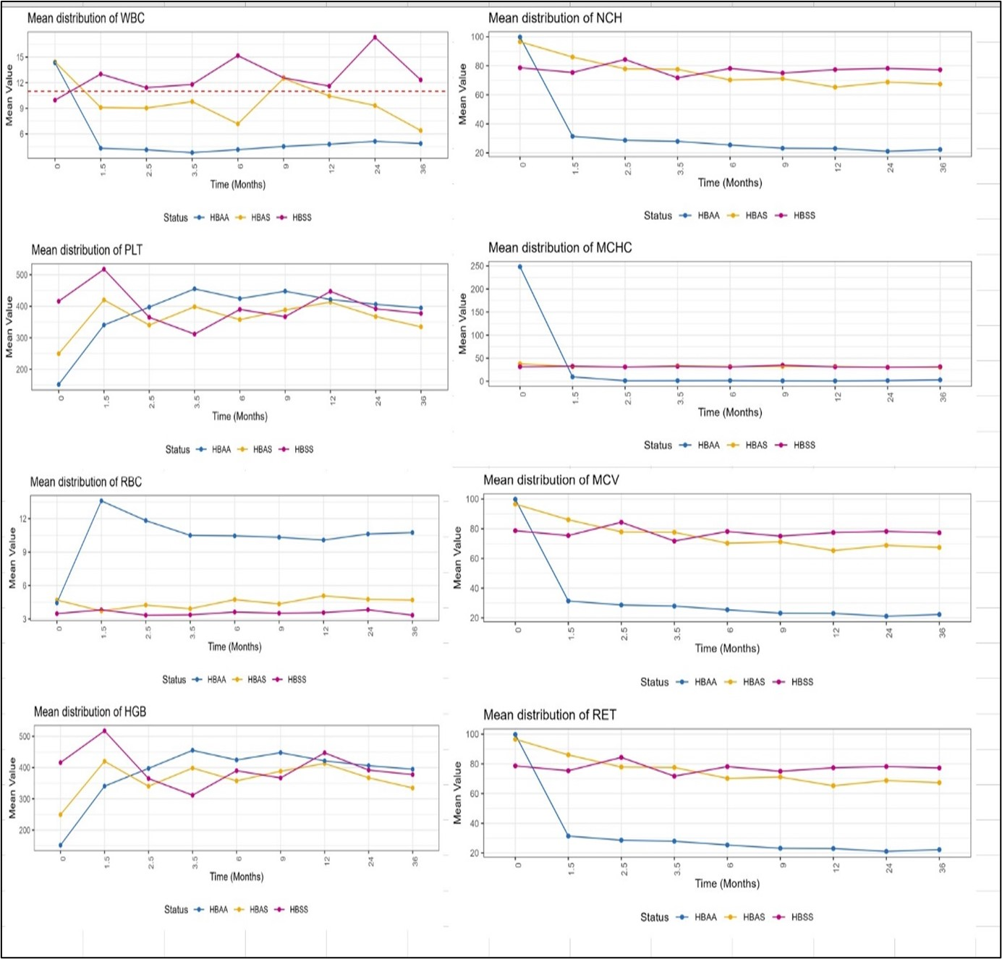
Mean distribution of WBC
Mean distribution of MCH

