Supplemental appendix

Inclusion Criteria
Inclusion criteria for the qualitative interview survey
Individuals must meet all of the following criteria for study entry:
- A person diagnosed with paroxysmal nocturnal hemoglobinuria (PNH)
- A person on PNH treatment or with a past history of PNH treatment
- A person aged 16 years or older at the time of consent (a person aged 16 years or older but younger than 18 years does not have to give his/her assent through a special form but must be able to understand the content of the information sheet.)
- A person with sufficient understanding to participate in the study
- A patient who has given consent to participate in this study (if the patient is a minor, consent from the patient's legal representative is also required)
- A person who can complete the procedures specified in the protocol
- A person living in Japan at the time of consent
- A person who has the equipment or communication environment to have an interview

Exclusion Criteria
Subjects meeting any of the following criteria will be excluded from the study:
    - A person who has difficulty giving consent or participating in the study due to a lack of Japanese language skills
    - A person who cannot participate in the survey

Supplemental patient narratives
Narratives related to feelings of being a burden on others among those who reported it are as follows:
- "My mother has to take time off from work to accompany me on those days when I have to go the hospital, so I can't help but feel that I'm becoming a burden on her." (F-20s)
- “The person who generally drives me to the hospital is my husband. He waits nearby while I'm being examined, and then picks me up when I'm done. I feel that I am being a burden on him.” (F-70s）
- “My husband is taking time off work to drive me to my hospital visits.” (F-50s）
- "The medical expenses that accumulate over the year come out of my income, and I feel uncomfortable about that." (M-40s)
- "When I need to have a meeting on a particular day, and it coincides with my hospital visit…it disrupts the schedule. It's fine if it's just one or two people, but it happens across various areas, including clients, so I feel like I'm causing considerable inconvenience…In the future, when I'm being evaluated for the next stage of my career, I may fall behind…This means I'm causing an inconvenience to my family. At work, I feel that my subordinates think I should move up quickly to open up a position for them, so I feel like I'm causing inconvenience to both those above and below me, as well." (M-40s)
- "I'm also causing inconvenience to my family. If a family member catches a cold, I have to ask them to wear a mask and such…Also, I can't take them on overseas trips or go out for meals as often, so those are some areas of inconvenience." (M-60s​)
- "If I catch an infectious disease, I'm told to go to the hospital immediately, so I have to take sudden leaves, and I feel uncomfortable about that." (F-30s)

Narratives related to worry, anxiety, or fear among those who reported it are as follows:
- "The blood test results did not exceed the required levels, so I couldn’t receive medication. From there, I had to undergo testing once a month for about a year… (While waiting for the treatment to start), I was gradually becoming less mobile, and I would likely be unable to work in the future. However, there was no treatment available, and this period of uncertainty was the most difficult for me due to the anxiety it caused." (M-40s)
- "Both physically and mentally, I wonder every day if I can get through it, if everyone will understand and if I can make it through the day. Almost every day starts with those kinds of thoughts." (F-40s)
- "I have no idea how my future financial situation will unfold." (F-40s)
- "I'm able to go to a hospital that is far from where I live at the moment, but I worry about whether I'll be able to get there on my own without burdening my family as I get older. Of course, it's best for now to have the doctor examine me, get blood tests, and receive treatment. But thinking ahead, it would be most appreciated if there was such a hospital nearby." (F-60s)
- "With this treatment, I'm not experiencing too many side effects right now. But I wonder if side effects might suddenly appear years from now." (F-40s)
- "Having oral medication would be ideal, but I'm still anxious about things like timing and forgetting to take it - that would be my fault, but I still worry about it." (F-60s)

Narratives related to suffering or pain among those who reported it are as follows:
- "I had a hard time when I quit my club activity." (F-10s)
- "It was like just waiting for the illness to progress. That time was the most difficult." (M-40s)
Table S1. Additional baseline and disease characteristics of the study population.

Characteristic | N=30
Employment status, n (%)
Working​ | 20 (66.7)​
Full-time employees​ | 12 (40.0)​
Part-time job | 4 (13.3)​
Temporary employees of worker dispatch offices​ | 1 (3.3)​
Self-employed (with employees)​ | 1 (3.3)​
Self-employed (no employee)​ | 2 (6.7)​
Not working​ | 10 (33.3)​
School​ | 1 (3.3)​
Housekeeping​ | 4 (13.3)​
Others (e.g., elderly)​ | 5 (16.7)​
Household structure, n (%)
Only parents and unmarried children​ | 8 (26.7)​
Married​ | 8 (26.7)​
Single​ | 7 (23.3)​
Three-generation household​ | 3 (10.0)​
Other​ | 3 (10.0)​
Not willing to answer​ | 1 (3.3)​
Mean duration of PNH (SD), years* | 11.0 (8.8)
Current complications, n (%)†
None | 10 (33.3)
Aplastic anemia | 8 (26.7)
Myelodysplastic syndrome | 2 (6.7)
Chronic kidney disease | 2 (6.7)
Leukemia | 1 (3.3)
Other/I do not know | 9 (30.0)

Duration of current primary treatment
Ravulizumab, n (%)
≥1 to <6 months | 1 (3.3)
≥6 to <12 months | 2 (6.7)
≥12 months | 14 (46.7)
Transfusion therapy, n (%)
<1 month | 1 (3.3)
≥1 to <6 months | 1 (3.3)
≥6 to <12 months | 0
≥12 months | 5 (16.7)
Eculizumab, n (%)
≥12 months | 4 (13.3)
Other treatments for PNH, n (%)†,‡
Immunosuppressants | 6 (20.0)​
Iron preparations or folic acid​ | 4 (13.3)​
Corticosteroids | 3 (10.0)​
Anabolic steroids | 3 (10.0)​
Thrombopoietin receptor agonist | 2 (6.7)​
Medications being evaluated in a clinical trial​ | 2 (6.7)​
Heparin​ | 1 (3.3)​
Warfarin​ | 1 (3.3)​
Erythropoiesis stimulating factors | 1 (3.3)​
Other​ | 7 (23.3)​
I don't know​ | 1 (3.3)​
Not applicable​ | 12 (40.0)​
* Data available for 25 patients, five patients reported “I don’t know” as a response.
† Multiple answers were allowed.
‡ Other treatments could have been received in combination with the primary treatment.

Table S2. Combinations of primary treatments reported by all patients.

Combinations of primary treatment | All patients (N=30)
Eculizumab | 2 (6.7)
Ravulizumab | 14 (46.7)
Eculizumab + transfusion therapy | 2 (6.7)
Ravulizumab + transfusion therapy | 3 (10.0)*
Transfusion therapy | 2 (6.7)†
Other | 7 (23.3)‡
* One patient answered "Other" in addition to ravulizumab and transfusion therapy as primary treatment. This patient's other treatments were immunosuppressants and anabolic steroids.
† One patient answered "I don't know" in addition to transfusion therapy.
‡ Details of other treatments for these seven patients are shown in Table S3.

Table S3: Combinations of treatments reported by patients who chose “Other" as primary treatment

Treatments | Patients who chose “Other" as primary treatment  (N=7)
Immunosuppressants | 1
Immunosuppressants and thrombopoietin receptor agonist | 1
Corticosteroids and iron preparations or folic acid | 1
Medications being evaluated in a clinical trial | 2*
Other | 2
* One patient answered “Other" in addition to medications being evaluated in a clinical trial.

Table S4. Baseline annual household income and reporting of financial concern during the study.

Annual household income, n (%)* | All patients  (N=30) | Patients reporting financial concern  (N=23)
< ¥2 million | 4 (13.3)​ | 3 (13.0)
≥ ¥2 million to < ¥4 million ​ | 8 (26.7)​ | 4 (17.4)
≥ ¥4 million to < ¥6 million ​ | 6 (20.0)​ | 5 (21.7)
≥ ¥6 million to < ¥8 million ​ | 0 | 0
≥ ¥8 million to < ¥10 million ​ | 3 (10.0)​ | 3 (13.0)
≥ ¥10 million​ | 3 (10.0)​ | 3 (13.0)
I don't know​ | 3 (10.0)​ | 2 (8.7)
Not willing to answer​ | 3 (10.0)​ | 3 (13.0)
* The median annual household income in Japan is 4.23 million yen, as reported by the Ministry of Health, Labor and Welfare of Japan.¹

1. Ministry of Health, Labour and Welfare of Japan. (2022). Comprehensive Survey of Living Conditions. Retrieved from https://www.mhlw.go.jp/toukei/saikin/hw/k-tyosa/k-tyosa22/dl/03.pdf (in Japanese; accessed June 9, 2025).
Figure S1. Patient flowchart.

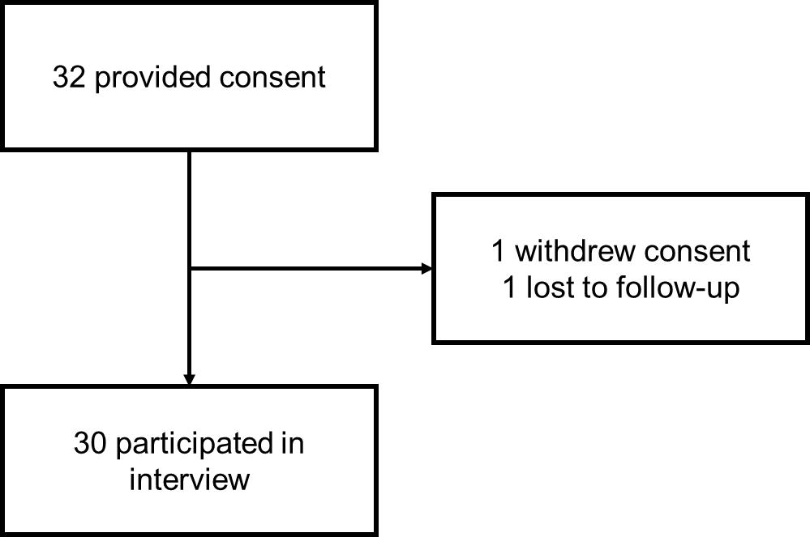

Figure S2. Reported symptoms experienced by patients with PNH. Multiple responses were allowed for each category.
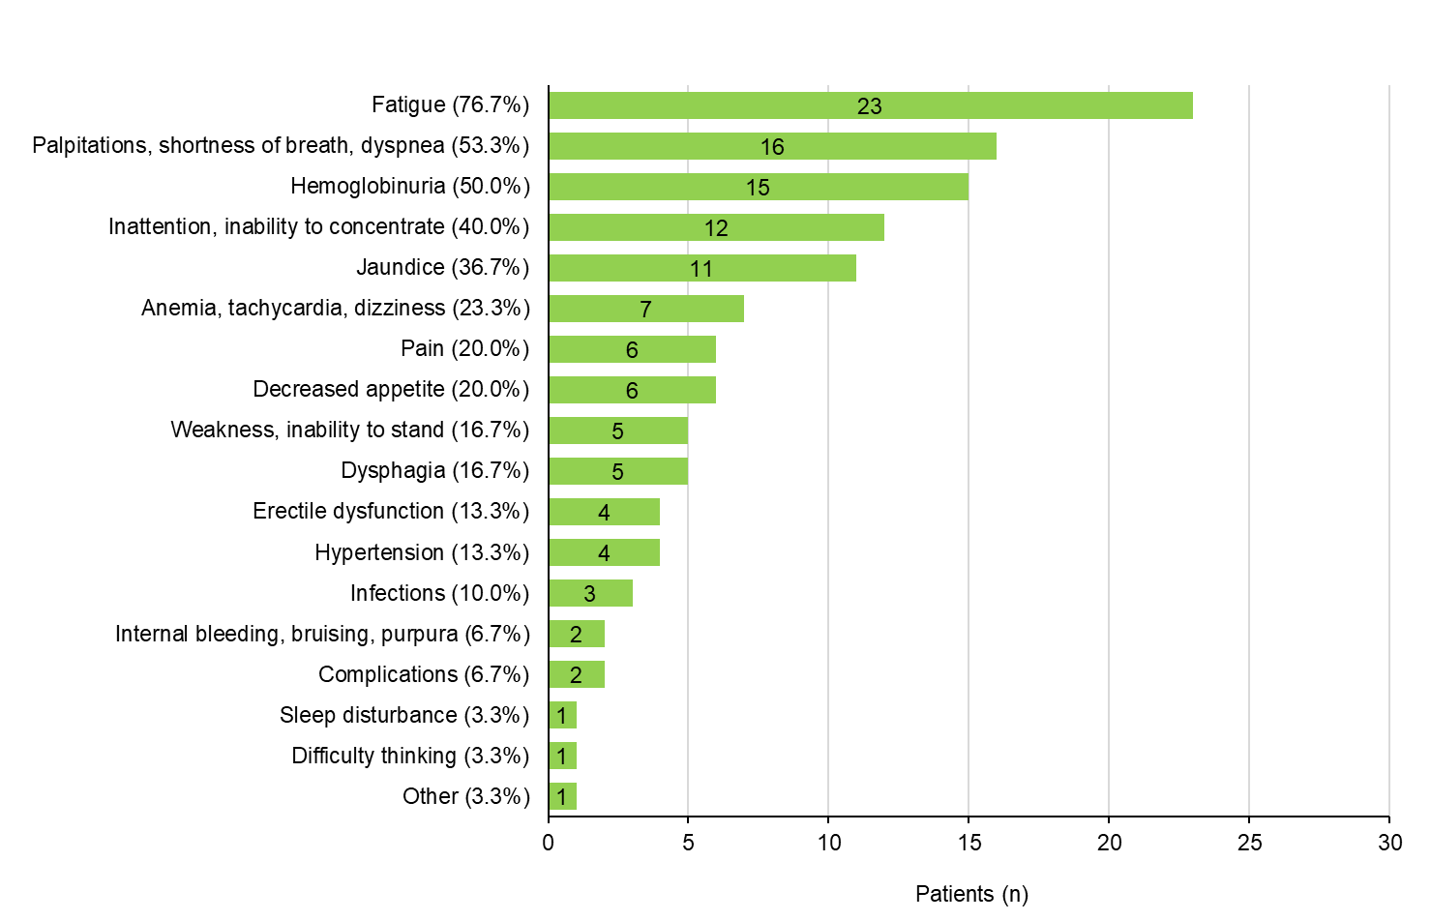

Figure S3. Reported side effects experienced by patients with PNH. Multiple responses were allowed for each category.
