Supplemental Figure 1
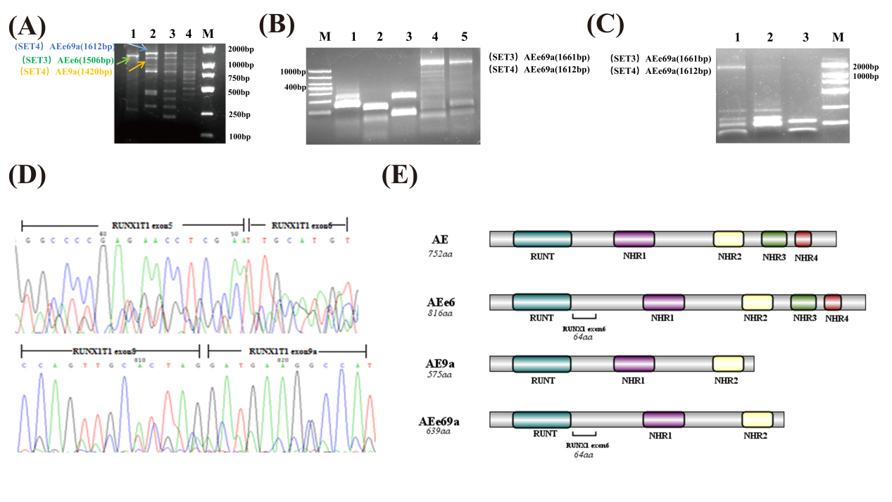
Supplemental Figure 1. Electrophoresis and sequencing results of e6 and 9a in AEe69a located in the same transcript and structural sketch of each fusion protein. (A) Electrophoretic results of primed sample 1 amplified by primer pairs SET3 and 4. Lane 1: presumed formation of AEe6 (1506bp); Lane 2: presumed formation of both AE9a (1420bp) and AEe69a (1612bp) .;Lanes 3 and 4 show the amplification results of gradient PCR,62 and 64°C respectively.(B)Electrophoretic results of primed sample 2 amplified by primer pairs SET3 and 4. Lane 1:AE and AEe6 co-expression; Lane 2: AEe6; Lane 3: AE9a;Lane 4: presumed formation of AEe69a (1661bp) ;Lane 5: presumed formation of AEe69a (1612bp) . (C)Electrophoresis results following the increase in the molecular weight of the marker. Lane 1,3:AEe69a (1661bp);Lane2:AEe69a (1612bp). (D)Forward and reverse sequencing results of initial patient 2 amplified by primer pairs SET3. (E)structural sketch of each fusion protein.

Supplemental Figure 2
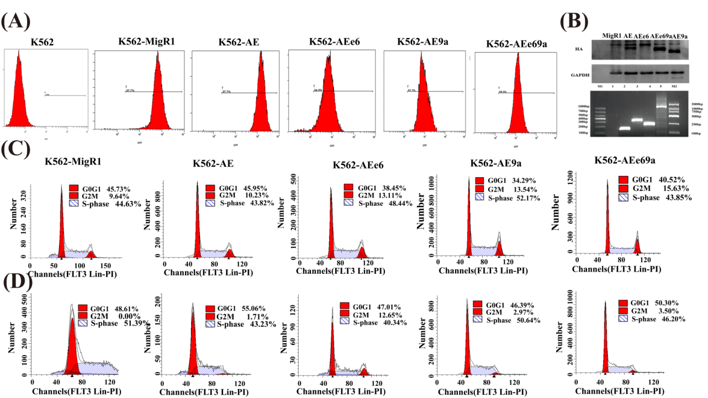
Supplemental Figure 2. Results of GFP, RT-PCR, and Western Blot (WB) validation after the successful construction of each cell model, alongside the proportion of cells in G0/G1, S, and G2/M phases in the five groups after 24 and 48 hours of TG101209 treatment. (A)GFP positivity of each group of cells was determined by flow cytometry. (B)Top: Western Blot (WB) validation results; bottom: RT-PCR validation results. Lane 1: blank control;Lane 2: AE(1661bp);Lane 3: AEe6(358bp);Lane 4: AE9a(229bp);Lane 5: AEe69a(1661bp). (C) Determination of the cycle of five groups of cells after 24h action of TG101209 by flow cytometry. (D)Determination of the cycle of five groups of cells after 48h action of TG101209 by flow cytometry.

