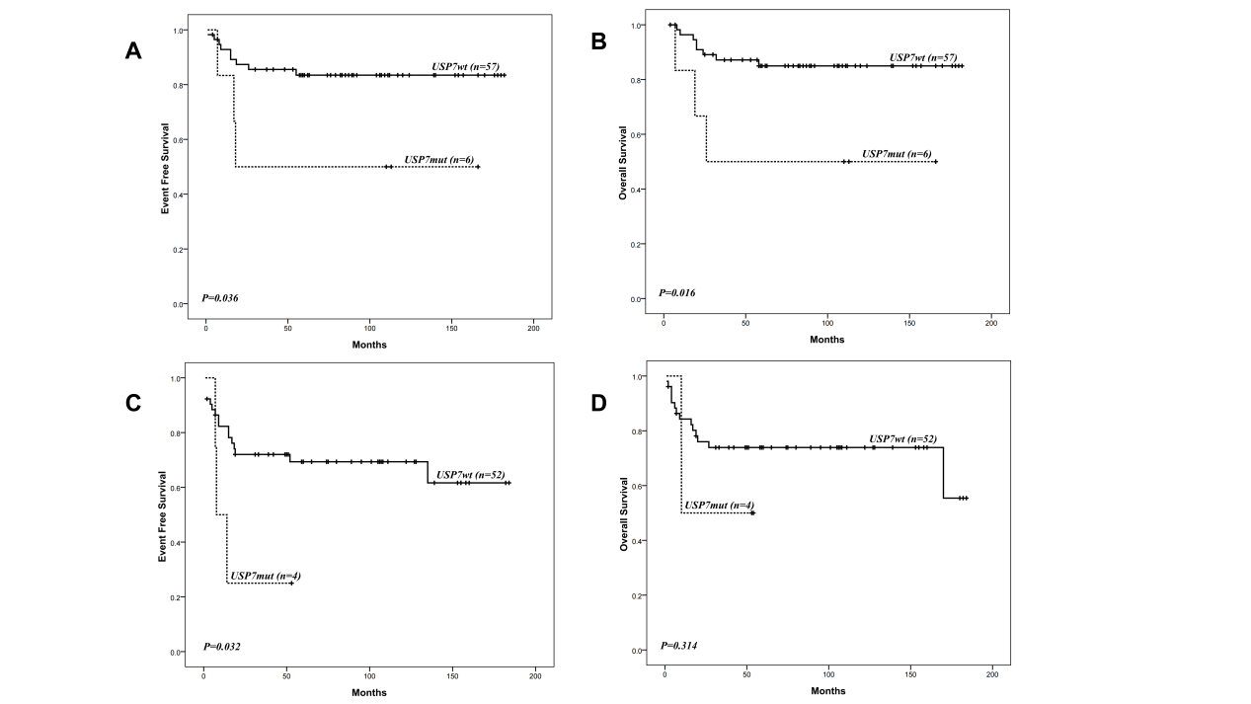
Supplementary Figure S1 Comparision of USP7 mutation on EFS and OS in NOTCH1^{mut} and NOTCH1^{wt} subgroup with T-ALL. EFS (A) and OS (B) according to USP7 mutation in NOTCH1^{mut} subgroup. EFS (C) and OS (D) according to USP7 mutation in NOTCH1^{wt} subgroup.

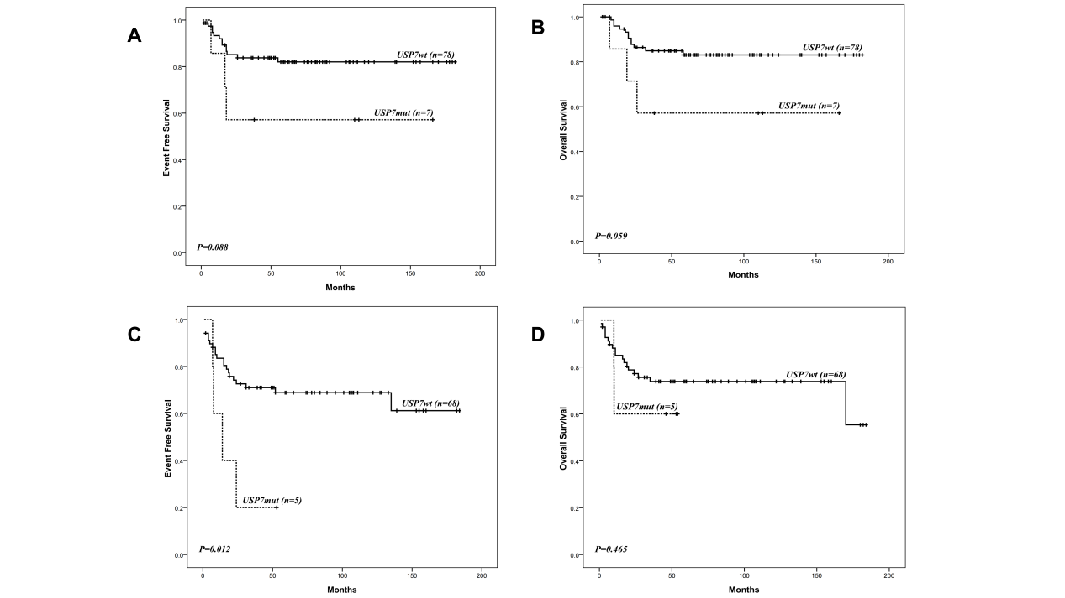
Supplementary Figure S2 Comparision of USP7 mutation on EFS and OS in NOTCH1^{mut} and NOTCH1^{wt} subgroup with T-ALL/LBL. EFS (A) and OS (B) according to USP7 mutation in NOTCH1^{mut} subgroup. EFS (C) and OS (D) according to USP7 mutation in NOTCH1^{wt} subgroup.
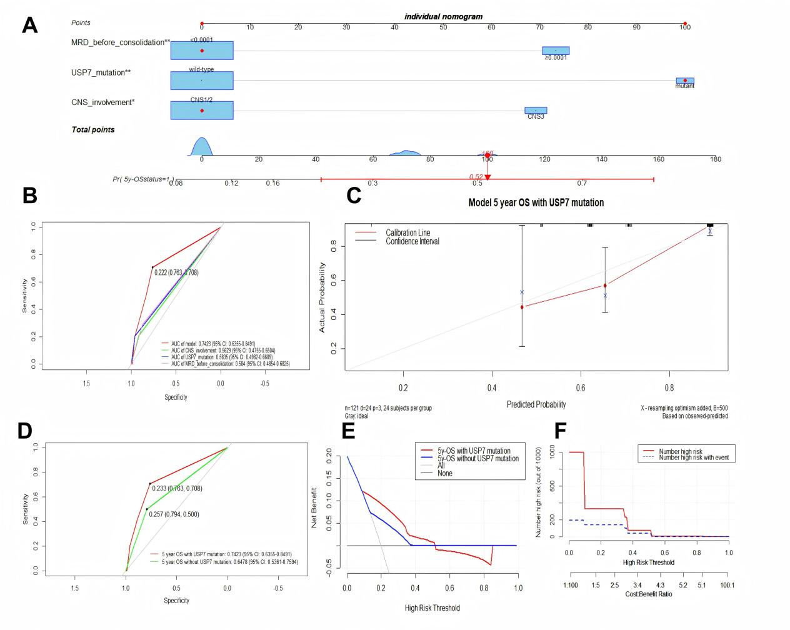
Supplementary Figure S3 Nomogram for predicting 5-year OS in pediatric T-ALL/T-LBL patients.
(A) Individual nomogram integrating three prognostic variables: USP7 mutation status, MRD pre-consolidation, and CNS involvement. Each variable is assigned a score, and the total score corresponds to an estimated probability of 5-year OS. (B) Receiver Operating Characteristic (ROC) curve showing the model’s ability to distinguish between survival outcomes. The Area Under the Curve (AUC) was 0.7423 (95% CI: 0.6355–0.8491), indicating acceptable discriminatory performance. (C) Calibration curve comparing predicted vs. observed 5-year OS probabilities. The closer the curve follows the ideal diagonal line (where predicted = actual), the better the model's accuracy. (D) Comparison of ROC curves for the prediction model with and without inclusion of USP7 mutation status. The improved AUC when including USP7 confirms its added value in outcome prediction. (E) Decision Curve Analysis (DCA) evaluating the clinical usefulness of the model across different risk thresholds. The model shows net clinical benefit when its curve lies above the “treat all” and “treat none” reference lines, particularly between 10% and 55% threshold probabilities. (F) Clinical Impact Curve (CIC) displaying the estimated number of high-risk patients (red line) and actual event-positive cases (blue line) at varying risk thresholds. This illustrates the trade-off between the number of patients labeled as high-risk and the detection of true events.

