Supplementary materials
Internal tandem duplications of FLT3 containing exogenous sequences are associated with poor clinical outcomes in acute myeloid leukemia

Shao-Tong Li^{1, 2, #}, Xiu-Min Shi^{1, 2, #}, Qiu-Ju Liu^{1, 2}, Ye-Hui Tan^{1, 2}, Hai Lin^{1, 2}, Yan-Ping Yang^{1, 2}, Jing-Nan Sun^{1, 2}, Yun-Wei Zhang^{1, 2}, Long Su^{1, 2 *}, Su-Jun Gao^{1, 2, *}

¹ Department of Hematology, The First Hospital of Jilin University, Changchun 130021, China.
² Key Laboratory of Hematology Precision Medicine of Jilin Province, The First Hospital of Jilin University, Changchun 130021, China.

# Shao-Tong Li and Xiu-Min Shi contribute equally to this work.

*Correspondence:
Long Su: Tel: +86-0431-88782172; fax: +86-0431-88786134; E-mail address: sulong@jlu.edu.cn. Department of Hematology, The First Hospital of Jilin University; Changchun 130021, China.
Su-Jun Gao: Tel.: +86-0431-88782157; fax: +86-0431-88786134; E-mail address: sjgao@jlu.edu.cn. Department of Hematology, The First Hospital of Jilin University; Changchun 130021, China.

Running title: FLT3-ITD mutations in acute myeloid leukemia

Supplementary Tables:
Table S1 Mutations of 193 genes analyzed in this study
193 gene panel
ABCB1 | ABL1 | AKT1 | AKT3 | ALK | ANKRD26 | APC | ARID1A | ARID1B | ARID2
ASXL1 | ASXL2 | ATG2B | ATM | ATRX | B2M | BCL11B | BCL2 | BCL6 | BCOR
BCORL1 | BIRC3 | BLM | BRAF | BRCA1 | BRCA2 | BRCC3 | BTK | CALR | CARD11
CBL | CBLB | CCND1 | CCND3 | CD28 | CD58 | CD79A | CD79B | CDA | CDKN1B
CDKN2A | CDKN2B | CEBPA | CHD2 | CHD8 | CREBBP | CRLF2 | CSF1R | CSF3R | CSMD1
CTLA4 | CUX1 | CXCR4 | DDX3X | DDX41 | DHX15 | DIS3 | DKC1 | DNM2 | DNMT3A
DPYD | ECT2L | EED | EGFR | ELANE | EP300 | EPCAM | EPOR | ETNK1 | ETV6
EZH2 | FAT1 | FBXW7 | FLT3 | FOXO1 | GATA1 | GATA2 | GATA3 | GNA13 | GNAS
GSKIP | GSTM1 | GSTP1 | HAX1 | HNRNPK | HRAS | ID3 | IDH1 | IDH2 | IKZF1
IL7R | ITPKB | JAK1 | JAK2 | JAK3 | KDM5A | KDM6A | KIT | KLF2 | KMT2A
KMT2B | KMT2C | KMT2D | KMT2E | KRAS | LAMB4 | LRP1B | MAP2K1 | MAPK1 | MEF2B
MLH1 | MPL | MSH2 | MSH6 | MTHFR | MTRR | MYC | MYD88 | NF1 | NOTCH1
NOTCH2 | NPM1 | NRAS | NSD2 | NT5C2 | NUDT15 | NUMB | PAX5 | PDGFRA | PDGFRB
PEG3 | PHF6 | PIGA | PIK3CA | PLCG2 | PMS2 | POT1 | PPM1D | PRPF40B | PRPF8
PTEN | PTPN11 | PTPRD | RAD21 | RAP1A | RB1 | RBBP4 | RELN | RHOA | RIT1
RRAS | RRAS2 | RUNX1 | SAMD9 | SAMD9L | SAMHD1 | SETBP1 | SETD2 | SF1 | SF3A1
SF3B1 | SH2B3 | SLCO1B1 | SMC1A | SMC3 | SOD2 | SOS1 | SPEN | SRP72 | SRSF2
STAG2 | STAT3 | STAT5B | SUZ12 | SYK | TCF3 | TENT5C | TERC | TERT | TET2
TNFAIP3 | TNFRSF14 | TP53 | TPMT | TRAF3 | U2AF1 | U2AF2 | WT1 | XPO1 | ZAP70
ZBTB7A | ZMYM3 | ZRSR2

Table S2 Information about the abnormal karyotypes
Patients with abnormal karyotypes
Case 9 | +8
Case 10 | +6
Case 12 | inv(16)(p12q22)
Case 18 | der(7); inv(7)(p14q21); del(7)(q21)
Case 20 | inv(3)(q21q26.2); -7
Case 24 | t(6;9)(p23;q34)
Case 30 | +8
Case 33 | t(6;9)(p23;q34)
Case 39 | t(X;11)(p22.1;p11.2)
Case 46 | t(6;9)(p23;34)
Case 58 | del(20)(q11.2q13.3)
Case 59 | +8
Case 68 | del(7)(q22q34); t(8;21)(q22;q22)
Case 69 | t(9;11)(p22;q23)
Case 78 | t(5;14)(q14;q32)
Case 80 | t(8;21)(q22;q22)
Case 94 | t(5;14)(q33;q32)
Case 98 | del(5q); del(7)(q22;q34)
Case101 | +8
Case 105 | del(6)(p23); t(11;19)(q23;p13.1)
Case 106 | +8
Case 114 | +8
Case 115 | t(6;9)(p23;q34); del(9)(q22)
Case 117 | inv(16)(p13q22)
Case 118 | t(7;11)(p15;p15)
Case 120 | t(3;21)(q26;q22)
Case 123 | t(6;13)(p21;q14)

Table S3 Pathways or gene families of co-mutations
Pathways or gene families | All patients (n = 124)
DNA methylation | DNMT3A (33), IDH1 (8), IDH2 (20), TET2 (12), EED (1), KMT2A (1), KMT2B (1), KMT2C (2), KMT2D (4), KMT2E (1)
Receptor tyrosine kinase | FLT3-TKD (8), KIT (6), EGFR (1), PDGFRA (2)
RAS pathway | KRAS (6), NRAS (14), CBL (2), PTPN11 (11), NF1 (5), JAK2 (1), SOS1 (1), MPL (1), SH2B3 (2)
Transcriptional regulation | NPM1 (59), CEBPA (12), RUNX1(15), ZBTB7A (2), MYC (1), SETBP1 (2), EP300 (3), CREBBP (2)
Chromatin modifier | ASXL1 (4), BCOR (7), BCORL (2), SETD2 (1)
Cohesin complex | STAG2 (3), RAD21 (5), SMC1A (1), SMC3 (2)
Spliceosome | U2AF1 (5), ZRSR2 (4), SRSF2 (4), SF3B1 (2), HNRNPK (1), SF1(1)
Tumor suppressor | WT1 (19), PHF6 (4)
Others | FAT1 (1), CSF3R (1), BLM (2), BRCA1(1), GSKIP (1), SRP72 (1), SAMHD1 (1), ATG2B (2), PIK3CA (1), CARD11 (1), DHX15 (2), SUZ12 (1), PTPRD (2), SAMD9 (1)

Table S4 Detailed mutational information of all the patients
Specific FLT3-ITD information |  | Exogenous sequences
Case 1 | 1780_1800dup
 | 1740_1799dup
Case 2 | 1834_1835ins | CCCAC
Case 3 | 1779_1793dup
 | 1793_1794ins | T
Case 4 | 1732_1779dup
Case 5 | 1770_1793dup
Case 6 | 1789_1824dup
Case 7 | 1834_1835ins | AC
Case 8 | 1801_1802ins | CCTT
Case 9 | 1831_1832ins | TCCC
Case 10 | 1794_1811dup
 | 1791_1829dup
Case 11 | 1777_1806dup
Case 12 | 1746_1817dup
Case 13 | 1724_1801dup
Case 14 | 1789_1809dup
Case 15 | 1791_1793dup
Case 16 | 1823_1824ins | T
Case 17 | 1745_1795dup
Case 18 | 1781_1807dup
 | 1799_1800ins | CCGG
Case 19 | 1742_1798dup
Case 20 | 1754_1771dup
 | 1833_1834ins | CCTATTACCGA
Case 21 | 1804_1805ins | GG
Case 22 | 1779_1811dup
Case 23 | 1756_1794dup
Case 24 | 1740_1832dup
 | 1806_1807ins | AGGGG
 | 1810_1811ins | G
Case 25 | 1738_1818dup
Case 26 | 1793_1794ins | T
Case 27 | 1784_1816dup
Case 28 | 1738_1806dup
Case 29 | 1747_1782dup
Case 30 | 1720_1788dup
Case 31 | 1769_1770ins | AGGGCC
Case 32 | 1791_1792ins | TC
 | 1775_1804dup
Case 33 | 1827_1828ins | CGGTCGGC
 | 1805_1806ins | CCTCCTTGG
Case 34 | 1797_1799dup
Case 35 | 1857_1898dup
Case 36 | 1743_1835dup
 | 1764_1787dup
Case37 | 1774_1827dup
Case 38 | 1773_1799dup
Case 39 | 1788_1789ins | CCCC
Case 40 | 1795_1796ins | TCCCCG
Case 41 | 1723_1806dup
 | 1742_1804dup
 | 1790_1807dup
Case 42 | 1835_1836ins | A
Case 43 | 1780_1800dup
Case 44 | 1777_1778ins | GG
Case 45 | 1792_1827dup
 | 1803_1804ins | GATAT
Case 46 | 1817_1818ins | CACTC
Case 47 | 1796_1828dup
Case 48 | 1773_1793dup
Case 49 | 1787_1788ins | TGAAATGATGAG
Case 50 | 1801_1802ins | C
Case 51 | 1731_1787dup
Case 52 | 1734_1823dup
Case 53 | 1773_1796dup
Case 54 | 1722_1799dup
Case 55 | 1827_1828ins | C
Case 56 | 1734_1769dup
Case 57 | 1770_1793dup
Case 58 | 1780_1818dup
 | 1830_1831ins | TCCT
Case 59 | 1779_1817dup
Case 60 | 1797_1798ins | T
Case 61 | 1756_1833dup
Case 62 | 1745_1792dup
Case 63 | 1743_1817dup
Case 64 | 1721_1825dup
Case 65 | 1794_1795ins | AGAAGGGGGGCACATGCA
Case 66 | 1766_1834dup
Case 67 | 1747_1794dup
Case 68 | 1775_1776ins | GG
Case 69 | 1787_1788ins | TGAAATG
Case 70 | 1770_1793dup
Case 71 | 1720_1788dup
 | 1782_1783ins | GG
Case 72 | 1724_1801dup
Case 73 | 1793_1792ins | CA
Case 74 | 1766_1834dup
 | 1817_1818ins | GGCGGGGCG
Case 75 | 1744_1785dup
Case 76 | 1759_1800dup
Case 77 | 1762_1812dup
Case 78 | 1793_1794ins | GGA
Case 79 | 1792_1793ins | G
 | 1821_1822ins | GACG
Case 80 | 1770_1793dup
Case 81 | 1837_1837+1ins | CAC
 | 1792_1827dup
Case 82 | 1823_1824ins | CCCC
Case 83 | 1792_1827dup
 | 1827_1828ins | C
Case 84 | 1744_1803dup
Case 85 | 1759_1806dup
Case 86 | 1782_1783ins | GG
Case 87 | 1806_1807ins | AGCCC
Case 88 | 1770_1793dup
Case 89 | 1748_1792dup
Case 90 | 1748_1786dup
Case 91 | 1788_1811dup
 | 1796_1813dup
Case 92 | 1837_1837+1ins | A
Case 93 | 1748_1831dup
Case 94 | 1752_1805dup
 | 1781_1822dup
 | 1805_1806ins | GG
Case 95 | 1748_1792dup
Case 96 | 1817_1818ins | GGACGG
Case 97 | 1717_1836dup
Case 98 | 1781_1782ins | CG
Case 99 | 1774_1800dup
Case 100 | 1795_1796ins | TA
Case 101 | 1829_1830ins | T
Case 102 | 1793_1794ins | TTTA
Case 103 | 1841_1842ins | A
Case 104 | 1793_1891dup
Case 105 | 1929_1930ins | CC
Case 106 | 1744_1902dup
Case 107 | 1744_1863dup
Case 108 | 1869_1870ins | ACG
Case 109 | 1803_1859dup
Case 110 | 1862_1863ins | GCCTTTTA
Case 111 | 1770_1793dup
 | 1857_1858ins | CGGGAATAT
Case 112 | 1743_1784dup
Case 113 | 1781_1816dup
Case 114 | 1828_1829ins | CCCCCA
Case 115 | 1799_1800ins | GC
Case 116 | 1853_1854ins | G
Case 117 | 1825_1826ins | GTCA
Case 118 | 1837_1837+1ins | AGGAGGTGTGG
Case 119 | 1770_1790dup
Case 120 | 1793_1794ins | CCTTAGGGAG
Case 121 | 1751_1789dup
Case 122 | 1770_1793dup
Case 123 | 1759_1788dup
Case 124 | 1789_1790ins | GCGG
 | 1738_1836dup
FLT3 (NM_004119.2)
Table S5 Characteristics of 102 AML patients who received the first induction chemotherapy
Variable | All patients (n = 102) | Duplication (n = 58) | Insertion (n = 44) | P
Age
≥60 | 15 (14.71%) | 10 (17.24%) | 5 (11.36%)
<60 | 87 (85.29%) | 48 (82.76%) | 39 (88.64%) | 0.406
Sex
Male | 50 (49.02%) | 31 (53.45%) | 19 (43.18%)
Female | 52 (50.98%) | 27 (46.55%) | 25 (56.82%) | 0.137
WBC (×10⁹) | 47.60 (1.40−399.00) | 37.00 (1.40−208.8) | 55.90 (1.80−399.00) | 0.072
HGB (g/L) | 73.00 (35.00−160.00) | 71.00 (37.00−160.00) | 76.00 (35.00−145.00) | 0.241
PLT (×10⁹) | 36.00 (2.00−430.00) | 36.00 (2.00−430.00) | 36.50 (10.00−262.00) | 0.978
BM Blast (%) | 84.50 (21.00−99.00) | 83.50 (21.00−97.50) | 87.80 (21.00−99.00) | 0.549
Co-mutations
MR mut | 19 (18.63%) | 13 (22.41%) | 6 (13.64%) | 0.259
NPM1 | 46 (45.10%) | 33 (56.90%) | 13 (29.55%) | 0.006
DNMT3A | 24 (23.53%) | 17 (29.31%) | 7 (15.91%) | 0.023
Adverse cytogenetics | 9 (8.82%) | 1 (1.72%) | 8 (18.18%) | 0.005
Features of ITD
VAF (%) | 21.01 (1.20−93.00) | 19.30 (1.20−93.00) | 25.80 (1.80−76.90) | 0.549
Length (bp) | 48.00 (3.00−249.00) | 43.50 (3.00−249.00) | 53.00 (15.00−192.00) | 0.129
ITDs in TKD1 | 15 (14.71%) | 5 (8.62%) | 10 (22.73%) | 0.046
AML: acute myeloid leukemia; WBC: white blood cells; HGB: hemoglobin; PLT: platelet; BM: bone marrow; MR mut: MDS-related mutations (ASXL1, BCOR, EZH2, RUNX1, SF3B1, SRSF2, STAG2, U2AF1, ZRSR2); ITD: internal tandem duplication; VAF: variant allel frequency; TKD: tyrosine kinase domain.

Table S6 Characteristics of 68 AML patients with FLT3-ITD mutation in long-term follow-up
Variable | All patients (n = 68) | Duplication (n = 37) | Insertion (n = 31) | P
Age
≥60 | 7 (10.29%) | 5 (13.51%) | 2 (6.45%)
<60 | 61 (89.71%) | 32 (86.49%) | 29 (93.55%) | 0.422
Sex
Male | 33 (48.53%) | 18 (48.65%) | 15 (48.39%)
Female | 35 (51.47%) | 19 (51.35%) | 16 (51.61%) | 1.000
WBC (×10⁹) | 47.60 (1.40−399.00) | 43.60 (1.40−208.80) | 49.10 (2.70−399.00) | 0.626
HGB (g/L) | 78.50 (35.00−160.00) | 78.00 (35.00−160.00) | 79.00 (39.00−134.00) | 1.000
PLT (×10⁹) | 38.00 (2.00−430.00) | 40.00 (2.00−430.00) | 37.00 (10.00−97.00) | 0.626
BM Blast (%) | 88.00 (21.00−99.00) | 87.50 (21.00−97.50) | 89.50 (21.00−99.00) | 0.478
Co-mutations
MR mut | 10 (14.71%) | 7 (18.92%) | 3 (9.68%) | 0.326
NPM1 | 35 (51.47%) | 23 (62.16%) | 12 (38.71%) | 0.092
DNMT3A | 21 (30.88%) | 14 (37.84%) | 7 (22.58%) | 0.274
Adverse cytogenetics | 3 (4.41%) | 0 (00.00%) | 3 (9.68%) | 0.090
Features of ITD
VAF (%) | 23.90 (1.30−93.00) | 21.40 (1.30−93.00) | 24.80 (1.80−71.40) | 1.000
Length (bp) | 46.50 (3.00−249.00) | 45.00 (3.00−249.00) | 51.00 (15.00−192.00) | 1.000
ITDs in TKD1 | 10 (14.71%) | 3 (8.12%) | 7 (22.58%) | 0.093
AML: acute myeloid leukemia; WBC: white blood cells; HGB: hemoglobin; PLT: platelet; BM: bone marrow; MR mut: MDS-related mutations (ASXL1, BCOR, EZH2, RUNX1, SF3B1, SRSF2, STAG2, U2AF1, ZRSR2); ITD: internal tandem duplication; VAF: variant allel frequency. TKD: tyrosine kinase domain.

Table S7 Detailed formulas for predicting 1-, 2- , 3- year RFS and OS rate
Formulas for predicting survival rates
1-year RFS probability = 0.00011x³ - 0.00893x² + 0.17189x - 0.07788
2-year RFS probability = 0.00011x³ - 0.00719x² + 0.08978x + 0.58087
3-year RFS probability = 0.00011x³ - 0.00666x² + 0.06844x + 0.70258
1-year OS probability = 0.0001x³ - 0.00813x² + 0.13249x + 0.28853
2-year OS probability = 0.00018x³ - 0.00928x² + 0.08816x + 0.66373
3-year OS probability = 0.00018x³ - 0.00928x² + 0.08816x + 0.66373
RFS: relapse-free survival; OS: overall survival; x: the total scores of RFS or OS nomograms

Table S8 Comparison of baseline characteristics between the 68 patients included in the survival analysis and the 56 patients who were excluded
Variables | All patients (n = 124) | Included patients (n = 68) | Excluded patients (n = 56) | P
Age | 49.50 (16.70−75.30) | 44.44 (18.13−68.45) | 55.35 (16.70−75.30) | 0.002
Sex
Male | 65 (52.42%) | 33 (48.53%) | 32 (57.14%)
Female | 59 (47.58%) | 35 (51.47%) | 24 (42.86%) | 0.339
WBC (×10⁹/L) | 52.10 (1.40−399.00) | 47.60 (1.40−399.00) | 60.28 (1.76−384.34) | 0.367
HGB (g/L) | 75.00 (35.00−160.00) | 78.50 (35.00−160.00) | 73.50 (38.00−146.00) | 0.705
PLT (×10⁹/L) | 36.00 (2.00−430.00) | 38.00 (2.00−430.00) | 32.00 (4.00−262.00) | 0.460
BM Blasts (%) | 83.30 (21.00−99.00) | 88.00 (21.00−99.00) | 77.50 (23.50−97.00) | 0.019
Co-mutations
MR mut | 24 (19.35%) | 10 (14.71%) | 14 (25.00%) | 0.149
NPM1 | 59 (47.58%) | 38 (55.88%) | 21 (37.50%) | 0.041
DNMT3A | 33 (26.61%) | 21 (30.88%) | 12 (21.43%) | 0.236
Adverse cytogenetics | 9 (7.44%) | 4 (5.88%) | 5 (9.43%) | 0.503
Features of ITD
VAF (%) | 18.10 (1.20−93.00) | 20.19 (1.30−93.00) | 16.69 (1.20−76.94) | 0.588
Length (bp) | 48.00 (3.00−249.00) | 45.00 (3.00−249.00) | 49.50 (6.00−189.00) | 0.588
Insertion-ITD | 57 (45.97%) | 31 (45.59%) | 26 (46.43%) | 0.926
ITDs in TKD1 | 25 (20.16%) | 15 (22.06%) | 10 (17.86%) | 0.562
WBC: white blood cells; HGB: hemoglobin; PLT: platelet; BM: bone marrow; NA: not available; MR mut: MDS-related mutations (ASXL1, BCOR, EZH2, RUNX1, SF3B1, SRSF2, STAG2, U2AF1, ZRSR2); VAF: variant allel frequency; JMD: juxtamembranous domain; TKD: tyrosine kinase domain.

Supplementary Figures:
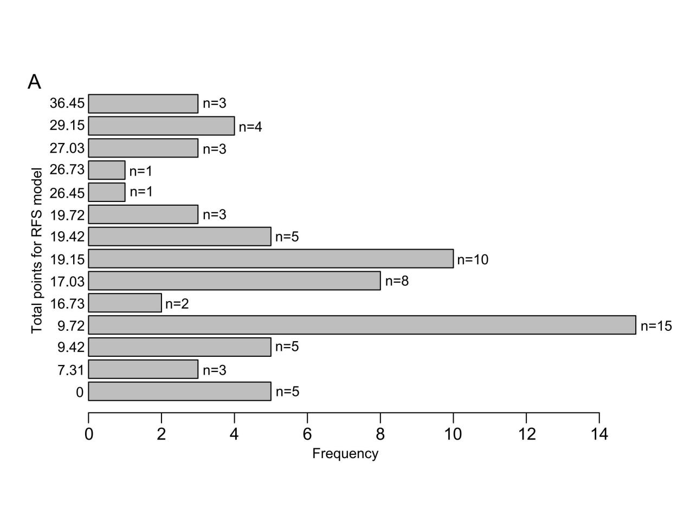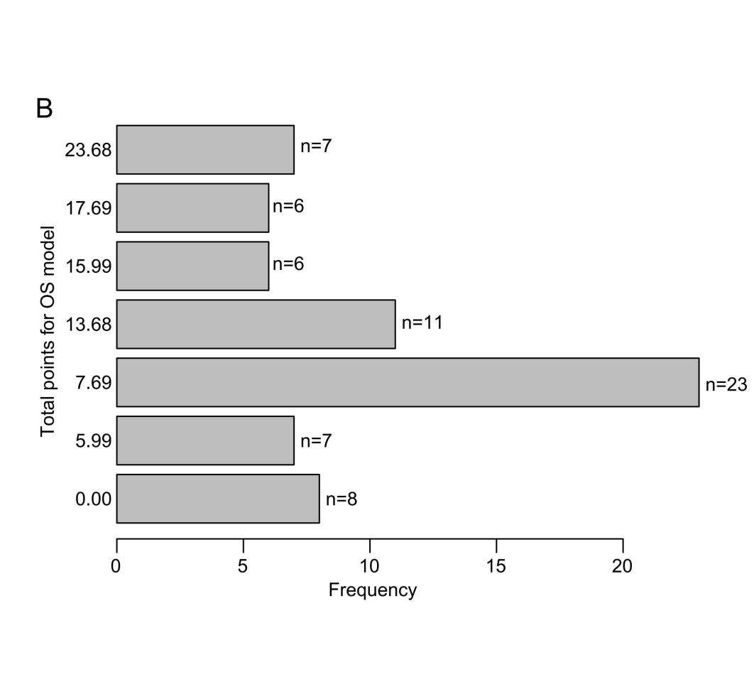
Supplementary Figure 1 Distribution of total scores for the RFS model (A) and the OS model (B)
RFS: relapse-free survival; OS: overall survival

