Supplementary Material
Quantification of serum biomarkers：
Methods:
Sample preparation :Thaw frozen serum and plasma samples on ice and mix well by vortexing. Centrifuge at 10,000 × g for 5–10 minutes to pellet out particulates. Avoid multiple freeze/thaw cycles. If samples are high in lipid content, centrifuge at 10,000 × g for 10 minutes and transfer contents to a new tube.
Plasma sample preparation： Collect samples in sodium citrate or EDTA tubes. If using heparin as an anticoagulant, no more than 10 IU of heparin per mL of blood collected should be used to prevent assay interference that can result in a false positive signal. 2. Centrifuge samples at 1,000 × g at 4°C for 10 minutes within 30 minutes of collection. 3. Collect the plasma fraction. Use immediately or store aliquots at–80°C.
Serum sample preparation 1. Allow blood to clot for 20–30 minutes at 20–25°C. 2. Centrifuge at 1,000 × g for 10 minutes at 20–25°C. 3. Collect the serum fraction. Alternatively, a serum separator tube can be used following the manufacturer’s instructions. 4. Use immediately or store aliquots at –80°C. Avoid multiple freeze/thaw cycles.
Cell culture supernatant preparation 1. Centrifuge samples at 1,400 rpm for 10 minutes at 4°C to remove particulates. 2. Aliquot the clarified medium into clean polypropylene microcentrifuge tubes. 3. Use immediately or store aliquots at –80°C. Avoid multiple freeze/thaw cycles.
Preparation of reagents Before starting with the assay protocol, define the plate map. Mark the standard, sample and background wells using the plate map to determine the number of wells used.
Prepare 1X Wash Buffer Bring the Wash Buffer Concentrate (10X) to room temperature and vortex for 15 seconds. Mix 20 mL of the Wash Buffer Concentrate (10X) with 180 mL ddH2O. Mix gently to avoid foaming. Wash Buffer (1X) can be stored at 2–8°C for up to 6 months.
Prepare Standard Mixes For experiments measuring serum or plasma samples, use 1X UAB as the diluent to reconstitute and dilute the standard. For experiments measuring cell culture supernatant samples, use fresh cell culture medium as the diluent.1. Centrifuge both standard mix stock vials at 2,000 x g for 10 seconds. 2. Add 125 μL of diluent to each stock vial. 3. Vortex the vials at high speed for 30 seconds and centrifuge at 2,000 × g for 10 seconds to collect contents at the bottom of the vials. 4. Incubate on ice for 10 minutes to ensure complete reconstitution. 5. Combine the contents of each vial into one of the vials. 6. Vortex the vial at high speed for 30 seconds and centrifuge at 2,000 × g for 10 seconds to collect contents at the bottom of the vial.
Prepare 4-fold serial dilution 1. Label the tubes in the 8-Tube Strip: Std1, Std2, Std3, Std4, Std5, Std6 and Std7. 2. Add 200 μL of the reconstituted standard mix into Std1 tube. 3. Add 150 μL of diluent into Std2–Std7 tubes. 4. Transfer 50 μL from Std1 tube into Std2 tube. 5. Mix by pipetting up and down 10 times. 6. Transfer 50 μL of the mixed standards from Std2 tube into Std3 tube using new pipette tip. 7. Mix by pipetting up and down 10 times. 8. Repeat steps 4–7 for tubes Std4–Std7, changing pipette tips between dilution steps. 9. Add 150 μL of diluent to the last tube of the 8-Tube Strip to serve as a background. 10. Keep tubes on ice until ready to use.
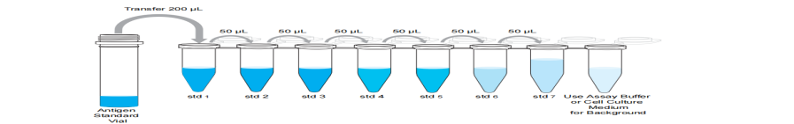
Assay Protocol
1. Add Capture Bead Mix to the plate.
a. Vortex the 1X Capture Bead Mix vial for 30 seconds at high speed.
b. Using a multichannel pipette, add 50 μL of the Capture Bead Mix to each well of the plate.
2. Wash beads using a Hand-Held Magnetic Plate Washer.
a. Place the plate on the Hand-Held Magnetic Plate Washer and wait 2 minutes to allow the
beads to settle on the bottom of each well.
b. Remove the liquid by quickly inverting the washer/plate assembly over a sink or waste
container.
c. Gently blot the inverted washer/plate assembly onto several layers of paper towels or
absorbent surface to remove any residual liquid.
d. Add 150 μL of 1X Wash Buffer into each well and wait 30 seconds.
e. Remove the liquid by quickly inverting the washer/plate assembly over a sink or waste
container.
f. Gently blot the inverted washer/plate assembly onto several layers of paper towels or
absorbent surface to remove any residual liquid.
g. Remove the plate from the magnet and proceed to step 3.
3. Add samples and standards to the plate.
a. Serum and plasma: Add 25 μL of 1X UAB to each well followed by 25 μL of prepared
standards or samples as defined on the plate layout. Add an additional 25 μL of 1X UAB to the
wells designated as backgrounds. Cell culture supernatants: Add 50 μL prepared standards
or samples as defined on the plate layout. Add 50 μL of cell culture medium to the wells
designated as backgrounds.
b. Seal the plate using one of the provided Plate Seals and cover with the provided Microplate
Lid. Shake at 600 rpm for 2 hours at room temperature.
4. Remove and discard the Plate Seal. Wash the plate following the steps below.
a. Place the plate on the Hand-Held Magnetic Plate Washer and wait 2 minutes to allow particles
to settle on the bottom of each well.
b. Remove the liquid by quickly inverting the washer/plate assembly over a sink or waste
container.
c. Gently blot the inverted washer/plate assembly onto several layers of paper towels or
absorbent surface to remove any residual liquid.
d. Add 150 μL of 1X Wash Buffer into each well and wait 30 seconds.
e. Remove the liquid by quickly inverting the washer/plate assembly over a sink or waste
container.
f. Gently blot the inverted washer/plate assembly onto several layers of paper towels or
absorbent surface to remove any residual liquid.
g. Repeat steps 4d-4f once for a total of two washes.
h. Remove the plate from the magnet and proceed to the next step.
5. Add Biotinylated detection Antibody Mix to the plate.
a. Using a multichannel pipette, add 25 μL of the detection antibody solution to each well of the
plate. Gently tap the plate to evenly distribute the solution in the wells.
b. Seal the plate using a new Plate Seal and cover with the provided Microplate Lid. Shake at
600 rpm for 30 minutes at room temperature.
6. Wash the plate following step 4.
7. Add Streptavidin-PE (SA-PE) to the plate.
a. Add 50 μL of SA-PE solution to each well.
b. Seal the plate using new Plate Seal and cover with the provided Microplate Lid. Shake at 600
rpm for 30 minutes at room temperature.
8. Wash the plate following step 4.
9. Prepare the plate for analysis on a xMAP™ instrument.
a. Add 120 μL of reading buffer into each well.
b. Seal the plate using new Plate Seal and cover with the provided Microplate Lid. Shake at 600
rpm for 5 minutes at room temperature.
10. Remove the Plate Seal and run the plate on a xMAP™ instrument
Follow the recommended guidelines and procedures for calibration and verification of the instrument.
Laser-based systems require 30 minutes to warm up prior to use
Analyse Results
The concentration of the samples can be calculated by plotting the expected concentration of the
standards against the NET MFI generated by each standard. A 5PL algorithm is recommended for the best curve fit. Analyze the assayed samples according to the operation manual for the Luminex™ instrument.

Refractory/Relapse HLH
Defining remission: The assessment of treatment was carried out every 2 weeks after the first course of treatment. Evaluation criteria: The efficacy was assessed according to the evaluation criteria proposed by Marsh et al¹². Complete remission (CR) was defined as the normalization of all quantifiable symptoms and laboratory markers of HLH, including values for sCD25, ferritin, triglyceride, hemoglobin, neutrophil, platelet counts, and alanine aminotransferase. Partial remission (PR) was defined as at least a 25% improvement in two or more quantifiable symptoms and laboratory markers by 2 weeks following treatment: sCD25 response 1.5-fold decrease, ferritin, and triglyceride decreased ≥25%, an increase by at least 100% to >0.5×10⁹ /L, in patients with an initial neutrophil count of <0.5×10⁹/L, an increase by at least 100% to>2×10⁹/L in patients with an initial neutrophil count of 0.5–2.0×10⁹/L and a decrease of at least 50% in patients with initial ALT> 400 U/l. Besides, body temperature had to revert to normal ranges to diagnose either CR or PR. Failure to achieve PR was defined as no response (NR). Refractory or Relapse HLH was defined as patients who did not achieve at least partial response 2 weeks after initial HLH therapy or patients who achieved at least PR but exhibited activated disease again.

Supplementary Table1. The baseline clinical data in EBV-HLH (n=75), L-HLH (n=73) and MAS (n=61) in all patients.
Baseline characteristics  (median) | EBV-HLH | L-HLH | MAS | p.adj  (EBV-HLHvsMAS) | p.adj  (EBV-HLHvsMAS) | p.adj  (L-HLHvsMAS) | p(K-W)
Sex/man(woman) | 48（27） | 49（24） | 10（51） | 2.462 | 1.904E-07 | 3.267E-08 | 7.958E-10
Age | 35 | 50 | 36 | 0.016 | 2.995 | 0.055 | 0.011
WBC(109/L) | 1.55 | 2.21 | 4.97 | 0.097 | 5.135E-09 | 1.572E-05 | 1.896E-09
GR（109/L) | 0.94 | 1.42 | 3.36 | 0.033 | 7.583E-09 | 9.845E-05 | 3.859E-09
Lymphocyte（109/L) | 0.34 | 0.42 | 0.89 | 0.947 | 9.366E-06 | 0.001 | 2.821E-06
monocyte（109/L) | 0.08 | 0.16 | 0.22 | 0.022 | 1.634E-05 | 0.114 | 2.328E-05
HB(g/L) | 84 | 81 | 84 | 1.862 | 1.166 | 0.538 | 0.403
PLT（109/L) | 44 | 38 | 86 | 2.508 | 3.323E-07 | 2.819 | 4.585E-08
CRP(mg/L) | 19 | 30.75 | 22.94 | 0.248 | 2.891 | 0.585 | 0.202
ALT(U/L) | 83 | 49 | 73 | 0.035 | 1.691 | 0.303 | 0.0395
AST(U/L) | 116.6 | 71.1 | 107.8 | 0.153 | 0.941 | 1.181 | 0.147
TBIL(umol/L) | 27.65 | 23.94 | 14.38 | 1.115 | 0.003 | 0.013 | 0.002
LDH(U/L) | 670.5 | 627 | 661 | 1.506 | 2.139 | 2.423 | 0.801
TG(mmol/L) | 2.27 | 2.41 | 2.42 | 2.198 | 2.047 | 1.188 | 0.722
Fbg(g/L) | 1.57 | 1.81 | 2.15 | 0.024 | 0.010 | 2.485 | 0.005
Ferritin（ng/ml) | 4081 | 3822 | 7478 | 1.920 | 0.488 | 0.693 | 0.311
sCD25(pg/ml) | 35572.5 | 40705 | 12580.5 | 0.227 | 4.057E-11 | 1.571E-12 | 6.716E-15
NK's activity | 0.155 | 0.1546 | 0.152 | 2.273 | 0.659 | 1.363 | 0.496
HLH, hemophagocytic lymphohistiocytosis; MAS, macrophage activation syndrome; EBV-HLH, EBV associated HLH;
Supplementary Figure1a. Principal components analyses (PCA) of the 34 serum biomarkers described in Method in EBV-HLH (n=15), L-HLH (n=14) and MAS (n=16) 2021-2002.
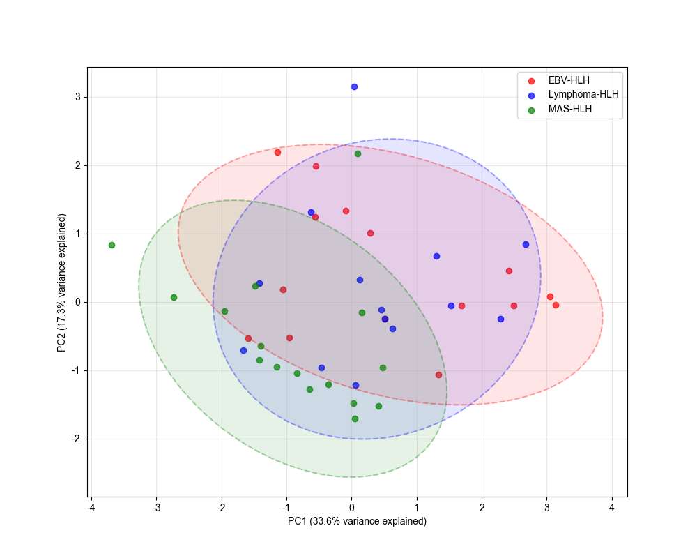
Supplementary Figure1b. Principal components analyses (PCA) of the 11 serum biomarkers described in Method in HC (n=9), EBV-HLH (n=23), L-HLH (n=30) and MAS (n=25) post-2022..
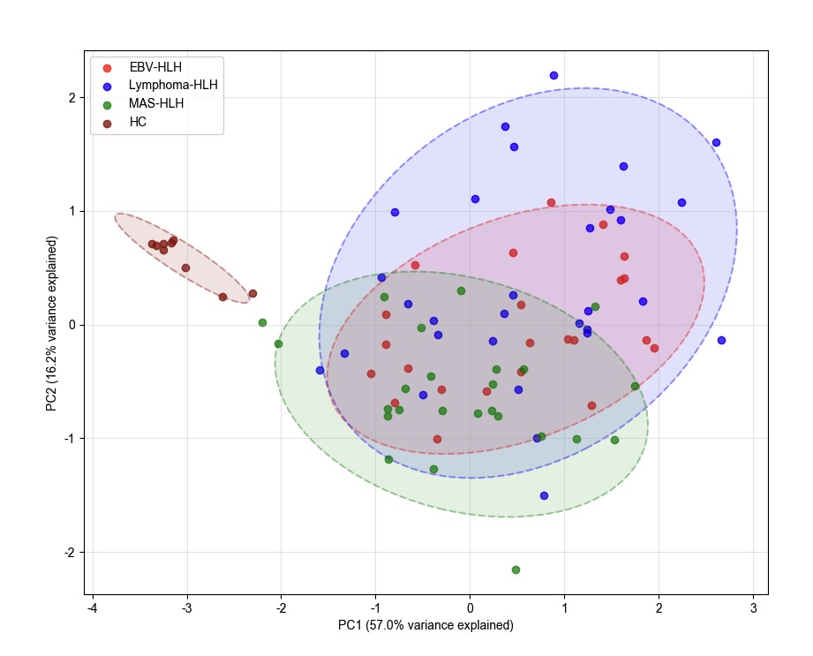

Supplementary Table2. The individual serum biomarkers in EBV-HLH (n=37), L-HLH (n=29) and MAS (n=20) pre-2021, by Kruskal-Wallis test followed by Bonferroni test for multiple comparisons.
Biomarkers（median/（pg/ml)） | EBV-HLH | L-HLH | MAS |  | p.adj (EBV-HLH vs L-HLH) | p.adj(EBV-HLH vs MAS) | p.adj(L-HLH vs MAS)
MIP-1α | 8.4 | 11.89 |  | 4.24 | 0.4459 | 0.0025 | 0.0032
SDF1-α | 427.5 | 331.6 |  | 561.8 | 0.1616 | 0.1837 | 0.0269
IL-27 | 9.1 | 8.8 |  | 8.675 | 0.8261 | 0.8261 | 0.8261
IL-1β | 0.8 | 1 |  | 0.75 | 0.5019 | 0.8009 | 0.5019
IL-2 | 3.6 | 3.2 |  | 2.8 | 0.0913 | 0.0913 | 0.7524
IL-4 | 5.7 | 5.7 |  | 5.305 | 0.7898 | 0.8344 | 0.7898
IL-5 | 4.15 | 3.9 |  | 4.065 | 0.5391 | 0.7823 | 0.5391
IP-10 | 191.11 | 57 |  | 165.2 | 0.0678 | 0.4271 | 0.2104
IL-6 | 6.4 | 5.52 |  | 5.43 | 0.4392 | 0.3251 | 0.4392
IL-7 | 0.75 | 0.6 |  | 0.5 | 1 | 0.2338 | 0.2338
IL-8 | 2 | 2.1 |  | 4.9 | 0.7417 | 0.7002 | 0.6548
IL-10 | 69.8 | 67.1 |  | 3.25 | 0.9948 | 0.0001 | 0.0004
Eotaxin | 18.5 | 18.2 |  | 32.35 | 0.401 | 0.0768 | 0.401
IL-12p70 | 2.9 | 3.37 |  | 2.95 | 0.0159 | 0.2542 | 0.2446
IL-13 | 1.8 | 1.6 |  | 2.565 | 0.362 | 0.362 | 0.3098
IL-17A | 1.08 | 1 |  | 1.1 | 0.9512 | 0.9512 | 0.9512
IL-31 | 4.5 | 4.63 |  | 4.465 | 0.7005 | 0.7005 | 0.7005
IL-1RA | 1349 | 627.42 |  | 484.06 | 0.8666 | 0.7433 | 0.7433
RANTES | 56.18 | 46.82 |  | 71.9 | 0.7825 | 0.9201 | 0.7825
IFN-γ | 202.8 | 192.76 |  | 202.6 | 0.9126 | 0.9126 | 0.9126
GM-CSF | 6.6 | 7.1 |  | 6.75 | 0.5314 | 0.8213 | 0.5314
TNF-α | 12.5 | 7.5 |  | 17.85 | 0.4934 | 0.4934 | 0.4811
MIP-1β | 102.8 | 83.9 |  | 102.75 | 0.98 | 0.98 | 0.98
IFN-α | 0.26 | 0.27 |  | 0.2 | 0.8141 | 0.237 | 0.237
MCP-1 | 35.8 | 89.2 |  | 56.9 | 0.5811 | 0.5811 | 0.5811
IL-9 | 2.3 | 3.3 |  | 2.145 | 0.0765 | 0.5808 | 0.0163
TNFβ | 3.3 | 4.7 |  | 3.045 | 0.2326 | 0.4366 | 0.1195
GRO-α | 6.7 | 2.78 |  | 2.2 | 0.4426 | 0.4426 | 0.6324
IL-1α | 0.4 | 0.34 |  | 0.305 | 0.7101 | 0.7101 | 0.7101
IL-23 | 5.4 | 7.26 |  | 6.205 | 0.7371 | 0.7371 | 0.7371
IL-15 | 1.7 | 1.56 |  | 1.575 | 0.7958 | 0.7958 | 0.7958
IL-18 | 366.4 | 250.1 |  | 516.55 | 0.3974 | 0.3974 | 0.3175
IL-21 | 3.5 | 4.22 |  | 3.1 | 0.6006 | 0.6006 | 0.6006
IL-22 | 15.82 | 12.65 |  | 6.95 | 0.514 | 0.008 | 0.0253
Supplementary Figure2a. 34 serum biomarkers were analyzed by K-W multiple comparison statistics among EBV-HLH (n=15), L-HLH (n=14) and MAS (n=16) between 2021 and 2022. Results are shown as Violin-plot, in which intermediary lines show the median of the levels of cytokines. The levels of biomarkers were transformed into log(X+1).
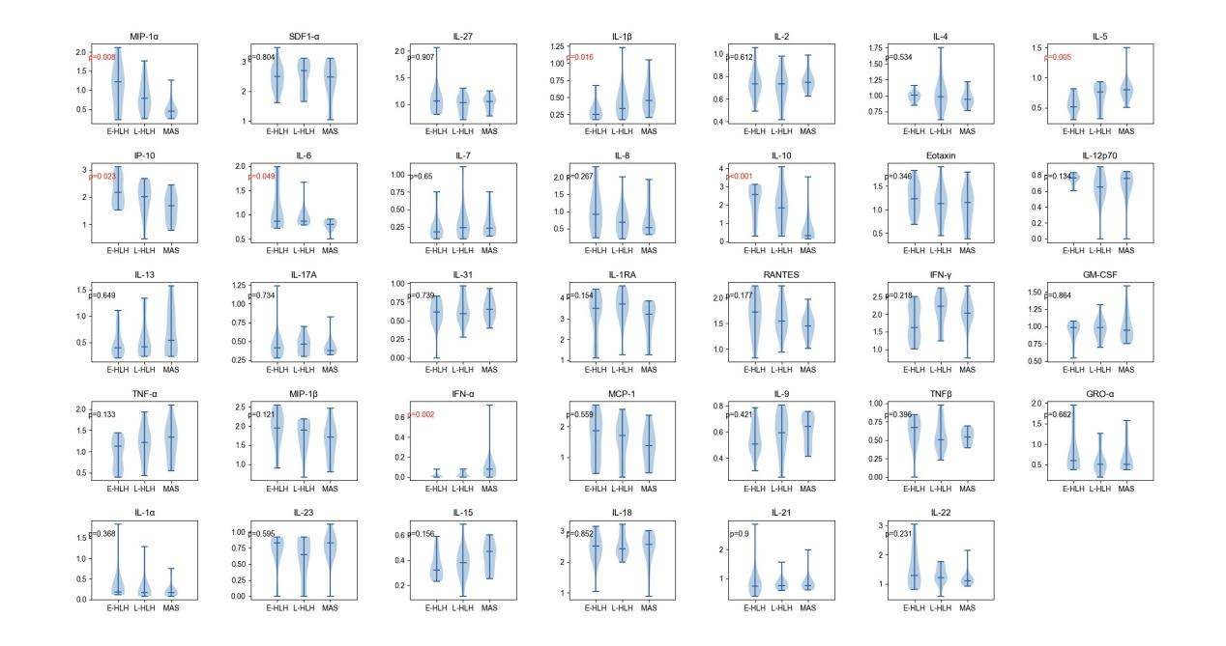MIP-1α, Macrophage inflammatory protein-1 α; SDF1-α, Stromal cell-derived factor-1; IP-10 (CXCL10), interferon-γ inducible protein-10; IL-1RA, IL-1 receptor antagonist; GM-CSF, Granulocyte-macrophage colony-stimulating factor; TNF-α, Tumor necrosis factor-α; MIP-1β, Macrophage inflammatory protein-1 alpha; MCP-1α, monocyte chemoline protein-α; GRO-α, Growth related oncogene-α

Supplementary Table3. The individual biomarkers in EBV-HLH (n=15), L-HLH (n=14) and MAS (n=16) between 2021 and 2022, by Kruskal-Wallis test followed by Bonferroni test for multiple comparisons.
Biomarkers（median/（pg/ml)） | EBV-HLH | L-HLH | MAS |  | p.adj(EBV-HLH vs L-HLH) | p.adj(EBV-HLH vs MAS) | p.adj(L-HLH vs MAS)
MIP-1α | 15.6 | 5.05 |  | 1.8 | 0.1903 | 0.018 | 0.018
SDF1-α | 313.8 | 517.25 |  | 302.2 | 0.8588 | 0.8588 | 0.8588
IL-27 | 10.6 | 9.95 |  | 10.45 | 1 | 1 | 1
IL-1β | 0.8 | 1.2 |  | 1.85 | 0.1603 | 0.0133 | 0.2767
IL-2 | 4.4 | 4.4 |  | 4.6 | 0.8441 | 0.7512 | 0.7512
IL-4 | 9.1 | 8.65 |  | 7.7 | 0.9652 | 0.719 | 0.719
IL-5 | 2.3 | 4.8 |  | 5.3 | 0.0777 | 0.0021 | 0.5326
IP-10 | 146.1 | 103.4 |  | 49.75 | 0.3154 | 0.0289 | 0.1159
IL-6 | 6.4 | 6.25 |  | 5.3 | 0.6782 | 0.0717 | 0.0717
IL-7 | 0.5 | 0.75 |  | 0.7 | 0.8216 | 0.8216 | 0.9501
IL-8 | 7.4 | 3.8 |  | 2.4 | 0.2879 | 0.2879 | 0.9337
IL-10 | 377.5 | 69.5 |  | 1.05 | 0.3369 | 0.0012 | 0.0012
Eotaxin | 16.1 | 12.55 |  | 13.05 | 0.4729 | 0.4729 | 0.7082
IL-12p70 | 4.8 | 3.5 |  | 4.7 | 0.1263 | 0.3596 | 0.3596
IL-13 | 1.5 | 1.6 |  | 2.45 | 0.7592 | 0.7592 | 0.7592
IL-17A | 1.6 | 1.9 |  | 1.4 | 0.8814 | 0.9209 | 0.8814
IL-31 | 3.1 | 2.95 |  | 3.5 | 0.8113 | 0.8113 | 0.819
IL-1RA | 3163 | 5354 |  | 1712.5 | 0.4849 | 0.4702 | 0.1449
RANTES | 51.7 | 34.05 |  | 27.5 | 0.7934 | 0.2162 | 0.3072
IFN-γ | 40.9 | 168.3 |  | 108.4 | 0.2785 | 0.4419 | 0.4419
GM-CSF | 8.7 | 8.55 |  | 7.75 | 0.8432 | 0.8432 | 0.8432
TNF-α | 12.3 | 15.55 |  | 21.25 | 0.174 | 0.174 | 0.8516
MIP-1β | 85.7 | 76.85 |  | 49.8 | 0.3286 | 0.1512 | 0.3286
IFN-α | 0 | 0 |  | 0.2 | 0.239 | 0.0032 | 0.0236
MCP-1 | 71.5 | 50.3 |  | 23.3 | 0.6467 | 0.6097 | 0.6097
IL-9 | 2.2 | 2.9 |  | 3.4 | 0.59 | 0.5723 | 0.884
TNFβ | 3.7 | 2.2 |  | 2.5 | 0.6671 | 0.3982 | 0.7707
GRO-α | 3 | 2.25 |  | 2.2 | 0.7319 | 0.7319 | 0.8677
IL-1α | 0.5 | 0.45 |  | 0.45 | 0.3842 | 0.3842 | 0.8338
IL-23 | 5.7 | 3.45 |  | 5.7 | 0.8762 | 0.9842 | 0.7551
IL-15 | 1.1 | 1.4 |  | 1.95 | 0.4695 | 0.2127 | 0.3286
IL-18 | 327.1 | 267.85 |  | 374.25 | 0.9741 | 0.9741 | 0.9834
IL-21 | 4.6 | 4.65 |  | 4.75 | 0.9212 | 0.9212 | 0.9212
IL-22 | 18.2 | 15.15 |  | 11.75 | 1 | 0.6966 | 0.1125

Supplementary Figure 2b. 11 serum biomarkers were analyzed by K-W multiple comparison statistics among EBV-HLH (n=23), L-HLH (n=30) and MAS (n=25) post-2022. Results are shown as Violin-plot, in which intermediary lines show the median of the levels of cytokines. The levels of biomarkers were transformed into log(X+1).
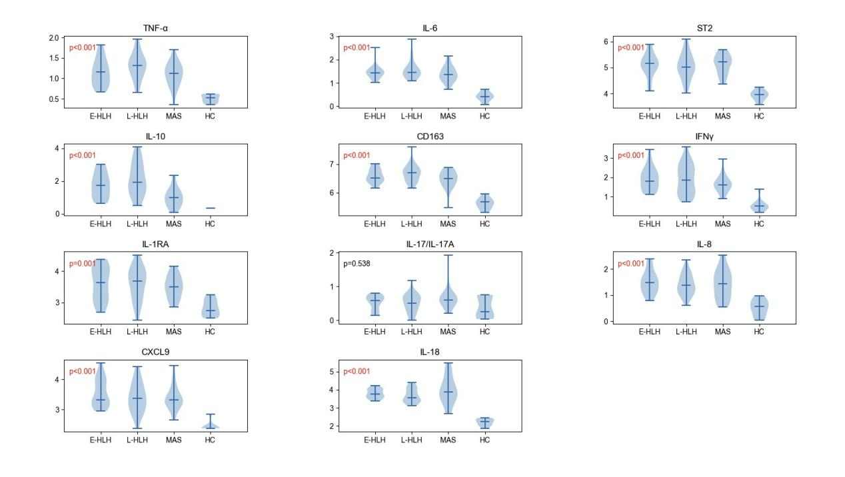TNF-α, Tumor necrosis factor-α; ST2, growth stimulation expressed gene 2; CD163, cluster of differentiation 163 IFN-γ, interferon-γ; IL-1RA, IL-1 receptor antagonist; CXCL9, chemokine (C-X-C motif ) ligand 9

Supplementary Table4. The individual biomarkers in EBV-HLH (n=23), L-HLH (n=30) and MAS (n=25) post-2022, by Kruskal-Wallis test followed by Bonferroni test for multiple comparisons.
Biomarkers（median/(pg/ml) | EBV-HLH | L-HLH | MAS | EBV-HLH vs L-HLH p.adj | EBV-HLH vs  MAS p.adj | - HLH vs MAS  p.adj
TNF-α | 13.3 | 19.9 | 12.4 | 0.1179 | 0.8607 |  | 0.0705
IL-6 | 26.4 | 27.6 | 21.8 | 0.4564 | 0.4564 |  | 0.3032
ST2 | 144728 | 102631.6 | 170980.8 | 0.8365 | 0.8365 | 0.8365
IL-10 | 53.7 | 84.9 | 8.8 | 0.2223 | 0.0025 | 0.0001
CD163 | 3315531.9 | 5011819 | 3112025 | 0.384 | 0.285 | 0.0858
IFNγ | 61.6 | 71.75 | 38.9 | 0.8505 | 0.4815 | 0.6185
IL-1RA | 4289.6 | 4831.85 | 3124.4 | 0.9071 | 0.7438 | 0.7438
IL-17/IL-17A | 2.8 | 2.25 | 3 | 0.7121 | 0.6569 | 0.5024
IL-8 | 29 | 23.5 | 26.2 | 0.8243 | 0.8243 | 0.9663
CXCL9 | 2074.3 | 2329.85 | 2122 | 0.6677 | 0.6677 | 0.9058
IL-18 | 5641.8 | 3720.1 | 7465 | 0.2897 | 0.3916 | 0.1924

Supplementary Table 5. TL-18 concentrations in EBV-HLH, L-HLH and MAS secondary to AOSD in all patients including pre-2021, 2021-2022 and post 2022.
IL-18 concentration（pg/ml） | EBV-HLH | L-HLH | MAS | p
pre-2021 | 366.4 | 250.1 | 587.15 | 0.022
2021-2022 | 327.1 | 267.85 | 489.25 | 0.428
post-2022 | 5641.8 | 3720.1 | 10186.5 | 0.025

Supplementary Figure 3a. Serum samples of patients between 2021 and 2022 with active EBV-HLH (n=15), L-HLH (n=14) and MAS (n=16) were analysed in a Luminex multiplex assays comprising 34 serum biomarkers. The levels of serum biomarkers were transformed into log(X+1). The dendrogram on the top of the heatmap indicated that 34 serum biomarkers were clustered after unsupervised hierarchical clustering of biomarkers expression profiles according to correlation distance. Colours indicate column Z score after transformation to log(X+1), in which the red indicated high expression and the blue indicated low expression.
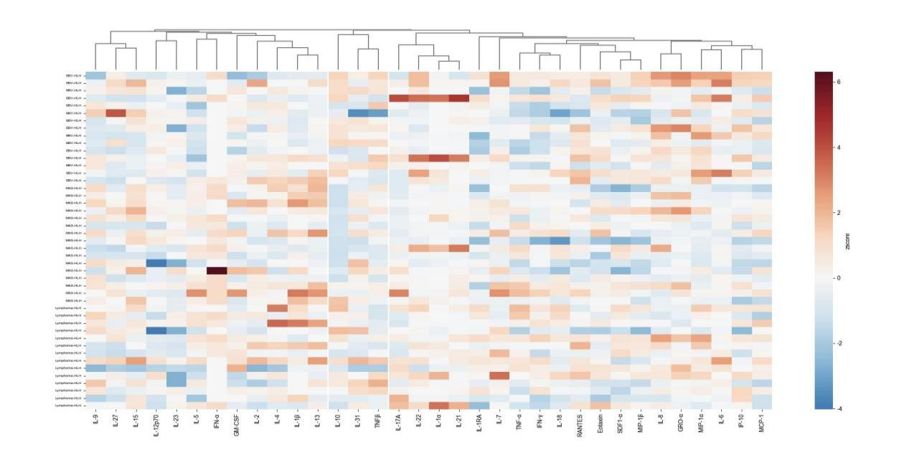
Supplementary Figure 3b. Serum samples of patients post-2022 with active EBV-HLH (n=23), L-HLH (n=30) and MAS (n=25) were analysed in a Luminex multiplex assays comprising 11 serum biomarkers. The levels of serum biomarkers were transformed into log(X+1). The dendrogram on the top of the heatmap indicated that 11 serum biomarkers were clustered after unsupervised hierarchical clustering of biomarkers expression profiles according to correlation distance. Colours indicate column Z score after transformation to log(X+1), in which the red indicated high expression and the blue indicated low expression.
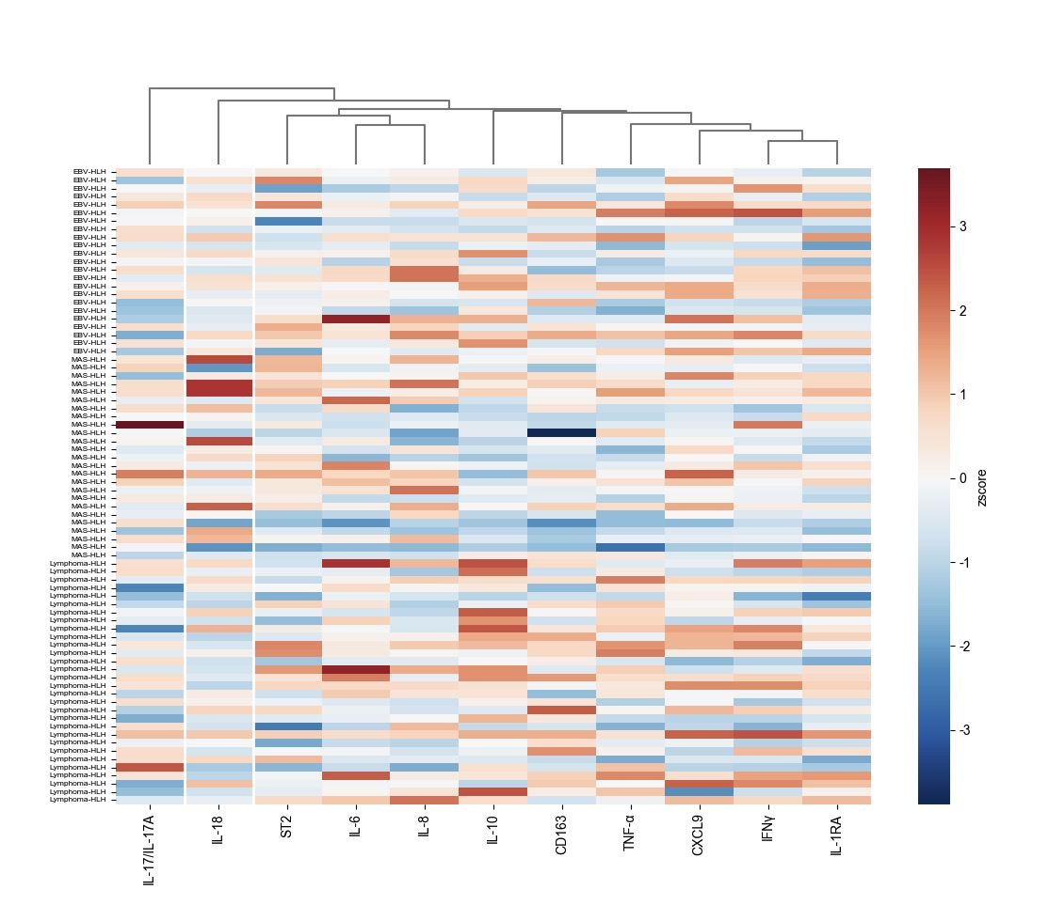
Supplementary Figure 4a. Serum samples of patients between 2021 and 2022 with active EBV-HLH (n=15), L-HLH (n=14) and MAS (n=16) were analysed in a Luminex multiplex assays comprising 34 serum biomarkers. The levels of serum biomarkers were transformed into log(X+1). The dendrogram on the left of the heatmap indicated the subjects were clustered according to ward.D2 linkage and the dendrogram on the top of the heatmap indicated 34 serum biomarkers were clustered according to correlation distance. Colours indicate column Z score after transformation to log(X+1), in which the red indicated high expression and the blue indicated low expression.
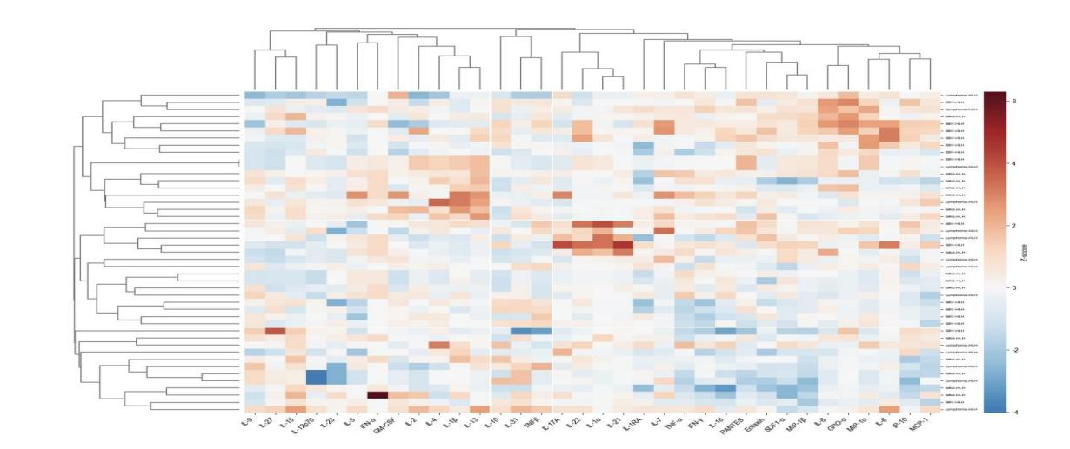
Supplementary Figure 4b. Serum samples of patients post-2022 with active EBV-HLH (n=23), L-HLH (n=30) and MAS (n=25) were analysed in a Luminex multiplex assays comprising 11 serum biomarkers. The levels of serum biomarkers were transformed into log(X+1). The dendrogram on the left of the heatmap indicated the subjects were clustered according to ward.D2 linkage and the dendrogram on the top of the heatmap indicated 34 serum biomarkers were clustered according to correlation distance. Colours indicate column Z score after transformation to log(X+1), in which the red indicated high expression and the blue indicated low expression.
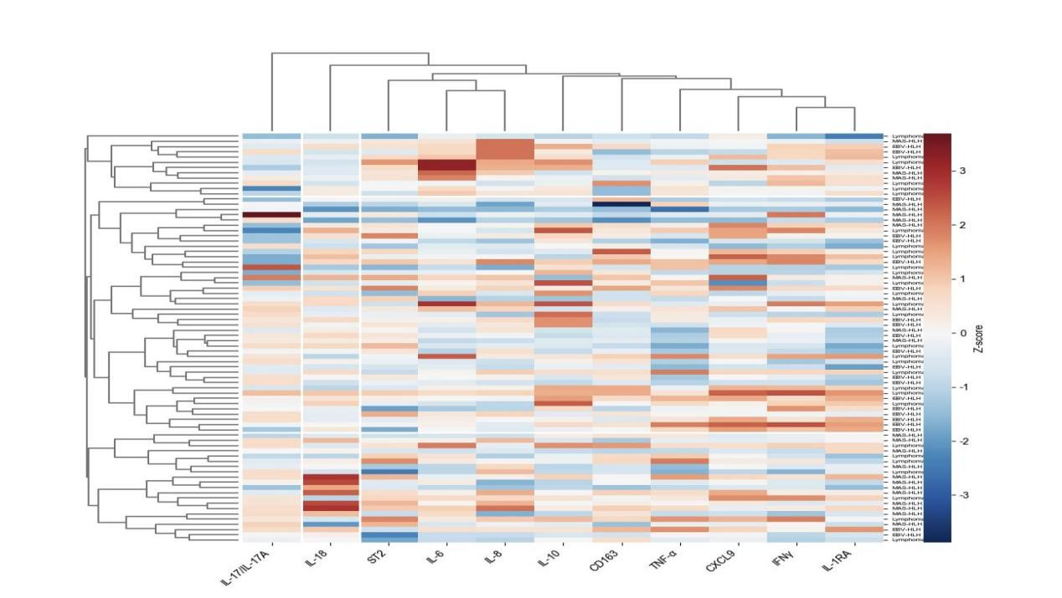
Supplementary Figure 5a. The relationship between clinical data (including age, sex, WBC, GR, HB, PLT, monocyte, lymphocyte, ALT, AST, TBIL, TG, LDH, CRP, Fbg, ferritin, sCD25 and NK cells activity) and 34 serum biomarkers in EBV-HLH (n=15), L-HLH (n=14) and MAS (n=16) between 2021 and 2022 was exhibited in the heatmap according to the Spearman’s Rank in which the red color indicated positive relationship and the blue color indicated negative relationship.
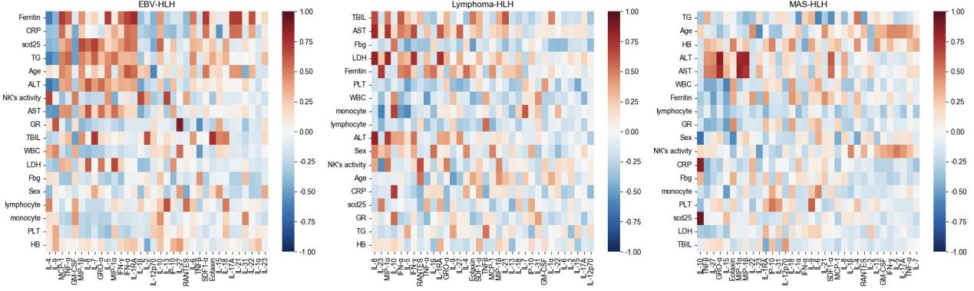

Supplementary Figure 5b. The relationship between clinical data (including age, sex, WBC,GR, HB, PLT, monocyte, lymphocyte, ALT, AST, TBIL, TG, LDH, CRP, Fbg, ferritin, sCD25 and NK cells activity) and 11 serum biomarkers in EBV-HLH (n=23), L-HLH (n=30) and MAS (n=25) post-2022 was exhibited in the heatmap according to the Spearman Coefficient, in which the red color indicated positive relationship and the blue color indicated negative relationship.
