Supplemental information
Supplemental Table 1. Supplemental patient characteristics: prior medical history and lymphoma CNS involvement
 | Available data (%) | Overall  N=365 |  | LOS ≤ 15 days  N=270 |  | LOS>15 days  N=95 |  | P value
 |  |  |  |  |  |  |  | Wilcoxon | OS | PFS
Prior medical condition | 100
Neoplasia |  | 74 | (20) | 57 | (21) | 17 | (18) | 0.5 | 0.084 | 0.65
Hemopathy |  | 12 | (3) | 8 | (3) | 4 | (4) | 0.5 | 0.66 | 0.32
Ischemic stroke |  | 11 | (3) | 10 | (4) | 1 | (1) | 0.3 | 0.54 | 0.53
Hemorrhagic stroke |  | 0 | (0) | 0 | (0) | 0 | (0)
Intracranial hypertension |  | 0 | (0) | 0 | (0) | 0 | (0)
Epilepsy |  | 5 | (1) | 2 | (1) | 3 | (3) | 0.1 | 0.77 | 0.64
Psychiatric disorder |  | 2 | (1) | 1 | (0) | 1 | (1) | 0.5 | 0.21 | 0.11
Lymphoma CNS involvement | 100
Deep structure involvement |  | 201 | (55) | 137 | (51) | 64 | (67) | 0.005 | 0.2 | 0.19
Brainstem |  | 55 | (15) | 36 | (13) | 19 | (20) | 0.11 | 0.32 | 0.8
Basal ganglion |  | 58 | (16) | 35 | (13) | 23 | (24) | 0.01 | 0.71 | 0.58
Thalamus |  | 34 | (9) | 18 | (7) | 16 | (17) | 0.003 | 0.54 | 0.52
Hippocampus |  | 4 | (1) | 2 | (1) | 2 | (2) | 0.28 | 0.53 | 0.89
Cerebellum |  | 52 | (14) | 34 | (13) | 18 | (19) | 0.13 | 0.72 | 0.23
Corpus callosum |  | 74 | (20) | 54 | (20) | 20 | (21) | 0.83 | 0.47 | 0.75
Periventricular |  | 36 | (10) | 23 | (9) | 13 | (14) | 0.15 | 0.99 | 0.84
Other involvement
Eye |  | 32 | (9) | 28 | (10) | 4 | (4) | 0.08 | 0.082 | <0.001
Frontal lobe |  | 162 | (44) | 141 | (52) | 41 | (43) | 0.78 | 0.62 | 0.79
Cerebral edema |  | 154 | (42) | 110 | (41) | 44 | (46) | 0.34 | 0.33 | 0.091
Abbreviations: CNS, central nervous system. LOS, Length of hospital stay.

Supplemental Table 2. Patient hospital path and diagnostic procedures
 | Available data (%) | Overall  N=365 |  | LOS ≤ 15 days  N=270 |  | LOS>15 days  N=95 |  | P value
 |  |  |  |  |  |  |  | Wilcoxon | OS | PFS
First admission ward | 96 |  |  |  |  |  |  | < 0.001 | 0.93 | 1
Hematology |  | 5 | (1) | 2 | (1) | 3 | (3) | 0.11 | 0.82 | 1
Neurology |  | 71 | (19) | 44 | (16) | 27 | (28) | 0.01 | 0.9 | 1
Neurosurgery |  | 237 | (65) | 193 | (71) | 44 | (46) | < 0.001 | 0.22 | 0.69
Ophthalmology |  | 2 | (1) | 2 | (1) | 0 | (0) | 1 | 0.75 | 0.57
Neurological ICU |  | 11 | (3) | 5 | (2) | 6 | (8) | 0.039 | 0.85 | 0.85
CCU |  | 3 | (1) | 2 | (1) | 1 | (1) | 1 | 0.4 | 0.96
Other |  | 20 | (6) | 10 | (4) | 10 | (11) | 0.011 | 0.44 | 0.95
Subsequent admission before Tx unit
ICU/CCU | 94 | 47 | (14) | 30 | (12) | 17 | (19) | 0.089 | 0.031 | 0.38
Transit through emergency room |  | 120 | (33) | 90 | (36) | 30 | (33) | 0.68 | 0.24 | 0.088
Community hospital |  | 111 | (30) | 76 | (30) | 35 | (39) | 0.12 | 0.093 | 0.45
Diagnostic procedures | >99
Cerebral biopsy |  | 307 | (84) | 225 | (84) | 82 | (87) | 0.49 | 0.44 | 0.34
CSF sampling |  | 16 | (4) | 11 | (4) | 5 | (5) | 0.57 | 0.43 | 0.59
Vitrectomy |  | 6 | (2) | 5 | (2) | 1 | (1) | 1 | 0.36 | 0.22
Tumorectomy |  | 35 | (10) | 29 | (10) | 6 | (7) | 0.21 | 0.34 | 0.38
Abbreviations: CCU, continuous care unit. CSF, Cerebrospinal fluid. ICU, intensive care unit. LOS, Length of hospital stay. Tx, treatment.

Supplemental Figure 1. ROC curves for LOS on PFS and OS
A. | 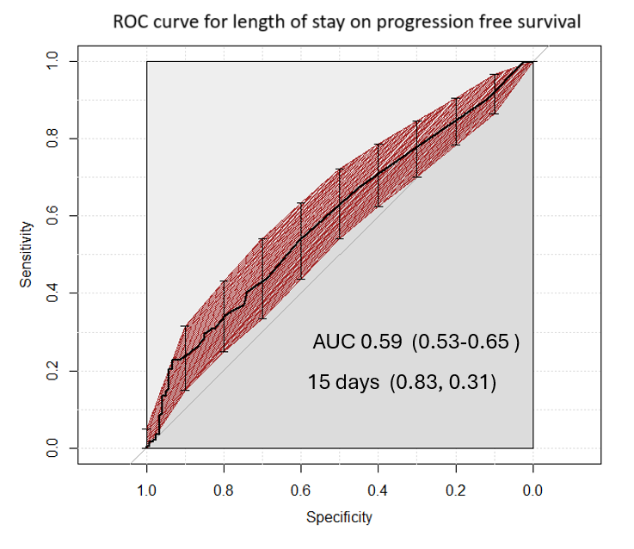 | B. | 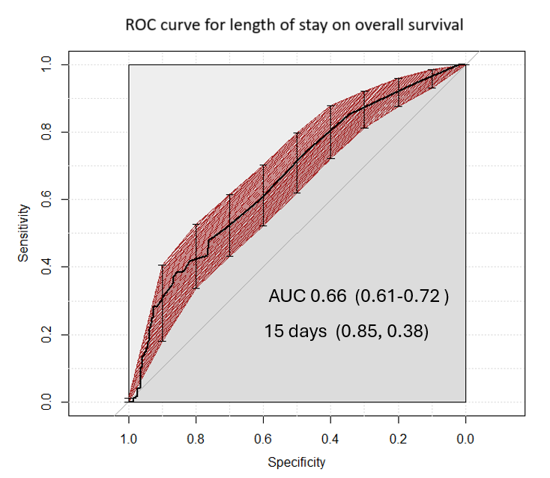
Legend: ROC curves calculated for LOS>15d as a predictor for (A) PFS and (B) OS.

Supplemental Figure 2. PFS according to LOS groups.
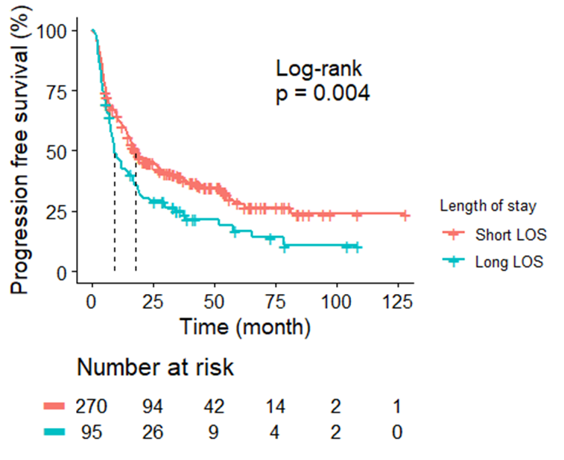

Supplemental Figure 3. KPS distribution in the cohort and LOS within the KPS strata
 | 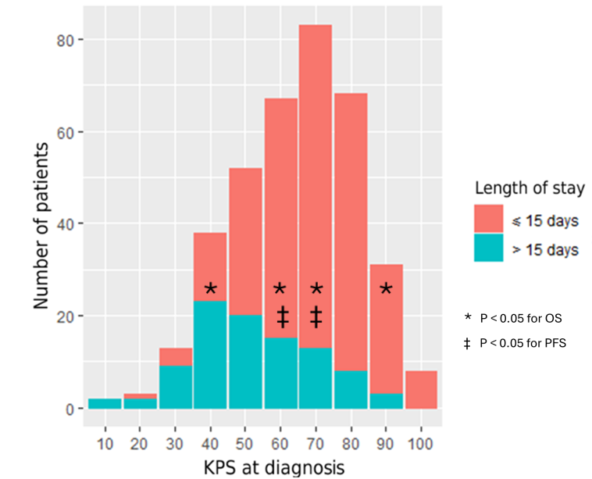 |  | 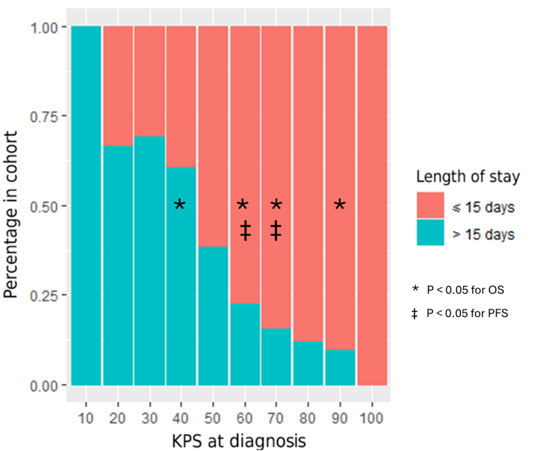
Legend: KPS distribution in the cohort and statistical significance of LOS on OS and/or PFS within each statrum. A. The number of patients of each LOS group is indicated as an absolute value. B. The percentage of each LOS group is indicated as a proportion of each stratum.

