Supplementary Information

sTable1 Multivariate analysis of association between candidate risk factors and complete response
Candidate prognostic factors | Comparison | Odds ratio | 95%CI | P value
Age | 61-74 vs ≤60 | 2.633 | 0.211 to 32.867 | 0.453
 | ≥75 vs ≤60 | 0.331 | 0.039 to 2.816 | 0.312
Chemotherapy | With versus without | 13.383 | 1.159 to 154.482 | 0.038

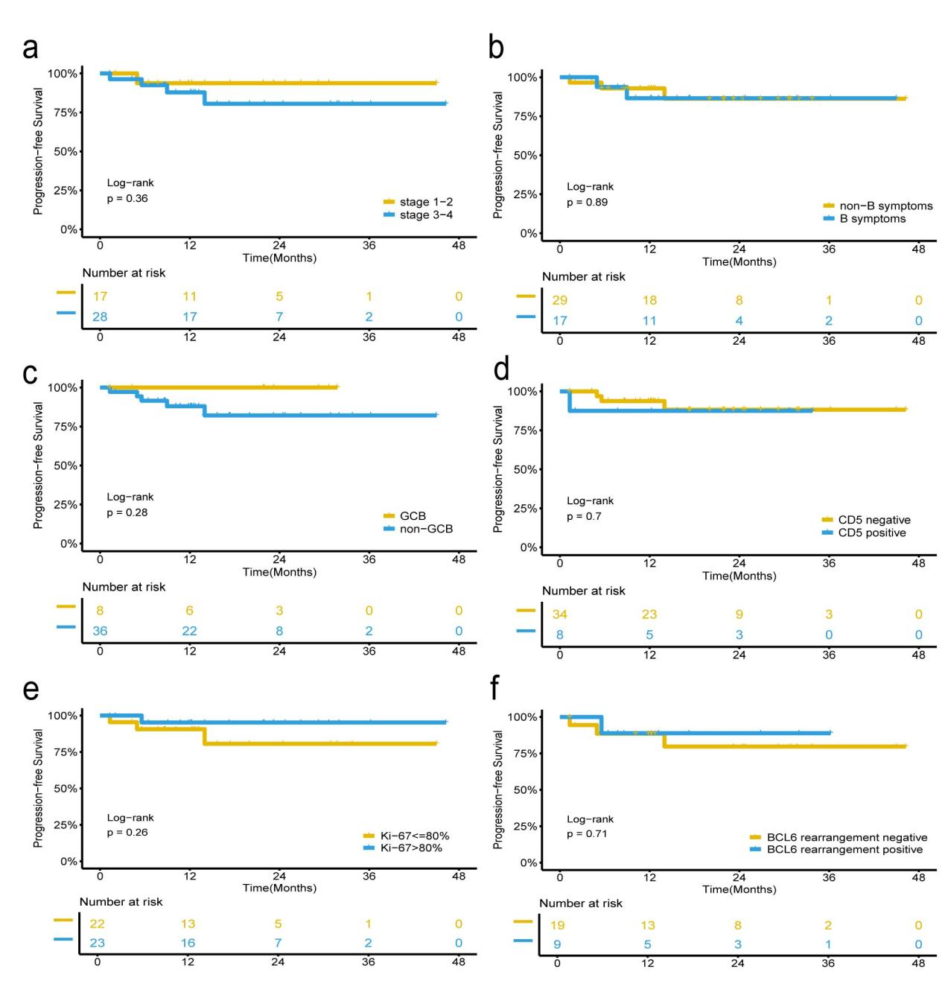
sFig.1 PFS varied across different groups stratifications. (a) Ann Arbor stage; (b) B symptoms; (c) cell of origin; (d) CD5; (e) Ki-67; (f) BCL6 rearrangement

