SUPPLEMENTAL INFORMATION FOR:
Frequent TCR Rearrangements in Pediatric B-cell Acute lymphoblastic leukemia: Genomic and Phenotypic Features
Jiajia Zheng^{1*}, Yiting Wang^{2,3*}, Zhiheng Li^{4*}, Peifang Xiao^{1*}, Jun Lu^{1*}, Hu Liu⁵，Yixin Hu^{1,5}, Shuiyan Wu⁶, Bohan Li¹, Li Gao¹, Qi Ji¹, Hailong He¹, Yi Wang¹, Jie Li¹, Nan Chen^{2,3},Lijun Meng^{2,3}, Yuanyuan Tian⁴, Yizhen Li⁵, Sheng Xiao⁷, Shaoyan Hu^{1,5}
¹Department of Hematology & Oncology, Children’s Hospital of Soochow University, Suzhou, China,215000,²Advanced Molecular Pathology Institute of Soochow University and SANO, Suzhou, China,215123,³Suzhou Sano Precision Medicine Ltd, Suzhou, China,215123,⁴Pediatric Clinical Research Institute, Children’s Hospital of Soochow University, Suzhou, China,215000,⁵Jiangsu Pediatric Hematology & Oncology Center, Suzhou, China, 215000,⁶Department of Intensive Care Unit, Children’s Hospital of Soochow University, Suzhou, China,215000,⁷Department of Pathology, Brigham and Women's Hospital, Harvard Medical School, Boston, MA, 02115, USA
*Equal first authorship
Supplemental Material and Methods
Patients: This study contained 97 continuous pediatric patients diagnosed with B-ALL at the Children's Hospital of Soochow University from June 2023 to January 2024. Informed consent was obtained from all patients following the institutional guidelines.
Diagnosis: All patients underwent standard MICM diagnostic procedures on bone marrow specimens, which included cytomorphology by bone marrow smear, immunophenotyping by flow cytometry, chromosome aberration analysis by karyotyping (R-banding), targeted DNA NGS, and transcriptome analysis. The diagnosis was established in accordance with the criteria specified in the 5th edition of the WHO Classification of Hematolymphoid Tumors.
Risk assessment: Patients with B-ALL aged 1 to <10 years were classified as low-risk (LR) if they met the following criteria: leukocyte count <50 × 10⁹/L, hyperdiploid karyotype, or the presence of ETV6::RUNX1 fusion, and no central nervous system (CNS) or testicular involvement. Additionally, minimal residual disease (MRD) <1× 10⁻² on day 19 and <1× 10⁻⁴ on day 46 of induction were required. High-risk (HR) patients included those with leukocyte count ≥300 × 10⁹/L, the TCF3::HLF fusion, MRD ≥1× 10⁻² (or ≥5% blasts without suitable markers) on day 46, or infants <6 months with KMT2A rearrangement. Patients not meeting the LR or HR classifications criteria are classified as intermediate-risk (IR).
Treatment: All patients received dexamethasone for the first 4 days, a combination of methylprednisone, daunorubicin, vincristine, and perasparaginase from days 5-28, and a combination of cyclophosphamide, 6-mercaptopurine, and cytarabine from days 29-35. Patients with ≥1× 10⁻⁴ MRD on day 19 received additional cycle of cyclophosphamide, 6-mercaptopurine, vincristine, cytarabine, and perasparaginase from days 50 to 57. Consolidation therapy included four courses of methotrexate and daily 6-mercaptopurine (Table S2). All patients underwent intrathecal therapy for prophylactic prevention of CNS leukemia, with no cranial irradiation administered (Table S3).
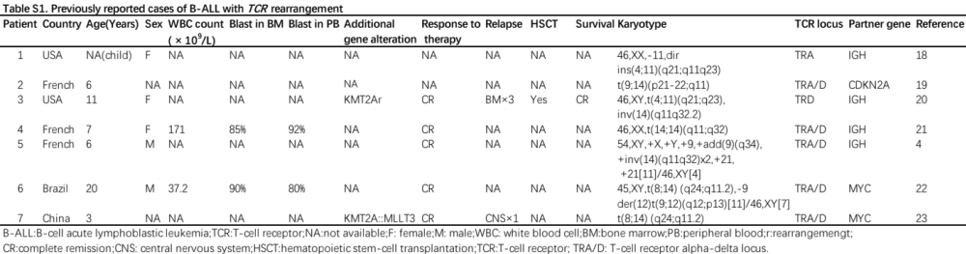
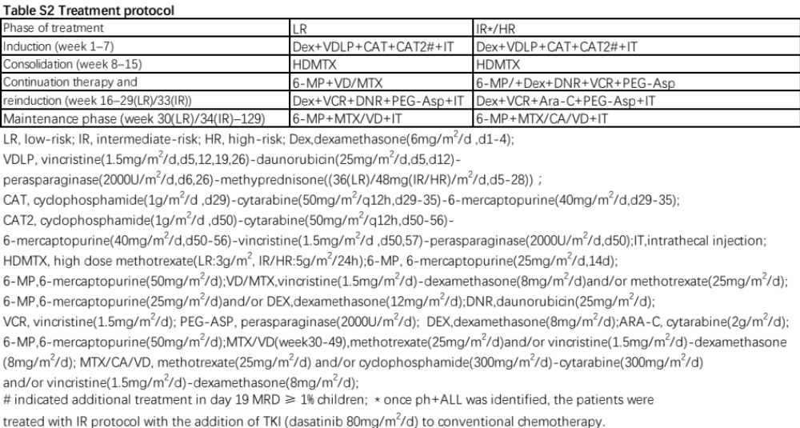

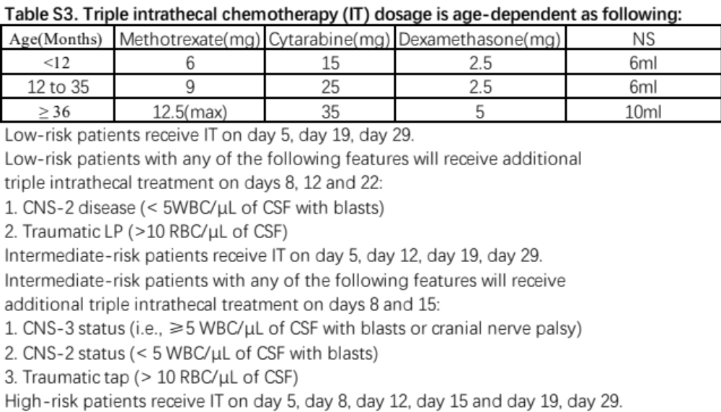
Supplemental Figure
Figure S1. Immunophenotypic characteristics of B-ALL patients with TRA/D rearrangement. Typical histograms showing CD3, CD10, CD19, CD20, CD22, cCD79a, CD13, CD33, and CD34 expression levels indicated as a positive rate (%). X-axis represents fluorescence intensity; Y-axis represents relative cell number;
Reference
- Yang W, Cai J, Shen S, et al. Pulse therapy with vincristine and dexamethasone for childhood acute lymphoblastic leukaemia (CCCG-ALL-2015): an open-label, multicentre, randomised, phase 3, non-inferiority trial. Lancet Oncol. 2021 Sep;22(9):1322-1332.

