Supplementary Figures

Supplementary Figure S1: Successfully detected translocations in the Run 3 (Cas9 read-out approach without multiplexing). This run provides a clear demonstration of sufficient coverage in target regions and unambiguously mapped reads, allowing for exact breakpoint localization (see Supplementary Table S4). Linked reads are colored with the same color; grey represents unlinked reads. Translocations IGH::BCL2, IGH::MYC, and IGH::CCND1 are shown.
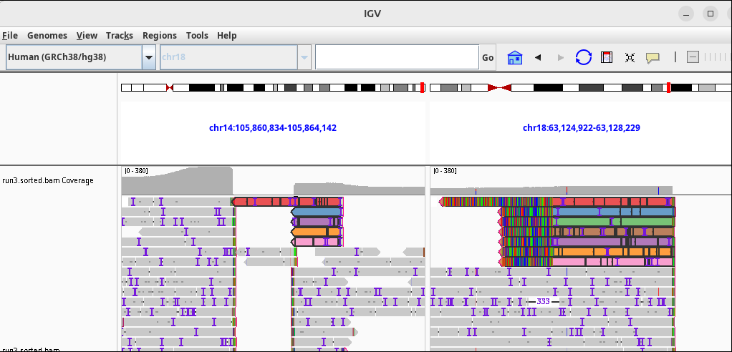
IGH::BCL2

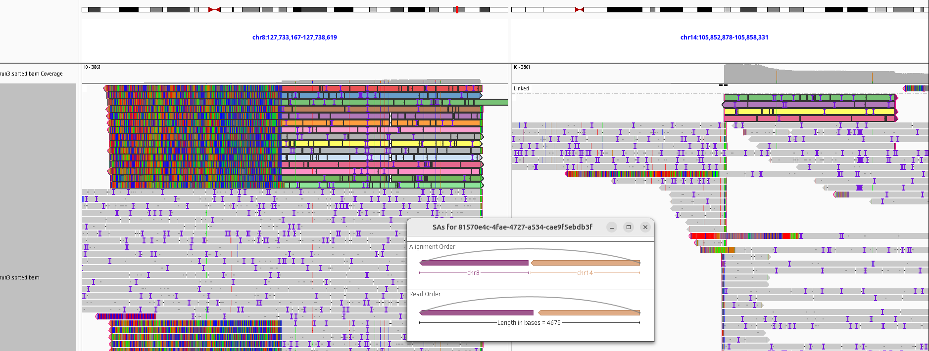
IGH::MYC
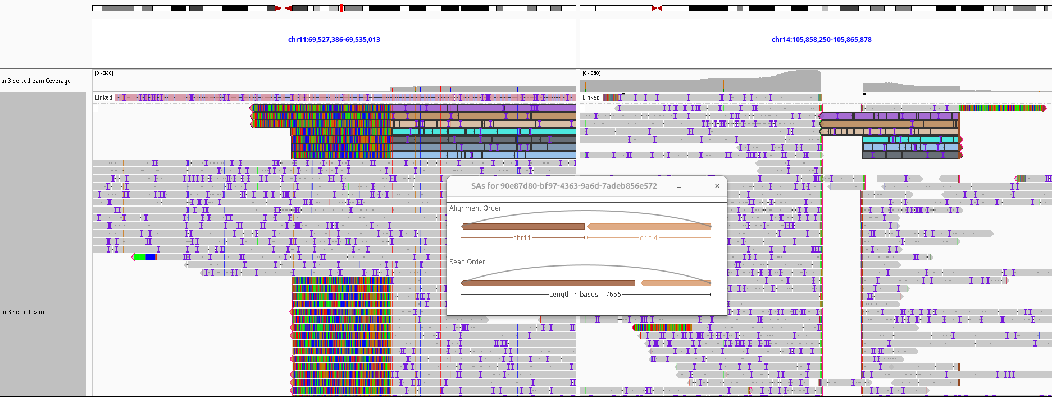
IGH::CCND1

Supplementary Figure S2: Failure to detect translocations in the Run 6 (adaptive sampling with barcoding). The overall coverage was generally low in this run, hampering the breakpoint detection. (A) An example of the MAVER-1 cell line with the barcode BC13 (in red frame), where no reads supporting the expected IGH::CCND1 translocation were present; (B) Even the identified IGH::MYC translocation in the Ramos cell line (BC11) is supported by only two out of three total reads.
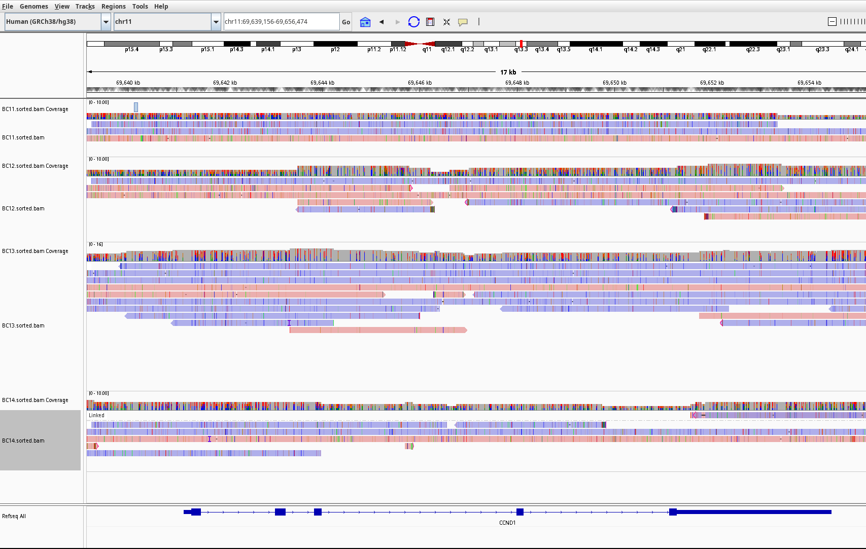
(A)
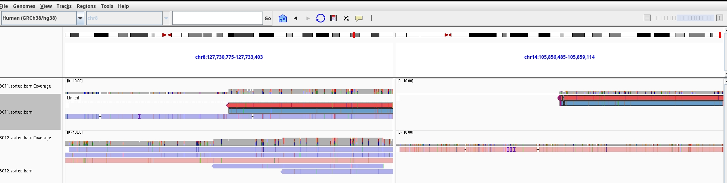
(B) IGH::MYC
Supplementary Figure S3: Uneven coverage across the samples in the Run 7 (adaptive sampling with barcoding). Although the samples were pooled in an equimolar fashion throughout the experiments, uneven read counts can be observed among samples within a single run. Here is an example of the cell line Granta-452 (BC23, in the red frame), where no reads supporting IGH::BCL2 translocation were found.

