Supplemental Figure 1
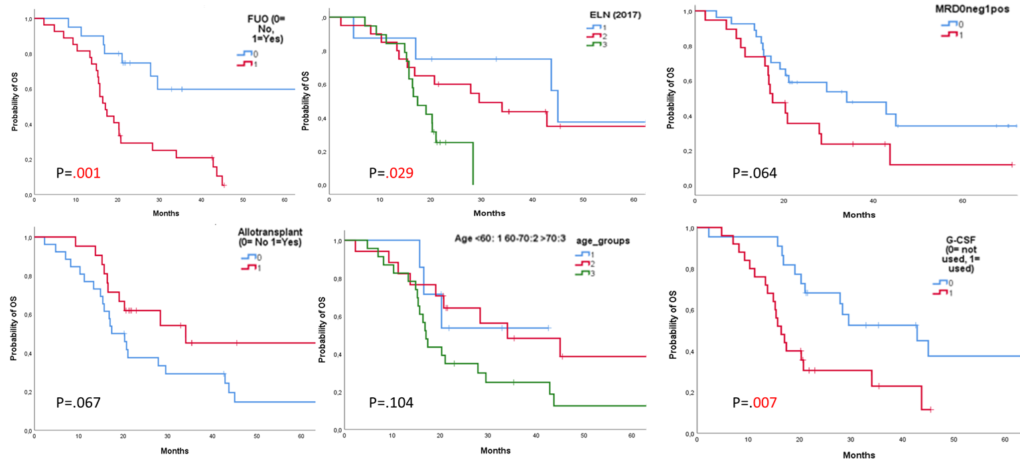
Kaplan-Meier curves for overall survival (OS) stratified by: (Top left) FUO: Patients experiencing febrile episodes of unknown origin (FUO), 1= red curve, had significantly worse OS (p = 0.001); (Top middle) ELN 2017 risk groups (1=favorable, 2=intermediate, 3=adverse): OS was significantly different across ELN risk groups (p = 0.029); (Top right) MRD positivity after IDAC trended toward inferior OS (p = 0.064); (Bottom left) Allogeneic transplant: Patients who received an allogeneic transplant showed a non-significant trend toward worse OS (p = 0.067); (Bottom middle) Age group (1= <60 years, 2= between 60-70 years, and 3= >70 years): OS differed across age categories, although not significantly (p = 0.104); (Bottom right) G-CSF usage: Use of G-CSF post-consolidation was associated with significantly worse OS (p = 0.007).
Abbreviations: OS, overall survival; FUO, febrile episode of unknown origin; MRD, measurable residual disease; ELN, European LeukemiaNet risk (1=Favorable, 2=Intermediate, 3=Adverse); G-CSF, granulocyte colony-stimulating factor.
Supplemental Figure 2
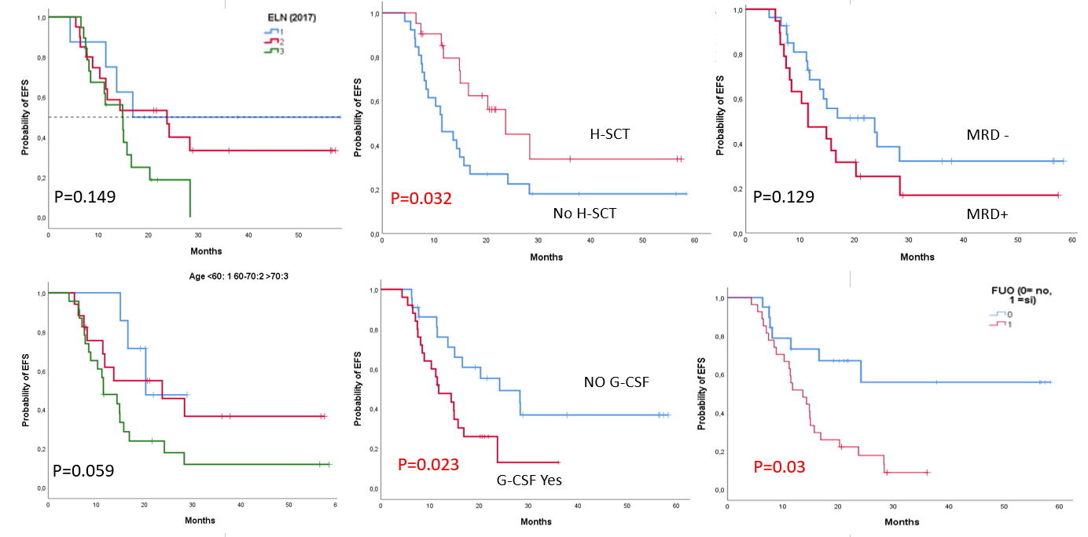

Kaplan-Meier curves for Event-free survival (EFS) stratified by: (Top left) ELN 2017 risk groups (1=favorable, 2=intermediate, 3=adverse); (Top middle) Allogeneic transplant: Patients who received an allogeneic transplant showed a non-significant trend toward worse EFS (p = 0.032); (Top right) MRD positivity after IDAC trended toward inferior OS (p = 0.129); (Bottom left); Age group: EFS differed across age categories, although not significantly (p = 0.059); (Bottom middle) G-CSF usage: Use of G-CSF post-consolidation was associated with significantly worse OS (p = 0.007) (Bottom right) Patients experiencing febrile episodes of unknown origin (FUO), 1= red curve, had significantly worse EFS (p = 0.003).
Abbreviations: EFS, Event-free survival; FUO, febrile episode of unknown origin; MRD, measurable residual disease; ELN, European LeukemiaNet risk (1=Favorable, 2=Intermediate, 3=Adverse); G-CSF, granulocyte colony-stimulating factor; H-SCT, Hematopoietic Stem Cell Transplantation.

Supplemental Figure 3

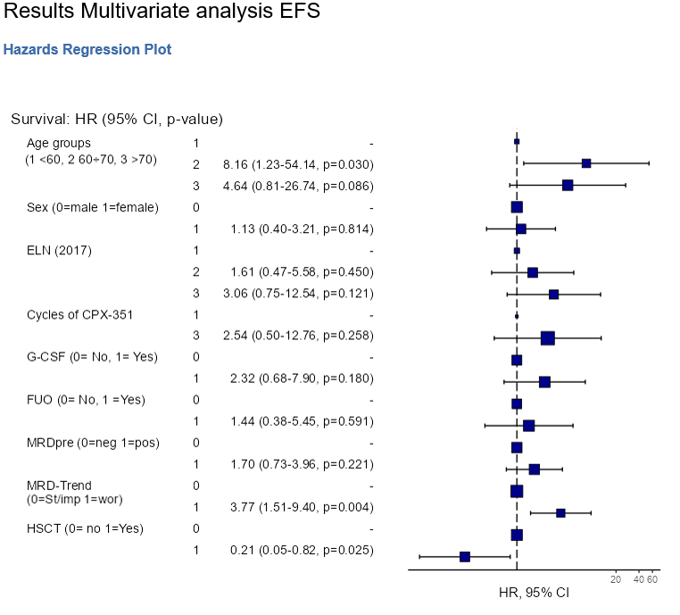
A forest plot showing hazard ratios referred to EFS of age sub-groups (<60 years, between 60-70 years, and >70 years), Sex, ELN-2017(Favorable, Intermediate, Adverse), the number of cycles of CPX-351 received before IDAC, usage of G-CSF, onset of FUO, Allotransplant (HSCT), MRD status before IDAC, and MRD trending after IDAC (0 stable or improved, 1 worsened). Blue dots indicate the mean HR, the horizontal lines represent the IC95%.
Abbreviations: EFS, Event-free survival; FUO, febrile episode of unknown origin; MRD, measurable residual disease; ELN, European LeukemiaNet; G-CSF, granulocyte colony-stimulating factor; HSCT, Hematopoietic Stem Cell Transplantation.

Supplemental Materials.

Measurable residual disease (MRD) Methods
MRD was evaluated before and after the cycle of IDAC according to ELN MRD recommendations using an 8-multiparametric flow cytometry (MFC) assay with a sensitivity of 10⁻³ to 10⁻⁵. We used leukemia-associated immunophenotype (LAIP) and different-from-normal aberrant immunophenotype approaches to evaluate MFC MRD. (Negativity considered <0.1%). In the presence of a molecular marker of MRD, assessment was performed using real-time quantitative PCR with a sensitivity of 10⁻⁴ to 10⁻⁶ [1].

1. Heuser M, Freeman SD, Ossenkoppele GJ, et al (2021) 2021 Update on MRD in acute myeloid leukemia: a consensus document from the European LeukemiaNet MRD Working Party. Blood 138:2753–2767. https://doi.org/10.1182/blood.2021013626

Supplemental Table 1. Results of univariate analysis for OS, calculated from the time of starting HDAC.

Dependent: Surv(mytime, myoutcome) |  | HR (univariable) | HR (multivariable)
age groups 1<60, 2 60-90, 3>70 | 1 | - | -
 | 2 | 1.88 (0.40-8.81, p=0.423) | 1.92 (0.36-10.13, p=0.444)
 | 3 | 3.83 (0.89-16.53, p=0.072) | 4.64 (0.79-27.21, p=0.089)
sex 0 Male 1 Female | 0 | - | -
 | 1 | 0.94 (0.45-1.96, p=0.872) | 1.17 (0.49-2.82, p=0.721)
Nr. Cycles of CPX-351 | 1 | - | -
 | 3 | 1.04 (0.31-3.47, p=0.950) | 1.10 (0.21-5.80, p=0.912)
ELN (2017) 1 fav; 2 interm. 3 adv. | 1 | - | -
 | 2 | 1.57 (0.50-4.91, p=0.438) | 2.63 (0.69-10.03, p=0.156)
 | 3 | 3.65 (1.10-12.08, p=0.034) | 4.59 (1.14-18.55, p=0.032)
G-CSF (0= not used, 1= used) | 0 | - | -
 | 1 | 2.80 (1.30-6.01, p=0.008) | 1.39 (0.45-4.34, p=0.570)
NF/FUO (0= no, 1 =yes) | 0 | - | -
 | 1 | 3.78 (1.67-8.57, p=0.001) | 3.31 (0.85-12.83, p=0.084)
MRDpre 0=neg 1=pos | 0 | - | -
 | 1 | 1.96 (0.93-4.15, p=0.077) | 2.12 (0.85-5.29, p=0.108)
MRD trending: Stable 0 worsened 1 | 0 | - | -
 | 1 | 1.81 (0.88-3.75, p=0.110) | 1.54 (0.70-3.41, p=0.286)
Allotransplant (0= no 1=yes) | 0 | - | -
 | 1 | 0.46 (0.21-1.01, p=0.053) | 0.49 (0.15-1.62, p=0.246)

Supplemental Table 2. Results of univariate analysis for EFS, calculated from the time of starting HDAC.
Dependent viables |  | HR (univariable) | HR (multivariable)
age groups 1<60, 2 60-90, 3>70 | 1 | - | -
 | 2 | 2.69 (0.57-12.60, p=0.210) | 8.75 (1.40-54.70, p=0.020)
 | 3 | 5.03 (1.16-21.78, p=0.031) | 4.81 (0.82-28.22, p=0.082)
sex 0 Male 1 Female | 0 | - | -
 | 1 | 0.86 (0.41-1.79, p=0.686) | 1.17 (0.43-3.18, p=0.761)
Nr. Cycles of CPX-351 | 1 | - | -
 | 3 | 1.64 (0.50-5.41, p=0.418) | 3.05 (0.64-14.68, p=0.164)
ELN (2017) 1 fav; 2 interm. 3 adv. | 1 | - | -
 | 2 | 1.30 (0.42-4.03, p=0.653) | 1.77 (0.52-6.07, p=0.364)
 | 3 | 2.39 (0.78-7.32, p=0.128) | 3.46 (0.85-14.08, p=0.083)
G-CSF (0= not used, 1= used) | 0 | - | -
 | 1 | 2.43 (1.12-5.30, p=0.025) | 2.11 (0.58-7.65, p=0.254)
NF/FUO (0= no, 1 =yes) | 0 | - | -
 | 1 | 3.31 (1.46-7.52, p=0.004) | 1.60 (0.43-5.96, p=0.484)
MRDpre 0=neg 1=pos | 0 | - | -
 | 1 | 1.51 (0.73-3.13, p=0.265) | 1.47 (0.63-3.39, p=0.371)
MRD trending: Stable 0 worsened 1 | 0 | - | -
 | 1 | 1.73 (0.84-3.57, p=0.137) | 3.85 (1.51-9.82, p=0.005)
Allotransplant (0= no 1=yes) | 0 | - | -
 | 1 | 0.42 (0.19-0.93, p=0.032) | 0.2 (0.05-0.75, p=0.017)

