Supplementary Materials for
TP53 mutation predict poor prognosis in diffuse large B-cell lymphoma: A single-center study

Haiyan Zhang¹ ², Xiang Zhang² ³ ⁴ ⁵, Jinghan Wang² ³ ⁴ ⁵, Xuewu Zhang² ³ ⁴ ⁵, Yunfei Lv²³ ⁴ ⁵, Yanan Zhu² ³ ⁴ ⁵, Xingnong Ye² ³ ⁴ ⁵, Juying Wei²³ ⁴ ⁵, Min Yang² ³ ⁴ ⁵, Gaixiang Xu² ³ ⁴ ⁵, Chunmei Yang² ³ ⁴ ⁵, Haitao Meng² ³ ⁴ ⁵, Wanzhuo Xie² ³ ⁴ ⁵, Jie Jin² ³ ⁴ ⁵, Hongyan Tong^{*2 3 4 5}, Wenjuan Yu^{*2 3 4 5}.

† Correspondence to:Wenjuan Yu and Hongyan Tong,
Department of Hematology, The First Affiliated Hospital, Zhejiang University School of Medicine, Hangzhou, 310000, China.
Email:drwjyu1977@zju.edu.cn and tonghongyan@zju.edu.cn

This PDF file includes:
Supplementary Figures (Figure S1-S2)
Supplementary Tables (Table S1, S4-S8)
Other Supplementary Materials for this manuscript include the following (separate file):
Supplemental Table S2. The characteristics of the TP53 mutations.
Supplemental Table S3. Clinical and pathological features of the 444 DLBCL patients.

Supplemental Table S1 All genes tested in this study.
ARID1A | ARID1B | ASXL3 | ATM | B2M | BCL2
BCL6 | BCOR | BIRC3 | BRAF | BTK | CARD11
CBL | CCND1 | CCND3 | CCR4 | CCR7 | CD28
CD58 | CD79B | CDKN1B | CDKN2A | CDKN2B | CREBBP
CTNNB1 | CXCR4 | DDX3X | DNMT3A | DUSP2 | EP300
EPHA7 | EZH2 | FAS | FYN | GATA3 | GNA13
GNAI2 | HNRNPA2B1 | ID3 | IDH1 | IDH2 | INO80
INPP5D | IRF4 | ITPKB | JAK1 | JAK3 | JUNB
KIT | KLF2 | KMT2D | MAP2K1 | MAPK1 | MEF2B
MFHAS1 | MYC | MYD88 | NOTCH1 | NOTCH2 | NRAS
PAX5 | PIK3CD | PIM1 | PLCG1 | PLCG2 | POT1
PRDM1 | PRKCB | PTEN | PTPN1 | RHOA | RRAGC
SETD2 | SF3B1 | SGK1 | SH2D1A | SMARCA4 | SOCS1
STAT3 | STAT5B | STAT6 | TCF3 | TET2 | TET3
TNFAIP3 | TNFRSF14 | TNFRSF1B | TP53 | VAV1 | XPO1
ACTB | ALK | ARID2 | ATP6AP1 | ATP6V1B2 | BCL7A
BCORL1 | BIRC6 | BTG1 | BTG2 | CARMIL2 | CD70
CD79A | CD83 | CHD2 | CIITA | CNOT3 | CSF2RB
CSNK1A1 | DDX41 | DTX1 | EGR1 | EGR2 | ERBB4
FAT1 | FBXO11 | FBXW7 | FOXO1 | GTF2I | HIST1H1B
HIST1H1C | HIST1H1D | HIST1H1E | HIST1H2AC | HIST1H2AM | HIST1H2BC
HIST1H2BK | HIST1HЗB | HIST1H3D | HIST1HЗH | HIST1H3J | HIST1H4E
HIST1H4J | HIST2H2BE | HVCN1 | IGLL5 | IKZF1 | IL4R
IL7R | IRF2BP2 | IRF8 | KDM6A | KLHL14 | KLHL6
KMT2C | KRAS | LYN | MAP3K14 | MED12 | MGA
MLH1 | MPEG1 | MS4A1 | MSH2 | MSH6 | MTOR
NF1 | NFKBIA | NFKBIE | NSD2 | P2RY8 | PCB1
PHF6 | PIK3CA | PIK3R1 | PMS2 | POU2AF1 | POU2F2
PPM1D | PRF1 | PRPS1 | PTPN6 | PTPRD | RB1
ROBO1 | RPS15 | S1PR2 | SAMHD1 | SMARCB1 | SMC1A
SPEN | SRCAP | TBL1XR1 | TFAP4 | TLR2 | ТМЕМЗ0А
TMSB4X | TRAF2 | TRAF3 | UBE2A | UNC13D | USP7
VMA21 | XIAP | ZFP36L1 | ZMYM3 | ZNF217

Supplemental Table S4 Clinical and pathological features of DLBCL patients TP53 wt, TP53 mut and overall
Characteristics | TP53 wt  (n=335) | TP53 mut  (n=109) | P | Overall  (n=444)
gender |  |  | 0.536
Male, n (%) | 173 (51.6) | 60 (55.0) |  | 233(52.5)
Female, n (%) | 162 (48.4) | 49 (45.0) |  | 211 (47.5)
Age, Median (IQR) |  |  | 0.027 | 61 (50-69)
≤ 60yrs, n (%) | 176 (52.5) | 44 (40.4) |  | 220 (49.5)
> 60yrs, n (%) | 159 (47.5) | 65 (59.6) |  | 224 (50.5)
ECOG* |  |  | 0.187
＜ 2, n (%) | 252 (75.2) | 75 (68.8) |  | 327 (73.6)
≥ 2, n (%) | 83 (24.8) | 34 (31.2) |  | 117 (26.4)
LDH*, Median (IQR) |  |  | 0.027
Elevated, n (%) | 159 (47.5) | 65 (59.6) |  | 224 (50.5)
normal, n (%) | 176 (52.5) | 44 (40.4) |  | 220 (49.5)
Ann Arbor stage |  |  | 0.058
I-II, n (%) | 101 (30.6) | 43 (40.6) |  | 144 (33.0)
III-IV, n (%) | 229 (69.4) | 63 (59.4) |  | 292 (67.0)
Unknown | 5 | 3 |  | 8
Extranodal involvement |  |  | 0.290
≤1, n (%) | 215 (64.2) | 76 (69.7) |  | 291 (65.5)
＞1, n (%) | 120 (35.8) | 33 (30.3) |  | 153 (34.5)
IPI* |  |  | 0.468
0-1, n (%) | 101 (30.6) | 35 (33.0) |  | 136 (31.2)
2, n (%) | 71 (21.5) | 19 (17.9) |  | 90 (20.6)
3, n (%) | 84 (25.5) | 22 (20.8) |  | 106 (24.3)
4-5, n (%) | 74 (22.4) | 30 (28.3) |  | 104 (23.9)
Unknown | 5 | 3 |  | 8
B symptom |  |  | 0.961
Yes, n (%) | 93 (27.8) | 30 (27.5) |  | 123 (27.7)
No, n (%) | 242 (72.2) | 79 (72.5) |  | 321 (72.3)
bulky disease (≥7.5cm) |  |  | 0.180
Yes, n (%) | 21 (6.3) | 11 (10.1) |  | 32 (7.2)
No, n (%) | 314 (93.7) | 98 (89.9) |  | 412 (92.8)
Bone marrow infiltration |  |  | 0.775
Yes, n (%) | 53 (15.8) | 16 (14.7) |  | 69 (15.5)
No, n (%) | 282 (84.2) | 93 (85.3) |  | 375 (84.5)
MYC high-expression |  |  | 0.002
Yes, n (%) | 159 (51.6) | 73 (68.9) |  | 232 (56.0)
No, n (%) | 149 (48.4) | 33 (31.1) |  | 182 (44.0)
Unknown | 27 | 3 |  | 30
BCL-2 high-expression
Yes, n (%) | 255 (78.9) | 78 (72.7) | 0.149 | 333 (77.3)
No, n (%) | 68 (21.1) | 30 (27.8) |  | 98 (22.7)
Unknown | 12 | 1 |  | 13
DEL* |  |  | 0.021
Yes, n (%) | 123 (39.5) | 56 (52.3) |  | 179 (42.8)
No, n (%) | 188 (60.5) | 51 (47.7) |  | 239 (57.2)
Unknown | 24 | 2 |  | 26
Hans classification |  |  | 0.161
GCB, n (%) | 107 (32.1) | 43 (39.4) |  | 150 (33.9)
non-GCB, n (%) | 226 (67.9) | 66 (60.6) |  | 292 (66.1)
Unknown | 2 | 0 |  | 2
Ki67 |  |  | 0.172
highly expressed, n (%) | 203 (61.5) | 73 (68.9) |  | 276 (63.3)
non-highly expressed, n (%) | 127 (38.5) | 33 (31.1) |  | 160 (36.7)
Unknown, n (%) | 5 | 3 |  | 8
Relapsed/ Refractory disease |  |  | ＜0.001
Yes, n (%) | 87 (26.0) | 47 (43.5) |  | 134 (30.3)
No, n (%) | 247 (74.0) | 61 (56.5) |  | 308 (69.7)
Unknown | 1 | 1 |  | 2
ECOG, Eastern Cooperative Oncology Group performance status; LDH, lactate dehydrogenase; IPI, International Prognostic Index. DEL, double-expressor lymphomas; GCB, germinal center B-cell-like.Data are expressed as n(%) unless otherwise specified.
Supplementary Table S5 Univariate and multivariate analysis of OS and PFS in patients with DLBCL.
 |  | Univariate analysis | Multivariate analysis
 |  | P | P | HR | 95.0% CI
OS
 | TP53 mutation | ＜0.001 | ＜0.001 | 2.944 | 1.897-4.568
 | IPI > 2 | ＜0.001 | ＜0.001 | 4.185 | 2.371-7.389
 | B symptom | ＜0.001 | 0.007 | 1.848 | 1.182-2.889
 | bone marrow infiltration | ＜0.001 | 0.023 | 1.793 | 1.082-2.969
 | DEL | ＜0.001 | 0.025 | 1.653 | 1.065-2.564
 | bulky disease( ≥7.5cm) | 0.499 | -
 | Hans classification | 0.168 | -
 | Ki67 high-expression | 0.637 | -
PFS
 | TP53 mutation | ＜0.001 | ＜0.001 | 2.384 | 1.636-3.474
 | IPI > 2 | ＜0.001 | ＜0.001 | 5.148 | 3.140-8.442
 | B symptom | ＜0.001 | 0.004 | 1.750 | 1.200-2.552
 | bone marrow infiltration | ＜0.001 | 0.007 | 1.763 | 1.165-2.668
 | DEL | 0.013 | 0.309 | 1.208 | 0.839-1.739
 | bulky disease( ≥7.5cm) | 0.118 | -
 | Hans classification | 0.804 | -
 | Ki67 high-expression | 0.284 | -
IPI, International Prognostic Index. DEL, double-expressor lymphomas.
- Variables not included in the multivariable model due to non-significance (P > 0.1) in univariable analysis.

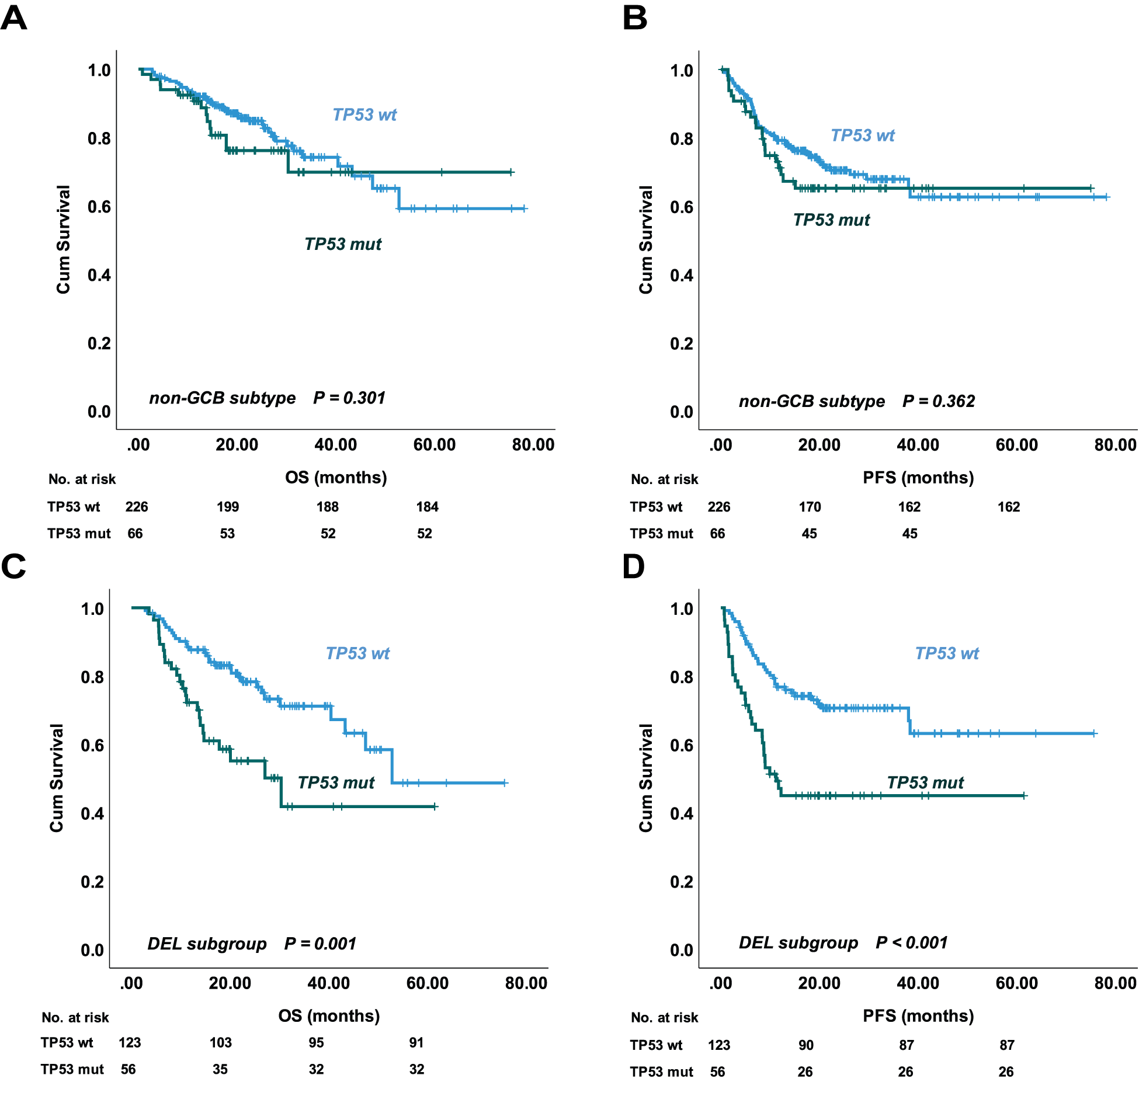
Supplemental Fig. S1 Prognostic impact of TP53 mutation in additional DLBCL subgroups (non-GCB and DEL). (A) Overall survival analysis of TP53 mutation in patients with non-GCB-DLBCL. (B) Progression-free survival analysis of TP53 mutation in patients with non-GCB-DLBCL. (C) Overall survival analysis of TP53 mutation in patients with DEL. (D) Progression-free survival analysis of TP53 mutation in patients with DEL.

Supplementary Table S6 Multivariable Cox Regression Analysis for OS and PFS in patients with DLBCL, Including the interaction between TP53 mutation and DEL.
OS |  | HR | 95.0% CI | P
 | TP53 mutation | 3.946 | 1.967-7.918 | < 0..001
 | IPI > 2 | 5.520 | 3.194-9.541 | < 0.001
 | GCB subtype (vs. non-GCB) | 1.476 | 0.949-2.295 | 0.084
 | DEL | 2.266 | 1.274-4.031 | 0.005
 | TP53 mutation × DEL | 0.560 | 0.231-1.354 | 0.198
PFS
 | TP53 mutation | 1.998 | 1.115-3.581 | 0.020
 | IPI > 2 | 6.700 | 4.168-10.772 | < 0.001
 | GCB subtype (vs. non-GCB) | 1.271 | 0.866-1.866 | 0.220
 | DEL | 1.200 | 0.760-1.896 | 0.434
 | TP53 mutation × DEL | 1.250 | 0.581-2.688 | 0.568
IPI, International Prognostic Index; DEL, double-expressor lymphomas; GCB, germinal center B-cell-like.

Supplemental Fig. S2 Prognostic impact of specific TP53 mutational characteristics (A) Overall survival analysis of TP53 DNA-binding domains (DBD) and non-DBD mutation. (B) Progression-free survival analysis of TP53 DBD and non-DBD mutation. (C) Overall survival analysis of TP53 single-site and multiple-site mutations in DLBCL. (D) Progression-free survival analysis of TP53 single-site and multiple-site mutations. (E) Overall survival analysis of TP53 gain-of-function (GOF) and loss-of-function (LOF) mutations. (F) Progression-free survival analysis of TP53 GOF and LOF mutations. (G) Overall survival analysis according to TP53 mutation variant allele frequency (VAF). (H) Progression-free survival analysis according to TP53 mutation VAF.
Supplementary Table S7 Univariable and Multivariable Cox Proportional Hazards Analyses for OS and PFS in DLBCL patients with TP53 mutation (n=109).
 |  | Univariate analysis | Multivariate analysis
 |  | P | P | HR | 95.0% CI
OS
 | IPI > 2 | ＜0.001 | 0.001 | 6.380 | 2.174 - 18.725
 | GCB subtype (vs. non-GCB) | ＜0.001 | ＜0.001 | 4.028 | 1.843 - 8.801
 | VAF ≥ 53% | 0.002 | 0.074 | 2.005 | 0.935 - 4.302
 | DEL | 0.212 | -
 | DBD (vs. non-DBD) mutations | 0.771 | -
 | single-site (vs. multiple-site) mutations | 0.810 | -
 | GOF (vs. LOF) mutations | 0.324 | -
PFS
 | IPI > 2 | ＜0.001 | ＜0.001 | 6.503 | 2.619 - 16.148
 | GCB subtype (vs. non-GCB) | 0.001 | 0.001 | 3.104 | 1.569 - 6.142
 | VAF ≥ 53% | ＜0.001 | 0.007 | 2.564 | 1.288 - 5.103
 | DEL | 0.043 | 0.434 | 1.319 | 0.659 - 2.642
 | DBD (vs. non-DBD) mutations | 0.445 | -
 | single-site (vs. multiple-site) mutations | 0.324 | -
 | GOF (vs. LOF) mutations | 0.326 | -
IPI, International Prognostic Index; DEL, double-expressor lymphomas.
- Variables not included in the multivariable model due to non-significance (P > 0.1) in univariable analysis.

Supplementary Table S8 Sensitivity analysis of survival outcomes after excluding Early treatment-related deaths in patients with TP53 mutation (n=108)
 | OS |  | PFS
 | P | HR (95.0% CI) | P | HR (95.0% CI)
IPI > 2 | 0.001 | 6.036 (2.050-17.778) | ＜ 0.001 | 6.503 (2.619-16.148)
GCB | ＜ 0.001 | 4.565 (2.034-10.246) | 0.001 | 3.104 (1.569-6.142)
VAF ≥ 53% | 0.044 | 2.232 (1.023-4.871) | 0.007 | 2.564 (1.288-5.103)
DEL | - | - | 0.434 | 1.319 (0.659-2.642)
IPI, International Prognostic Index; GCB, germinal center B-cell-like; VAF, variant allele frequency; DEL, double-expressor lymphomas.
- Variables not included in the multivariable model due to non-significance (P > 0.1) in univariable analysis.

