Supplementary Materials:
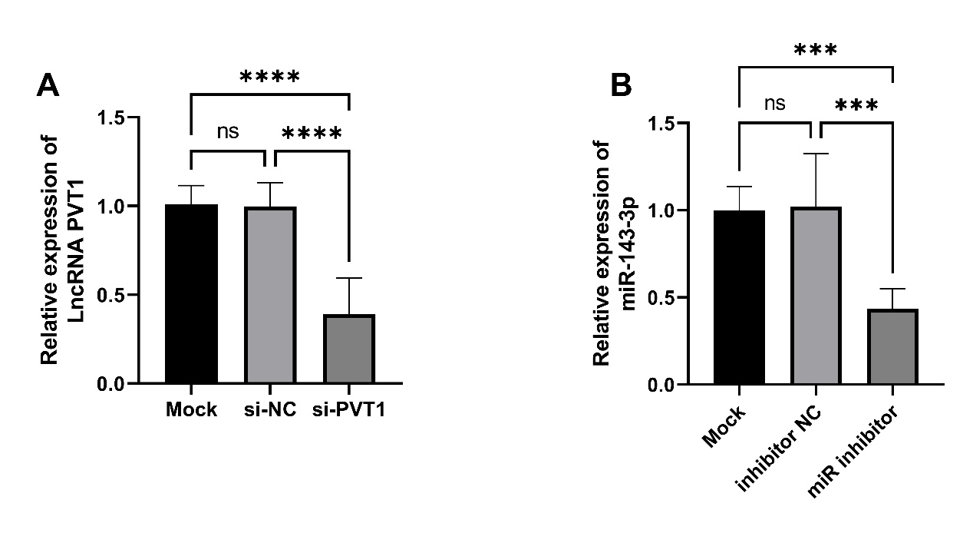
Supplementary Figure 1 Validation of si-PVT1 and miR inhibitor transfection efficiency. A. si-PVT1. B. miR-143-3p inhibitor. Mock: Untransfected group (blank control). si-NC: Negative control group.
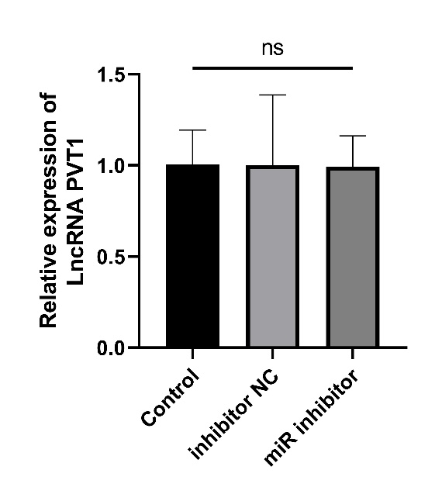
Supplementary Figure 2 Changes in LncRNA PVT1 expression in endothelial cells following transfection with miR inhibitor in the absence of si-PVT1.

