Supplementary Information

Real-world effectiveness of bortezomib maintenance following VMP induction in transplant-ineligible multiple myeloma: a target trial emulation study

Running title: Bortezomib maintenance therapy in Transplant-Ineligible NDMM

Jung Yeon Lee^{1,2,†}, Suein Choi^{3,4, †}, Seungpil Jung^{3,4}, Sung-Soo Park¹, Jin Seok Kim², Seung-Hwan Shin⁵, Young-Woo Jeon⁶, Seung-Ah Yahng⁷, Je-Jung Lee⁸, Hyo Jung Kim⁹, Gyeong-Won Lee¹⁰, Hyeon-Seok Eom¹¹, Min Kyoung Kim¹², Yundeok Kim¹³, Jihyun Kwon¹⁴, Chang-Ki Min^{1,*}; Korean Multiple Myeloma Working Party (KMMWP)
Contents
Supplementary Table 1: Summary of the target trial emulation protocol
……………………………………………………………… page 3
Supplementary Table 2: Baseline characteristics of the overall unmatched study cohort
……………………………………………………………… page 4
Supplementary Table 3: Sensitivity analysis
……………………………………………………………… page 5
Supplementary Table 4: Baseline characteristics of matched patients (< 70 years)
……………………………………………………………… page 6
Supplementary Table 5: Baseline characteristics of matched patients (≥70 years)
……………………………………………………………… page 7
Supplementary Figure 1: Love plot
………………………………………………………………page 8
Supplementary Figure 2: Forest plot for comparing overall survival (OS) of each group
………………………………………………………………page 9

Supplementary Table 1. Summary of the target trial emulation protocol
Component | Target trial specification | Target trial emulation
Eligibility criteria | Patients aged > 18 years with remaining progression-free for at least 60 days after completing 9th course of bortezomib-melphalan-prednisone (VMP) between August 2010 and May 2024. | Same as for the target trial
Treatment strategies | Case: Bortezomib maintenance therapy  Control: No bortezomib maintenance therapy | Same as for the target trial.
Treatment assignment | Patients are randomly assigned to a case or control treatment strategy at baseline are informed of this allocation. | Patients were evaluated for 60 days after completion of 9th VMP. Randomization was emulated by using a 1:1 propensity score matching.
Outcomes | 6-years mortality | Same as for the target trial
Follow-up | Follow-up commences at the start of eligibility criteria and continues until the death, six years from the baseline, or end of the study period, whichever occurs first. | Same as for the target trial
Causal contrasts | Intention-to-treat effect: the effect of being assigned to a given treatment strategy. | Observational analogue of intention-to-treat effect.
Statistical analysis | Survival rate using Kaplan-Meier survival curve; Hazard ratio (HR) for bortezomib maintenance therapy using Cox proportional hazard model. | Survival rate and HR were estimated via 1:1 propensity score matching.

Supplementary Table 2. Baseline characteristics of the overall unmatched study cohort
Characteristic | Overall  (N = 178) | Control  (N = 118) | Case  (N = 60) | P-value
Median follow-up, months (95% CI) | 63.9 (56.8, 69.2) | 72.0 (68.8, NA) | 51.5 (44.8, 61.5) | <0.001
Sex, n (%) |  |  |  | 0.269
Male | 101 (56.7%) | 63 (53.4%) | 38 (63.3%)
Female | 77 (43.3%) | 55 (46.6%) | 22 (36.7%)
Age, n (%) |  |  |  | 0.284
<70 | 61 (34.3%) | 44 (37.3%) | 17 (28.3%)
70-74 | 69 (38.8%) | 41 (34.7%) | 28 (46.7%)
$≥$75 | 48 (27.0%) | 33 (28.0%) | 15 (25.0%)
Heavy chain type, n (%) |  |  |  | 0.699
IgG | 100 (56.2%) | 50 (42.4%) | 32 (53.3%)
Non-IgG | 78 (43.8%) | 68 (57.6%) | 28 (46.7%)
Light chain type, n (%) |  |  |  | 0.540
Kappa | 98 (55.1%) | 66 (55.9%) | 32 (53.3%)
Lambda | 78 (43.8%) | 50 (42.4%) | 28 (46.7%)
Unknown | 2 (1.1%) | 2 (1.7%) | 0 (0.0%)
ISS stage, n (%) |  |  |  | 0.535
I | 40 (22.5%) | 23 (19.5%) | 17 (28.3%)
II | 69 (38.8%) | 49 (41.5%) | 20 (33.3%)
III | 64 (36.0%) | 43 (36.4%) | 21 (35.0%)
Unknown | 5 (2.8%) | 3 (2.5%) | 2 (3.3%)
$β^{2}$-microglobulin, mg/L, mean (SD) | 6.62 (6.09) | 6.55 (6.11) | 6.73 (6.10) | 0.858
Albumin, g/dL, mean (SD) | 3.47 (0.66) | 3.37 (0.63) | 3.66 (0.67) | 0.005
Lactate dehydrogenase $≥$ULN, n (%) | 69 (38.8%) | 35 (29.7%) | 34 (56.7%) | 0.001
Hemoglobin, g/dL, mean (SD) | 10.22 (1.71) | 9.60 (1.63) | 11.42 (1.14) | <0.001
Absolute neutrophil count, x 10⁹, mean (SD) | 2.98 (1.33) | 3.02 (1.46) | 2.92 (1.05) | 0.659
Absolute lymphocyte count, x 10⁹, mean (SD) | 1.46 (0.75) | 1.73 (0.77) | 0.95 (0.34) | <0.001
Platelet count, x 10⁹/L, mean (SD) | 188.84 (67.83) | 191.45 (72.70) | 183.78 (57.48) | 0.479
eGFR, mL/min/1.73m², n (%) |  |  |  | 0.030
<30 | 36 (20.2%) | 29 (24.6%) | 7 (11.7%)
<30-59 | 47 (26.4%) | 34 (28.8%) | 13 (21.7%)
$≥$60 | 95 (53.4%) | 55 (46.6%) | 40 (66.7%)
Cytogenetic abnormalities, n (%) |  |  |  | 0.010
Standard risk | 72 (40.4%) | 56 (47.5%) | 16 (26.7%)
High risk | 33 (18.5%) | 16 (13.6%) | 17 (28.3%)
Unknown | 73 (41.0%) | 46 (39.0%) | 27 (45.0%)
VMP induction response, n (%) |  |  |  | 0.033
PR | 43 (24.2%) | 25 (21.2%) | 18 (30.0%)
VGPR | 70 (39.3%) | 42 (35.6%) | 28 (46.7%)
CR/sCR | 65 (36.5%) | 51 (43.2%) | 14 (23.3%)
Abbreviations) CI = confidence interval, Ig = immunoglobulin, SD = standard deviation, IU = international unit, ULN = upper limit of normal, eGFR = estimated glomerular filtration rate, PR = partial response, VGPR = very good partial response, CR/sCR = complete response/stringent complete response

Supplementary Table 3. Sensitivity analysis for eligibility criteria and observation period
HR (95% CI) |  | Eligibility criteria
Follow-up period | Outcome | 30 days | 60-days | 90-days
4-year mortality | OS | 0.606 (0.321, 1.145) | 0.608 (0.302, 1.223) | 0.757 (0.373, 1.537)
4-year mortality | PFS | 0.397 (0.256, 0.616) | 0.457 (0.299, 0.697) | 0.407 (0.253, 0.656)
5-year mortality | OS | 0.640 (0.350, 1.170) | 0.654 (0.335, 1.277) | 0.809 (0.403, 1.624)
5-year mortality | PFS | 0.381 (0.250, 0.582) | 0.437 (0.292, 0.653) | 0.397 (0.249, 0.632)
6-year mortality | OS | 0.715 (0.396, 1.289) | 0.703 (0.385, 1.284) | 0.837 (0.429, 1.635)
6-year mortality | PFS | 0.381 (0.250, 0.582) | 0.437 (0.292, 0.653) | 0.391 (0.246, 0.623)
7-year mortality | OS | 0.702 (0.392, 1.259) | 0.696 (0.381, 1.271) | 0.816 (0.423, 1.573)
7-year mortality | PFS | 0.381 (0.250, 0.582) | 0.437 (0.292, 0.653) | 0.391 (0.246, 0.623)
Abbreviations) HR = Hazard ratio, CI = confidence interval, OS = Overall survival, PFS = Progression-free survival

Supplementary Table 4. Baseline characteristics of matched patients (< 70 years)
Characteristic | Overall  (N = 33) | Control  (N = 16) | Case  (N = 17) | P-value
Median follow-up, months (95% CI) | 67.2 (61.5, NA) | 72.0 (52.0, NA) | 63.9 (56.8, NA) | 0.040
Sex, n (%) |  |  |  | 0.792
Male | 23 (69.7%) | 12 (75.0%) | 11 (64.7%)
Female | 10 (30.3%) | 4 (25.0%) | 6 (35.3%)
Heavy chain type, n (%) |  |  |  | 0.567
IgG | 20 (60.6%) | 11 (68.8%) | 9 (52.9%)
Non-IgG | 13 (39.4%) | 5 (31.2%) | 8 (47.1%)
Light chain type, n (%) |  |  |  | 0.364
Kappa | 19 (57.6%) | 11 (68.8%) | 8 (47.1%)
Lambda | 14 (42.4%) | 5 (31.2%) | 9 (52.9%)
Unknown
ISS stage, n (%) |  |  |  | 0.626
I | 8 (24.2%) | 3 (18.8%) | 5 (29.4%)
II | 10 (30.3%) | 6 (37.5%) | 4 (23.5%)
III | 15 (45.5%) | 7 (43.8%) | 8 (47.1%)
Unknown | 5 (2.8%) | 3 (2.5%) | 2 (3.3%)
$β^{2}$-microglobulin, mg/L, mean (SD) | 8.00 (7.57) | 7.66 (7.96) | 8.30 (7.45) | 0.814
Albumin, g/dL, mean (SD) | 3.57 (0.68) | 3.35 (0.46) | 3.78 (0.80) | 0.065
Lactate dehydrogenase $≥$ULN, n (%) | 15 (45.5%) | 5 (31.2%) | 10 (58.8%) | 0.215
Hemoglobin, g/dL, mean (SD) | 10.61 (1.95) | 9.43 (1.83) | 11.72 (1.32) | <0.001
Absolute neutrophil count, x 10⁹, mean (SD) | 3.00 (1.16) | 3.03 (1.40) | 2.97 (0.95) | 0.883
Absolute lymphocyte count, x 10⁹, mean (SD) | 1.44 (0.80) | 2.13 (0.65) | 0.83 (0.19) | <0.001
Platelet count, x 10⁹/L, mean (SD) | 195.50 (60.97) | 214.07 (64.48) | 179.12 (54.38) | 0.107
eGFR, mL/min/1.73m², n (%) |  |  |  | 0.400
<30 | 4 (12.1%) | 1 (6.2%) | 3 (17.6%)
<30-59 | 12 (36.4%) | 5 (31.2%) | 7 (41.2%)
$≥$60 | 17 (51.5%) | 10 (62.5%) | 7 (41.2%)
Cytogenetic abnormalities, n (%) |  |  |  | 0.827
Standard risk | 12 (36.4%) | 5 (31.2%) | 7 (41.2%)
High risk | 8 (24.2%) | 4 (25.0%) | 4 (23.5%)
Unknown | 13 (39.4%) | 7 (43.8%) | 6 (35.3%)
VMP induction response, n (%) |  |  |  | 0.263
PR | 10 (30.3%) | 7 (43.8%) | 3 (17.6%)
VGPR | 15 (45.5%) | 6 (37.5%) | 9 (52.9%)
CR/sCR | 8 (24.2%) | 3 (18.8%) | 5 (29.4%)
Abbreviations) CI = confidence interval, Ig = immunoglobulin, SD = standard deviation, IU = international unit, ULN = upper limit of normal, eGFR = estimated glomerular filtration rate, PR = partial response, VGPR = very good partial response, CR/sCR = complete response/stringent complete response

Supplementary Table 5. Baseline characteristics of matched patients (≥70 years)
Characteristic | Overall  (N = 75) | Control  (N = 38) | Case  (N = 37) | P-value
Median follow-up, months (95% CI) | 57.1 (49.6, 63.4) | 67.2 (59.6, NA) | 49.6 (43.6, 57.1) | 0.003
Sex, n (%) |  |  |  | 1.000
Male | 45 (60.0%) | 23 (60.5%) | 22 (59.5%)
Female | 30 (40.0%) | 15 (39.5%) | 15 (40.5%)
Heavy chain type, n (%) |  |  |  | 0.555
IgG | 41 (54.7%) | 19 (50.0%) | 22 (59.5%)
Non-IgG | 34 (45.3%) | 19 (50.0%) | 15 (40.5%)
Light chain type, n (%) |  |  |  | 0.396
Kappa | 36 (48.0%) | 16 (42.1%) | 20 (54.1%)
Lambda | 38 (50.7%) | 21 (55.3%) | 17 (45.9%)
Unknown | 1 (1.3%) | 1 (2.6%) | 0 (0.0%)
ISS stage, n (%) |  |  |  | 0.282
I | 22 (29.3%) | 12 (31.6%) | 10 (27.0%)
II | 24 (32.0%) | 9 (23.7%) | 15 (40.5%)
III | 29 (38.7%) | 17 (44.7%) | 12 (32.4%)
Unknown | 5 (2.8%) | 3 (2.5%) | 2 (3.3%)
$β^{2}$-microglobulin, mg/L, mean (SD) | 6.40 (5.63) | 6.48 (5.70) | 6.32 (5.64) | 0.904
Albumin, g/dL, mean (SD) | 3.51 (0.62) | 3.45 (0.65) | 3.57 (0.59) | 0.429
Lactate dehydrogenase $≥$ULN, n (%) | 31 (41.3%) | 11 (28.9%) | 20 (54.1%) | 0.064
Hemoglobin, g/dL, mean (SD) | 10.39 (1.66) | 9.53 (1.67) | 11.27 (1.10) | <0.001
Absolute neutrophil count, x 10⁹, mean (SD) | 2.86 (1.09) | 2.83 (1.07) | 2.88 (1.11) | 0.841
Absolute lymphocyte count, x 10⁹, mean (SD) | 1.40 (0.77) | 1.78 (0.86) | 1.01 (0.40) | <0.001
Platelet count, x 10⁹/L, mean (SD) | 185.76 (68.23) | 190.73 (77.62) | 180.65 (57.65) | 0.526
eGFR, mL/min/1.73m², n (%) |  |  |  | 0.263
<30 | 12 (16.0%) | 8 (21.1%) | 4 (10.8%)
<30-59 | 15 (20.0%) | 9 (23.7%) | 6 (16.2%)
$≥$60 | 48 (64.0%) | 21 (55.3%) | 27 (73.0%)
Cytogenetic abnormalities, n (%) |  |  |  | 0.832
Standard risk | 19 (25.3%) | 10 (26.3%) | 9 (24.3%)
High risk | 18 (24.0%) | 8 (21.1%) | 10 (27.0%)
Unknown | 38 (50.7%) | 20 (52.6%) | 18 (48.6%)
VMP induction response, n (%) |  |  |  | 0.825
PR | 24 (32.0%) | 11 (28.9%) | 13 (35.1%)
VGPR | 31 (41.3%) | 16 (42.1%) | 15 (40.5%)
CR/sCR | 20 (26.7%) | 11 (28.9%) | 9 (24.3%)
Abbreviations) CI = confidence interval, Ig = immunoglobulin, SD = standard deviation, IU = international unit, ULN = upper limit of normal, eGFR = estimated glomerular filtration rate, PR = partial response, VGPR = very good partial response, CR/sCR = complete response/stringent complete response
Supplementary Figure 1. Love plot: covariate balance across case and control cohort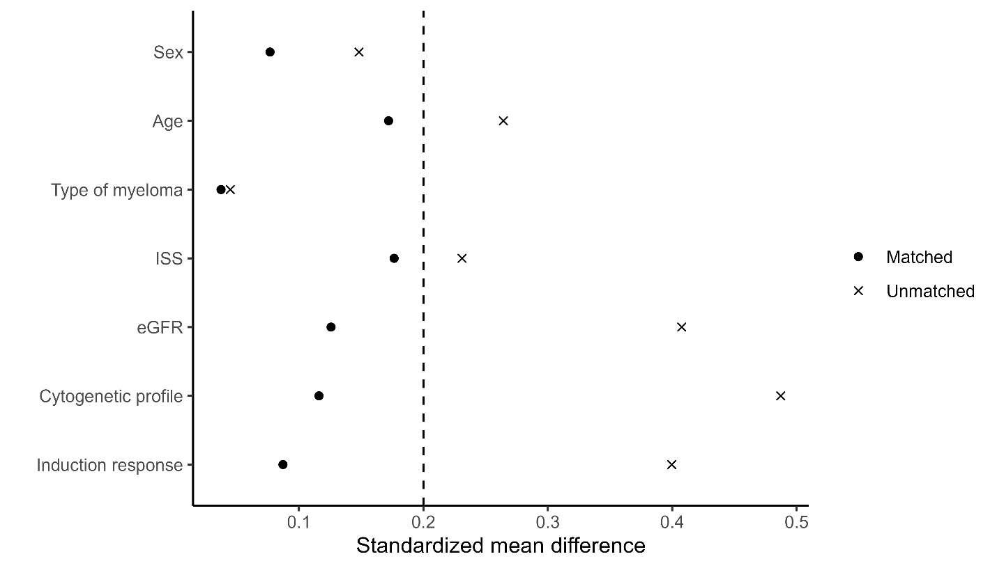

Supplementary Figure 2. Forest plot for subgroup analysis on overall survival of each cohort
Abbreviations) HR, hazard ratio; CI, confidence interval
