Supplementary Information

Manuscript title: Overall survival with momelotinib vs best available therapy in patients with ruxolitinib-experienced myelofibrosis: a matching-adjusted indirect comparison

Journal name: Annals of Hematology

Authors: Francesca Palandri¹; Venediktos Kapetanakis²; Balázs Dobi³; Massimo Breccia⁴; Giuseppe A. Palumbo⁵; Elisabetta Abruzzese⁶; Massimiliano Bonifacio⁷; Mario Tiribelli⁸; Elena Maria Elli⁹; Erika Morsia¹⁰; Filippo Branzanti¹¹; Catherine Ellis¹²; Nicholas Ballew¹²; Tom Liu¹²; Kelesitse Phiri¹²; Fulya Sen Nikitas¹³; Shiyuan Zhang¹²; Dwaipayan Patnaik¹⁴
Author affiliations: ¹IRCCS Azienda Ospedaliero-Universitaria di Bologna, Istituto di Ematologia "Seràgnoli," Bologna, Italy; ²Evidera, London, UK; ³Evidera, Budapest, Hungary; ⁴Department of Translational and Precision Medicine, Azienda Policlinico Umberto I, Sapienza University, Roma, Italy; ⁵Department of Scienze Mediche, Chirurgiche e Tecnologie Avanzate "G.F. Ingrassia," University of Catania, Catania, Italy; ⁶S Eugenio Hospital, ASL Roma 2, Tor Vergata University, Roma, Italy; ⁷Department of Engineering for Innovation Medicine, Section of Innovation Biomedicine, University of Verona, Verona, Italy; ⁸Division of Hematology and BMT, ASUFC and Department of Medicine, University of Udine, Udine, Italy; ⁹Hematology Division and Bone Marrow Unit, Fondazione IRCCS, San Gerardo dei Tintori, Monza, Italy; ¹⁰Hematology Unit, Department of Clinical and Molecular Sciences, DISCLIMO, Università Politecnica delle Marche, Ancona, Italy; ¹¹Dipartimento di Medicina Specialistica, Diagnostica e Sperimentale, Università di Bologna, Bologna, Italy; ¹²GSK plc, Collegeville, PA, USA; ¹³GSK plc, London, UK; ¹⁴GSK plc, Baar, Switzerland
Corresponding author: Francesca Palandri, francesca.palandri@unibo.it

Supplementary Table 1. Study Population

SIMPLIFY-1ª [1], SIMPLIFY-2^{b} [2], and MOMENTUM^{c} [3] | RUX-MF^{d,e} (Palandri et al [2025] [4])
Cohort 1: Patients in the SIMPLIFY-1 trial who switched from ruxolitinib to momelotinib during the OLE phase (n=197) | Aggregate data for BAT for the subset of patients who discontinued ruxolitinib in the chronic phase (provided by the authors)
Cohort 2: Patients in the SIMPLIFY-2 trial who were randomly assigned to momelotinib at baseline (n=104)
Cohort 3: Patients in the SIMPLIFY-2 trial who crossed over to the momelotinib arm from ruxolitinib in the BAT arm (n=36)
Cohort 4: Patients in the MOMENTUM trial who were randomly assigned to momelotinib at baseline (n=130)
Cohort 5: Patients in the MOMENTUM trial who crossed over to the momelotinib arm from the danazol arm (n=40)
BAT, best available therapy; OLE, open-label extension; OS, overall survival; .
ª The total median duration of follow-up (combined randomized and open-label extension phases) was 35.3 months (range, 0.4-59.3 months) in the SIMPLIFY-1 trial [5].
^{b} The total median duration of follow-up (combined randomized and open-label extension phases) was 28.2 months (range, 0.3-50.4 months) in the SIMPLIFY-2 trial [5].
^{c} Median follow-up in the overall anemic population of MOMENTUM for patients who were randomly assigned to momelotinib at baseline was 7.5 months in the subgroup of patients with platelet counts <50×10⁹/L at baseline, 8.9 months in the subgroup of patients with platelet counts <100×10⁹/L at baseline, and 9.0 months overall [6].
^{d} Patients were observed for a total of 286.8 patient-years after ruxolitinib discontinuation, up to 72 months [7].
^{e} The OS data from Palandri et al (2025) that were used in the analyses are for the subset of patients who discontinued ruxolitinib in the chronic disease phase and subsequently received either conventional or novel agents (ie, patients who discontinued ruxolitinib and did not receive subsequent treatment were not included in the analyses) [4].
Supplementary Table 2. Treatments Received by Patients in Palandri et al (2025) [4] who Discontinued Ruxolitinib in the Chronic Disease Phase

Treatment | N=267
Conventional therapy
Danazol | 14
Corticosteroids | 12
Hydroxyurea | 55
ESA | 4
Splenectomy | 7
Support/RBC transfusions | 90
Interferon | 1
Ruxolitinib rechallenge | 18
Investigational JAK inhibitor (fedratinib) | 34
Investigational JAK inhibitor (pacritinib) | 2
Other investigational agents | 23
Crossover from conventional therapy to novel therapy
Hydroxyurea to ruxolitinib | 3
Danazol to other investigational agents | 1
Hydroxyurea to other investigational agents | 1
Hydroxyurea to investigational JAK inhibitor | 1
Crossover from novel therapy to conventional therapy
Investigational JAK inhibitor to hydroxyurea | 1

ESA, erythropoietin-stimulating agent; JAK, Janus kinase; OS, overall survival; RBC, red blood cell.

Supplementary Table 3. Population Characteristics Matched in Each Population-Matching Model

Matching Factorsª | Model A | Model B | Model C^{b}  (Model 1) | Model D | Model E^{b}  (Model 2)
Age, mean | ✓ | ✓ | ✓ | ✓ | ✓
Mean of squared age | ✓ | - | - | - | -
Male sex | ✓ | ✓ | ✓ | ✓ | ✓
Mean of Hb level | ✓ | ✓ | - | ✓ | -
Mean of squared Hb level | ✓ | - | - | - | -
Hb level <10 g/dL^{c} | ✓ | ✓ | ✓ | ✓ | ✓
Hb level missing | ✓ | ✓ | ✓ | ✓ | -
Mean of WBC count | ✓ | ✓ | - | ✓ | -
Mean of squared WBC count | ✓ | - | - | - | -
WBC count >25×10⁹/L | ✓ | ✓ | ✓ | - | -
WBC count missing | ✓ | ✓ | ✓ | ✓ | -
Mean of platelet count | ✓ | ✓ | - | ✓ | -
Mean of squared platelet count | ✓ | - | - | - | -
Platelet count <100×10⁹/L | ✓ | ✓ | ✓ | - | -
Platelet count missing | ✓ | ✓ | ✓ | ✓ | -
Mean of spleen length | ✓ | ✓ | - | ✓ | -
Mean of squared spleen length | ✓ | - | - | - | -
Spleen length ≥10 cm | ✓ | ✓ | ✓ | - | -
Spleen length missing | ✓ | ✓ | ✓ | ✓ | -
Mean of TSS | ✓ | ✓ | - | ✓ | -
Mean of squared TSS | ✓ | - | - | - | -
TSS ≥20^{d} | ✓ | ✓ | ✓ | - | -
Mean of BMI | ✓ | ✓ | - | ✓ | -
Mean of squared BMI | ✓ | - | - | - | -
BMI >25 kg/m² | ✓ | ✓ | ✓ | - | ✓
BMI missing | ✓ | ✓ | ✓ | ✓ | ✓
MF subtype | ✓ | ✓ | ✓ | ✓ | ✓
DIPSS intermediate-2-risk assumption^{e} | ✓ | ✓ | ✓ | ✓ | ✓
BAT, best available therapy; BMI, body mass index; DIPSS, Dynamic International Prognostic Scoring System; ESS, effective sample size; Hb, hemoglobin; IPSS, International Prognostic Scoring System; MAIC, matching-adjusted indirect comparison; MF, myelofibrosis; MFSAF, Myelofibrosis Symptom Assessment Form; MPN-SAF, Myeloproliferative Neoplasm Symptom Assessment Form; TSS, Total Symptom Score, WBC, white blood cell.
ª Variables were selected based on the published literature and clinical expert opinions.
^{b} Momelotinib-treated patients were reweighted to match the BAT population using these models with different matching factors.
^{c} Matched in all models in the anemic subpopulation.
^{d} MOMENTUM, SIMPLIFY-1/SIMPLIFY-2, and Palandri et al. (2025) [4] used different methods for assessing TSS (MFSAF v4.0, MPN-SAF v2.0, and MPN-10 TSS, respectively). However, based on expert opinion from the GSK clinical team, this difference is not expected to lead to bias in an MAIC.
^{e} Disease status was defined by IPSS in SIMPLIFY-1 but by DIPSS in all other studies. DIPSS assigns 2, instead of 1, adverse points for Hb <10 g/dL. High and intermediate was previously reclassified in SIMPLIFY-1 according to the DIPSS definition.

Supplementary Table 4. Analytical Scenarios for MAICs

Analytical scenario | Description
Base case | Patients who received momelotinib within 1 month since RUX discontinuation from  SIMPLIFY-1, SIMPLIFY-2, and MOMENTUM | vs | 267 patients who received  2L BAT  (Palandri et al [2025])
Sensitivity analysis 1 | Patients who received momelotinib within 1 month since RUX discontinuation from  SIMPLIFY-2 and MOMENTUM | vs | 267 patients who received  2L BAT  (Palandri et al [2025])
Sensitivity analysis 2 | Patients who received momelotinib within 1 month since RUX discontinuation from  SIMPLIFY-1 and SIMPLIFY-2 | vs | 267 patients who received  2L BAT  (Palandri et al [2025])
Supplemental analysis | All patients who received momelotinib from  SIMPLIFY-1, SIMPLIFY-2, and MOMENTUM | vs | 267 patients who received  2L BAT  (Palandri et al [2025])

2L, second line; BAT, best available therapy; MAIC, matching-adjusted indirect comparison; RUX, ruxolitinib.

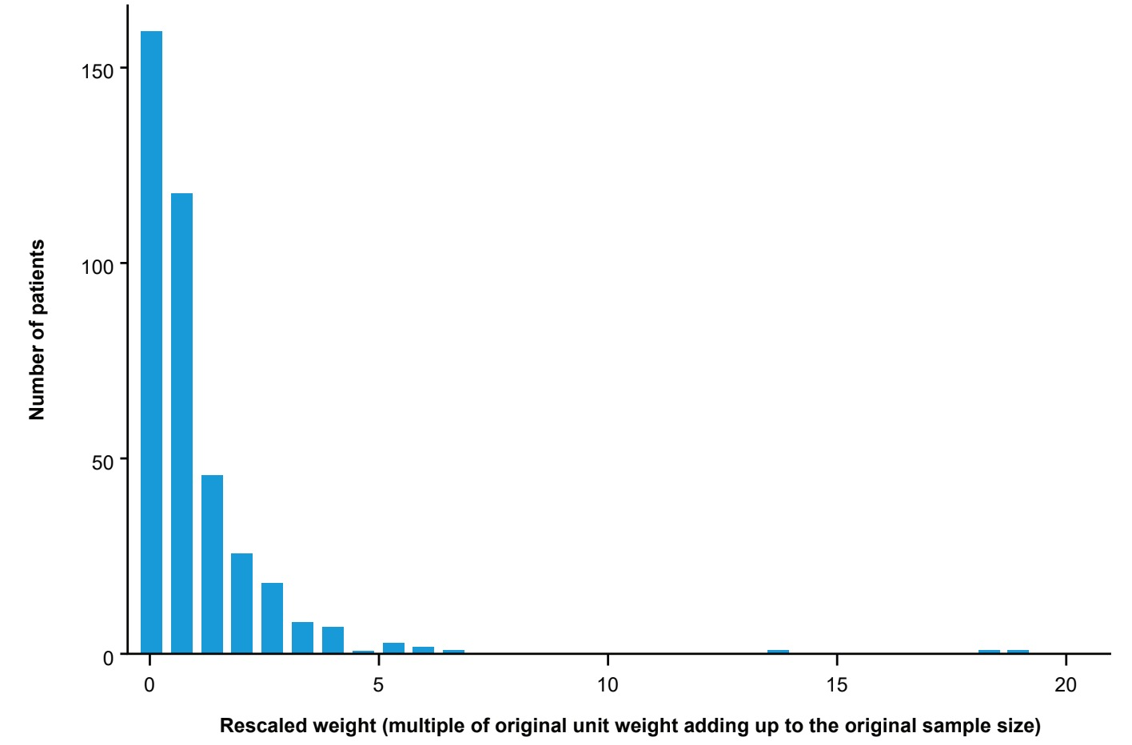

Supplementary Figure 1. Rescaled Weight Distribution Plot in the Index Patient Population (overall population, model 1)

Original sample size: 383
Effective sample size: 89.40589
In Model 1 of the overall population, 3 out of 383 patients (0.8% of original sample size) received large weights (>10) that accounted for about 13% of the ESS.

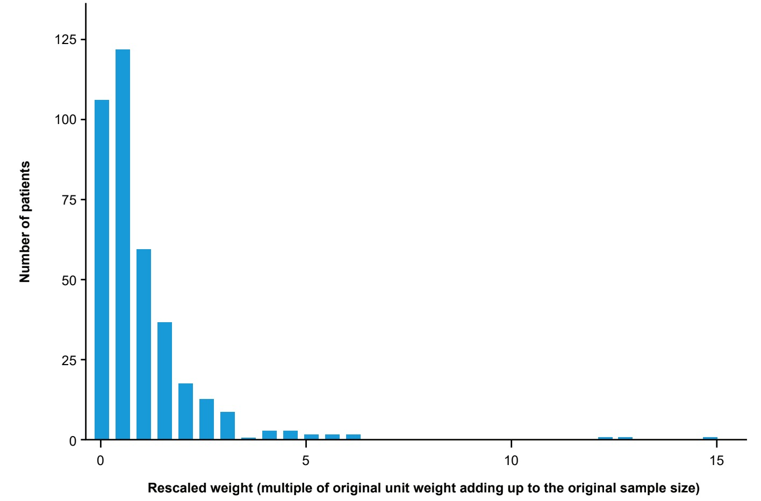

Supplementary Figure 2. Rescaled Weight Distribution Plot in the Index Patient Population (overall population, model 2)

Original sample size: 383
Effective sample size: 116.9219
In Model 2 of the overall population, 3 out of 383 patients (0.8% of original sample size) received large weights (>10) that accounted for about 10% of the ESS.

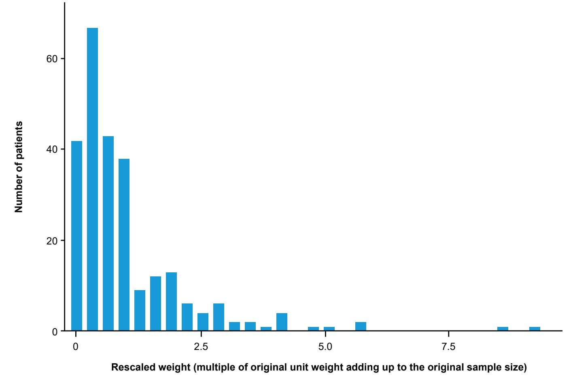
Supplementary Figure 3. Rescaled Weight Distribution Plot in the Index Patient Population (anemic population, model 1)

Original sample size: 255
Effective sample size: 98.47648
In Model 1 of the overall population, 2 out of 255 patients (0.8% of original sample size) received relatively large weights (>7.5) that accounted for about 7% of the ESS.

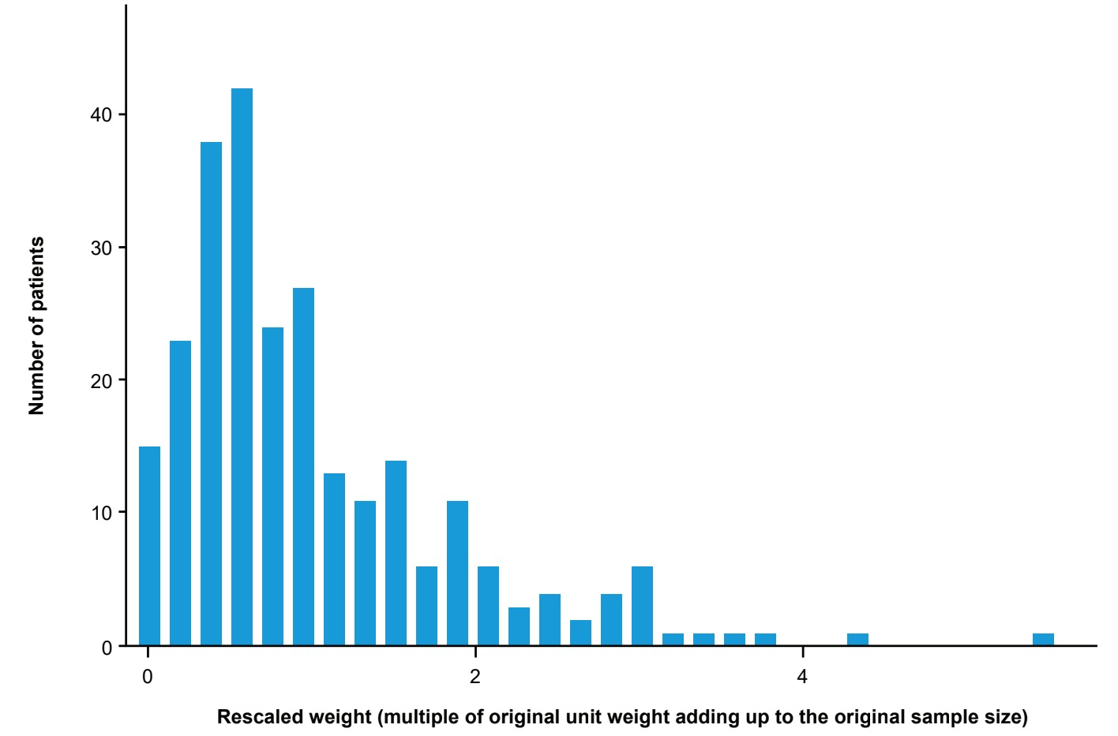
Supplementary Figure 4. Rescaled Weight Distribution Plot in the Index Patient Population (anemic population, model 2)

Original sample size: 255
Effective sample size: 146.2414
In Model 2 of the overall population, 1 out of 255 patients (0.4% of original sample size) received a relatively large weight (>5) that accounted for about 2.5% of the ESS.

Supplemental References

1. Mesa RA, Kiladjian JJ, Catalano JV, Devos T, Egyed M, Hellmann A, McLornan D, Shimoda K, Winton EF, Deng W, Dubowy RL, Maltzman JD, Cervantes F, Gotlib J (2017) SIMPLIFY-1: A phase III randomized trial of momelotinib versus ruxolitinib in Janus kinase inhibitor-naive patients with myelofibrosis. J Clin Oncol 35 (34):3844-3850. doi:10.1200/jco.2017.73.4418
2. Harrison CN, Vannucchi AM, Platzbecker U, Cervantes F, Gupta V, Lavie D, Passamonti F, Winton EF, Dong H, Kawashima J, Maltzman JD, Kiladjian JJ, Verstovsek S (2018) Momelotinib versus best available therapy in patients with myelofibrosis previously treated with ruxolitinib (SIMPLIFY 2): a randomised, open-label, phase 3 trial. Lancet Haematol 5 (2):e73-e81. doi:10.1016/s2352-3026(17)30237-5
3. Verstovsek S, Gerds AT, Vannucchi AM, Al-Ali HK, Lavie D, Kuykendall AT, Grosicki S, Iurlo A, Goh YT, Lazaroiu MC, Egyed M, Fox ML, McLornan D, Perkins A, Yoon SS, Gupta V, Kiladjian JJ, Granacher N, Lee SE, Ocroteala L, Passamonti F, Harrison CN, Klencke BJ, Ro S, Donahue R, Kawashima J, Mesa R (2023) Momelotinib versus danazol in symptomatic patients with anaemia and myelofibrosis (MOMENTUM): results from an international, double-blind, randomised, controlled, phase 3 study. Lancet 401 (10373):269-280. doi:10.1016/s0140-6736(22)02036-0
4. Palandri F, Breccia M, Morsia E, Elli EM, Benevolo G, Tiribelli M, Beggiato E, Farina M, Caocci G, Pugliese N, Tieghi A, Crugnola M, Binotto G, Cavazzini F, Isidori A, Dedola A, Scalzulli E, Moioli A, Cavalca F, Caserta S, Duminuco A, Martino B, Lemoli RM, Cilloni D, Bocchia M, Pane F, Heidel FH, Bonifacio M, Palumbo GA, Branzanti F, Iurlo A, Abruzzese E (2025) Treatment strategies and survival after ruxolitinib discontinuation in myelofibrosis patients: the italian RUX-MF multicenter study. Leuk Res 154:107719. doi:10.1016/j.leukres.2025.107719
5. Momelotinib (Ojjaara): Indication: For the treatment of splenomegaly and/or disease-related symptoms, in adult patients with intermediate or high-risk primary myelofibrosis (MF), post polycythemia vera myelofibrosis or post essential thrombocythemia MF who have moderate to severe anemia: Reimbursement Recommendation [Internet]. Ottawa (ON): Canadian Agency for Drugs and Technologies in Health; 2025 Feb. Available from: https://www.ncbi.nlm.nih.gov/books/NBK612726/.
6. Kiladjian JJ, Vannucchi AM, Gerds AT, Gupta V, Verstovsek S, Egyed M, Platzbecker U, Mayer J, Grosicki S, Illés Á, Woźny T, Oh ST, McLornan D, Kirgner I, Yoon SS, Harrison CN, Klencke B, Huang M, Kawashima J, Mesa R (2023) Momelotinib in myelofibrosis patients with thrombocytopenia: post hoc analysis from three randomized phase 3 trials. Hemasphere 7 (11):e963. doi:10.1097/hs9.0000000000000963
7. Palandri F, Breccia M, Bonifacio M, Polverelli N, Elli EM, Benevolo G, Tiribelli M, Abruzzese E, Iurlo A, Heidel FH, Bergamaschi M, Tieghi A, Crugnola M, Cavazzini F, Binotto G, Isidori A, Sgherza N, Bosi C, Martino B, Latagliata R, Auteri G, Scaffidi L, Griguolo D, Trawinska M, Cattaneo D, Catani L, Krampera M, Lemoli RM, Cuneo A, Semenzato G, Foà R, Di Raimondo F, Bartoletti D, Cavo M, Palumbo GA, Vianelli N (2020) Life after ruxolitinib: Reasons for discontinuation, impact of disease phase, and outcomes in 218 patients with myelofibrosis. Cancer 126 (6):1243-1252. doi:10.1002/cncr.32664

