Supplementary Methods
RNA-sequencing analysis
The mRNA with PolyA was specifically captured by two rounds of purification using Dynabeads Oligo (dT) (Thermo Fisher, Cat# 25-61005, USA). The captured mRNAs were fragmented with the Magnesium Ion Interruption Kit (NEBNext® Magnesium RNA Fragmentation Module, Cat# E6150S, USA) at 94°C for 5-7 min. The fragmented RNA was passed through Invitrogen SuperScriptTM II Reverse Transcriptase (Invitrogen, Cat# 1896649, USA) to synthesize cDNA. The DNA-RNA complex duplexes were then converted into DNA duplexes by two-stranded synthesis using E. coli DNA polymerase I (NEB, Cat# m0209, USA) and RNase H (NEB, Cat# m0297, USA), while the duplexes were doped with dUTP Solution (Thermo Fisher, Cat# R0133, USA), which complemented the ends of the duplexes to be flat and added an A base at each terminal to enable them to bind to the DNA with a T base at the end, and then used magnetic beads to screen and purify its fragment size. The second strand was digested with UDG enzyme (NEB, cat.m0280, MA, US), and the fragment size of 300 ± 50 bp strand-specific library was formed by PCR procedure: pre-denaturation holding at 95°C for 3 min, denaturation at 98°C for a total of 8 cycles of 15 sec each, annealing to 60°C holding at 60°C for 15 sec, extension at 72°C for 30 sec, and a final extension held at 72°C for 5 min. Finally, Illumina NovaseqTM 6000 (LC Bio Technology CO., Ltd. Hangzhou, China) was used to perform bipartite sequencing according to the standard operation, with the sequencing mode of PE150.
Olink proteomics analysis
Proteins were measured using the Olink®-Immuno-Oncology panel (Olink Proteomics AB, Uppsala, Sweden) according to the manufacturer's instructions. The Proximity Extension Assay (PEA) technology used for the Olink protocol has been well described (Assarsson et al, 2014), and enables 92 analytes to be analyzed simultaneously, using 1 µL of each sample. In brief, pairs of oligonucleotide-labeled antibody probes bind to their targeted protein, and if the two probes are brought in close proximity the oligonucleotides will hybridize in a pair-wise manner. The addition of a DNA polymerase leads to a proximity-dependent DNA polymerization event, generating a unique PCR target sequence. The resulting DNA sequence is subsequently detected and quantified using a microfluidic real-time PCR instrument (Signature Q100, LC-Bio Technology CO., Ltd., Hangzhou, China). Data is then quality controlled and normalized using an internal extension control and an inter-plate control, to adjust for intra- and inter-run variation. The final assay read-out is presented in Normalized Protein eXpression (NPX) values, which is an arbitrary unit on a log₂-scale where a high value corresponds to a higher protein expression. All assay validation data (detection limits, intra- and inter-assay precision data, etc.) are available on manufacturer's website (www.olink.com).

Table S1. Demographic characteristics of the healthy donors
No. | Sex | Age | WBC | NLR | HGB | PLT
1 | M | 27 | 6.85 | 0.990 | 146 | 194
2 | M | 25 | 4.37 | 1.664 | 153 | 207
3 | F | 33 | 3.26 | 1.021 | 124 | 184
4 | M | 35 | 6.85 | 0.820 | 158 | 224
5 | M | 43 | 4.34 | 1.068 | 140 | 252
6 | F | 38 | 5.39 | 1.746 | 131 | 310
7 | M | 47 | 8.97 | 1.382 | 153 | 262
8 | M | 58 | 6.97 | 1.382 | 144 | 301
9 | M | 40 | 7.19 | 1.671 | 152 | 301
10 | F | 13 | 6.42 | 1.075 | 134 | 297
11 | M | 16 | 10.05 | 1.332 | 149 | 297
12 | M | 27 | 6.39 | 2.980 | 147 | 289
13 | F | 22 | 9.84 | 4.000 | 130 | 248

Table S2. Primer sequences for RT-qPCR
Gene | Forward (5'→3‘) | Reverse (5'→3‘)
GAPDH | GGTGTGAACCATGAGAAGTATGA | GAGTCCTTCCACGATACCAAAG
GATA1 | ACTGACCATGCGGAAGGATG | CCACCACCATAAAGCCACCA
KLF1 | CAGGTGTGATAGCCGAGACC | TCTTGGTGTAGCTCTTGCCG
AHSP | CAGGATTGAAGGAGTTCAGCG | AGTTCATCCAGTCCTCCACC
ALAS2 | TGTCCGTCTGGTGTAGTAATGA | GCTCAAGCTCCACATGAAACT
HBA1 | ACCCGGTCAACTTCAAGCTC | AAGAAGCATGGCCACCGAGG
HBB | CAACCCTAAGGTGAAGGCTCA | CTCACTCAGTGTGGCAAAGGTG
HBG | CACTCGCTTCTGGAACGTCT | GGTAGACAACCAGGAGCCTTC
TRFC | TGAGAGGTACAACAGCCAACT | GGAAGTAGCACGGAAGAAGTC
SPTA1 | AATGCCAGTACCTTCCTTCAATG | CAGAGCGTCTTCCAAGTTGTC
SLC4A1 | CCTTCGTCCTCATCCTCACT | GCCACTTCGTCGTATTCATCC
EPB42 | TAGACCACACCTTGCCATCA | GCCACACTGAACGGAATCTG
GYPA | GGCTGGTGTTATTGGAACGA | TAAAGGCACGTCTGTGTCAGG

Table S3. Annotation of DEGs associated with erythroid differentiation
Gene Symbol | Gene ID | Gene Name | Function of Encoded Protein
GATA1 | 2623 | GATA binding protein 1 | an important transcription factor of erythroid development by regulating the switch of fetal hemoglobin to adult hemoglobin
KLF1 | 10661 | KLF transcription factor 1 | a hematopoietic-specific transcription factor that induces high-level expression of adult beta-globin and other erythroid genes
EPOR | 2057 | Erythropoietin receptor | a member of the cytokine receptor family that binds to erythropoietin to activate Jak2 tyrosine kinase, thereby promoting different intracellular pathways
ALAS2 | 212 | 5'-aminolevulinate synthase 2 | an erythroid-specific mitochondrially located enzyme to catalyze the heme biosynthetic pathway
AHSP | 51327 | alpha hemoglobin stabilizing protein | a molecular chaperone which binds specifically to free alpha-globin and is involved in hemoglobin assembly
PKLR | 5313 | pyruvate kinase L/R | a pyruvate kinase that catalyzes the transphosphorylation of phohsphoenolpyruvate into pyruvate and ATP
TFRC  (CD71) | 7037 | transferrin receptor | a cell surface receptor necessary for cellular iron uptake
HBA1 | 3039 | hemoglobin subunit alpha 1 | α-chain structural subunit of adult hemoglobin
HBA2 | 3040 | hemoglobin subunit alpha 2 | α-chain structural subunit of adult hemoglobin
HBB | 3043 | hemoglobin subunit beta | β-chain structural subunit of adult hemoglobin
HBM | 3042 | hemoglobin subunit mu | α-chain structural subunit of adult hemoglobin
HBG1 | 3047 | hemoglobin subunit gamma 1 | γ-chain structural subunit of fetal hemoglobin
HBG2 | 3048 | hemoglobin subunit gamma 2 | γ-chain structural subunit of fetal hemoglobin
SPTA1 | 6708 | spectrin alpha, erythrocytic 1 | a member of a family of molecular scaffold proteins that link the plasma membrane to the actin cytoskeleton
SPTB | 6710 | spectrin beta, erythrocytic | a member of the spectrin gene family, along with ankyrin involving in cell membrane organization and stability
EPB42 | 2038 | erythrocyte membrane protein band | an ATP-binding protein which may regulate the association of protein 3 with ankyrin
SLC4A1 | 6521 | solute carrier family 4 member 1 | a member of the anion exchanger family expressed on the erythrocyte plasma membrane, functioning as a chloride/bicarbonate exchanger
GYPA  (CD235a) | 2993 | glycophorin A | major sialoglycoproteins of the human erythrocyte membrane, bearing the antigenic determinants for the MN and Ss blood groups
GYPB | 2994 | glycophorin B
GYPE | 2996 | glycophorin E | a sialoglycoprotein carrying the M blood group antigen

Table S4. DEPs between MPN patients and healthy controls or between anemic and non-anemic patients
Expression  Levels | Ph-negative MPN Patients vs Healthy Controls | Anemic vs Non-anemic Patients
DOWN | MP | EGF
DOWN | IL2 | TWEAK
DOWN | CD5 | VEGFR-2
DOWN | TRAIL | PDGF subunit B
DOWN | FASLG | ANGPT1
DOWN |  | IL7
DOWN |  | CCL17
DOWN |  | CXCL5
DOWN |  | CD40-L
DOWN |  | MCP-2
DOWN |  | MCP-4
DOWN |  | ICOSLG
DOWN |  | MMP7
DOWN |  | Gal-1
DOWN |  | CXCL1
DOWN |  | TRAIL
DOWN |  | FASLG
UP | CXCL13 | IL10
UP | IL15 | CCL3
UP | ANGPT2 | NOS3
UP | IL6 | TNF
UP | TNFRSF4 | CSF-1
UP | IL8 | CXCL9
UP | PD-L1 | CCL23
UP | MCP-1 | IL12RB1
UP | PGF | TNFRSF9
UP | LAG3 | Gal-9
UP | LAMP3 | CD28
UP | CD244 | PD-L2
UP | TNFRSF12A | MCP-3
UP | CD27 | CXCL13
UP | CAIX | IL15
UP | CXCL11 | ANGPT2
UP | FGF2 | IL6
UP | CD40 | TNFRSF4
UP | CCL20 | IL8
UP |  | PD-L1
UP |  | MCP-1
UP |  | PGF
Note: Common downregulated DEPs are highlighted in green, while common upregulated DEPs are marked in red.
Table S5. Annotation of selected DEPs in Immuno-Oncology proteomics analysis
Protein symbol | UniProt ID | Full Name | Function
TRAIL  (TNF10) | P50591 | TNF superfamily member 10 | a cytokine that belongs to the TNF ligand family which induces apoptosis in transformed and tumor cells
FASLG  (TNFL6) | P48023 | Fas ligand | a member of the TNF superfamily, which induces apoptosis triggered by binding to FAS
VEGFR-2 | P52583 | kinase insert domain receptor | one of the two receptors of the vascular endothelial growth factor (VEGF)
EGF | P01133 | epidermal growth factor | a member of the epidermal growth factor superfamily that acts a potent mitogenic factor
IL-6 | P05231 | interleukin 6 | a cytokine that functions in inflammation and the maturation of B cells
IL-8 (CXCL8) | P10145 | interleukin 8 | a member of the CXC chemokine family and a major mediator of the inflammatory response
IL-10 | P22301 | interleukin 10 | a cytokine has pleiotropic effects in immunoregulation and inflammation
IL-15 | P40933 | interleukin 15 | a cytokine that regulates T and natural killer cell activation and proliferation.
CXCL13 | O43927 | C-X-C motif chemokine ligand 13 | B lymphocyte chemoattractant that promotes the migration of B lymphocytes
ANGPT2 | O15123 | angiopoietin 2 | an antagonist of angiopoietin 1 that may induce endothelial cell apoptosis.
PD-L1 (CD274) | Q9NZQ7 | programmed cell death 1 ligand 1 | an immune inhibitory receptor ligand which interacts with its receptor to inhibit T-cell activation and cytokine production
TNFRSF4 | P43489 | TNF receptor superfamily member 4 | a member of the TNF-receptor superfamily that activate NF-κB through its interaction with adaptor proteins TRAF2 and TRAF5

A B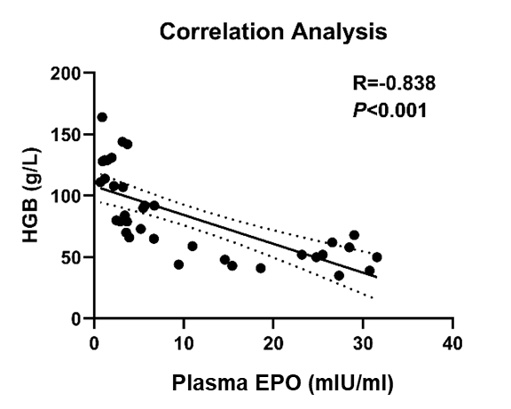
Figure S1. Analysis of plasma EPO levels in patients with Ph-negative MPN
(A) Plasma EPO levels in non-anemic patients, anemic patients without and with TD. Data are presented as mean ± SD. (B) Spearson’s correlation analysis between plasma EPO levels and HGB levels.

Figure S2. Enrichment analysis of DEGs associated with erythroid differentiation using the Metascape platform
A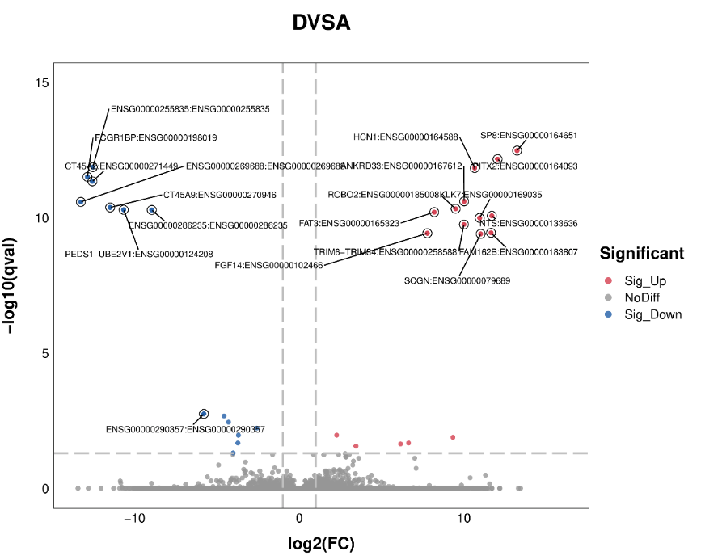
B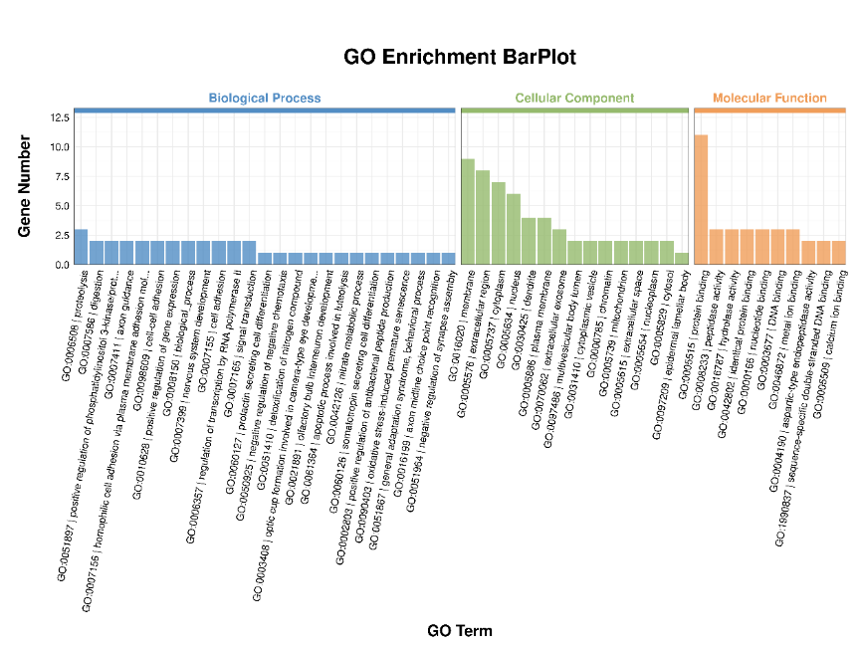
C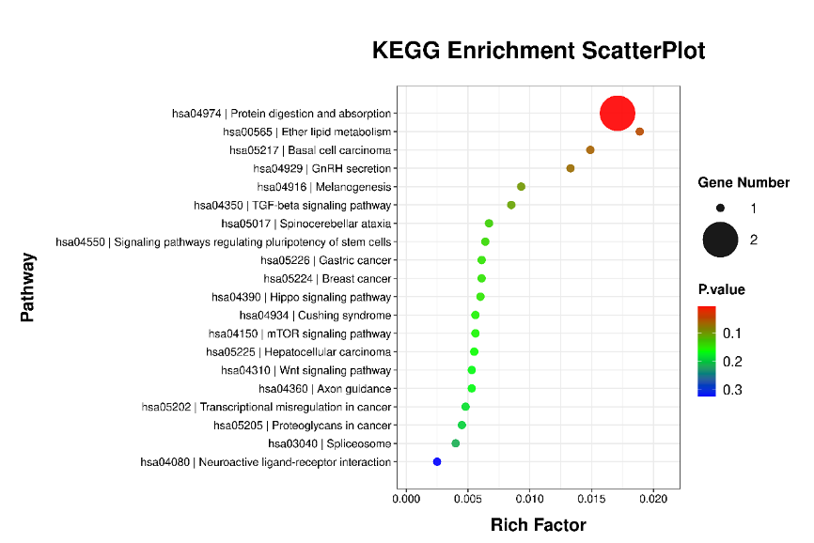
Figure S3. Transcriptome analysis of anemic patients with and without TD
(A) Volcano plot. (B) GO enrichment barplot. (C) KEGG enrichment scatterplot.
A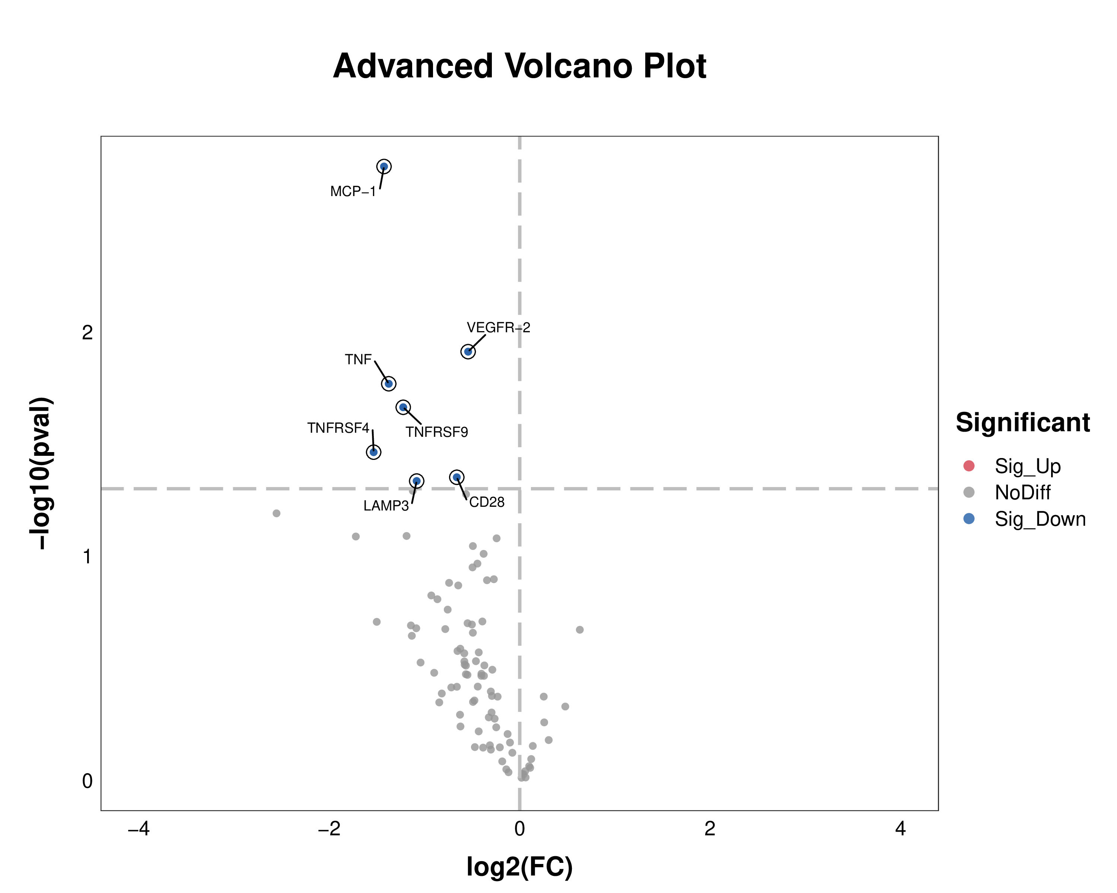
B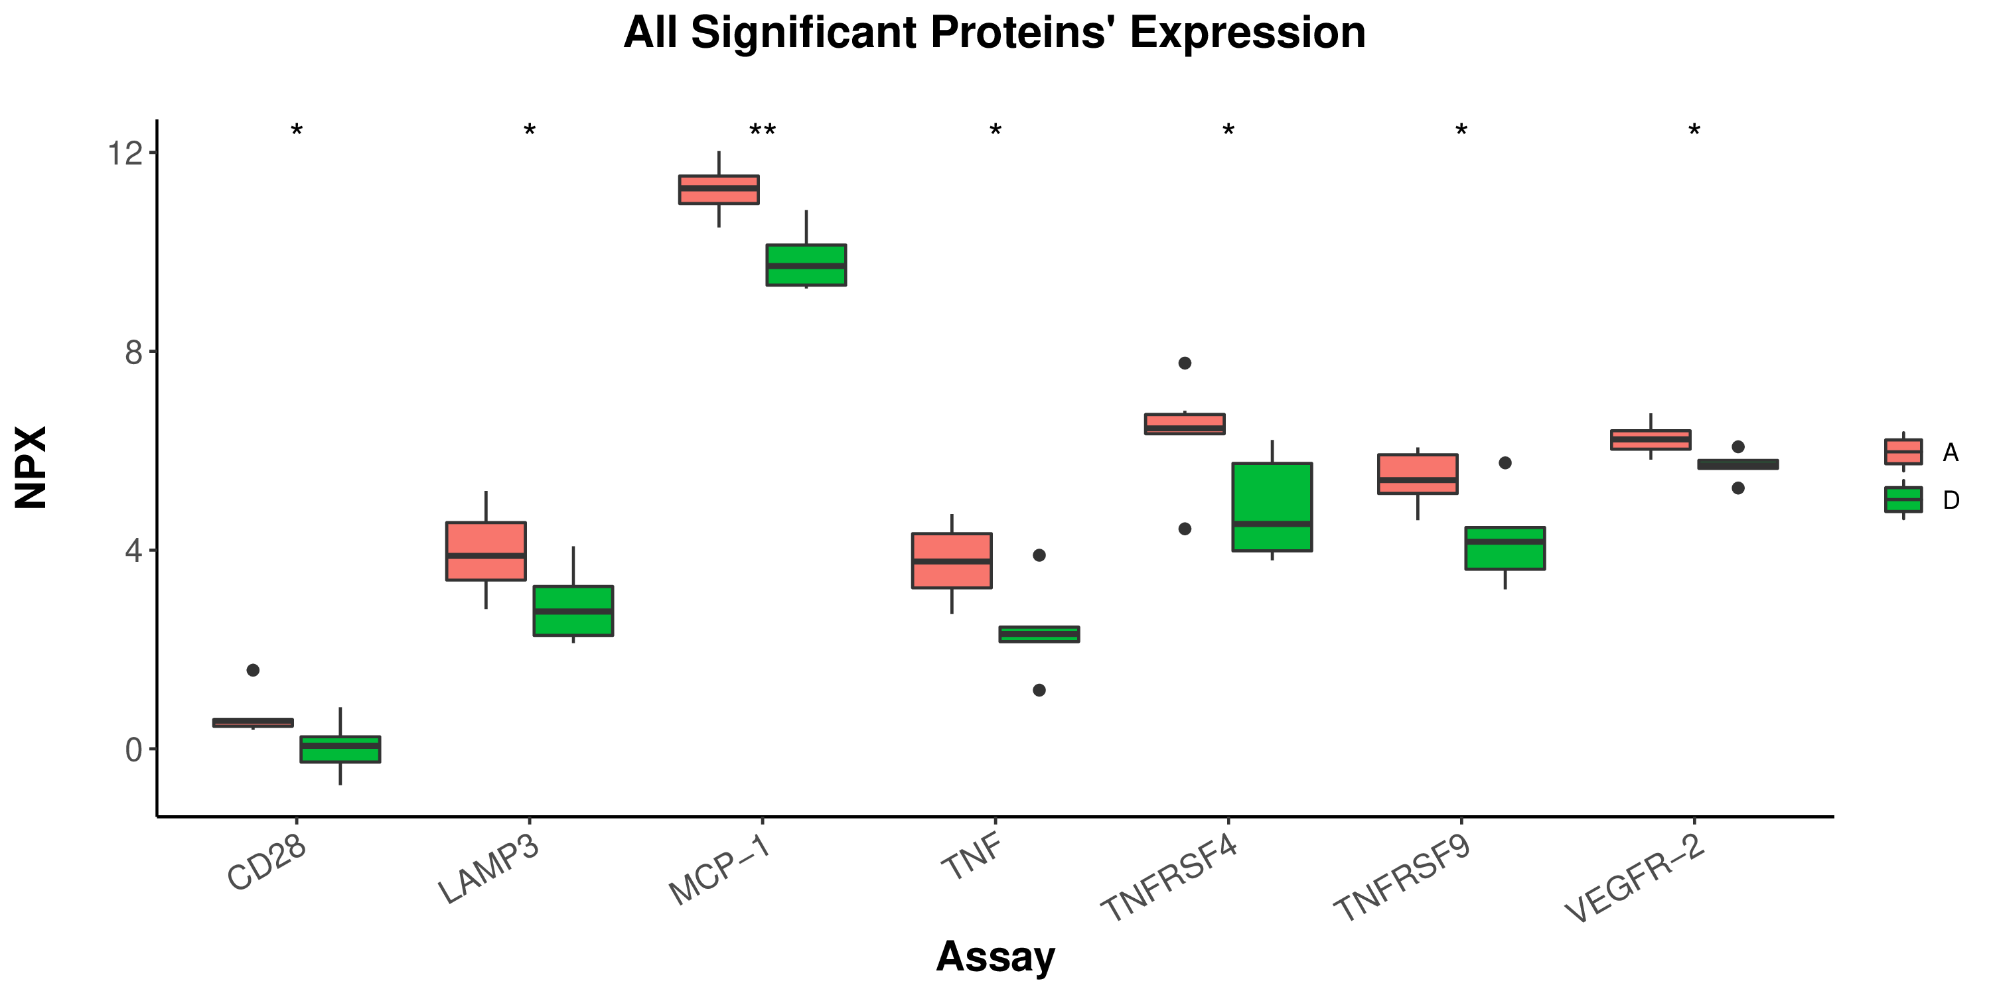
C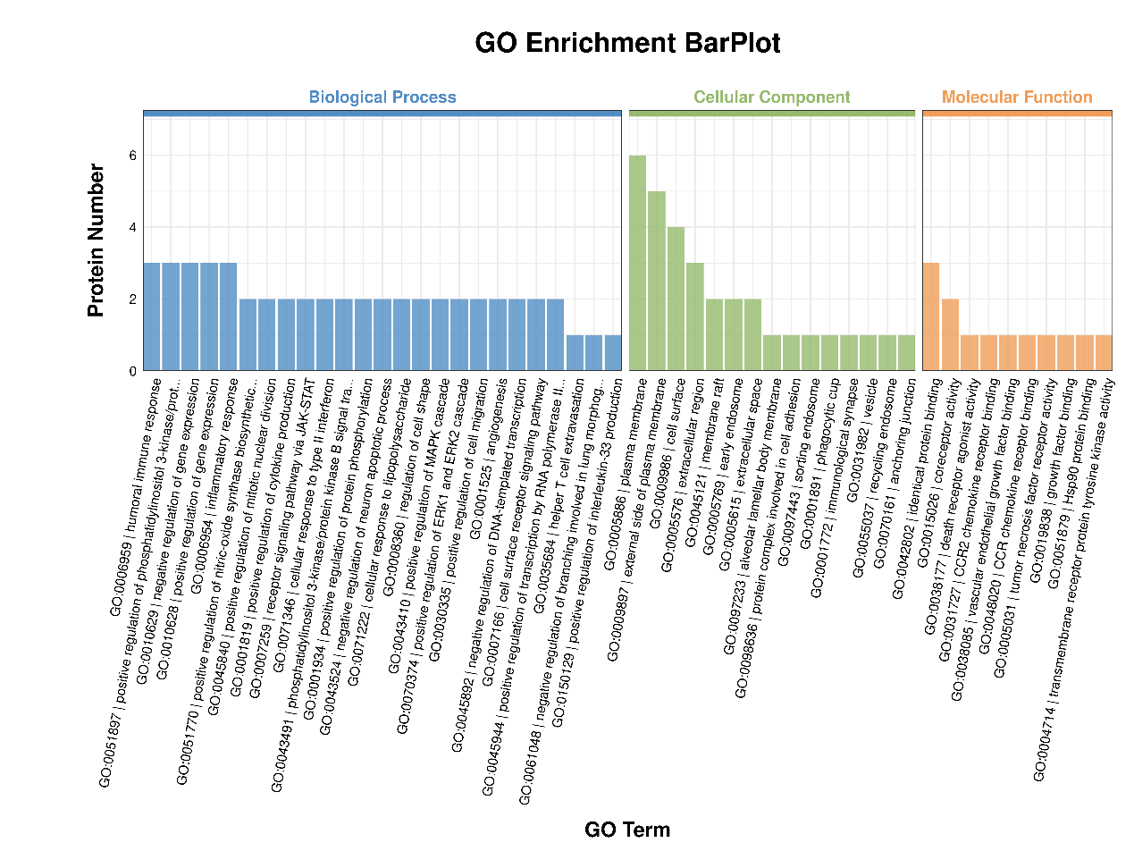
D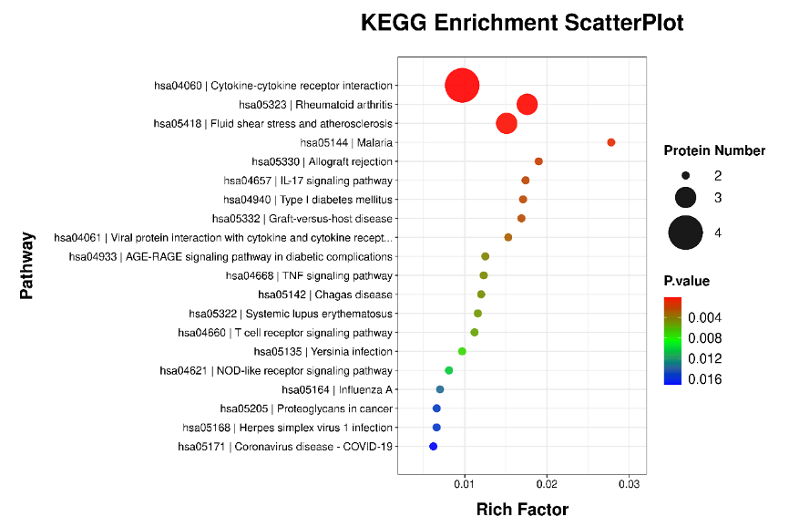
Figure S4. Proteomics analysis of anemic patients with and without TD
(A) Volcano plot. (B) Expression of DEPs between anemic patients without (red) and with TD (green). (C) GO enrichment barplot. (D) KEGG enrichment scatterplot.
A Bb
B
Figure S5. Spearman’s correlation analysis of selected 12 DEPs with DEGs associated with erythroid differentiation (A) and HGB levels (B)
A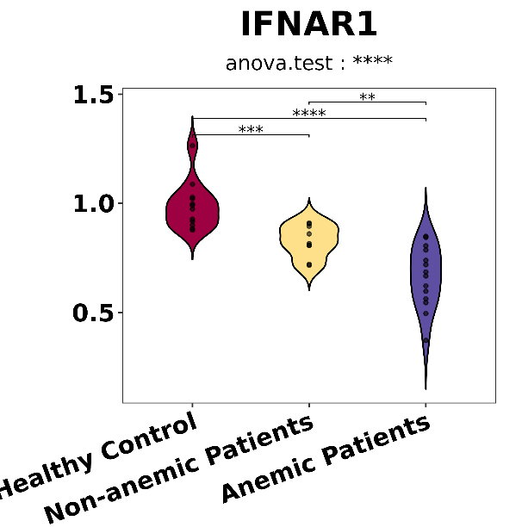B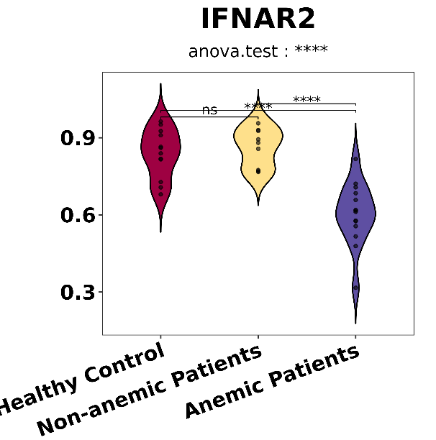
Figure S6. Transcriptome sequencing analysis of IFNAR1 (A) and IFNAR2 (B) among healthy controls, non-anemic patients, and anemic patients
A B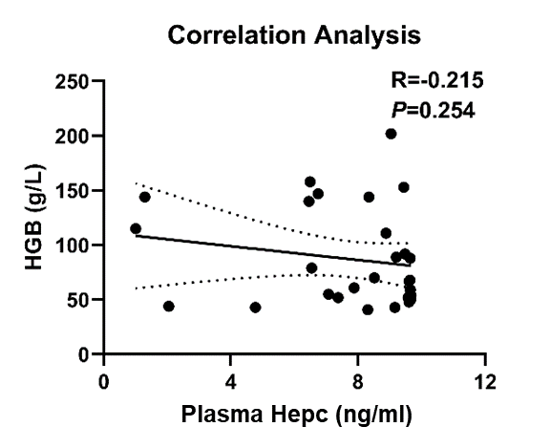
Figure S7. Analysis of plasma hepcidin levels in patients with Ph-negative MPN
(A) Plasma hepcidin levels in non-anemic patients, patients without and with TD. Data are presented as mean ± SD. (B) Spearson’s correlation analysis between plasma hepcidin levels and HGB levels.

