Incidence of infections in patients treated with rituximab for Autoimmune Disorders of Hematological Interest or Non-Hodgkin Lymphoma

Supplemental Material

Supplemental Table 1. The Site of infection is stratified according to CTCAE 5.0 grading. 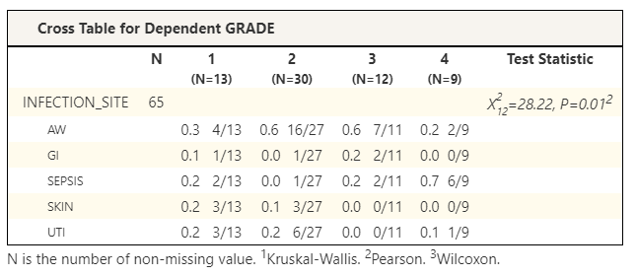

Supplemental Table 2. Clinical differences in patient who not received (0 column) ore received (1 column) anti PCP Prophylaxis.

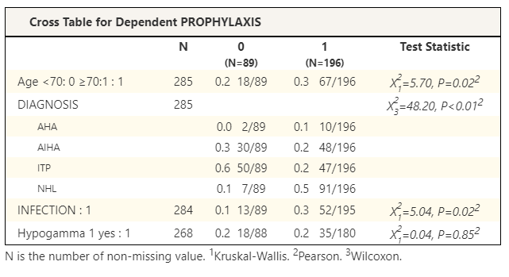
Cross Table for Dependent PROPHYLAXIS
 | N | No proph. | Yes prophylaxis | Test Statistic
 |  | (N=89) | (N=196)
Age <70: 0 ≥70:1 : 1 | 285 | 0.2 18/89 | 0.3 67/196 | Χ²₁=5.70, P=0.02²
DIAGNOSIS | 285 |  |  | Χ²₃=48.20, P<0.01²
AHA |  | 0.0 2/89 | 0.1 10/196
AIHA |  | 0.3 30/89 | 0.2 48/196
ITP |  | 0.6 50/89 | 0.2 47/196
NHL |  | 0.1 7/89 | 0.5 91/196
INFECTION | 284 | 0.1 13/89 | 0.3 52/195 | Χ²₁=5.04, P=0.02²
Hypogamma | 268 | 0.2 18/88 | 0.2 35/180 | Χ²₁=0.04, P=0.85²

N is the number of non-missing value. ¹Kruskal-Wallis. ²Pearson. ³Wilcoxon.

Supplemental Table 3 Logistic regression showing Odd Ratios (OR) in univariable and multiviable analysis.

Risk-factors |  | OR (univariable) | OR (multivariable)
Age <=70=0; >70=1
 | 1 | 1.655 (1.94-3.03, p=0.076) | 1.53 (0.78-2.98, p=0.208)
SEX | 0 | - | -
 | 1 | 1.07 (0.62-1.87, p=0.805) | 1.35 (0.72-2.53, p=0.347)
DIAGNOSIS | AHA | - | -
 | AIHA | 1.10 (0.27-4.48, p=0.889) | 0.78 (0.17-3.58, p=0.752)
 | ITP | 0.93 (0.23-3.74, p=0.921) | 1.04 (0.23-4.39, p=0.996)
 | NHL | 0.68 (0.17-2.78, p=0.595) | 0.49 (0.11-2.11, p=0.333)
PROPHYLAXIS |  | - | -
 |  | 2.126 (1.09-4.15, p=0.027) | 2.62 (1.21-5.67, p=0.014)
Hypo-GAMMA |  | - | -
 |  | 2.807 (1.45-5.41, p=0.002) | 2.73 (1.37-5.45, p=0.004)

Supplemental figure showing histograms of age distribution of the 4 cohorts of patients: AHA acquired hemophilia A; AIHA autoimmune hemolytic anemia; ITP immune thrombocytopenia; NHL B-cell non-Hodgkin lymphomas.
