SUPPLEMENTARY DATA

SUPPLEMENTARY TABLE 1. Univariate analyses of ICU mortality and overall survival.
 | ICU mortality |  | Overall survival
 | OR (95% CI) | P | HR (95% CI) | P
Age, years | 1.00 (0.97-1.02) | >0.9 | 1.00 (0.99-1.02) | 0.5
Female gender | 1.03 (0.53-1.97) | >0.9 | 1.05 (0.74-1.48) | 0.8
HCT_CI
0-1 | Ref. |  | Ref.
2-3 | 0.98 (0.42-2.22) | >0.9 | 1.02 (0.67-1.57) | >0.9
≥4 | 1.19 (0.29-4.41) | 0.8 | 0.62 (0.27-1.41) | 0.3
Transplant year
2002-2010 | Ref. |  | Ref.
2011-2015 | 1.08 (0.46-2.50) | 0.9 | 1.05 (0.68-1.62) | 0.8
2016-2021 | 1.59 (0.75-3.39) | 0.2 | 1.05 (0.70-1.57) | 0.8
Disease
Acute leukemia | Ref. |  | Ref.
Lymphoproliferative disorder | 0.90 (0.35-2.18) | 0.8 | 0.93 (0.57-1.53) | 0.8
MDS | 0.64 (0.13-2.42) | 0.5 | 1.85 (0.94-3.66) | 0.075
MPN | 0.99 (0.43-2.23) | >0.9 | 0.99 (0.64-1.53) | >0.9
Myeloma | 1.70 (0.38-7.75) | 0.5 | 0.83 (0.38-1.83) | 0.6
Aplastic anemia |  | >0.9 | 1.48 (0.36-6.08) | 0.6
Conditioning regimen
MAC | Ref. |  | Ref.
RIC | 0.56 (0.27-1.14) | 0.11 | 0.85 (0.58-1.26) | 0.4
Sequential | 0.38 (0.12-1.07) | 0.077 | 0.86 (0.51-1.47) | 0.6
TBI | 1.30 (0.66-2.54) | 0.5 | 1.09 (0.76-1.56) | 0.6
ATG | 0.83 (0.43-1.58) | 0.6 | 0.98 (0.70-1.38) | >0.9
Graft source
Bone marrow | Ref. |  | Ref.
Peripheral blood | 1.72 (0.49-8.01) | 0.4 | 1.60 (0.78-3.28) | 0.2
Cord blood | 2.40 (0.38-16.9) | 0.4 | 1.25 (0.45-3.44) | 0.7
HLA matching
HLA-matched sibling donor | Ref. |  | Ref.
HLA-matched unrelated donor | 1.99 -0.93-4.36) | 0.081 | 1.63 (1.09-2.43) | 0.018
Mismatched unrelated donor | 0.63 (0.09-2.90) | 0.6 | 1.35 (0.66-2.80) | 0.4
HLA haplo-identical donor | 1.35 (0.46-3.82) | 0.6 | 1.11 (0.62-1.98) | 0.7
Cord blood | 2.03 (0.45-8.71) | 0.3 | 1.03 (0.46-2.29) | >0.9
Prior acute GVHD | 1.50 (0.77-2.92) | 0.2 | 1.10 (0.77-1.58) | 0.6
Active GVHD at ICU admission | 1.54 (0.71-3.33) | 0.3 | 1.52 (1.01-2.29) | 0.046
Reason for ICU admission
Respiratory | Ref. |  | Ref.
Hemodynamic | 0.62 (0.28-1.31) | 0.2 | 0.91 (0.61-1.36) | 0.6
Neurologic | 0.32 (0.05-1.35) | 0.2 | 0.97 (0.46-2.04) | >0.9
Renal | 1.43 (0.37-5.59) | 0.6 | 1.42 (0.70-2.88) | 0.3
Multi-organ failure | 5.71 (0.79-115) | 0.13 | 1.55 (0.56-4.29) | 0.4
Cardiac arrest | 2.86 (0.26-63.3) | 0.4 | 1.71 (0.53-5.48) | 0.4
Liver | 1.43 (0.05-37.2) | 0.8 | 3.05 (0.74-12.6) | 0.12
Hydro-electrolytic | _ |  | 0.84 (0.20-3.47) | 0.8
Surveillance | _ |  | 1.03 (0.44-2.38) | >0.9
SOFA on day 1 | 1.31 (1.17-1.49) | <0.001 | 1.17 (1.10-1.24) | <0.001
SOFA on day 1
0-6 | Ref. |  | Ref.
7-9 | 2.30 (1.04-5.12) | 0.040 | 1.36 (0.90-2.04) | 0.14
≥10 | 5.41 (2.35-13.0) | <0.001 | 2.84 (1.84-4.36) | <0.001
Mechanical ventilation | 21.1 (8.75-59.6) | <0.001 | 2.29 (1.61-3.26) | <0.001
Renal replacement therapy | 8.38 (3.44-22.8) | <0.001 | 2.93 (1.91-4.50) | <0.001
Vasopressors | 10.8 (5.13-24.2) | <0.001 | 2.32 (1.64-3.29) | <0.001
Number of organ failures | 5.26 (3.35-8.93) | <0.001 | 1.75 (1.47-2.08) | <0.001

Abbreviations: ATG, antithymocyte globulin; GVHD, graft-versus-host disease; HCT-CI, hematopoietic cell transplantation comorbidity index; HLA, human leukocyte antigen; HR, hazard ratio; ICU, intensive care unit; IQR, interquartile range; MAC, myeloablative conditioning; MDS, myelodysplastic syndrome; MPN, myeloproliferative neoplasm; OR, odds ratio; RIC, reduced intensity conditioning; SOFA, sequential organ failure assessment; TBI, total body irradiation.

SUPPLEMENTARY TABLE 2. Univariate regression models of patients with a length of stay ≥3 days.

 | ICU mortality |  |  | Overall survival
Characteristic | OR (95% CI) | P | C-statistic  (95% CI) | HR (95% CI) | P | C-statistic  (95% CI)
SOFA on day 1 | 1.15 (1.01-1.33) | 0.039 | 0.61 (0.51-0.71) | 1.10 (1.03-1.20) | 0.005 | 0.60 (0.52-0.67)
SOFA on day 1 |  |  | 0.58 (0.52-0.69) |  |  | 0.59 (0.53-0.67)
0-6 | Ref. |  |  | Ref.
7-9 | 1.58 (0.63-3.98) | 0.3 |  | 1.12 (0.69-1.82) | 0.6
≥10 | 2.13 (0.80-5.75) | 0.13 |  | 2.21 (1.32-3.69) | 0.002
SOFA on day 3 | 1.38 (1.20-1.63) | <0.001 | 0.77 (0.67-0.85) | 1.16 (1.09-1.23) | <0.001 | 0.69 (0.61-0.76)
SOFA on day 3 |  |  | 0.74 (0.65-0.83) |  |  | 0.66 (0.59-0.72)
0-6 | Ref. |  |  | Ref.
7-9 | 2.82 (1.03-7.95) | 0.045 |  | 1.90 (1.15-3.13) | 0.013
≥10 | 12.7 (4.23-43.2) | <0.001 |  | 3.66 (2.16-6.21) | <0.001
Delta-SOFA | 1.35 (1.15-1.62) | <0.001 | 0.71 (0.60-0.82) | 1.14 (1.05-1.23) | 0.002 | 0.61 (0.52-0.70)
Delta-SOFA |  |  | 0.65 (0.56-0.75) |  |  | 0.59 (0.52-0.65)
Stable or improving | Ref. |  |  | Ref.
Worsening | 3.62 (1.60-8.43) | 0.002 |  | 1.79 (1.17-2.74) | 0.007
Organ support |  |  | 0.78 (0.69-0.86) |  |  | 0.62 (0.56-0.69)
No organ support | Ref. |  |  | Ref.
Same organ support | 3.84 (1.27-12.3) | 0.019 |  | 1.23 (0.72-2.10) | 0.4
New organ support | 14.7 (5.23-46.8) | <0.001 |  | 2.43 (1.51-3.91) | <0.001
Abbreviations: CI, confidence interval; ICU, intensive care unit; SOFA, sequential organ failure assessment.

SUPPLEMENTARY TABLE 3. Characteristics of patients admitted to the ICU according to length of stay (+/- 5 days).
Characteristic | ICU patients  (n=161) | <5 days  (n=81) | ≥5 days  (n=80) | P
Age, years (IQR) | 54 (45-62) | 55 (45-62) | 53 (45-58) | 0.32
Female gender, n (%) | 66 (41%) | 34 (42%) | 32 (40%) | 0.80
HCT-CI, n (%) |  |  |  | 0.14
0-1 | 120 (75%) | 55 (68%) | 65 (81%)
2-3 | 31 (19%) | 19 (23%) | 12 (15%)
≥4 | 10 (6%) | 7 (9%) | 3 (4%)
Transplant year, n (%) |  |  |  | 0.004
2002-2010 | 60 (37%) | 20 (25%) | 40 (50%)
2011-2015 | 42 (26%) | 26 (32%) | 16 (20%)
2016-2021 | 59 (37%) | 35 (43%) | 24 (30%)
Disease, n (%) |  |  |  | 0.061
Acute leukemia | 73 (45%) | 41 (51%) | 32 (40%)
Lymphoproliferative disorder | 29 (18%) | 19 (23%) | 10 (12%)
MDS | 11 (7%) | 5 (6%) | 6 (8%)
MPN | 38 (24%) | 13 (16%) | 25 (31%)
Myeloma | 8 (5%) | 2 (3%) | 6 (8%)
Aplastic anemia | 2 (1%) | 1 (1%) | 1 (1%)
Conditioning regimen, n (%) |  |  |  | 0.39
MAC | 49 (30%) | 27 (33%) | 22 (28%)
RIC | 88 (55%) | 40 (49%) | 48 (60%)
Sequential | 24 (15%) | 14 (17%) | 10 (12%)
TBI, n (%) | 55 (34%) | 18 (22%) | 37 (46%) | 0.001
ATG, n (%) | 77 (48%) | 43 (53%) | 34 (42%) | 0.18
Graft source, n (%) |  |  |  | 0.26
Bone marrow | 12 (7%) | 6 (7%) | 6 (7%)
Peripheral blood | 140 (87%) | 73 (90%) | 67 (84%)
Cord blood | 9 (6%) | 2 (3%) | 7 (9%)
HLA matching, n (%) |  |  |  | 0.23
HLA-matched sibling donor | 53 (33%) | 27 (33%) | 26 (32%)
HLA-matched unrelated donor | 66 (41%) | 35 (43%) | 31 (39%)
Mismatched unrelated donor | 10 (6%) | 3 (4%) | 7 (9%)
HLA haplo-identical donor | 23 (14%) | 14 (17%) | 9 (11%)
Cord blood | 9 (6%) | 2 (3%) | 7 (9%)
Number of transplants, n (%) |  |  |  | 0.34
1 | 150 (93%) | 77 (95%) | 73 (91%)
2 | 11 (7%) | 4 (5%) | 7 (9%)
Prior acute GVHD, n (%) | 57 (35%) | 26 (32%) | 31 (39%) | 0.38
Reason for ICU admission, n (%) |  |  |  | 0.093
Respiratory | 68 (42%) | 27 (33%) | 41 (51%)
Hemodynamic | 53 (33%) | 33 (41%) | 20 (25%)
Neurologic | 11 (7%) | 4 (5%) | 7 (9%)
Renal | 10 (6%) | 4 (5%) | 6 (8%)
Multi-organ failure | 5 (3%) | 3 (4%) | 2 (3%)
Cardiac arrest | 3 (2%) | 1 (1%) | 2 (3%)
Liver | 2 (1%) | 2 (3%) | 0
Hydro-electrolytic | 2 (1%) | 2 (3%) | 0
Surveillance | 7 (4.3%) | 5 (6%) | 2 (3%)
Comfort measures only, n (%) | 43 (27%) | 18 (22%) | 25 (31%) | 0.20
SOFA on day 1 (IQR) | 7.0 (5.0-9.0) | 7.0 (5.0-9.0) | 6.0 (5.0-9.0) | 0.87
SOFA on day 1, n (%) |  |  |  | 0.77
0-6 | 80 (50%) | 39 (48%) | 41 (51%)
7-9 | 45 (28%) | 22 (27%) | 23 (29%)
≥10 | 36 (22%) | 20 (25%) | 16 (20%)
Mechanical ventilation, n (%) | 82 (51%) | 27 (33%) | 55 (69%) | <0.001
Renal replacement therapy, n (%) | 29 (18%) | 9 (11%) | 20 (25%) | 0.022
Vasopressors, n (%) | 73 (45%) | 33 (41%) | 40 (50%) | 0.24
Number of organ failures, n (%) |  |  |  | <0.001
0 | 60 (37%) | 44 (54%) | 16 (20%)
1 | 42 (26%) | 14 (17%) | 28 (35%)
2 | 35 (22%) | 14 (17%) | 21 (26%)
3 | 24 (15%) | 9 (11%) | 15 (19%)
Death in ICU, n (%) | 58 (36%) | 27 (33%) | 31 (39%) | 0.47
Death in hospital, n (%) | 87 (54%) | 41 (51%) | 46 (57%) | 0.38
Abbreviations: ATG, antithymocyte globulin; GVHD, graft-versus-host disease; HCT-CI, hematopoietic cell transplantation comorbidity index; HLA, human leukocyte antigen; ICU, intensive care unit; IQR, interquartile range; MAC, myeloablative conditioning; MDS, myelodysplastic syndrome; MPN, myeloproliferative neoplasm; RIC, reduced intensity conditioning; SOFA, sequential organ failure assessment; TBI, total body irradiation.

SUPPLEMENTARY TABLE 4. Univariate regression models of patients with a length of stay ≥5 days.
 | ICU mortality |  |  | Overall survival
Characteristic | OR (95% CI) | P | C-statistic  (95% CI) | HR (95% CI) | P | C-statistic  (95% CI)
SOFA on day 1 | 1.14 (0.98-1.34) | 0.09 | 0.59 (0.50-0.72) | 1.08 (0.99-1.17) | 0.070 | 0.58 (0.49-0.68)
SOFA on day 1 |  |  | 0.55 (0.51-0.68) |  |  | 0.55 (0.50-0.65)
0-6 | Ref. |  |  | Ref.
7-9 | 1.48 (0.52-4.26) | 0.5 |  | 1.02 (0.58-1.79) | >0.9
≥10 | 1.50 (0.45-4.91) | 0.5 |  | 1.48 (0.79-2.76) | 0.2
SOFA on day 5 | 1.34 (1.15-1.62) | <0.001 | 0.77 (0.66-0.88) | 1.15 (1.07-1.23) | <0.001 | 0.66 (0.56-0.75)
SOFA on day 5 |  |  | 0.73 (0.62-0.84) |  |  | 0.63 (0.55-0.72)
0-6 | Ref. |  |  | Ref.
7-9 | 2.53 (0.79-8.38) | 0.12 |  | 1.68 (0.92-3.04) | 0.089
≥10 | 11.0 (3.00-48.5) | <0.001 |  | 3.22 (1.69-6.13) | <0.001
Delta-SOFA | 1.23 (1.01-1.55) | 0.035 | 0.68 (0.52-0.79) | 1.07 (0.97-1.19) | 0.2 | 0.56 (0.48-0.66)
Delta-SOFA |  |  | 0.56 (0.50-0.66) |  | 0.6 | 0.54 (0.47-0.62)
Stable or improving | Ref. |  |  | Ref.
Worsening | 1.89 (0.66-5.54) | 0.20 |  | 1.19 (0.66-2.13)
Organ support |  |  | 0.77 (0.69-0.86) |  |  | 0.63 (0.55-0.71)
No organ support | Ref. |  |  | Ref.
Same organ support | 17.1 (4.34-115) | <0.001 |  | 2.01 (1.17-3.45) | 0.011
New organ support | 32.7 (5.37-310) | <0.001 |  | 3.86 (1.79-8.36) | <0.001
Abbreviations: ICU, intensive care unit; SOFA, sequential organ failure assessment.

SUPPLEMENTARY FIGURE 1. Flowchart.
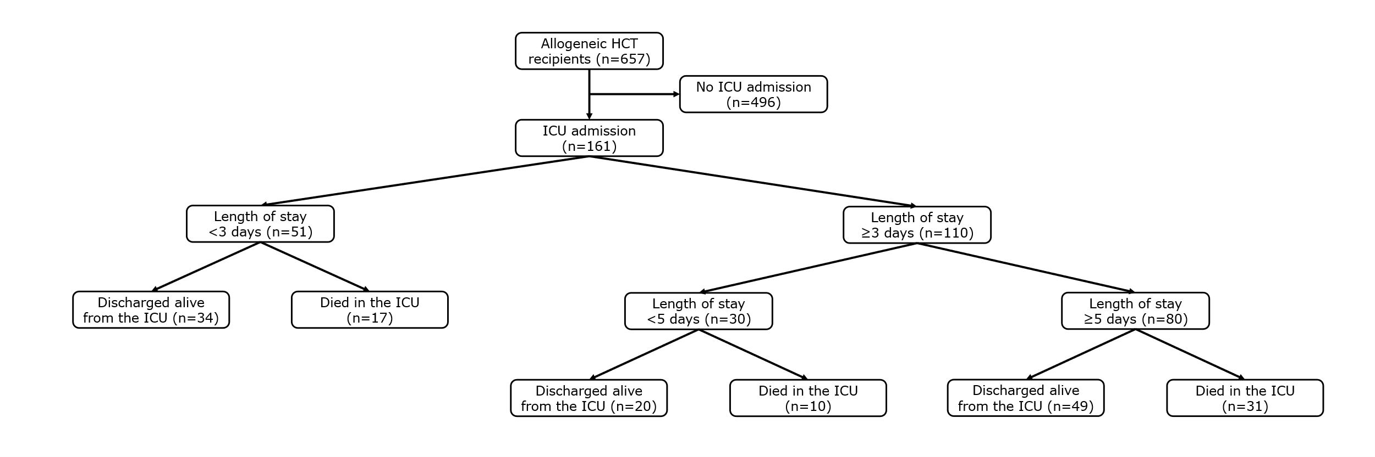

SUPPLEMENTARY FIGURE 2. Flow chart of allogeneic HCT recipients admitted to the ICU with description of states and transitions used in the multistate model.
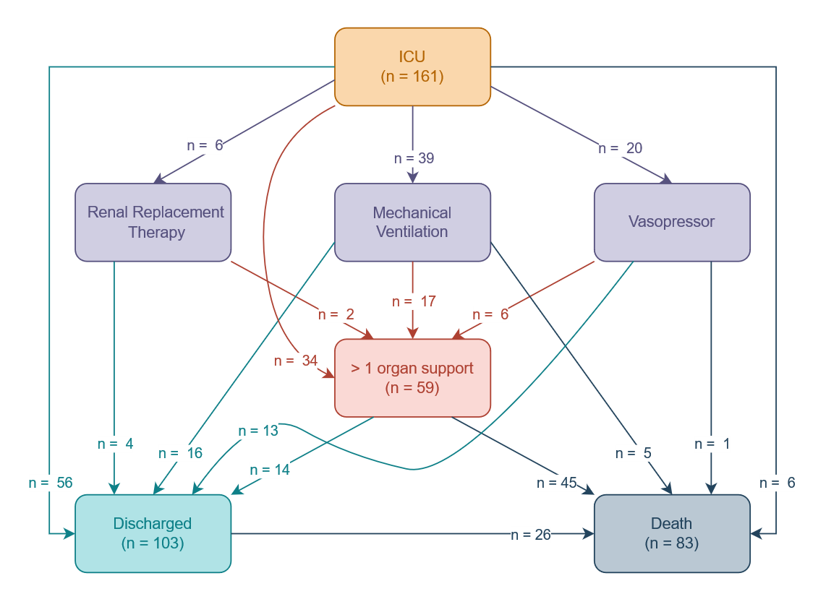

SUPPLEMENTARY FIGURE 3. Overall survival according to need for (A) mechanical ventilation, (B), renal replacement therapy, or (C) vasopressors.
A.
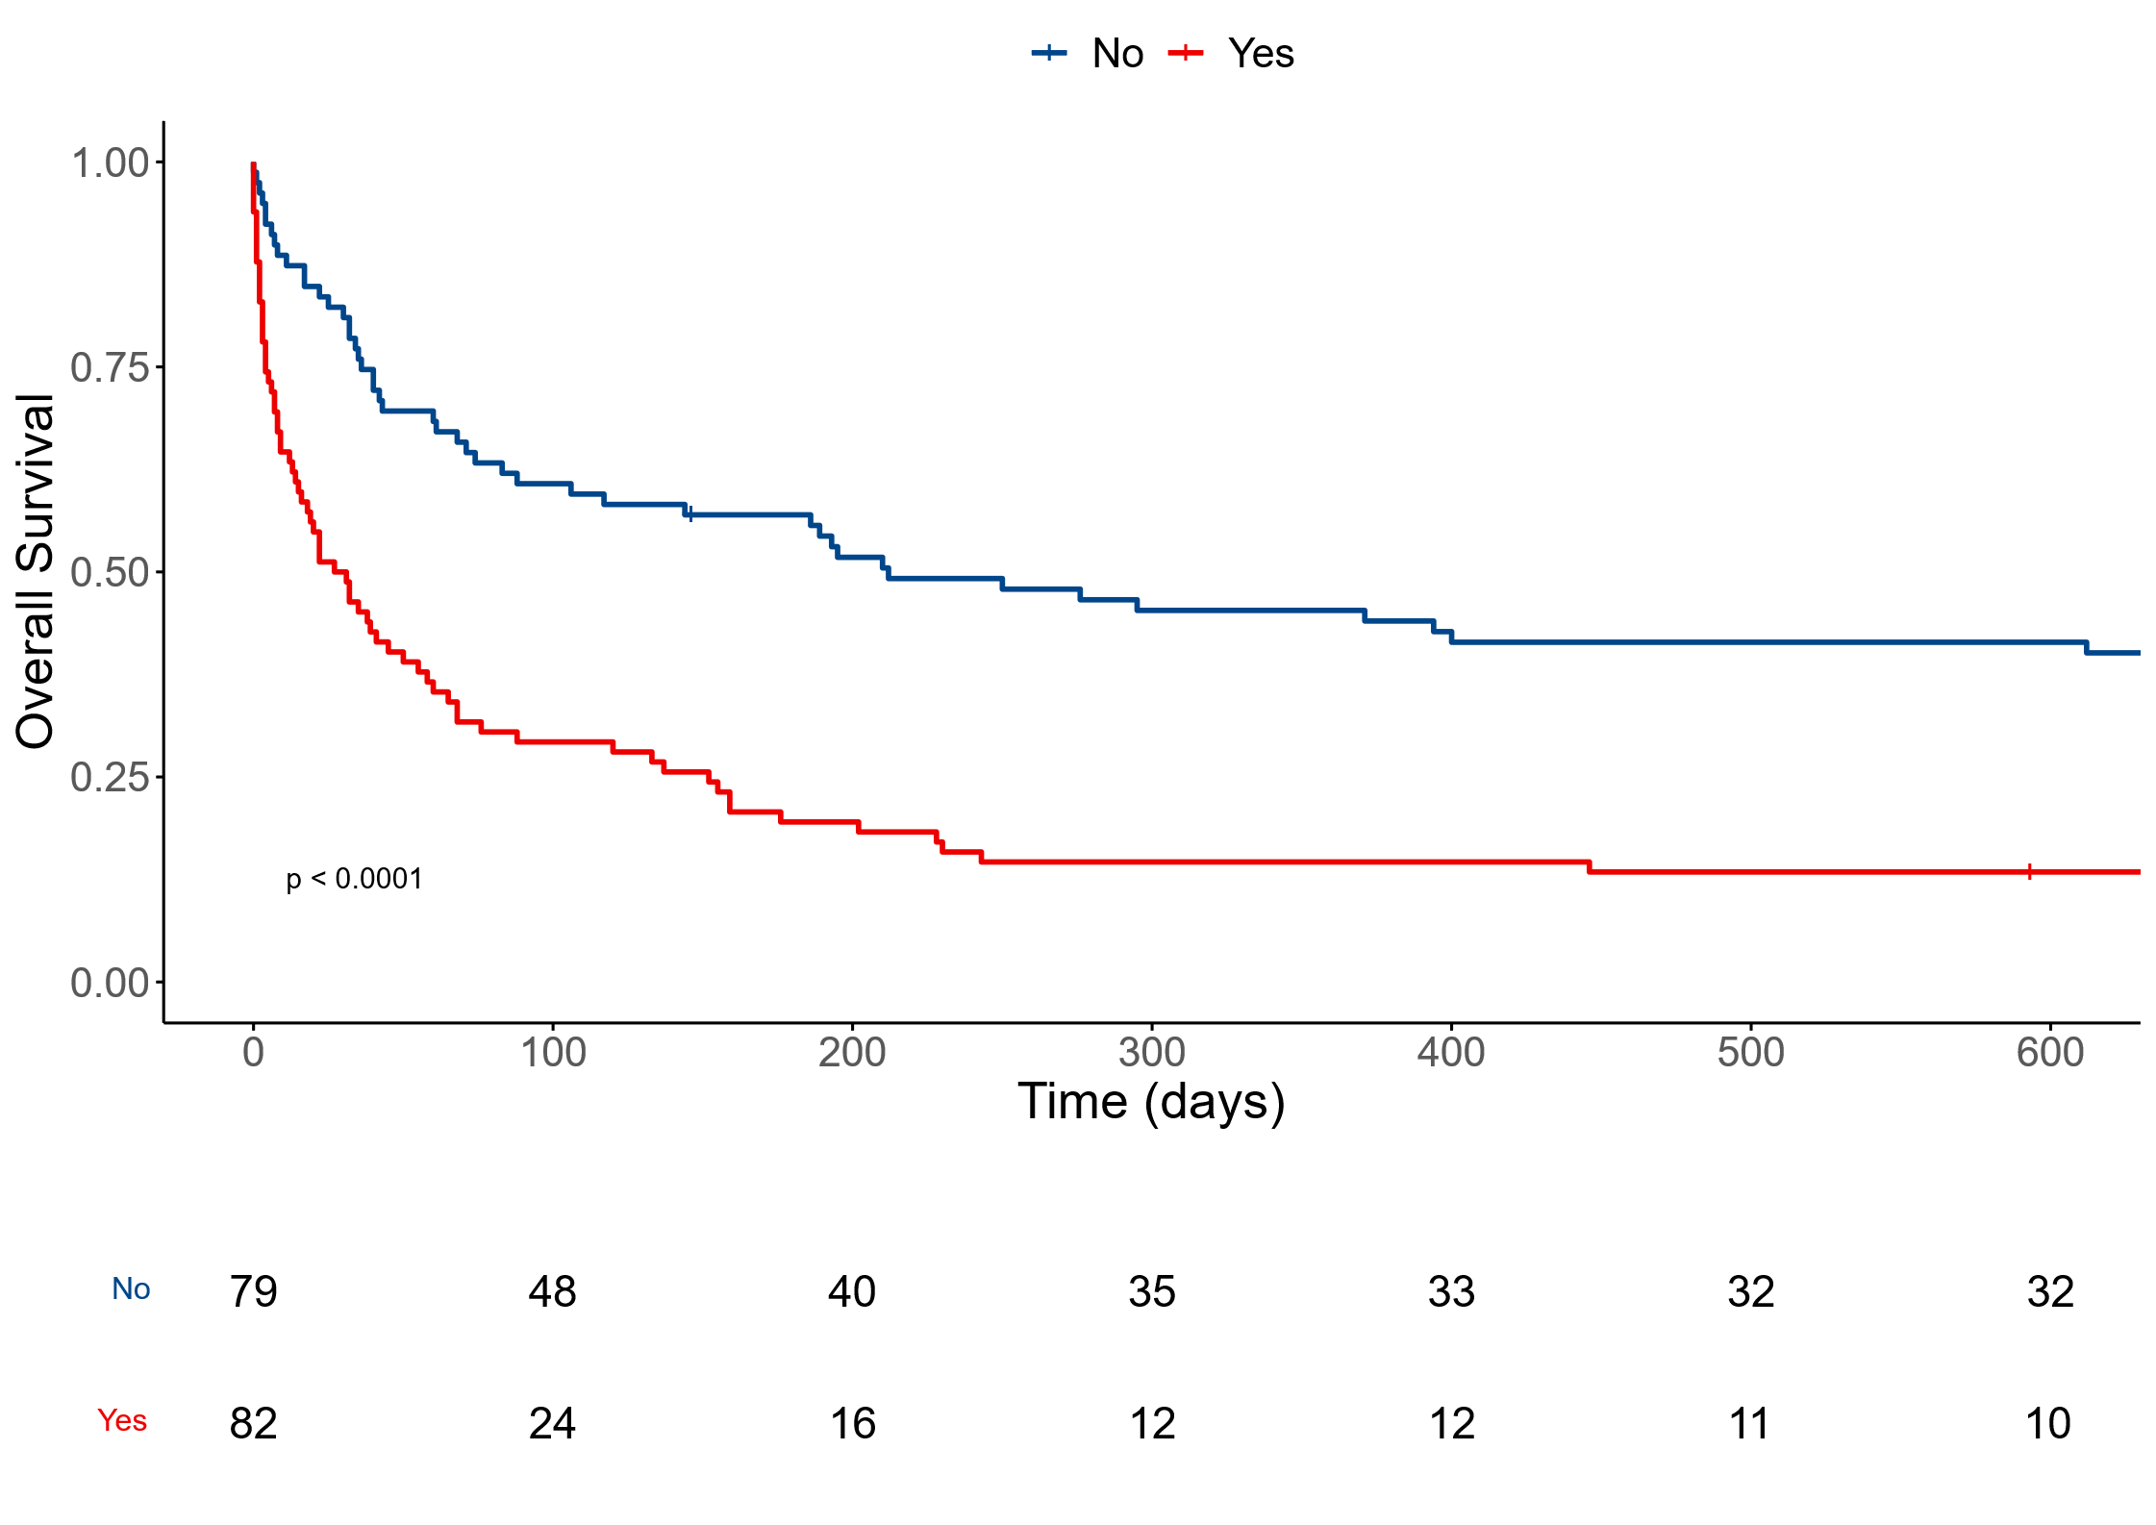
B.
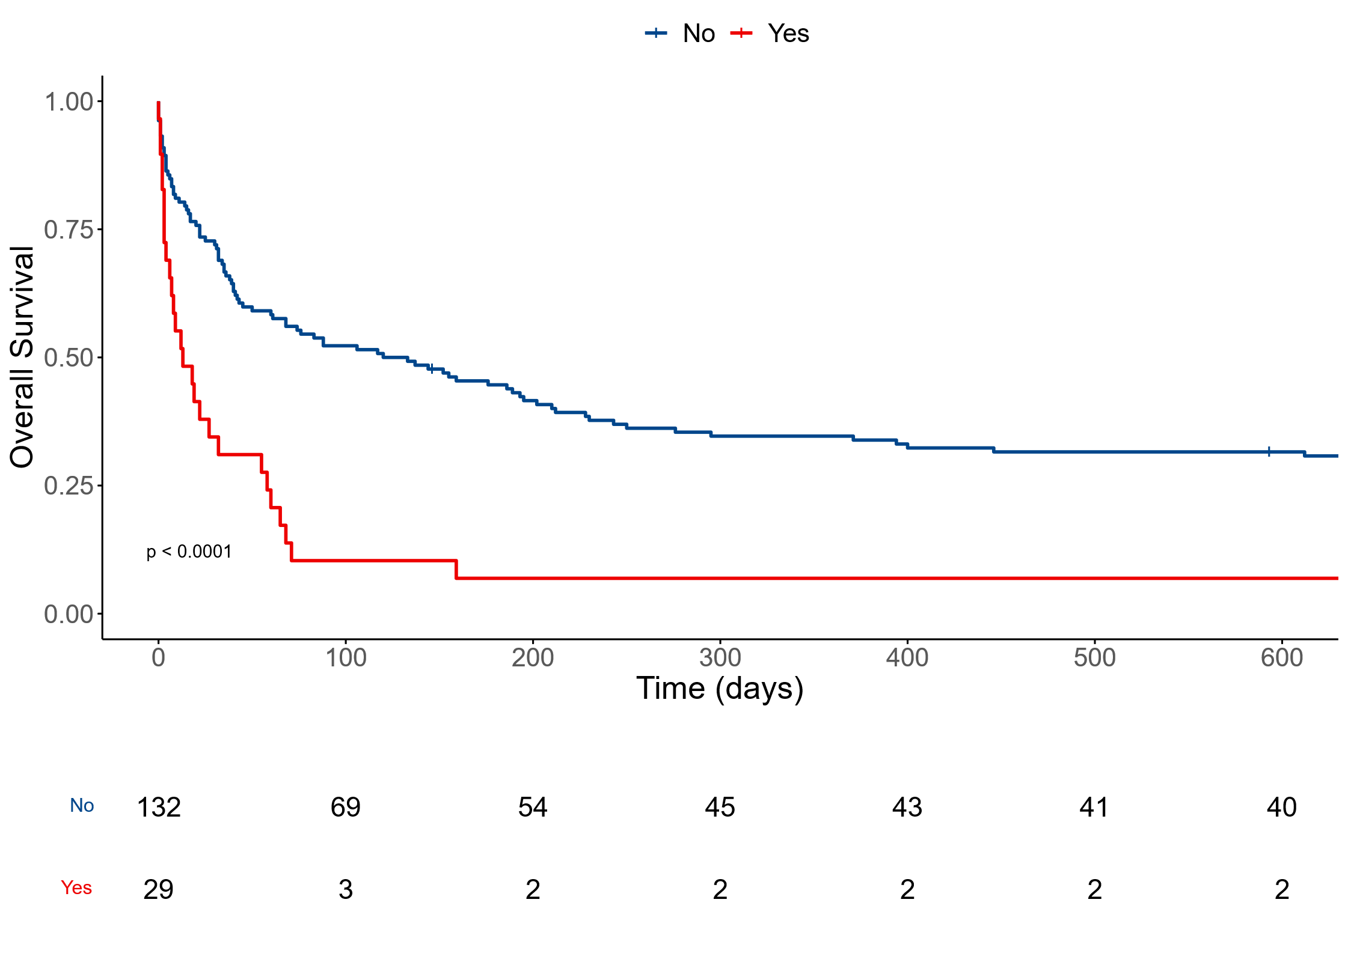

C.
