Supplementary Figure S1. Results of luminescence assay for compounds tested against seven human AML cell lines

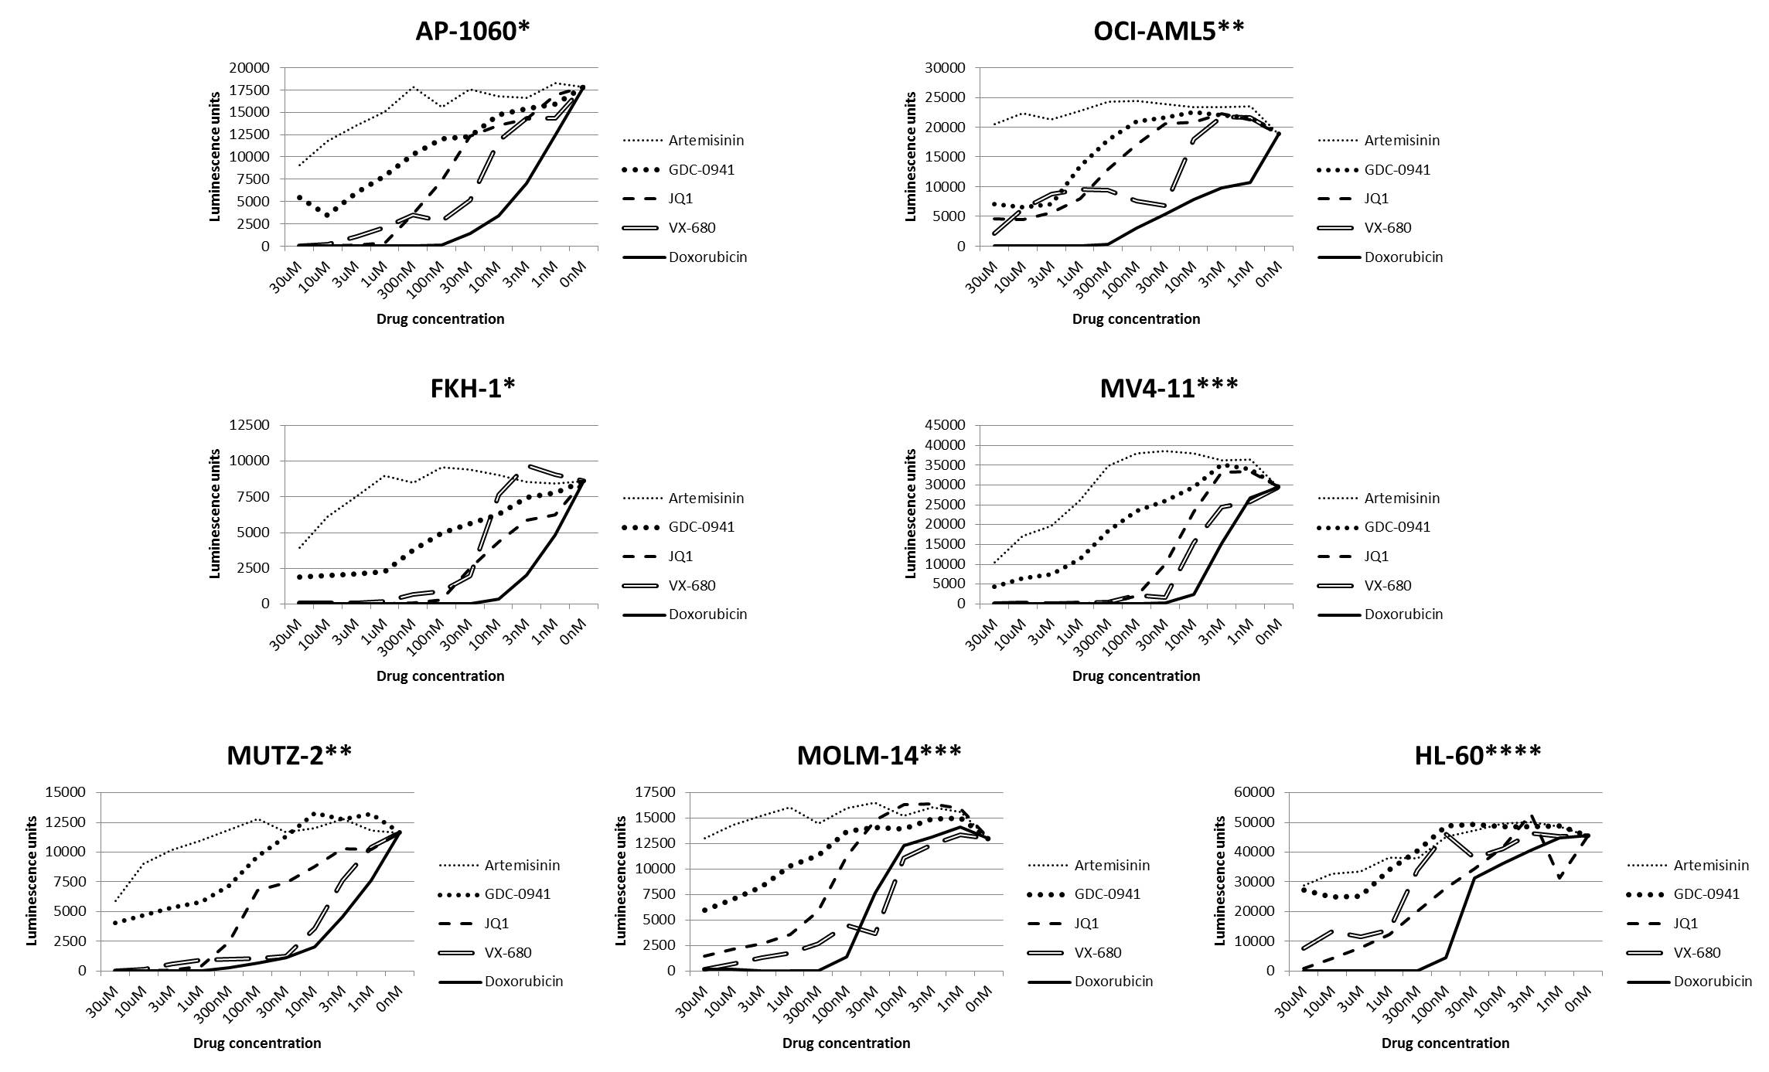

Supplementary Figure S1: a, AP-1060. b, OCI-AML5. c, FKH-1. d, MV4-11. e, MUTZ-2. f, MOLM-14. g, HL-60. Curves represent the average of two independent experiments. Luminescence at 0 nM drug concentration was determined by averaging five control wells. Luminescence units are reported as measured by a luminometer as part of the CellTiter-Glo assay. Cell lines are labeled by mechanism of MYC overexpression: *no known MYC overexpression; **trisomy 8; ***FLT3-ITD and gain of chromosome 8; ****MYC amplification.

