Supplementary Figure S2: MYC protein expression, at basal levels and following exposure to the drugs

a

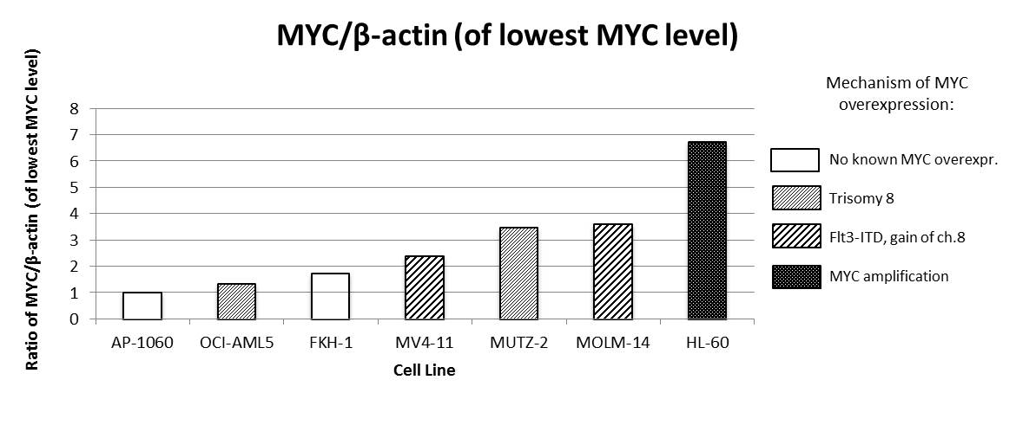

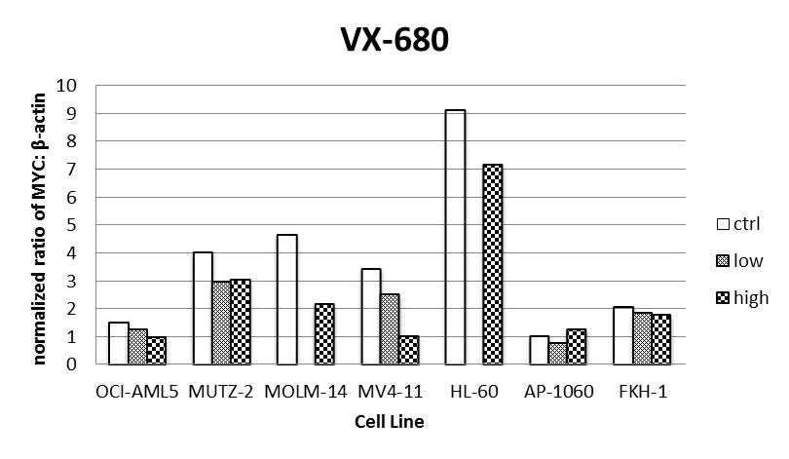
b

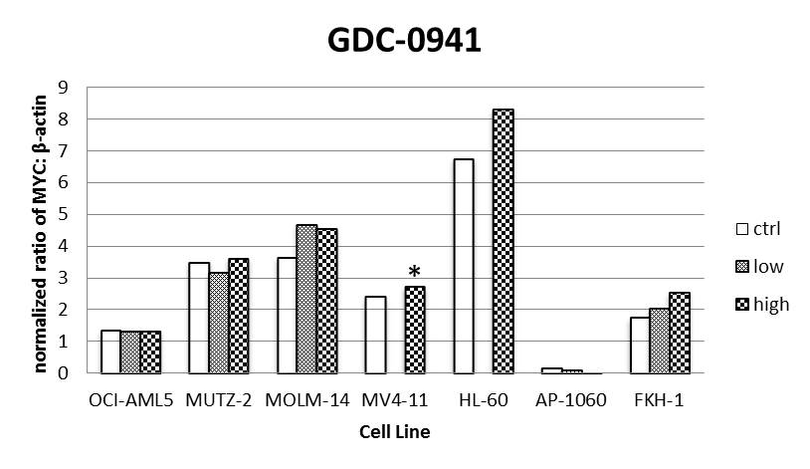
c

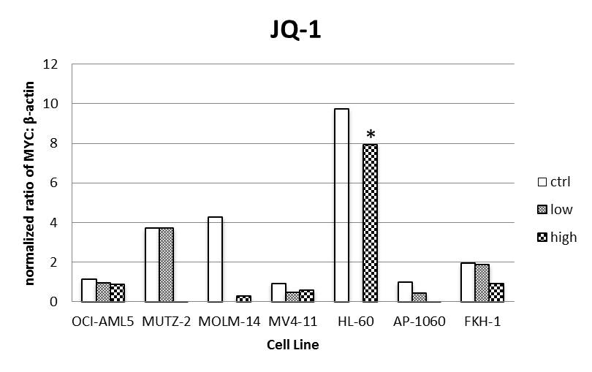
d

Supplementary Figure S2: a, MYC:β-actin ratios were determined from the Western blot presented in Fig. 3a (untreated samples were grown for one doubling time), and normalized to the cell line with the lowest MYC:β-actin ratio, AP-1060. b, MYC:β-actin ratios were calculated following treatment with VX-680 at concentrations spanning the GI50. c, MYC:β-actin ratios were calculated following treatment with GDC-0941 at concentrations spanning the GI50 (unless specified, see asterisk below). d, MYC:β-actin ratios were calculated following treatment with JQ1 at concentrations spanning the GI50 (unless specified, see asterisk below). Notes for Figures S3b-d in electronic supplementary material: in a few instances, only one drug concentration was investigated (above the GI50 in all cases); refer to Fig. 3b for the original Western Blots. *: in these two cases, the drug concentration tested isn’t immediately above the GI50 but rather another half-log unit higher, yet no decrease in MYC levels is observed at these higher drug concentrations (for MV4-11, GI50 for GDC-0941 was 212.7nM; for HL-60, GI50 for JQ-1 was 250.1nM).

