Supplementary Figure S3. Luminescence results of the CellTiter-Glo assay, plotted over drug concentration, with best-fit logistic regression, associated GI50 values, and R² correlation coefficients

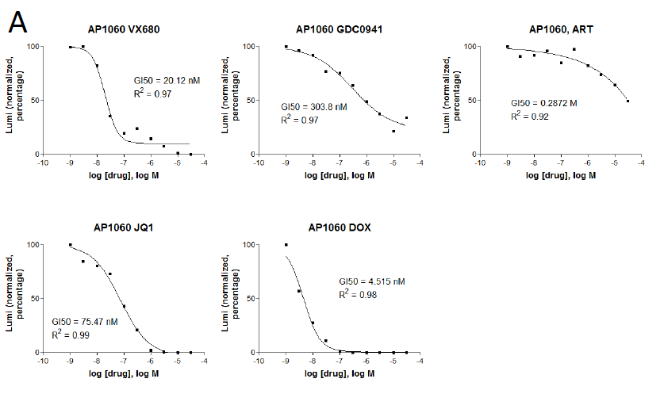
a

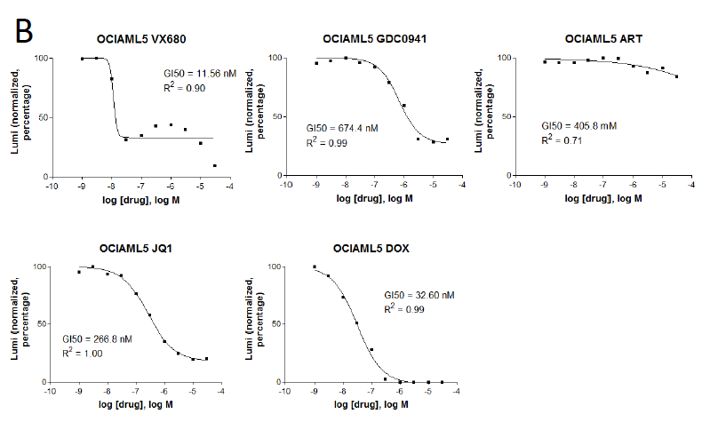
b

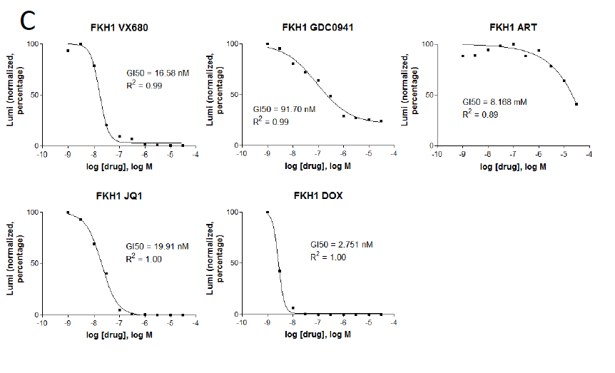
c

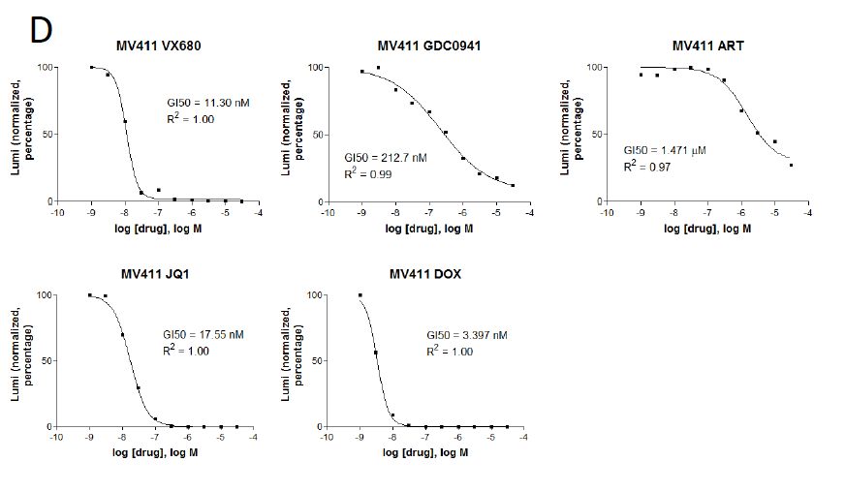
d

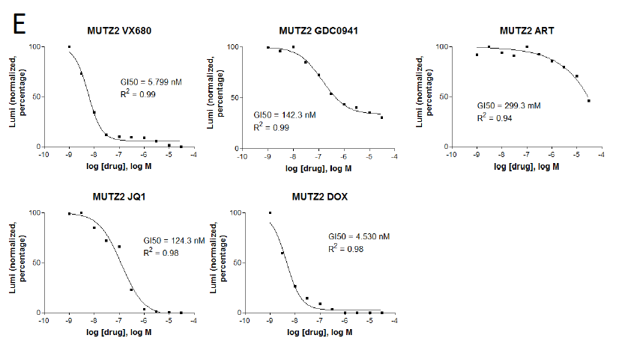
e

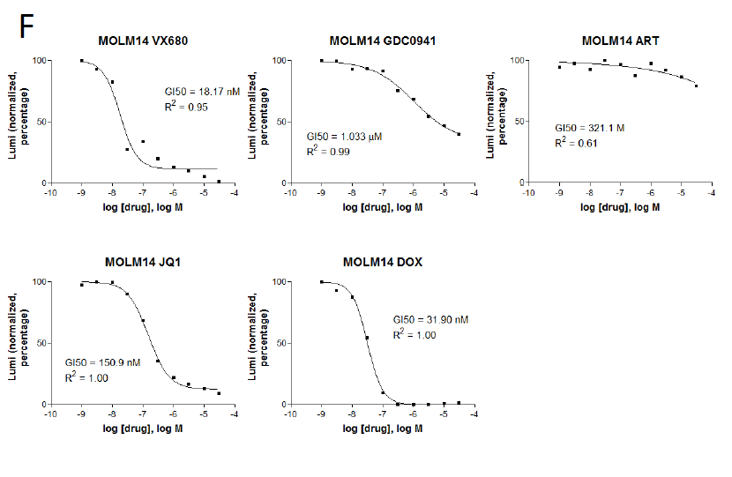
f

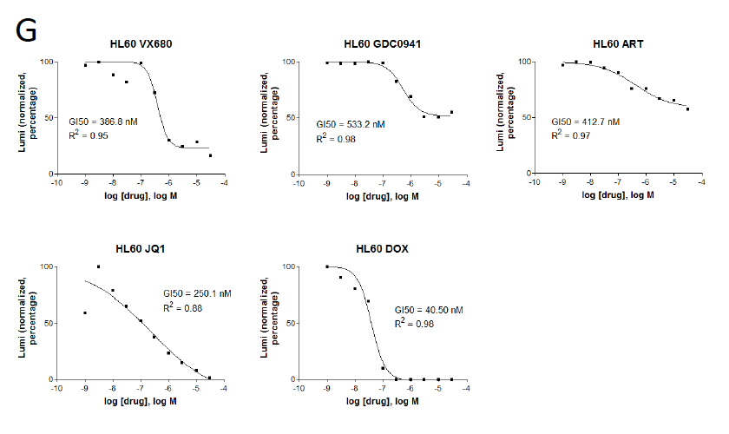
g

Supplementary Figure S3: a, AP-1060: no known MYC overexpression. b, OCI-AML5: characterized by trisomy 8. c, FKH-1: no known MYC overexpression. d, MV4-11: characterized by FLT3-ITD and trisomy 8. e, MUTZ-2: characterized by trisomy 8. f, MOLM-14: characterized by FLT3-ITD and trisomy 8. g, HL-60: characterized by MYC amplification. Abbreviations: ART, artemisinin; DOX, doxorubicin.

