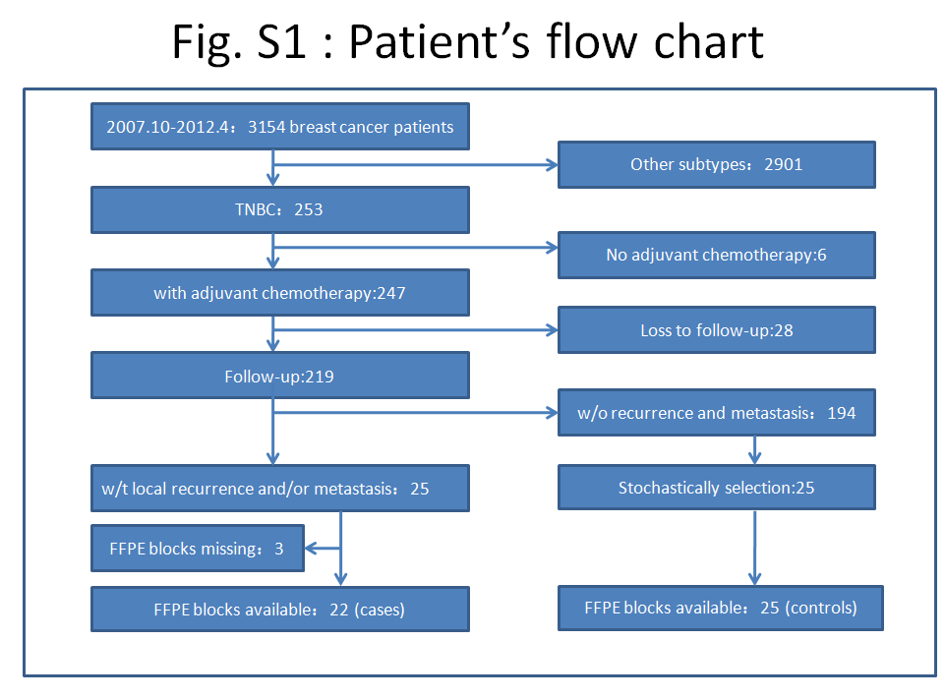
Table S１Relationshop between DFS and clinicopathological features in 47 patients
Characteristics | Total | Recurrence or Metastasis  Yes No |  | P value
Age (mean±SD) | 47 | 49.36±13.37 | 46.80±8.32 | 0.192
Menopausal status |  |  |  | 0.468
premenopausal  postmenopausal | 25  22 | 10  12 | 15  10
Tumor size (cm) |  |  |  | 0.746
≤2  ＞2 | 20  27 | 8  14 | 12  13
Number of positive LNs |  |  |  | 0.694
negative  positive | 8  39 | 3  19 | 5  20
Histologic grade |  |  |  | 0.335
Well and moderate  poor | 10  37 | 3  19 | 7  18
LVI |  |  |  | 0.689
positive  negative | 10  37 | 5  17 | 5  20
P53 expression |  |  |  | 0.378
positive  negative | 29  18 | 15  7 | 14  11
Ki-67 (%) |  |  |  | 0.613
＜14  ≥14 | 8  39 | 3  19 | 5  20
AJCC clinical stage |  |  |  | 0.430
Ⅰ  Ⅱ  Ⅲ | 5  18  24 | 1  10  11 | 4  8  13
FOXC1 expression |  |  |  | 0.027*
Positive  negative | 23  24 | 15  7 | 8  17

Table S２Relationship between OS and clinicopathological features in 47 patients
Characteristics | Total | Failure event  Yes No |  | P value
Age (mean±SD) | 47 | 48.17±13.37 | 47.94±10.92 | 0.828
Menopausal status |  |  |  | 0.718
premenopausal  postmenopausal | 25  22 | 7  5 | 18  17
Tumor size (cm) |  |  |  | 0.099
≤2  ＞2 | 20  27 | 5  7 | 15  20
Number of positive LNs |  |  |  | 0.947
negative  positive | 8  39 | 2  10 | 6  29
Histologic grade |  |  |  | 0.298
Well and moderate  poor | 10  37 | 1  11 | 9  26
LVI |  |  |  | 0.200
positive  negative | 10  37 | 4  8 | 6  29
P53 expression |  |  |  | 0.439
positive  negative | 29  18 | 6  6 | 23  12
Ki-67 (%) |  |  |  | 0.983
＜14  ≥14 | 8  39 | 2  10 | 6  29
AJCC clinical stage |  |  |  | 0.275
Ⅰ  Ⅱ  Ⅲ | 5  18  24 | 1  3  8 | 4  15  16
FOXC1 expression |  |  |  | 0.147
Positive  negative | 23  24 | 8  4 | 15  20

Table S３FOXC1’S correlation with DFS in groups based on different chemotherapy regimens
Chemotherapy regimen | FOXC1 | Total | Recurrence or metastasis  Yes No |  | χ2 | P-value
TA:36 | positive  negative | 16  20 | 10  7 | 6  13 | 1.32 | 0.25
A:44 | positive  negative | 21  23 | 14  7 | 7  16 | 3.96 | 0.03*
T:39 | positive  negative | 18  21 | 11  7 | 7  14 | 1.51 | 0.22
C:29 | positive  negative | 14  15 | 8  4 | 6  11 | 2.34 | 0.13
CA:25 | positive  negative | 12  13 | 7  4 | 5  9 | 1.61 | 0.20

Table S４ FOXC1’S correlation with OS in groups based on different chemotherapy regimens
Chemotherapy regimen | FOXC1 | Total | Recurrence or metastasis  Yes No |  | χ2 | P-value
TA:36 | positive  negative | 16  20 | 4  4 | 12  16 | 0.11 | 0.74
A:44 | positive  negative | 21  23 | 8  4 | 13  19 | 0.56 | 0.13
T:39 | positive  negative | 18  21 | 4  4 | 14  17 | 0.006 | 0.94
C:29 | positive  negative | 14  15 | 4  2 | 10  13 | 1.04 | 0.31
CA:25 | positive  negative | 12  13 | 4  2 | 8  11 | 1.12 | 0.29

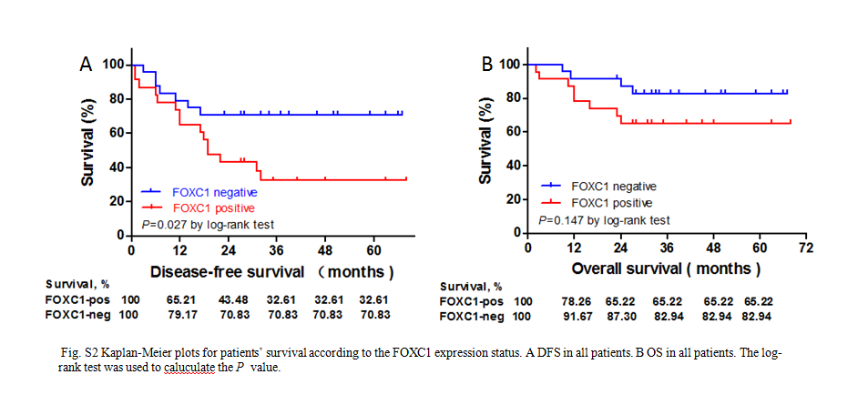

Table S５ Uni- and Multivariate analysis of parameters that predict OS in TNBC using anthracyclines in adjuvant settings by Cox regression analysis
Prognostic factor | HR | 95%CI～ | P-value
Univariate analysis
FOXC1 expression  Patient age  Menopausal status  Tumor size  Tumor grade  LVI  Lymph node status  P53  Ki-67 | 2.53  1.01  1.16  1.64  0.31  2.00  1.16  0.68  1.71 | 0.76～8.40  0.95～1.07  0.37～3.66  1.12～2.40  0.04～2.37  0.60～6.64  0.25～5.28  0.22～2.11  0.51～5.68 | 0.13  0.77  0.80  0.01*  0.26  0.26  0.85  0.51  0.38
Multivatiate analysis
FOXC1 expression  Tumor size | 2.55  1.62 | 0.76～8.54  1.12～2.36 | 0.13  0.01*

Table S6 More detail results of IHC according to the criteria
No. | Percentage of Positive cells (PP) (%) | Scale of PP | Scale of Staining Intensity (SI) | Arithmetic Product of PP and SI scale | FOXC1 expression
1 | 60 | 3 | 1 | 3 | negative
2 | 0 | 0 | 0 | 0 | negative
3 | ＞75 | 4 | 3 | 12 | positive
4 | 75 | 4 | 1 | 4 | positive
5 | ＞75 | 4 | 2 | 8 | positive
6 | 75 | 4 | 2 | 8 | positive
7 | ＞75 | 4 | 2 | 8 | positive
8 | 10 | 2 | 3 | 6 | positive
9 | 0 | 0 | 0 | 0 | negative
10 | 0 | 0 | 0 | 0 | negative
11 | 60 | 3 | 1 | 3 | negative
12 | ＞75 | 4 | 3 | 12 | positive
13 | 30 | 2 | 2 | 4 | positive
14 | 10 | 2 | 3 | 6 | positive
15 | 75 | 4 | 2 | 8 | positive
16 | 50 | 3 | 3 | 9 | positive
17 | 0 | 0 | 0 | 0 | negative
18 | 0 | 0 | 0 | 0 | negative
19 | 10 | 2 | 3 | 6 | positive
20 | ＞75 | 4 | 1 | 4 | positive
21 | 30 | 2 | 2 | 4 | positive
22 | ＞75 | 4 | 1 | 4 | positive
23 | 30 | 2 | 2 | 4 | positive
24 | 10 | 2 | 1 | 2 | negative
25 | 60 | 3 | 2 | 6 | positive
26 | 60 | 3 | 2 | 6 | positive
27 | 60 | 3 | 2 | 6 | positive
28 | 0 | 0 | 0 | 0 | negative
29 | 75 | 3 | 1 | 3 | negative
30 | 0 | 0 | 0 | 0 | negative
31 | 30 | 2 | 2 | 4 | positive
32 | 15 | 2 | 2 | 4 | positive
33 | 10 | 2 | 1 | 2 | negative
34 | 10 | 2 | 1 | 2 | negative
35 | 30 | 2 | 1 | 2 | negative
36 | 0 | 0 | 0 | 0 | negative
37 | 0 | 0 | 0 | 0 | negative
38 | 0 | 0 | 0 | 0 | negative
39 | 0 | 0 | 0 | 0 | negative
40 | 0 | 0 | 0 | 0 | negative
41 | 0 | 0 | 0 | 0 | negative
42 | 10 | 2 | 1 | 2 | negative
43 | 50 | 2 | 1 | 2 | negative
44 | 0 | 0 | 0 | 0 | negative
45 | ＞75 | 4 | 3 | 12 | positive
46 | 75 | 4 | 2 | 8 | positive
47 | 0 | 0 | 0 | 0 | negative

