Supplemental Figures
Suppl. Fig. 1. Homogeneous particle size distribution after micronization via rapid change in solvent. Size distribution of metarrestin particles (differential distribution of particle size (in µm; x-axis) versus relative distribution (%; y-axis) by size exclusion chromatography) before (left) and after (right) particle size reduction.

Suppl. Fig. 2. Synthesis scheme to boron-dipyrromethene (BODIPY) labeled analog of metarrestin. Activity of analogs in PC3M cells.
NCGC00247785
Metarrestin
PNC IC₅₀ = 0.397μM
NCGC00244845
Metarrestin analog
PNC IC₅₀ = 0.089μM
NCGC00387350
BODIPY tagged metarrestin analog
PNC IC₅₀ = 3.317μM

Suppl. Fig. 3. HPLC chromatogram (top) of hepatocytes incubated for 4 hours with metarrestin (NCG00247785). Extracted ions chromatogram (below) of peaks: 474 (parent) and metabolites 490a, 490b, 472.

Suppl. Fig. 4. Predicted metabolic pathways of metarrestin with MS/MS spectra of metabolites and structure elucidation.

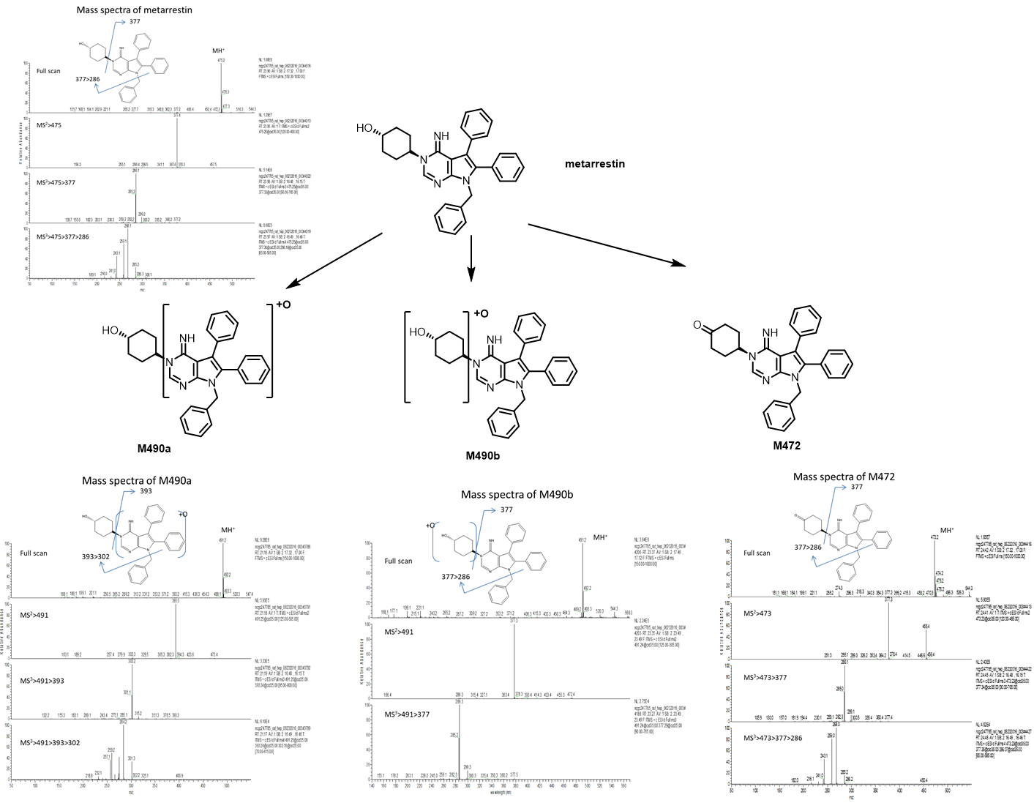

Suppl. Fig. 5. Synthesis and characterization of keto metarrestin. Metarrestin (200 mg, 0.421 mmol) was taken in DMSO (5 mL) and treated with Burgess Reagent (131mg, 0.548 mmol) under nitrogen according to the method described in literature. The reaction was stirred for 2 hours. Analysis via LCMS revealed very little ketone formation. The mixture was diluted with ethyl acetate and washed with water. The top ethyl acetate layer was dried with anhydrous magnesium sulfate which was filtered off. The filtrate was concentrated and subjected to purification by flash silica gel chromatography. This provided a fraction that was enriched with the ketone but still had metarrestin. A portion of this was loaded on a thin layer 20x20 cm glass plate with 1mm silica gel and eluted with 5-10% methanol in dichloromethane twice to provide a sample of the ketone derivative of metarrestin that was not contaminated with metarrestin (~7% yield).
¹H NMR (400 MHz, Chloroform-d) δ 7.75 (s, 1H), 7.33 – 7.15 (m, 11H), 7.11 – 7.01 (m, 2H), 6.99 – 6.91 (m, 2H), 5.69 – 5.49 (m, 1H), 5.28 (s, 2H), 2.73 – 2.60 (m, 2H), 2.60 – 2.50 (m, 2H), 2.46 - 2.36 (m, 2H), 2.05 (qd, J = 12.8, 4.5 Hz, 2H).
LCMS of purified metarrestin ketone:

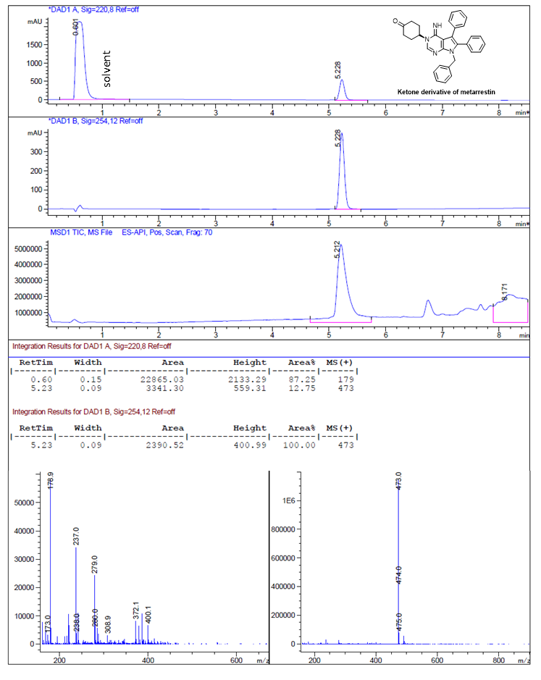

Suppl. Fig. 6. PNC disassembly of metarrestin (blue) vs keto-metarrestin (red) in P3CM cells (N=2 independent experiments; in triplicates; top). Representative images of PNC treated with vehicle (left) and at 10µM keto-metarrestin are shown on the bottom. Arrows (white) indicate peri-nucleolar compartment (PNC).

Suppl. Fig. 7. Metarrestin does not induce cell death in KPC tumors treated with 25mg/kg metarrestin by gavage (PO) for 14 days. Nuclear cleaved caspase 3 expression levels in metarrestin-treated KPC tumors. Representative images of cleaved caspase 3 immunohistochemistry in tumors of KPC mice treated with vehicle (top) or 25mg/kg metarrestin for 14 days (bottom). Images 20×, inset 40×.

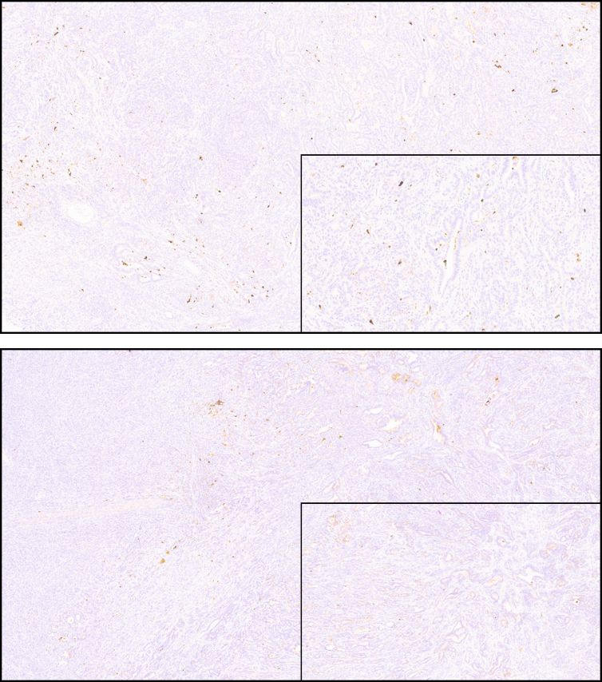

Suppl. Fig. 8. Relative mRNA expression of 18 genes with dysregulated expression in vehicle-treated KPC tumors and normalized expression (relative to non-tumor uninvolved pancreas) in KPC tumors treated with a 10mg/kg metarrestin diet, identified from RNA-seq gene expression profiling of KPC tumors.

Supplemental Tables
Suppl. Table 1. Validation of quantitative metarrestin analysis assay, mouse plasma. Intraday (n=6) and interday (n=18, three repeats) results. CV, coefficient of variance.
QC Conc (ng/mL) | Intraday |  |  | Interday
QC Conc (ng/mL) | Conc (ng/mL) | CV (%) | Deviation from nominal values (%) | Conc (ng/mL) | CV (%) | Deviation from nominal values (%)
LOQ (1.00) | 1.05 | 2.3 | +5 | 0.956 | 9.0 | -4
MQC (10.0) | 9.69 | 3.1 | -3 | 9.32 | 4.5 | -7
HQC (1000) | 937 | 8.2 | -6 | 1050 | 2.9 | +5

Suppl. Table 2. Validation of quantitative metarrestin analysis assay, mouse liver tissue. Intraday (n=6) and interday (n=18, three repeats) results.
QC Conc (ng/g) | Intraday |  |  | Interday
QC Conc (ng/g) | Conc (ng/g) | CV (%) | Deviation from nominal values (%) | Conc (ng/g) | CV (%) | Deviation from nominal values (%)
LOQ (5.00) | 5.01 | 8.4 | 0 | 4.81 | 7.0 | +4
MQC (500) | 513 | 3.3 | +3 | 510 | 8.1 | +2
HQC (20000) | 19500 | 4.4 | -3 | 19600 | 4.1 | -2

Suppl. Table 3. Preliminary toxicity profile of 10 female and 10 male Balb/c mice treated with vehicle (Group 1) and 25mg/kg metarrestin by PO gavage (Group 2) for 14 days (K, potassium; CRE, creatinine; P04, phosphorus; ALP, alkaline phosphatase; ALT, alanine transaminase; AST, aspartate transaminase; LD, lactate dehydrogenase; TP, total protein; GLOB, globulin; CHOL, cholesterol).
Mortality and Clinical Observation
Males | Group 1 | Group 2
N=10 | 0 mg/kg | 25 mg/kg
Death | 0 | 0
Hypoactivity | 0 | 0
Rough coat | 0 | 6
Cold to touch | 0 | 0
Thin | 0 | 0
Scant feces | 0 | 0
Females | Group 1 | Group 2
N=10 | 0 mg/kg | 25 mg/kg
Death | 0 | 0
Rough coat | 0 | 0
Scant feces | 0 | 0
Weight
Males | Group 1 | Group 2
N=10 | 0 mg/kg | 25 mg/kg
Day 1 | 31.1 ±1.73 | 31.4 ± 1.38
Day 7 | 32.4 ± 2.01 | 33.3 ± 2.02
Day 15 | 33.2 ± 2.46 | 34.4 ± 2.33
Females | Group 1 | Group 2
N=10 | 0 mg/kg | 25 mg/kg
Day 1 | 23.2 ± 1.66 | 23.1 ± 1.55
Day 7 | 24.1 ± 2.00 | 24.3 ± 1.32
Day 15 | 25.7 ± 2.20 | 25.8 ± 1.70
Weight Change
Males | Group 1 | Group 2
N=10 | 0 mg/kg | 25 mg/kg
Day 1 to 4 | 1.0 ± 0.64 | 1.1 ± 0.90
Day 4 to 7 | 0.3 ± 0.64 | 0.9 ± 0.59
Day 1 to 15 | 2.1 ± 1.23 | 3.1 ± 1.51
Females | Group 1 | Group 2
N=10 | 0 mg/kg | 25 mg/kg
Day 1 to 4 | 0.0 ± 0.88 | 0.0 ± 0.80
Day 4 to 7 | 0.9 ± 0.92 | 1.2 ±0.67
Day 1 to 15 | 2.5 ± 1.44 | 2.7 ± 1.04
Liver chemistry
Males | Group 1 | Group 2
Males | 0 mg/kg | 25 mg/kg
K | 7.3 ±0.28 | 7.3 ± 0.21
CRE | 0.11 ± 0.018 | 0.09 ± 0.015*
P04 | 9.9 ± 1.09 | 10.2 ± 0.50
ALP | 81 ± 12.3 | 84 ± 13.5
ALT | 175 ±86.9 | 137 ± 67.4
AST | 137 ± 67.4 | 88 ± 24.3
LD | 172 ± 37.6 | 659 ± 154.6
Females | Group 1 | Group 2
Females | 0 mg/kg | 25 mg/kg
TP | 5.2 ± 0.29 | 5.2 ± 0.21
GLOB | 2.0 ± 0.18 | 2.1 ± 0.13
ALP | 135 ± 33.9 | 136 ± 13.8
CHOL | 125 ± 9.1 | 123 ± 18.4
ALT | 77 ± 23.0 | 100 ± 47.6
AST | 105 ± 30.4 | 100 ± 28.3
LD | 591 ± 147.9 | 495 ± 89.7

Suppl. Table 4. Mean Day 10 metarrestin concentration in plasma and tumor at steady-state with 10 mg/kg/day (70 ppm) metarrestin chow dosing in tumor-bearing KPC mice.
Time (hr) | 0 | 3 | 6 | 9 | 12 | 15 | 24
Plasma concentration (μM) | 0.46 | 0.33 | 0.30 | 0.50 | 0.43 | 0.36 | 0.27
Tumor concentration (μM) | 7.9 | 10.3 | 8.0 | 10.8 | 10.7 | 7.2 | 6.7

Suppl. Table 5. Metarrestin pharmacokinetics in tumor-bearing KPC mice on day 10 after multiple oral dose treatment on food metarrestin chow (target dose: 10 mg/kg/day for 10 days).
 | Plasma | Tumor | Spleen | Liver
AUC_{0-24hr} (ng●hr/mL) | 4160 | 96100 | 109000 | 153000
T_{max} (hr) | 9 | 9 | 15 | 12
C_{max} (ng/mL) | 237 | 5100 | 5840 | 7250
AUC_{0-24hr} Ratio (Tissue/Plasma) |  | 23 | 26 | 37

