Supplementary Figure 1. Representative LC-Radioprofiles of Plasma (A), Urine (B) and Feces (C) Samples
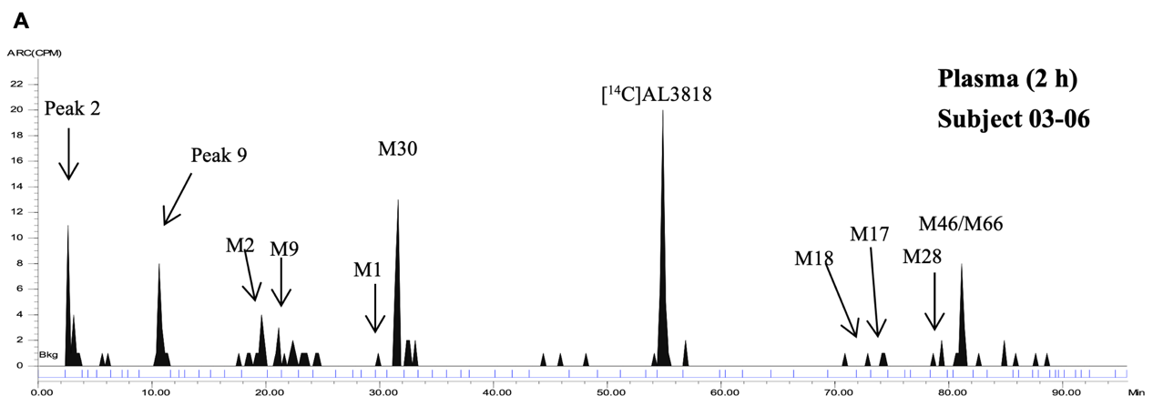
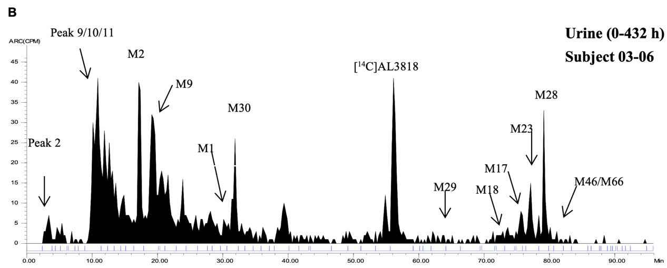
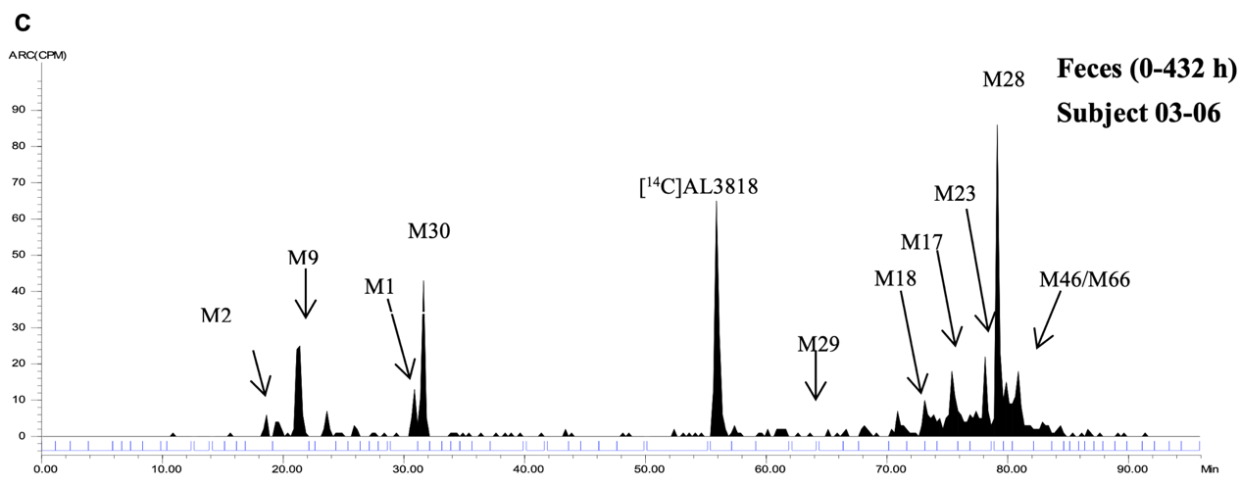
AL3818: Anlotinib

