Supplementary Materials
Online resource 1 Kaplan–Meier plots of overall survival by (a) quartiles of glasdegib cycle 1 AUC and (b) quartiles of glasdegib cycle 1 C_{max}. AUC area under the concentration–time curve, AUCQ AUC quartile, C_{max} maximum concentration, C_{max}Q C_{max} quartile, OS overall survival
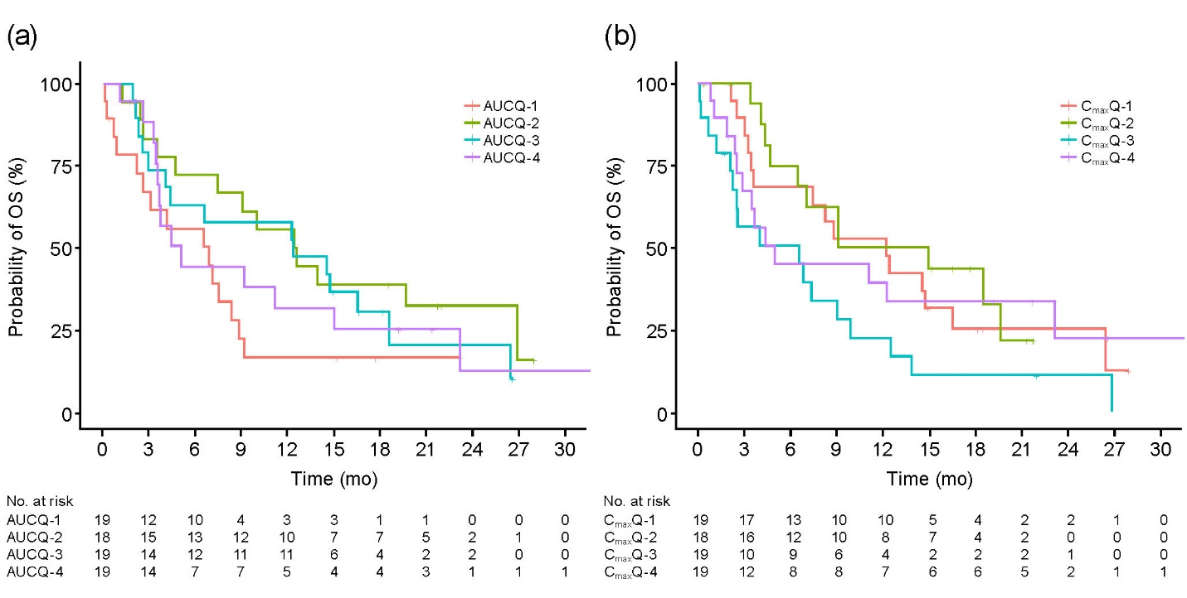

Online resource 2 Number of patients in each treatment arm, by disease setting and study phase

Treatment arm | Study phase | Disease setting | Patients, n
Glasdegib + LDAC | 1b | AML | 20
Glasdegib + LDAC | 1b | MDS | 3
Glasdegib + decitabine | 1b | AML | 5
Glasdegib + decitabine | 1b | MDS | 2
Glasdegib + LDAC | 2 | AML | 78
Glasdegib + LDAC | 2 | MDS | 10
LDAC alone | 2 | AML | 38
LDAC alone | 2 | MDS | 6
AML acute myeloid leukemia, LDAC low-dose cytarabine, MDS myelodysplatic syndrome

