SUPPLEMENTARY MATERIAL
First-in-human, open-label, phase 1/2 study of the monoclonal antibody PD-1 inhibitor cetrelimab (JNJ-63723283) in patients with advanced cancers
Enriqueta Felip¹ ∙ Victor Moreno² ∙ Daniel Morgensztern³ ∙ Giuseppe Curigliano⁴ ∙ Piotr Rutkowski⁵ ∙ José Manuel Trigo⁶ ∙ Aitana Calvo⁷ ∙ Dariusz Kowalski⁵ ∙ Diego Cortinovis⁸ ∙ Ruth Plummer⁹ ∙ Michele Maio¹⁰ ∙ Paolo A. Ascierto¹¹ ∙ Vladimir I. Vladimirov¹² ∙ Andres Cervantes¹³ ∙ Enrique Zudaire¹⁴ ∙ Anasuya Hazra¹⁴ ∙ Huybrecht T’jollyn¹⁵ ∙ Nibedita Bandyopadhyay¹⁶ ∙ James G. Greger¹⁴ ∙ Edward Attiyeh¹⁴ ∙ Hong Xie¹⁴ ∙ Emiliano Calvo^{17,}∗
¹ Thoracic Cancer Unit, Oncology Department, Vall d’Hebron University Hospital, Vall d’Hebron Institute of Oncology, Barcelona, Spain
² Phase 1 Trials Unit, START MADRID-FJD, Hospital Fundación Jiménez Díaz Medical Oncology Division, Madrid, Spain
³ Division of Oncology, Section of Medical Oncology, Washington University School of Medicine, St. Louis, MO, USA
⁴ Division of Early Drug Development, European Institute of Oncology, IRCCS and University of Milano, Milan, Italy
⁵ Department of Soft Tissue/Bone Sarcoma and Melanoma, Maria Sklodowska-Curie National Research Institute of Oncology, Warsaw, Poland
⁶ Department of Medical Oncology, Hospital Universitario Virgen de la Victoria y Regional, Malaga, Spain
⁷ Oncology Service, Hospital General Universitario Gregorio Maranon, Madrid, Spain
⁸ Oncology Unit, San Gerardo Hospital, Monza, Italy
⁹ Sir Bobby Robson Unit, Northern Centre for Cancer Care, Newcastle, Newcastle Hospitals NHS Trust and Newcastle University, UK
¹⁰ Oncological Immunotherapy, Azienda Ospedaliera Universitaria Senese, Siena, Italy
¹¹ Unit of Melanoma, Cancer Immunotherapy and Development Therapeutics, Istituto Nazionale Tumori- IRCCS-Fondazione Pascale, Napoli, Italy
¹² Pyatigorsky Oncology Dispensary, Pyatigorsk, Russia
¹³ Medical Oncology Department, INCLIVA Biomedical Research Institute. University of Valencia, Valencia, Spain
¹⁴ Janssen R&D, Spring House, PA, USA
¹⁵ Janssen R&D, Beerse, Belgium
¹⁶ Janssen R&D, Raritan, NJ, USA
¹⁷ START Madrid-CIOCC, Centro Integral Oncológico Clara Campal Medical Oncology Division, Sanchinarro University Hospital, Madrid, Spain
CONTENTS
Online Resource 1 Pharmacokinetic results after the first IV administration of cetrelimab 80, 240, 460, 480, and 800 mg 1
Online Resource 2 Mean (SD) serum concentration–time profiles of cetrelimab at 480 mg IV Q4W administration of frozen liquid, lyophilized drug and as pooled formulation 2
Online Resource 3 Pharmacokinetic results at steady state (Dose 5 for 480 mg Q4W IV; Dose 9 for 240 mg Q2W IV) 3
Online Resource 4 Serum concentrations of cetrelimab predose and at end of infusion after each IV 240 mg dose (phase 2) 4
Online Resource 5 Summary of serum cetrelimab concentrations by anti-cetrelimab antibodies status in patients who received cetrelimab 240 mg IV Q2W in the phase 2 part of LUC1001 5
Online Resource 6 Pharmacodynamic effects of cetrelimab on (a) IP10 and (b) IL2Ra 6
Online Resource 7 Progression-free survival for patients with NSCLC, melanoma, and MSI-H / dMMR CRC 7
Online Resource 8 Overall survival for patients with NSCLC, melanoma, and MSI-H / dMMR CRC 8
Online Resource 9 Response and duration of treatment for patients with NSCLC (N = 35) 9
Online Resource 10 Response and duration of treatment for patients with melanoma (N = 50) 10
Online Resource 11 Response and duration of treatment for patients with MSI-H/dMMR colorectal cancer (N = 48) 11

Online Resource 1 Pharmacokinetic results after the first IV administration of cetrelimab 80, 240, 460, 480, and 800 mg
 | IV 80 mg  n = 4ª | IV 240 mg  n = 16^{a,b} | IV 460 mg  n = 4ª | IV 480 mg  n = 22^{a,b,c} | IV 800 mg  n = 6^{a,d}
C_{max}, µg/mL, mean (SD) | 24.7 (3.6) | 72.7 (17.8) | 148.0 (8.4) | 164.0 (40.9) | 227.0 (53.9)
T_{max}, h, median (range) | 2.0 (1.0–3.1) | 1.2 (1.0–5.2) | 2.4 (1.3–3.4) | 3.0 (1.0–5.1) | 3.2 (1.0–6.1)
AUC_{0–336h}, µg∙h/mL, mean (SD) | 3630.0 (147.0) | 10,918.0 (2850.0) | 24,907.0 (5089.0) | 23,976.0 (7157.0) | 33,397.0 (4209.0)
AUC_{0–672h}, µg∙h/mL,  mean (SD) | — | — | — | 36,167.0 (11126.0) | —
AUC_{last}, µg∙h/mL,  mean (SD) | 3630.0 (147.0) | 11,167.0 (2912.0) | 24,907.0 (5089.0) | 36,953.0 (11427.0) | 33,397.0 (4209.0)
t_{last}, h, median  (range) | 340.0  (336.3–361.3) | 337.4  (311.4–723.0) | 338.1  (334.8–358.5) | 673.5  (600.1–1750.6) | 339.9  (336.1–363.4)
C_{max,dn}, µg/mL/mg,  mean (SD) | 0.31 (0.05) | 0.30 (0.07) | 0.32 (0.02) | 0.34 (0.09) | 0.28 (0.07)
AUC_{0–336h,dn}, µg∙h/mL/mg, mean (SD) | 45.4 (1.8) | 45.5 (11.9) | 54.1 (11.1) | 49.9 (14.9) | 41.7 (5.3)
AUC_{0–672h,dn}, µg∙h/mL/mg, mean (SD) | — | — | — | 75.3 (23.2) | —
t_{½}, h, mean (SD) | 268.9 (61.9) | 245.5 (49.3) | 234.0 (100.0) | 414.7 (111.7) | 251.6 (106.1)
AUC area under the serum concentration versus time curve, AUC_{0–336h} AUC from time 0–336 hours, AUC_{0–672h} AUC from time 0–672 hours, AUC_{last} AUC from time 0 to time of last measurable concentration, C_{max} maximum observed serum concentration, dn dose normalized, IV intravenous, SC subcutaneous, SD standard deviation, t_{½} half-life, t_{last} time of last measurable concentration, T_{max} time to C_{max}
ª An accurate determination of clearance was not possible in ≥ 3 patients; therefore, descriptive statistics for clearance after first dose are not reported
^{b} n = 14 for AUC_{0–336h} and AUC_{0–336h}, _{dn}, n = 15 for AUC_{last} and t_{last}, n = 11 for t_{½}
^{c} Frozen liquid and lyophilized cetrelimab data pooled
^{d} n = 20 for AUC_{0–672h} and AUC_{0–672h}, _{dn}, n = 21 for AUC_{last} and t_{last}, n = 18 for t_{½}
^{e} n = 5 for AUC_{0–336h}, AUC_{0–336h}, _{dn}, AUC_{last}, t_{½}, and t_{last}

Online Resource 2 Mean (SD) serum concentration–time profiles of cetrelimab at 480 mg IV Q4W administration of frozen liquid, lyophilized drug and as pooled formulation
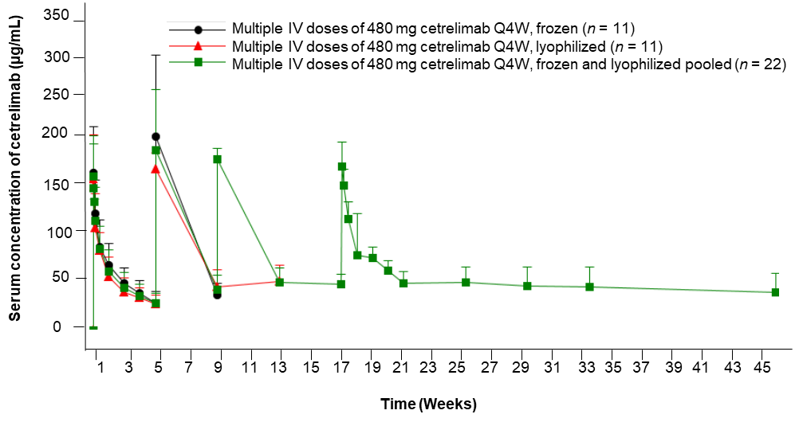
IV intravenous, Q4W every 4 weeks

Online Resource 3 Pharmacokinetic results at steady state (Dose 5 for 480 mg Q4W IV; Dose 9 for 240 mg Q2W IV)
 | 240 mg IV Q2W  n = 3ª | 480 mg IV Q4W  n = 4^{b,c}
C_{trough,} µg/mL, mean (SD) | 66.9 (10.5) | 48.2 (11.3)
C_{max}, µg/mL, mean (SD) | 139 (18.2) | 192 (33.7)
T_{max}, h, median (range) | 0.8 (0.6–2.5) | 0.9 (0.6–1.5)
AUCτ, µg∙h/mL, mean (SD) | 28,768.0 (5694.0) | 50,808.0 (12296.0)
AUC_{last}, µg∙h/mL, mean (SD) | 28,768.0 (5694.0) | 55,912.0 (14317.0)
t_{last}, h, median (range) | 338.1 (335.0–338.3) | 686.4 (670.7–815.8)
t_{½}, h, mean (SD) | — | 537.0 (69.2)
CL_{ss} mL/h, mean (SD) | 8.6 (1.6) | 9.8 (2.2)
AR_{Ctrough}, _{dose 5/dose 2}, mean (SD) | 3.3 (1.0) | 1.7 (0.3)
AR_{Cmax}, _{dose 5/dose 1}, mean (SD) | 2.1 (0.3) | 1.2 (0.2)
AR_{AUC}𝜏, _{dose 9/dose 2}, mean (SD) | 2.4 (0.4) | 1.5 (0.3)
C_{trough}, _{dn}, µg/mL/mg, mean (SD) | 0.28 (0.04) | 0.10 (0.02)
C_{max, dn}, µg/mL/mg, mean (SD) | 0.58 (0.08) | 0.40 (0.07)
AUCτ, _{dn}, µg∙h/mL/mg, mean (SD) | 120.0 (23.7) | 106.0 (25.6)
ª n = 4 for C_{trough}, C_{trough, dn} and AR_{Ctrough, dose 5/dose 2}
^{b} Frozen liquid and lyophilized cetrelimab data pooled
^{c} n = 3 for CL_{ss}, AUC_{𝜏}, AUC_{𝜏, dn} and AR_{AUC𝜏, dose 9/dose 1}
AR accumulation ratio, AUC area under the serum concentration–time curve, AUCτ AUC at dosing interval (τ), AUC_{last} AUC from time 0 to time of last measurable concentration, CL_{ss} total systemic clearance at steady state, C_{max} maximum observed serum concentration, C_{trough} trough concentration, dn dose normalized, IV intravenous, Q2W every 2 weeks, Q4W every 4 weeks, SD standard deviation, t_{½} half-life, t_{last} time of last measurable concentration, T_{max} time to C_{max}

Online Resource 4 Serum concentrations of cetrelimab predose and at end of infusion after each IV 240 mg dose (phase 2)
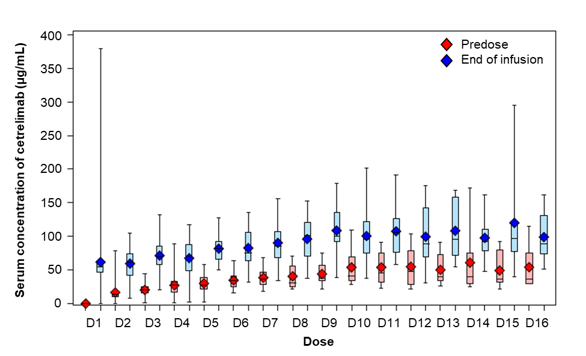
The bottom and top edges of the boxes indicate the interquartile range (the 25th and 75th percentiles). The diamonds indicate the mean value. The lines inside the boxes indicate the median value. The whiskers indicate the entire range of values. Boxes are shown only for time points where n ≥6
D dose, IV intravenous

Online Resource 5 Summary of serum cetrelimab concentrations by anti-cetrelimab antibodies status in patients who received cetrelimab 240 mg IV Q2W in the phase 2 part of LUC1001
Dose | Serum cetrelimab concentration, µg/mL, median (range)
Dose | Positive for anti-cetrelimab antibodiesª | Negative for anti-cetrelimab antibodies^{b}
Dose 1, Predose | BQL (BQL–BQL)  (n = 3) | BQL (BQL–BQL)  (n = 124)
Dose 1, 1 h | —  (n = 2) | 58.8 (22.3–380.0)  (n = 75)
Dose 2, Predose | 18.5 (15.7–23.2)  (n = 3) | 17.8 (4.6–79.0)  (n = 116)
Dose 2, 1 h | —  (n = 0) | 77.5 (8.6–919.0)  (n = 14)
Dose 3, Predose | —  (n = 2) | 25.4 (4.5–68.4)  (n = 106)
Dose 3, 1 h | —  (n =0) | 74.6 (19.4–406.0)  (n = 14)
Dose 4, Predose | 41.8 (29.1–49.8)  (n = 3) | 31.7 (BQL–90.7)  (n = 99)
Dose 4, 1 h | —  (n = 0) | 80.2 (14.9–146.0)  (n = 17)
Dose 5, Predose | 46.0 (33.9–59.4)  (n = 3) | 38.3 (5.0–150.0)  (n = 89)
Dose 6, 1 h | —  (n = 1) | 91.0 (52.8–169.0)  (n = 13)
ª Patients positive for anti-cetrelimab antibodies showed an increase in anti-cetrelimab antibodies titers during the study
^{b} Patients who showed an increase in anti-cetrelimab antibodies titers during the study were excluded
BQL below quantification limit (<0.04000 μg/mL), IV intravenous, Q2W every 2 weeks

Online Resource 6 Pharmacodynamic effects of cetrelimab on (a) IP10 and (b) IL2Ra
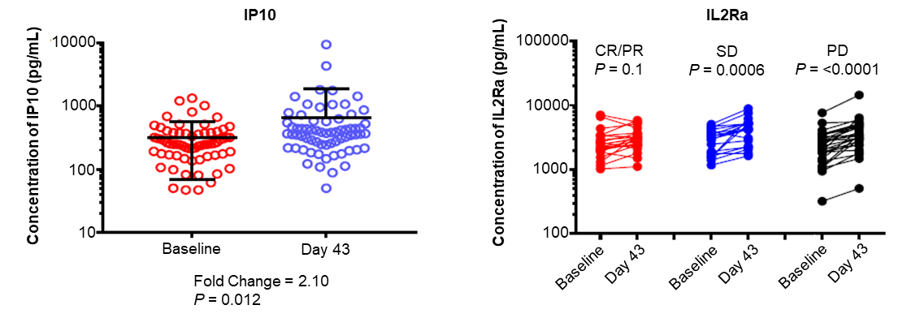
CR complete response, IL2Ra interleukin-2 receptor alpha, IP10 interferon gamma-inducible protein 10, PD progressive disease, PR partial response, SD stable disease

Online Resource 7 Progression-free survival for patients with NSCLC, melanoma, and MSI-H / dMMR CRC
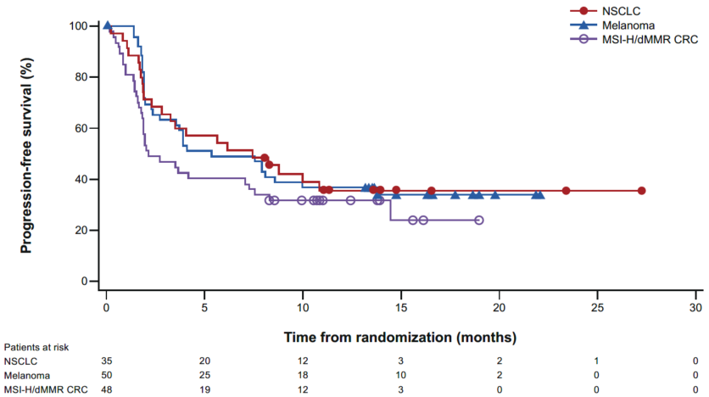
CRC colorectal cancer, NSCLC non-small-cell lung cancer, dMMR DNA mismatch repair deficient, MSI-H microsatellite instability–high

Online Resource 8 Overall survival for patients with NSCLC, melanoma, and MSI-H / dMMR CRC
[Placeholder for figure]
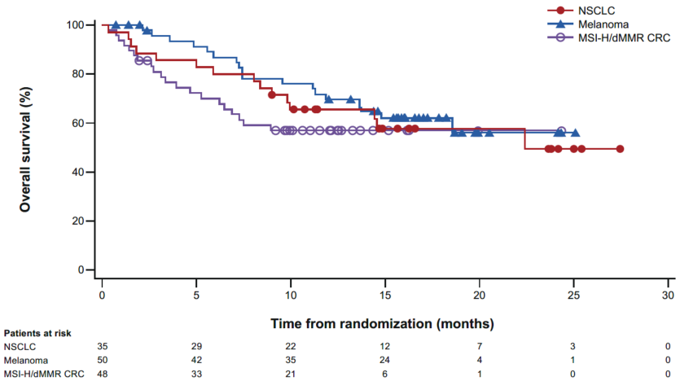
CRC colorectal cancer, NSCLC non-small-cell lung cancer, dMMR DNA mismatch repair deficient, MSI-H microsatellite instability–high

Online Resource 9 Response and duration of treatment for patients with NSCLC (N = 35)
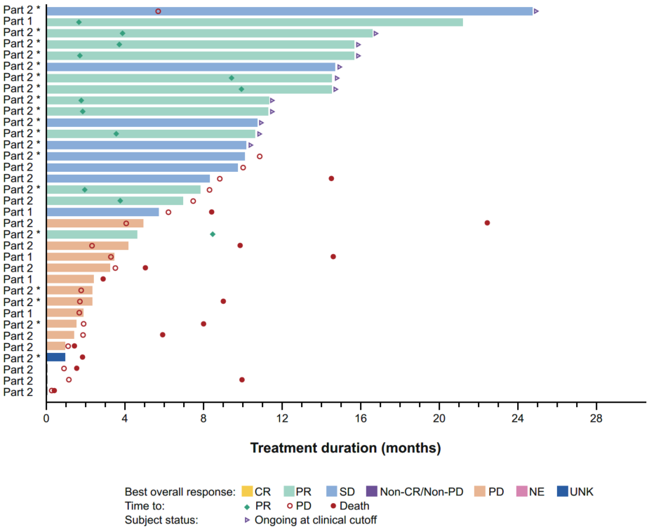
*Patient with PD-L1 high status
CR complete response, NE not evaluable, NSCLC non-small-cell lung cancer, PD progressive disease, PD-L1 programmed death ligand 1, PR partial response, SD stable disease, UNK unknown

Online Resource 10 Response and duration of treatment for patients with melanoma (N = 50)
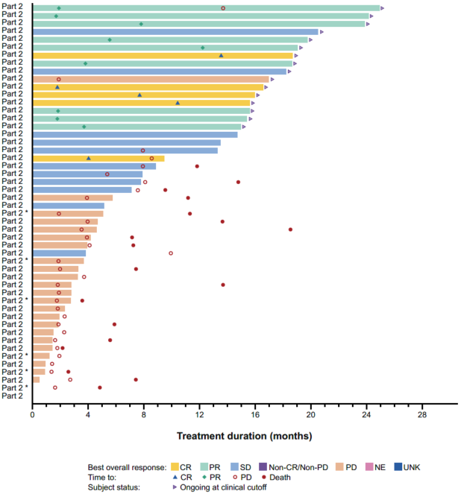
*Patient with PD-L1 high status
CR complete response, MSI-H microsatellite-high, NE not evaluable, PD progressive disease, PD-L1 programmed death ligand 1, PR partial response, SD stable disease, UNK unknown

Online Resource 11 Response and duration of treatment for patients with MSI-H/dMMR colorectal cancer (N = 48)
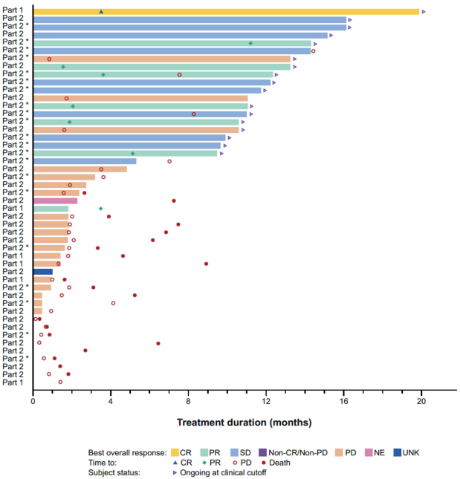
*Patient with centrally confirmed MSI-H status
CR complete response, CRC colorectal cancer, dMMR DNA mismatch repair deficient, MSI-H microsatellite instability–, NE not evaluable, NSCLC non-small-cell lung cancer, PD progressive disease, PR partial response, SD stable disease, UNK unknown

∗ Corresponding author at emiliano.calvo@startmadrid.com

