Supplemental Table S1. Patient PD Summary
Patient number, best response, cycles on study, and prior platinum | Diagnosis (biopsy site) and BRCA mutation | PAR levels from first pass biopsies:  pg/μg protein and % change | γH2AX levels from second pass biopsies: % Nuclear Area Positive | Epithelial-mesenchymal phenotype from second pass biopsies: Log(V/E) and p-value
1  PD (2 cycles)  Prior Pt | Uterine Sarcoma (lung)  BRCA2 g3237delCA | Pre: 21.30  Post: 5.00  -77% | Pre: 1.0%  Post: 6.3% | Pre: 2.56  Post: 4.58  p < 0.001
2  PR (18 cycles)  Prior Pt | Ovarian (liver)  BRCA1 gR1751X (5379C>T) | Pre: 2.00  Post: 1.90  -5% | Pre: NA*  Post: NA* | Pre: NA*  Post: NA*
3  PR (10 cycles)  Prior Pt | Ovarian (neck lymph node)  BRCA1 g187delAG | Pre: NA*  Post: 2.90 | Pre: NA*  Post: 6.2% | Pre: NA*  Post: not analyzed
4  PR (8 cycles)  No prior Pt | Prostate (cervical node)  BRCA2 gK1872X (5842A>T) | Pre: 29.30  Post: 1.20  -96% | Pre: 1.8%  Post: 5.2% | Pre: -0.64  Post: -0.12  p < 0.001
5  PR (6 cycles)  No prior Pt | Prostate (liver)  BRCA1 gQ1756fs*74 | Pre: 27.90  Post:2.40  -91% | Pre: 0.3%  Post: 1.7% | Pre: -1.68  Post: -1.26  p < 0.001
6  SD (6 cycles)  Prior Pt | Breast (Supraclavicular  node)  BRCA1 g 2576delC | Pre: 6.90  Post: 0.80  -88% | Pre: 2.5%  Post: 4.7% | Pre: 0.41  Post: 0.28  p > 0.05
7  SD (8 cycles)  No prior Pt | Prostate (iliac bone)  BRCA2 g c.476-2A>G | Pre: NA*  Post: NA* | Pre: NA*  Post: NA* | Pre: NA*  Post: NA*
8^  PR (8 cycles)  No prior Pt | Breast (liver)  BRCA2 g3917delC | Pre: 34.5  Progression^: 7.20  -79% | Pre: 0.5%  Progression^: 1.0% | Pre: -1.13  Progression^: -0.38  p < 0.001
9  PD (< 1 cycle)  Prior Pt | Pancreatic (omentum)  BRCA1 g3171ins5 | Pre: 17.61  Post: 0.34  -98% | Pre: 0.9%  Post: 2.6% | Pre: -1.42  Post: -1.24  p > 0.05
^Patient 8 post-dose biopsy was taken at progression (after cycle 8), not day 8 of treatment as for all other patients. *Biopsy tissue unanalyzable due to it containing less than 5% tumor cells or significant damage.
Supplemental Figure S1. Patient BRCA1/2 mutations

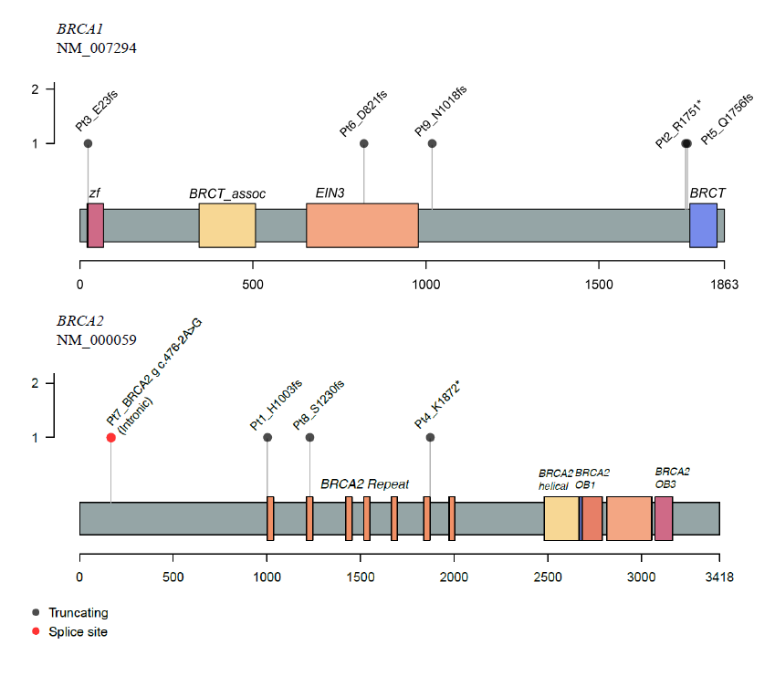
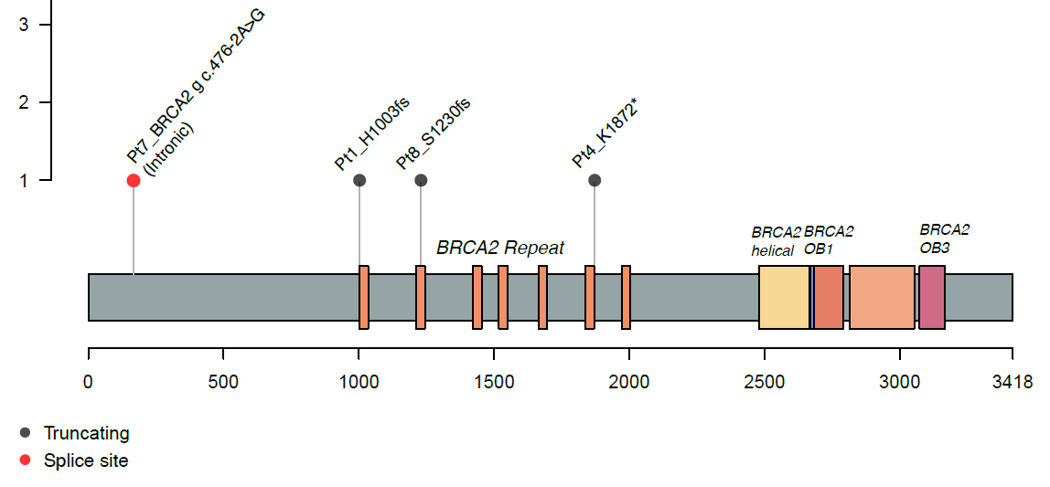
Patient BRCA1/2 mutations. The distribution of eligibility mutations within the BRCA1 and BRCA2 genes for the 9 patients on trial (note that the BRCA2 g c.476-2A>G mutation of patient #7 is intronic). BRCA1 domains: zf, zinc finger C3-HC4; BRCT-assoc., serine-rich domain associated with BRCT; EIN-3, ethylene-insensitive 3; BRCT, BRCA1 C terminus domain. BRCA2 domains: BRCA2-helical; BRCA2-OB1, oligonucleotide/ oligosaccharide binding domain 1; BRCA2-OB3, oligonucleotide/oligosaccharide-binding domain 3.
BRCA2
NM_000059

