Online Resource 1

Supplementary Information
Pharmacokinetic study of capivasertib and the CYP3A4 substrate midazolam in patients with advanced solid tumors
Cancer Chemotherapy and Pharmacology
Claire Miller, Roberto Sommavilla, Cindy L. O’Bryant, Minal Barve, Afshin Dowlati, Jason J. Luke, Mahmuda Khatun, Thomas Morris, Marie Cullberg

Supplementary Table 1 Important protocol deviations (part A; full analysis set)
 | Treatment period 1 | Treatment period 2 | Treatment period 3
 | Midazolam only  (N=21) | Capivasertib only  (N=21) | Capivasertib + midazolam  (N=20) | Total  (N=21)
Patients with at least one important protocol deviation, n (%) | 7 (33.3) | 3 (14.3) | 6 (30.0) | 15 (71.4)
Pre-dose cycle 1, day 1 sample had midazolam present, n (%) | 7 (33.3) | 0 | 0 | 7 (33.3)
Received capivasertib on an off-day, n (%)ª | 0 | 1 (4.8) | 3 (15.0)ª | 4 (19.0)
Documented use of disallowed medication, n (%)^{b} | 0 | 2 (9.5) | 0 | 2 (9.5)
Visit schedule not performed per study protocol, n (%) | 0 | 0 | 5 (25.0) | 5 (23.8)
Midazolam administration not performed at visit, n (%) | 0 | 0 | 1 (5.) | 1 (4.8)
Capivasertib PK sample not performed at visit, n (%) | 0 | 0 | 1 (5.0) | 1 (4.8)
Midazolam PK sample not performed at visit, n (%) | 0 | 0 | 1 (5.0) | 1 (4.8)
One patient had an important protocol deviation in treatment period 1 and treatment period 3, but is counted only once in the total. The same patient may have more than one important protocol deviation. Treatment period 1 (day 1 of cycle 1): patients received a single oral dose of midazolam (1 mg). Treatment period 2 (days 2–8 of cycle 1): patients received repeated oral doses of capivasertib 400 mg BID, given as an intermittent schedule (4 days on/3 days off). Treatment period 3 (days 8–15 of cycle 1): patients received single oral doses of midazolam (1 mg) on days 8 and 12 during intermittent capivasertib treatment (400 mg BID, 4 days on/3 days off). Treatment period 4 (day 16 of cycle 1 onwards): patients received repeated oral doses of capivasertib 400 mg BID, given as an intermittent schedule (4 days on/3 days off)
AE, adverse event; BID, twice daily; N, number of participants; n, number of observations in analysis; PK, pharmacokinetic
ªOne patient was given capivasertib 400 mg in the morning of cycle 1, day 6 (a non-dosing day), two patients took capivasertib 400 mg in the morning of cycle 1, day 13 (a non-dosing day), and one patient incorrectly took capivasertib 400 mg in the evening of day 7 (the last non-dosing day of that week). No adjustments for these incorrect doses were made and none of these doses were associated with symptoms or AEs; ^{b}One patient received cyclosporin and one patient received an investigational agent (monoclonal antibody)

Supplementary Table 2 PK parameters of capivasertib and its metabolite, AZ14102143, on day 12 of cycle 1 (PK analysis set)
Parameter | Summary  statistics | Capivasertib  (N=17) | AZ14102143  (N=17)
C_{max} (ng/mL) | Geometric mean (gCV%) | 1779ª (48.3) | 11,220ª (42.7)
AUCτ (h*ng/mL) | Geometric mean (gCV%) | 8499^{b} (36.7) | 68,810^{b} (50.4)
t_{max} (h) | Median (range) | 1.48ª (0.6–5.5) | 2.03ª (0.6–7.6)
t_{½λz} (h) | Geometric mean (gCV%) | 3.76^{c} (43.7) | 3.40^{d} (62.4)
CL/F (L/h) | Geometric mean (gCV%) | 46.37^{b} (39.1) | NA
C_{trough} cycle 1, day 9 (ng/mL) | Geometric mean (gCV%) | 10.96e (137.0) | 45.22e (242.1)
C_{trough} cycle 1, day 13 (ng/mL) | Geometric mean (gCV%) | 281.5^{f} (53.3) | 2575^{f} (106.9)
Treatment period 3 (day 12 of cycle 1): patients received a single oral dose of midazolam (1 mg) on day 12, corresponding to the 4th day on capivasertib (400 mg BID on an intermittent schedule [4 days on/3 days off])
AUCτ, area under plasma concentration–time curve in the dose interval; BID, twice daily; CL/F, apparent total body clearance of capivasertib from plasma after oral administration; C_{max}, maximum observed plasma (peak) drug concentration; C_{trough}, trough plasma concentration; gCV%, geometric coefficient of variation; N, number of participants per visit; n, number of observations in analysis; PK, pharmacokinetic; t_{½λz}, half-life associated with terminal slope (λz) of a semi-logarithmic concentration–time curve; t_{max}, time to reach maximum observed plasma (peak) drug concentration
ªn=16; ^{b}n=15; ^{c}n=14; ^{d}n=13; ^{e}n=20; ^{f}n=12

Supplementary Fig. 1 Patient disposition
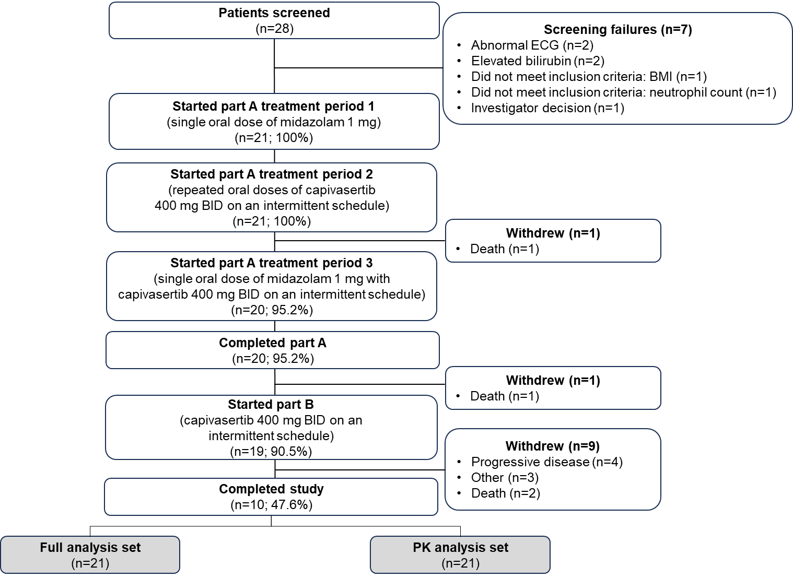
BID, twice daily; BMI, body mass index; ECG, electrocardiogram; PK, pharmacokinetic

Supplementary Fig. 2 Plasma concentration of capivasertib and its metabolite, AZ14102143, over time on day 12 of cycle 1 in part A (PK analysis set)ª
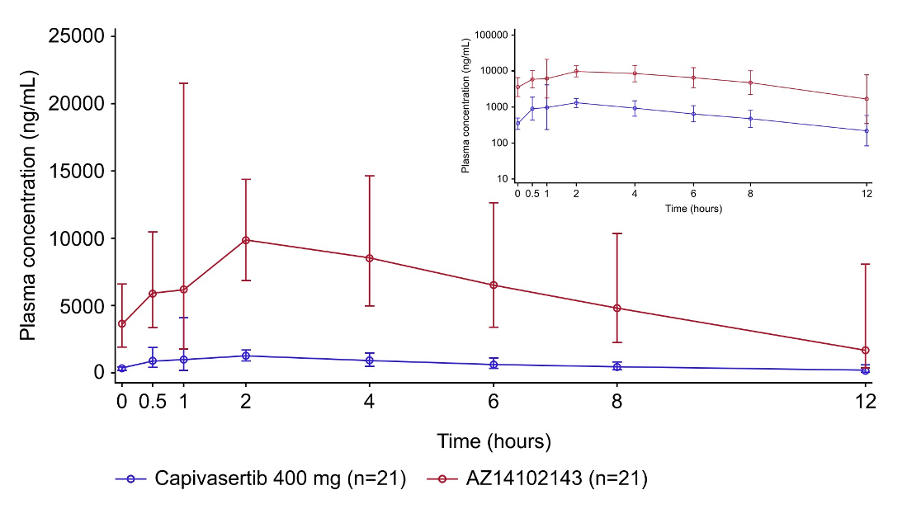Points and error bars show the geometric mean ± geometric SD of plasma concentrations. Inset shows geometric mean values plotted on a semi-logarithmic scale. Treatment period 3 (day 12 of cycle 1): patients received a single oral dose of midazolam (1 mg) on day 12, corresponding to the 4th day on capivasertib (400 mg BID on an intermittent schedule [4 days on/3 days off]). BID, twice daily; n, number of patients in the PK analysis set per treatment group; PK, pharmacokinetic; SD, standard deviation. ªA reliable elimination phase could not be determined for two capivasertib PK profiles and three metabolite PK profiles; these profiles were excluded

