Supplementary Information
Journal name: Cancer Chemotherapy and Pharmacology

Population pharmacokinetics of TLD-1, a novel liposomal doxorubicin, in a phase I trial
Anna M. Mc Laughlin^{a,b#}, Dagmar Hess^{c#}, Robin Micheletª, Ilaria Colombo^{d}, Simon Haefliger^{e}, Sara Bastian^{f}, Manuela Rabaglio^{e}, Michael Schwitter^{g}, Stefanie Fischer^{c}, Katrin Eckhardt^{h}, Stefanie Hayoz^{h}, Christoph Kopp^{h}, Marian Klose^{a,b}, Cristiana Sessa^{d}, Anastasios Stathis^{i,j}, Stefan Halbherr^{k}, Wilhelm Huisinga^{l}, Markus Joerger^{c*†}, Charlotte Kloft^{a*†}
ªDept. of Clinical Pharmacy and Biochemistry, Institute of Pharmacy, Freie Universitaet Berlin, Kelchstr. 31, 12169 Berlin, Germany
^{b}Graduate Research Training Program PharMetrX, Freie Universitaet Berlin/University of Potsdam, Berlin/Potsdam, Germany
^{c}Department. of Medical Oncology and Haematology, Cantonal Hospital St. Gallen, St. Gallen, Switzerland
^{d}Department of Medical Oncology, Oncology Institute of Southern Switzerland, EOC, Bellinzona, Switzerland
^{e}Department of Medical Oncology, Inselspital, Bern University Hospital, University of Bern, Bern, Switzerland
^{f}Department of Medical Oncology, Kantonsspital Graubünden, Chur, Switzerland
^{g}Oncology/Hematology, Kantonsspital Graubünden, Chur, Switzerland
^{h}Coordinating Center, Swiss Group for Clinical Cancer Research, Bern, Switzerland
^{i}Oncology Institute of Southern Switzerland, EOC, Bellinzona, Switzerland
^{j}Faculty of Biomedical Sciences, Universita della Svizzera Italiana, Lugano, Switzerland
^{k}Innomedica Switzerland AG, Switzerland
^{l}Institute of Mathematics, University of Potsdam, Potsdam, Germany
#Shared first authorship
†Shared senior authorship
*Corresponding authors:
Prof. Dr. Charlotte Kloft
Email: charlotte.kloft@fu-berlin.de
Freie Universität Berlin
Institut für Pharmazie
Abteilung Klinische Pharmazie & Biochemie
Kelchstr. 31
12169 Berlin
Germany
Prof. Dr. Dr. Markus Joerger
Email: markus.joerger@kssg.ch
Kantonsspital St. Gallen
Klinik für Medizinische Onkologie und Hämatologie
Rorschacher Strasse 95
9007 St. Gallen
Switzerland

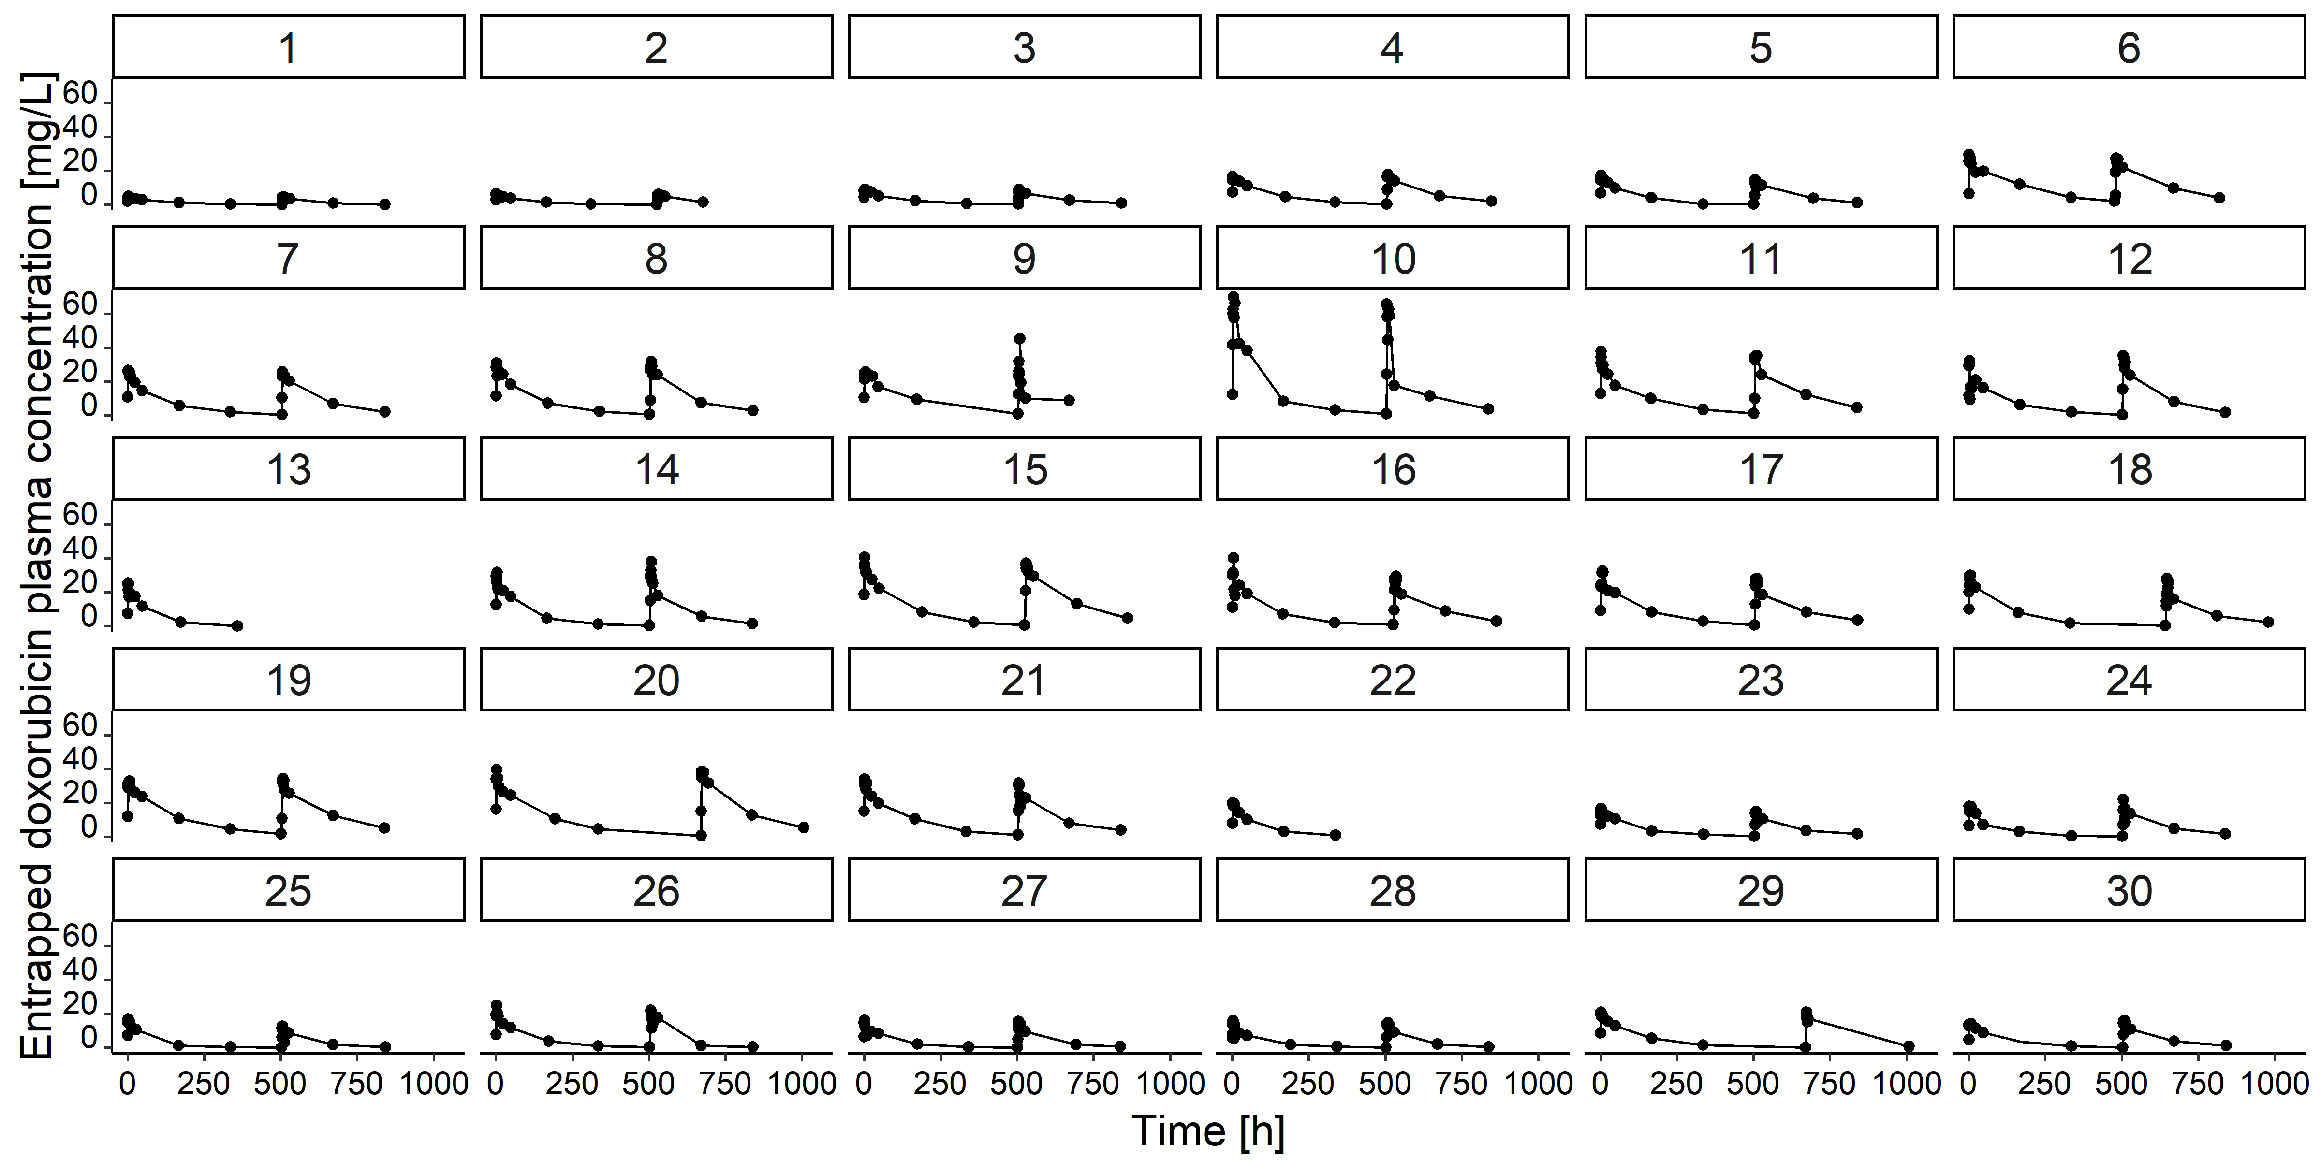

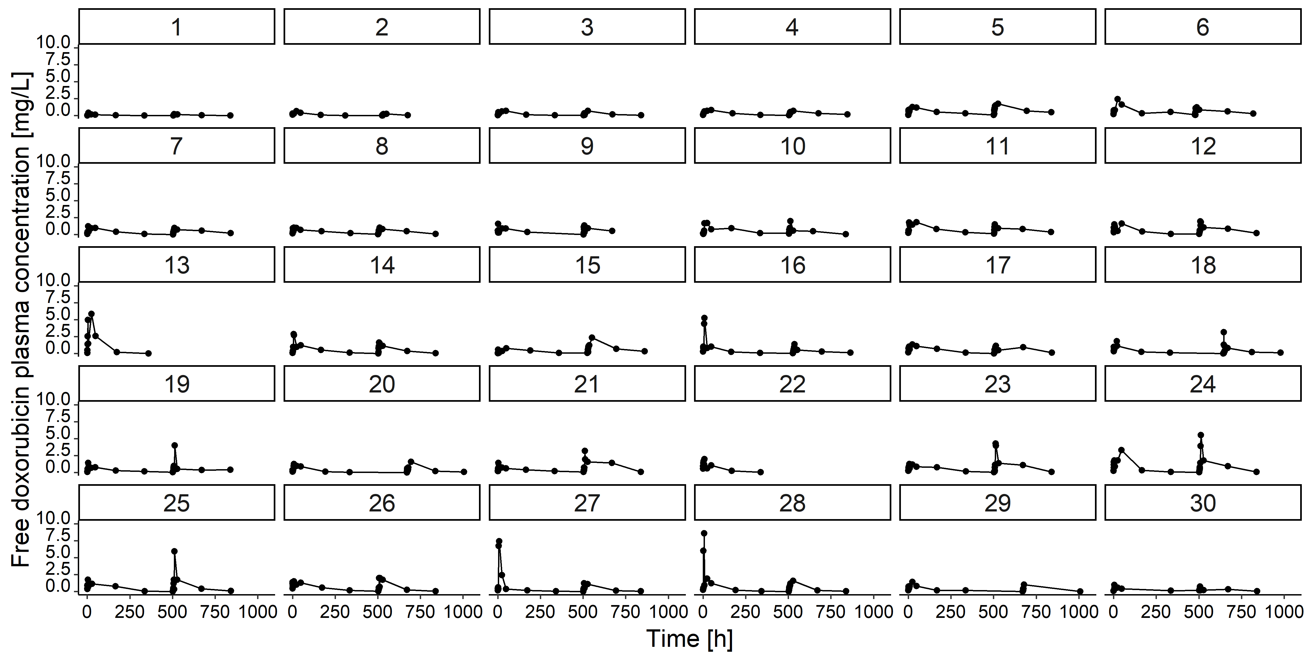

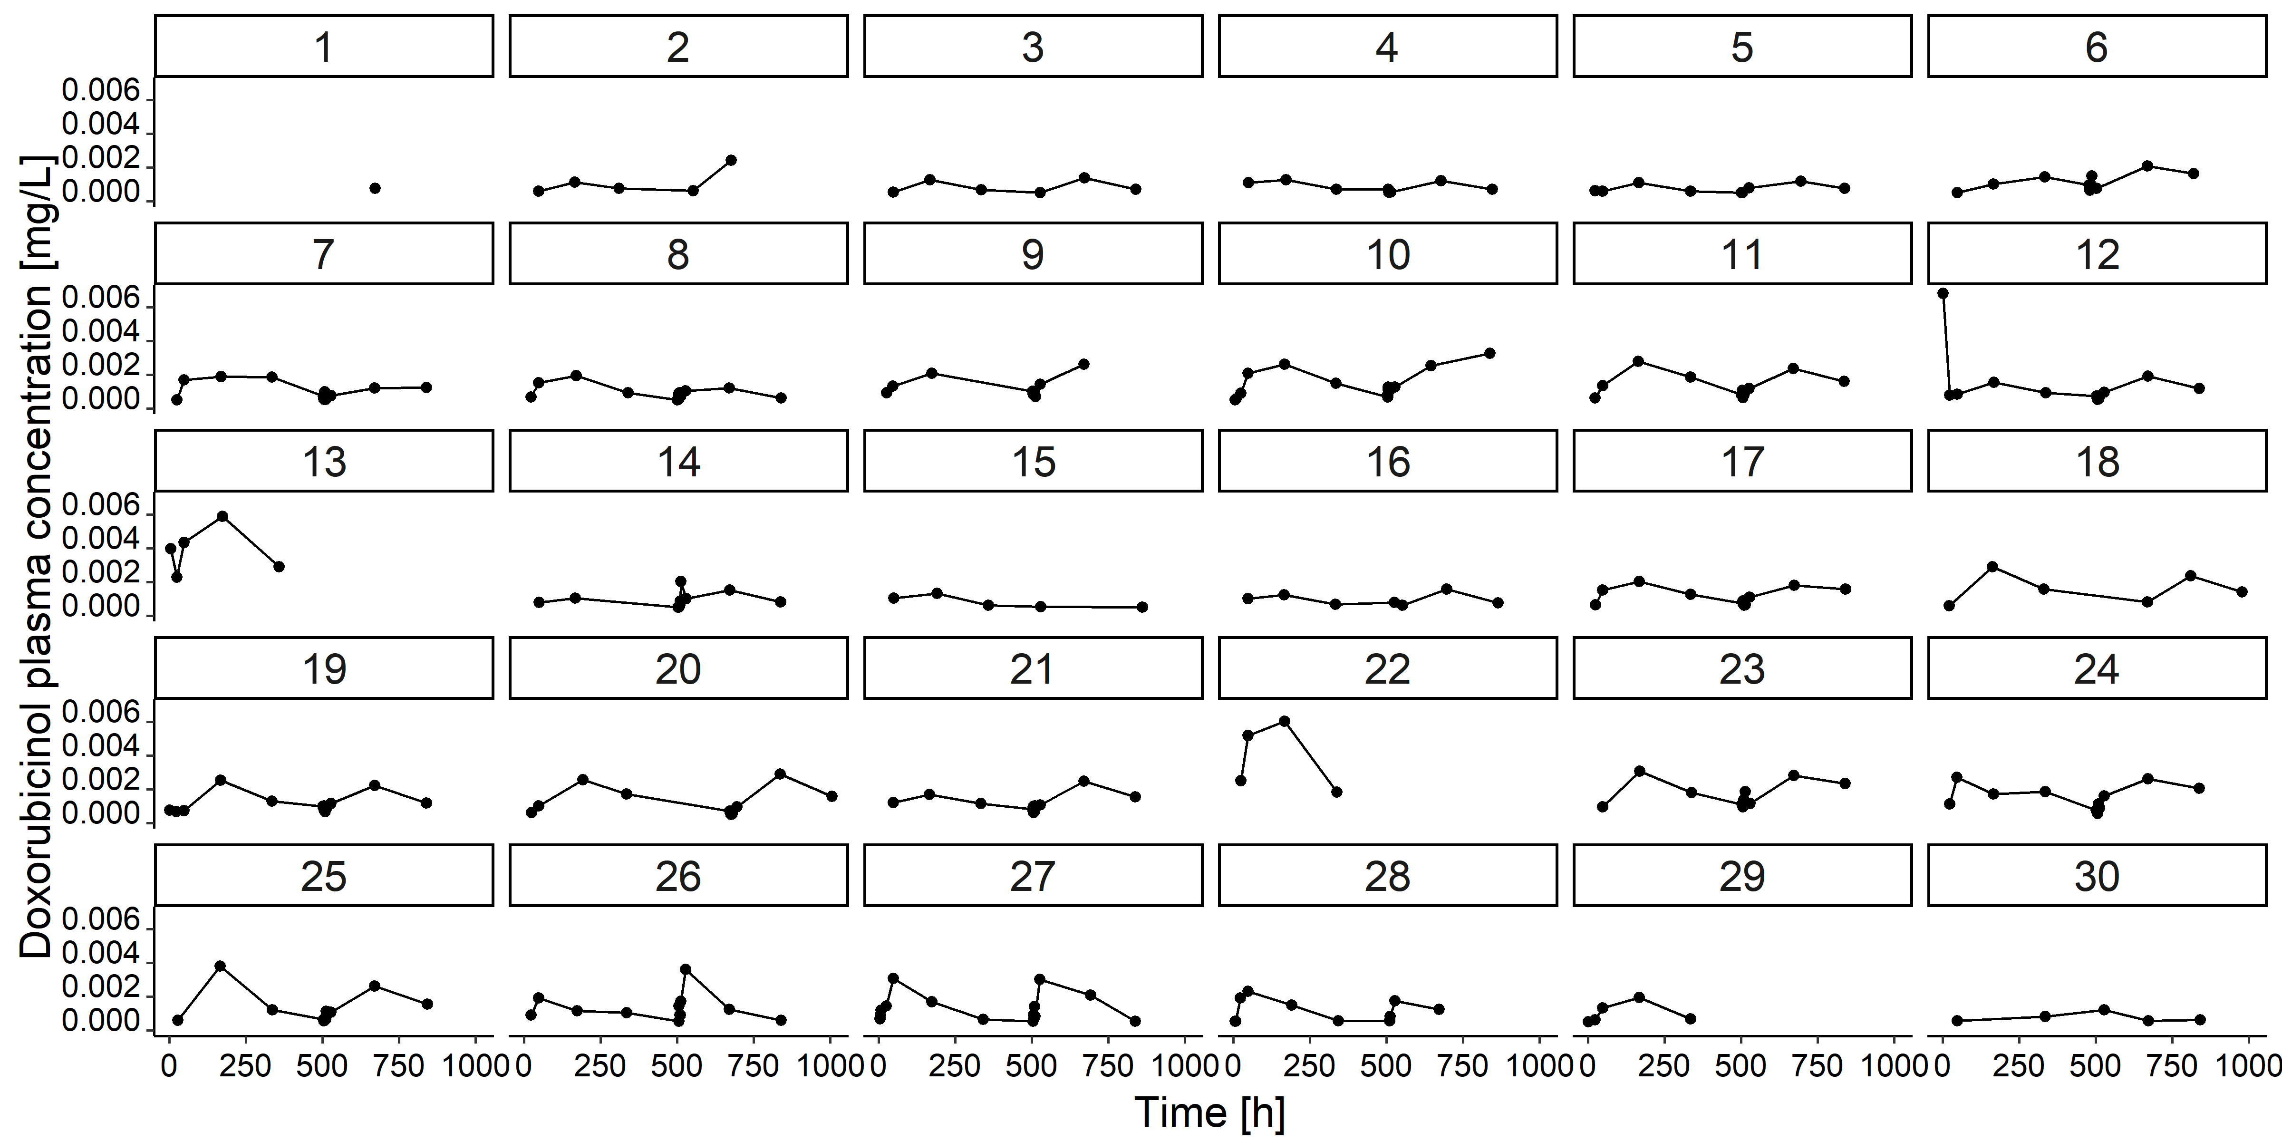

Supplementary Fig. 1 Concentration-time profiles of the observed plasma concentrations of entrapped doxorubicin (upper plots), free doxorubicin (middle plots), and doxorubicinol (lower plots) in the clinical TLD-1 dataset. Each panel represents an individual patient.
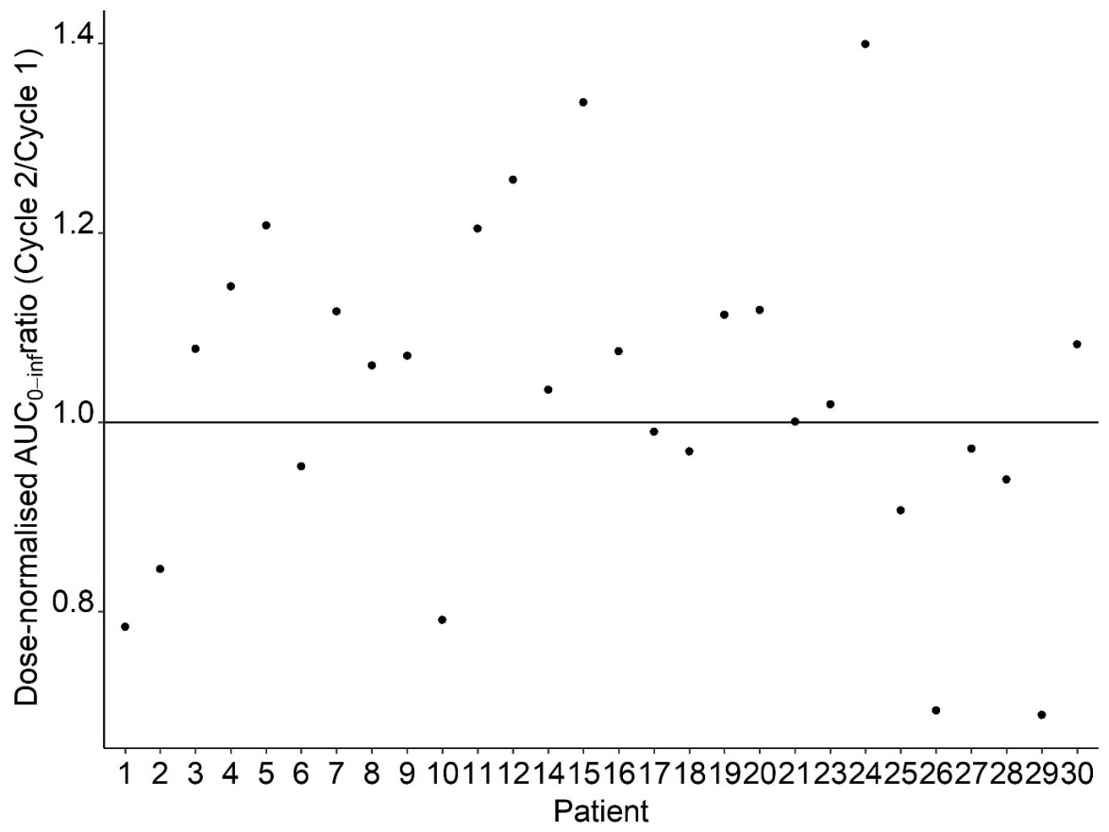
Supplementary Fig. 2 Ratios of individual dose-normalised AUC_{0-inf} of total doxorubicin in cycle 1 vs 2 in 28 patients treated with TLD-1. Two of the 30 patients were not included in this plot because for these patients only data from one cycle was available. Abbreviations: AUC_{0-inf}: Area under the concentration-time curve from t=0 to infinity.

Supplementary Fig. 3 Individual model-predicted central (panel a, left) and peripheral (panel b, right) volumes of distribution of doxorubicin_{free} vs. body surface area. Blue lines: typical model predictions for the central and peripheral volumes of distribution of doxorubicin_{free} vs. body surface area.

Supplementary Fig. 4 Entrapped doxorubicin: Measured concentrations (data points), typical predictions (dashed lines) and individual predictions (solid lines) in the clinical TLD-1 dataset.
Supplementary Fig. 5 Free doxorubicin: Measured concentrations (data points), typical predictions (dashed lines) and individual predictions (solid lines) in the clinical TLD-1 dataset.
Supplementary Fig. 6 Doxorubicinol: Measured concentrations (data points), typical predictions (dashed lines) and individual predictions (solid lines) in the clinical TLD-1 dataset.

