Supplemental material – additional pharmacokinetic analysis results

A sub-pharmacological test dose does not predict individual docetaxel exposure in prostate cancer patients

Marise Heerma van Voss^{1,2}*, Jessica Notohardjo^{1,2}*, Joyce van Dodewaard-de Jong¹, Haiko J Bloemendal^{1,3}, Rob ter Heine⁴

1. Meander Medical Center, department of internal medicine, Amersfoort, The Netherlands
2. Amsterdam University Medical Center, department of internal medicine, Amsterdam, The Netherlands
3. Radboudumc, Research Institute for Medical Innovation, department of Medical Oncology, Nijmegen, The Netherlands
4. Radboudumc, Research Institute for Medical Innovation, department of Pharmacy, Nijmegen, The Netherlands

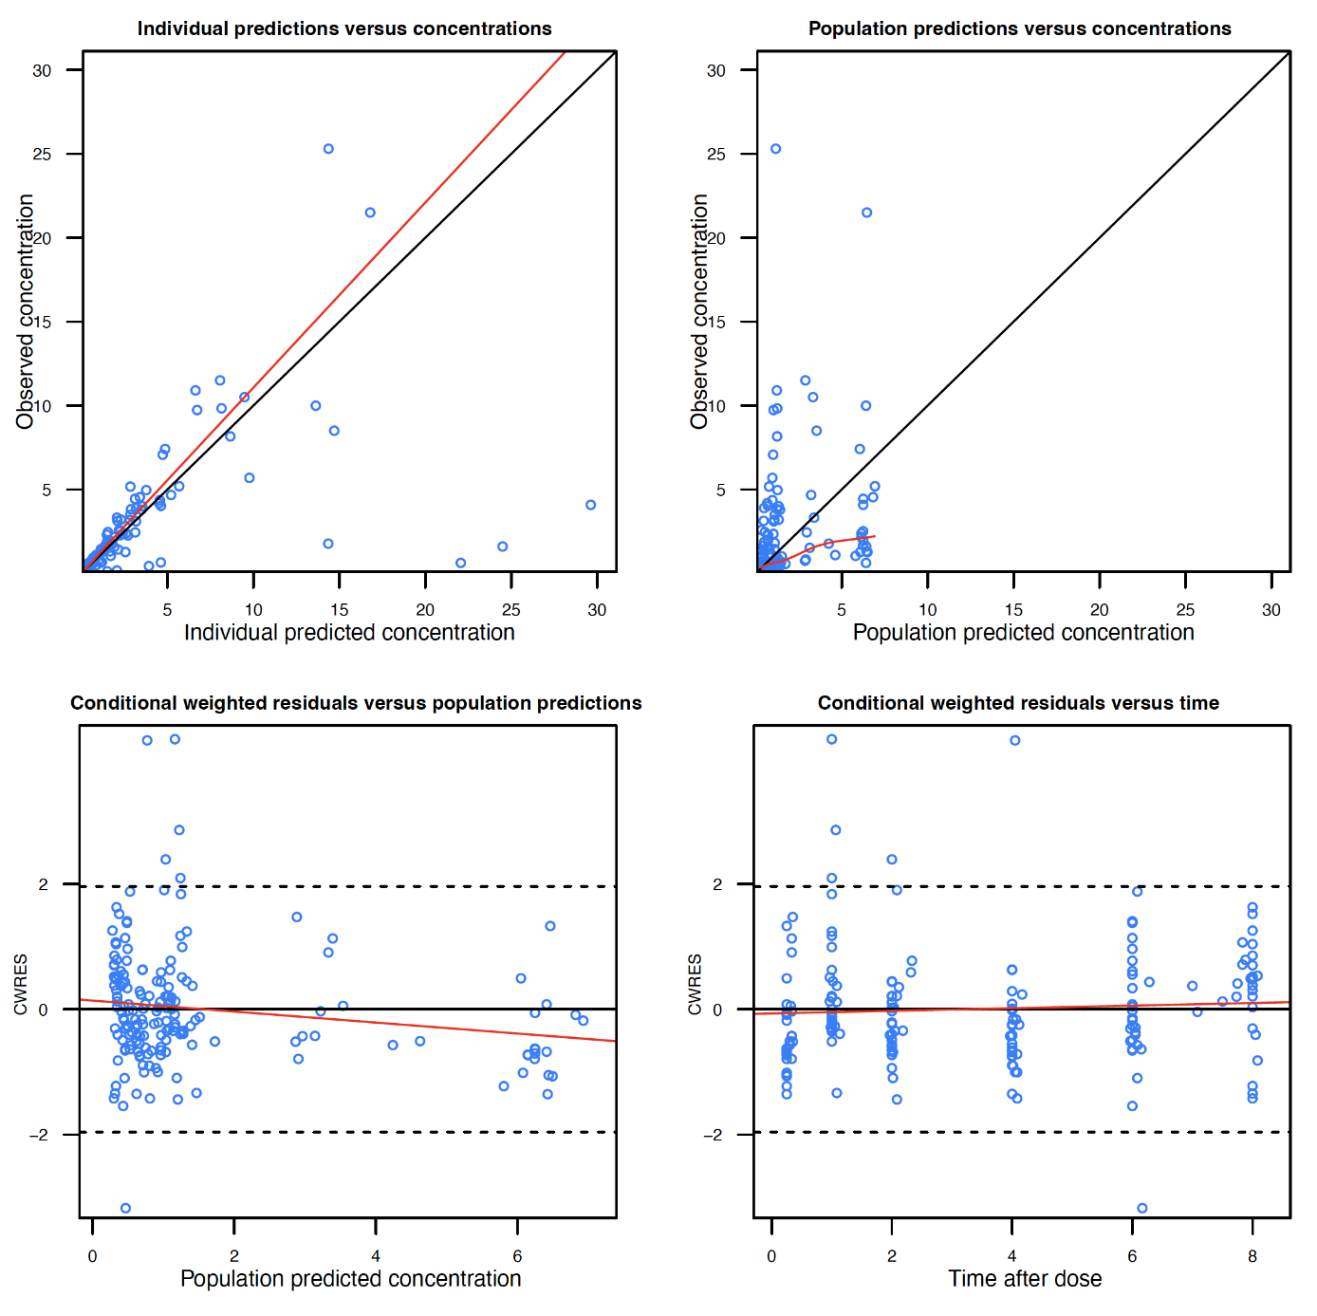
Goodness-of-fit plots for the millidose dataset
Concentrations are depicted in microgram/L units. Time units are in hours. The red line in each pane depicts the linear trendline.

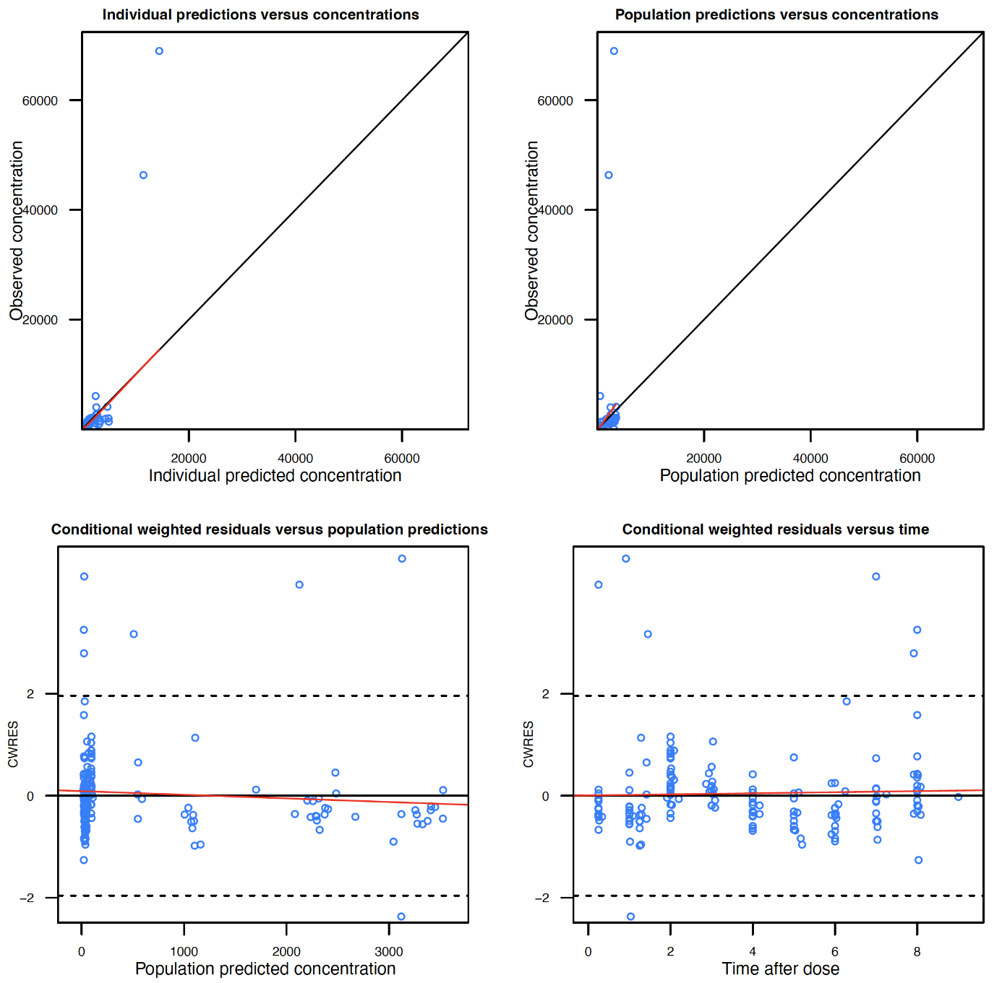
Goodness-of-fit plots for the therapeutic dataset
Concentrations are depicted in microgram/L units. Time units are in hours. The red line in each pane depicts the linear trendline.

Visual predictive check for the millidose dataset
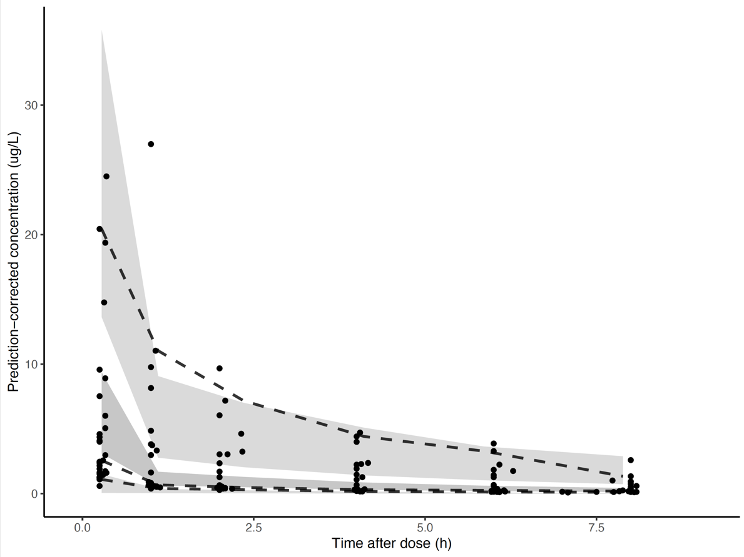

Visual predictive check for the therapeutic dose dataset
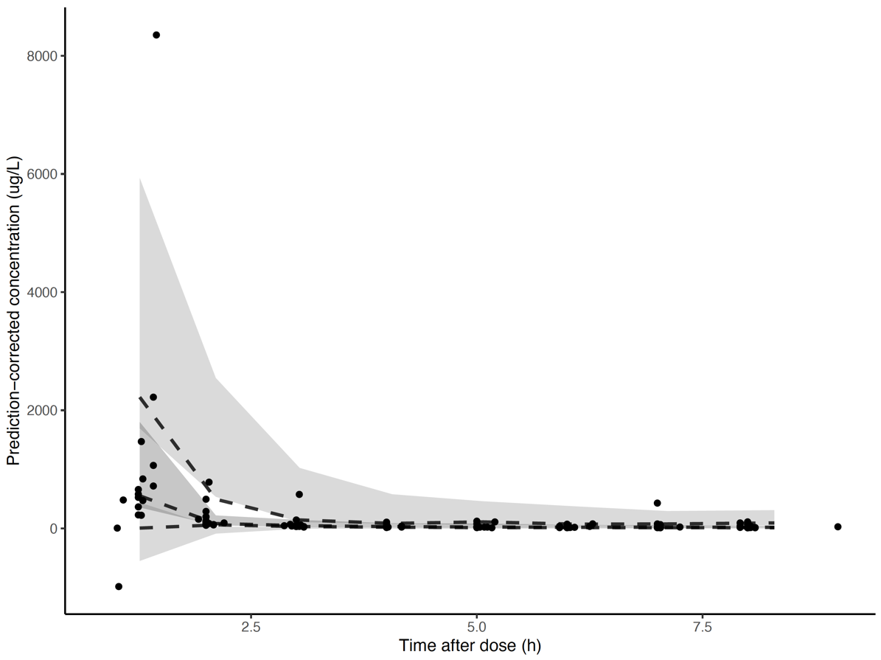

Docetaxel clearance versus AAG concentrations

The black and red dots represent the empirical bayes estimates for the docetaxel clearance versus AAG for the therapeutic and millidose, respectively.

