Biogeographical distribution of bacteria in soils with identical agricultural practices: Impacts of environmental factors
Muiz O. Akinyemi^{1,2}, Sinawo Tsipinana¹, Kazeem A. Alayande¹, Maphala Mokubedi¹, Rasheed A. Adeleke^{1,} *
¹Unit for Environmental Sciences and Management, North-West University, Potchefstroom, 2520, South Africa.
²Leeds Institute of Health Sciences, University of Leeds, Leeds, UK

*Corresponding author: Rasheed.Adeleke@nwu.ac.za
Journal: Current Microbiology journal

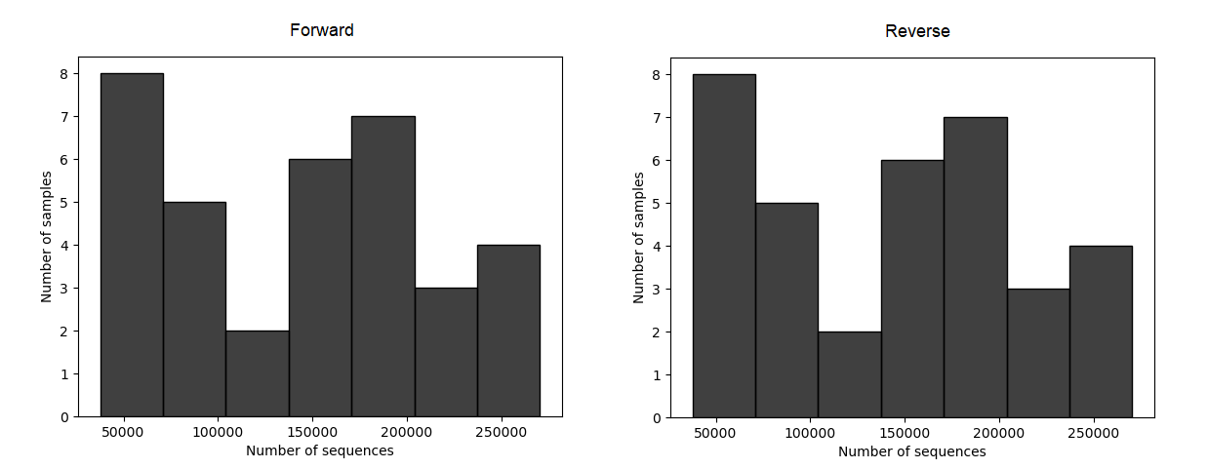Supplementary Figure S1: Barplot indicating the number of sequences recovered from soil samples collected in Free state and Mpumalanga province, South Africa

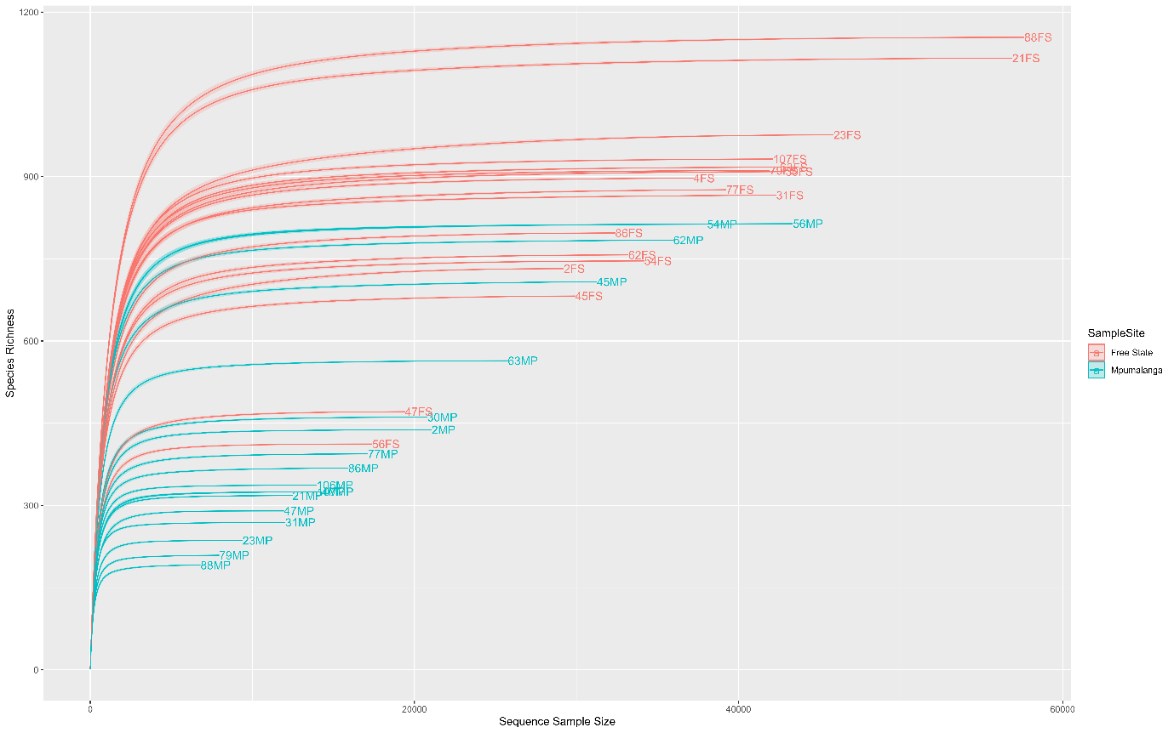
Supplementary Figure S2: Rarefaction curves of 16S rRNA genes recovered from soil samples collected in Free state and Mpumalanga province, South Africa

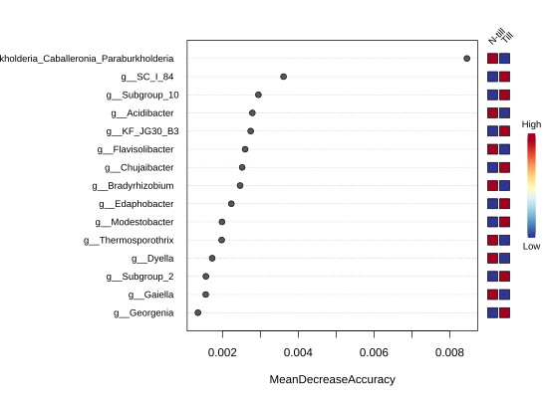
Supplementary Figure S3: Random Forest importance plot of the top 15 genus with the highest importance in till and non-till soil from Mpumalanga province. Features with at least 10 reads and with a minimum prevalence of 10% across samples were included. Data was further transformed to centered log ratio (CLR) before applying the Random Forest classification algorithm

