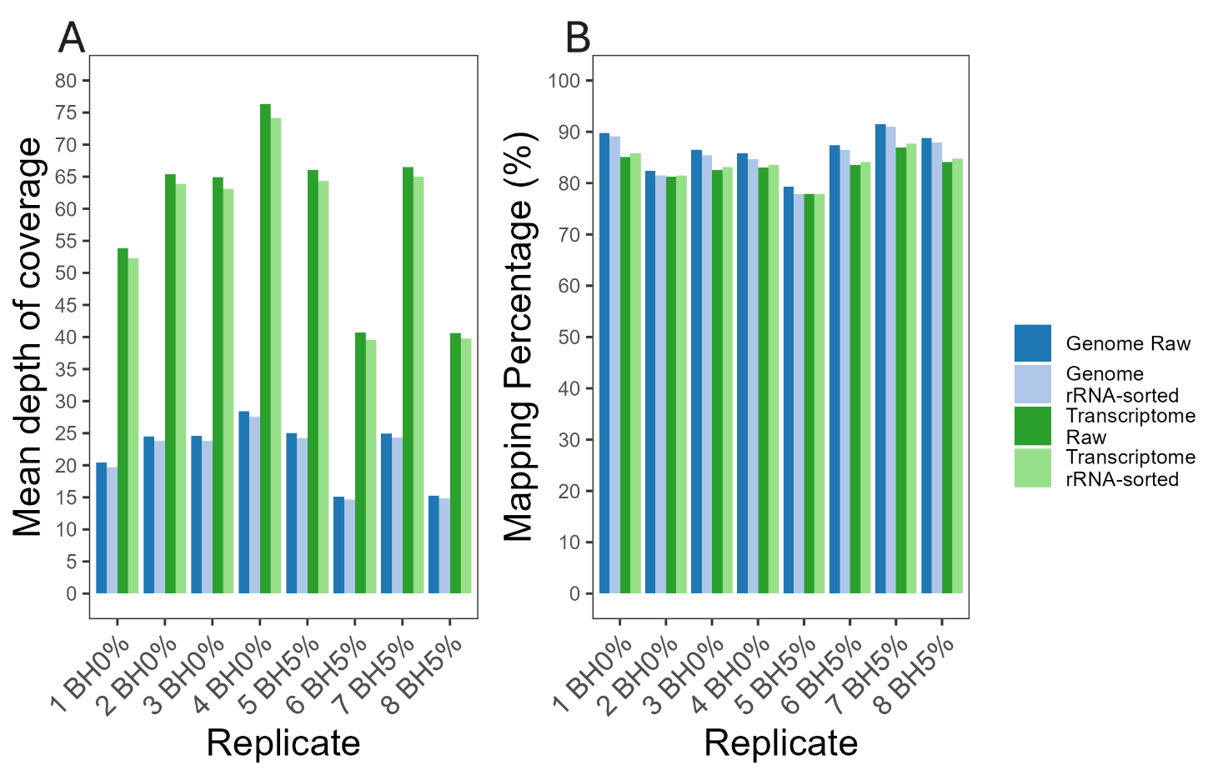
Figure S1 (A) Mean depth of coverage for reach replicate (1-8 BH0% and BH5%) is shown for raw reads and rRNA-filtered reads mapped to the genome and transcriptome. Genome Raw refers to raw reads mapped to the genome, Genome rRNA-sorted refers to rRNA-filtered reads mapped to the genome, Transcriptome Raw refers to raw reads mapped to both the genome and transcriptome, and Transcriptome rRNA-sorted refers to rRNA-filtered reads mapped to both the genome and transciptome. (B) Mapping identity in percentage of reads for each replicate using the same read and mapping definitions as in panel A
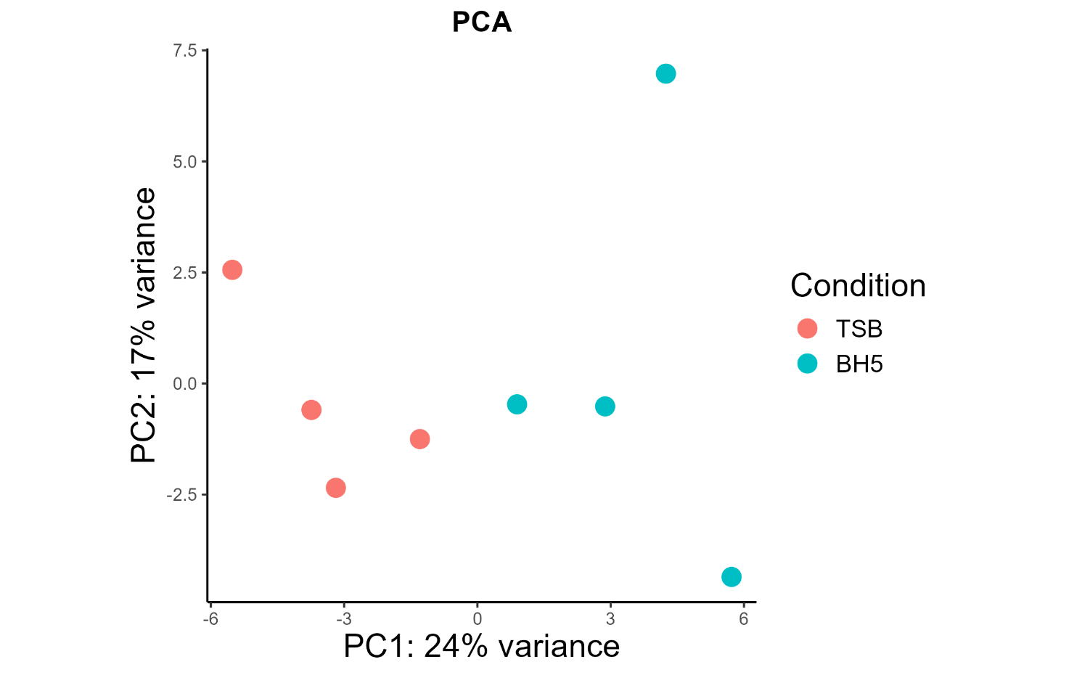
Figure S2 Principal component analysis (PCA) of eight samples. The PCA plot is grouped by conditions TSB and BH5, where blue dots represent samples from condition BH5 and red dots represents samples from condition TSB
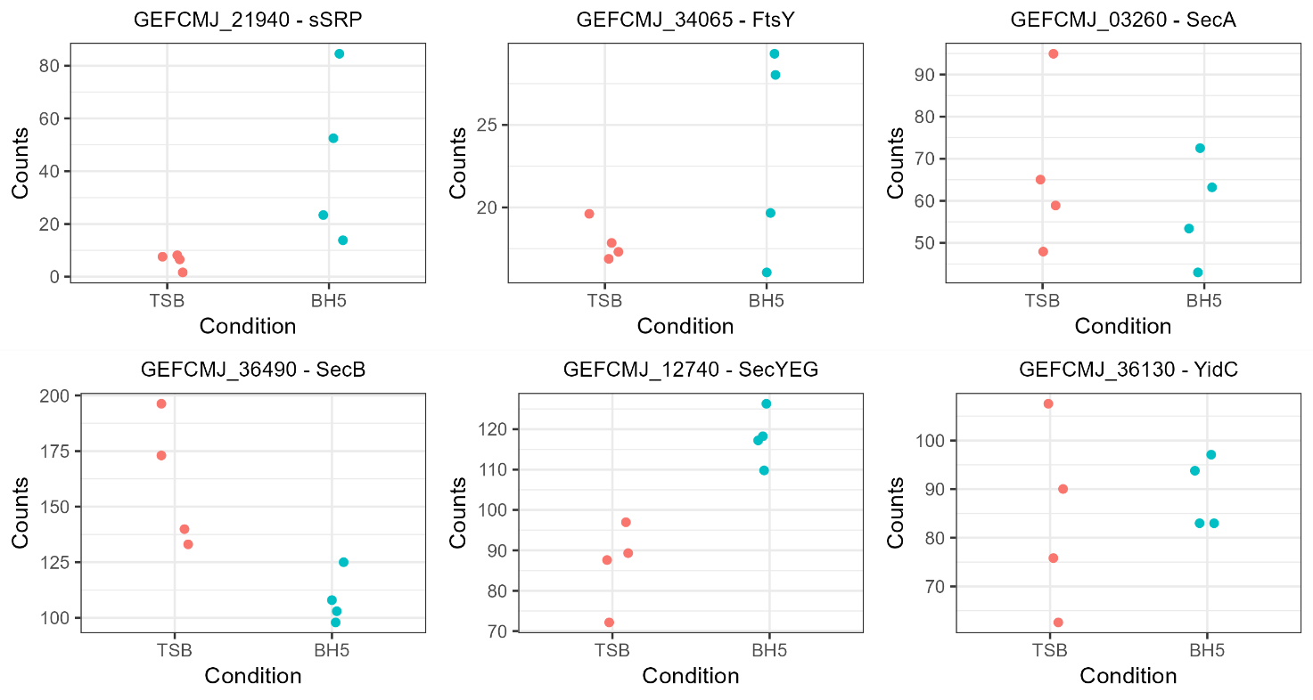
Figure S3 Normalised gene counts for samples in condition TSB and BH5, for genes involved in protein translocation in S. algae. In blue are counts for samples in BH5 and in red are counts for samples in TSB
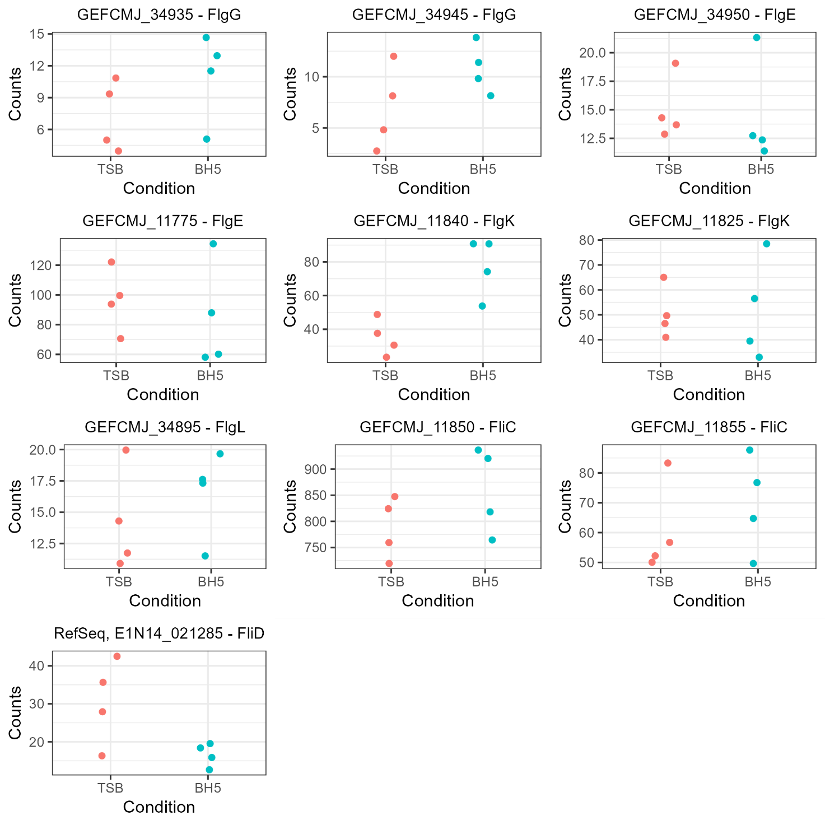
Figure S4 Normalised gene counts for samples in condition TSB and BH5, for genes involved in flagellar biosynthesis and cell motility in S. algae. In blue are counts for samples in BH5 and in red are counts for samples in TSB
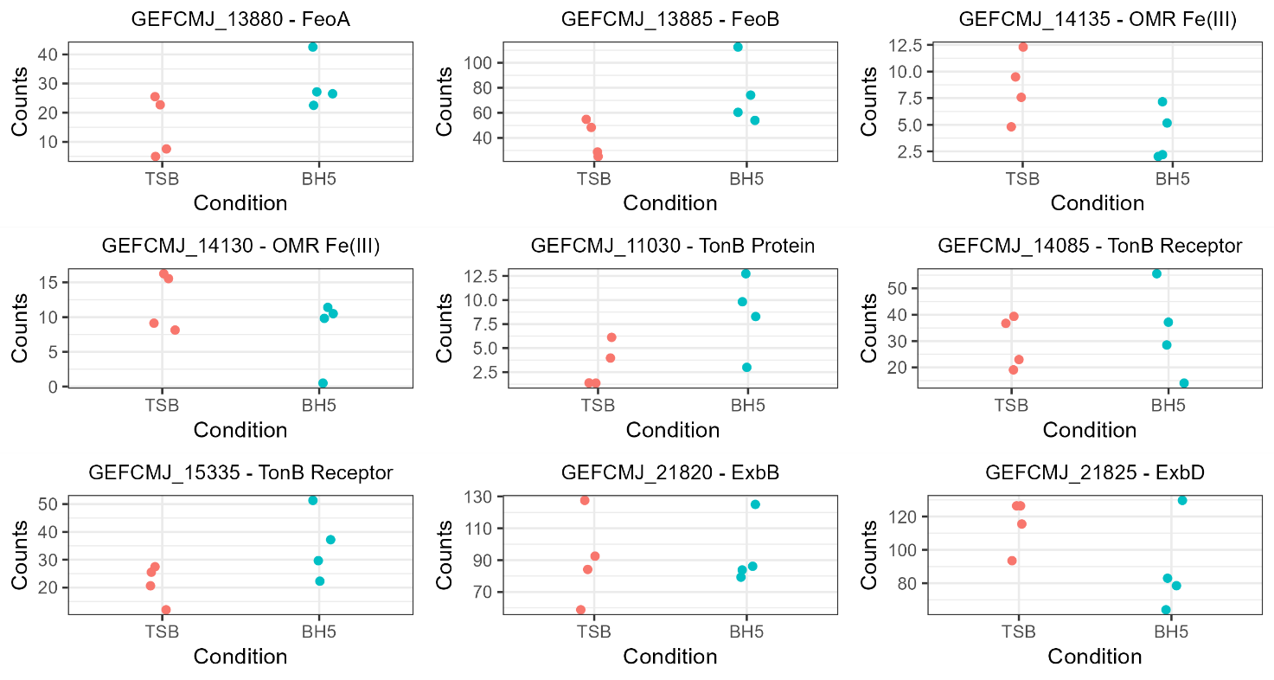
Figure S5 Normalised gene counts for samples in condition TSB and BH5, for genes involved in iron acquisition in S. algae. In blue are counts for samples in BH5 and in red are counts for samples in TSB.

Table S1 Raw and filtered read statistics of long-read sequencing of gDNA from S. algae
Read Statistics
 | Raw Read Statistics | Filtered Read Statistics
Mean Read Length | 4,935.3 | 9,504.3
Mean Read Quality | 10.3 | 12.6
Median Read Length | 2,704.0 | 7,878.0
Median Read Quality | 10.9 | 12.7
Number of Reads | 1,652,350.0 | 553,202.0
Read Length N50 | 10,465.0 | 11,707.0
Std. Dev Read Length | 5.797.3 | 5,808.0
Total Bases | 8,154,895,246.0 | 5,257,776,897.0
Number, percentage and gigabases (Gb) of reads above quality cutoffs
>Q5 | 1548713 (93.7%) 7.768Gb | 553202 (100.0%) 5.257Gb
>Q7 | 1365596 (82.6%) 6.950Gb | 553202 (100.0%) 5.258Gb
>Q10 | 989914 (59.9%) 5.160Gb | 514155 (92.9%) 4.841Gb
>Q12 | 568254 (34.4%) 3.031Gb | 349137 (63.1%) 3.202Gb
>Q15 | 40287 (2.4%) 0.134Gb | 44707 (8.1%) 0.356Gb

Table S2 Specific growth rate, doubling time and time passed before reaching exponential growth at increased concentrations of BH. Specific growth rate and doubling time was calculated using BCA values during exponential growth of S. algae
Growth Media | Specific Growth Rate (h⁻¹) | Doubling Time (h) | Exponential Phase Reaching Time (h)
TSB | 0.190 | 5.258 | 3.5
TSB, 2% BH | 0.101 | 9.904 | 4
TSB, 5% BH | 0.106 | 9.426 | 4
TSB, 10% BH | 0.077 | 13.020 | 4
TSB, 20% BH | 0.050 | 20.132 | 4.5

Table S3 Key statistics of the raw reads and full-length cDNA reads obtained from long-read sequencing of rRNA depleted cDNA
Read Statistics
 | Raw Read Statistics | Full-length cDNA reads
Mean Read Length | 602.4 | 313.7
Mean Read Quality | 9.9 | 14.9
Median Read Length | 392 | 202
Median Read Quality | 11.2 | 14.2
Number of Reads | 2,967,245 | 1,269,759
Read Length N50 | 952 | 541
Std. Dev Read Length | 2,328.5 | 424.3
Total Bases | 1,787,339,001 | 398,352,235
Number, percentage and gigabases (Gb) of reads above quality cutoffs
>Q5 | 2,337,387 (78.8%) 1.580Gb | 1,259,796 (99.2%) 0.398Gb
>Q7 | 2,046,312 (69.0%) 1.435Gb | 1,243,356 (97.9%) 0.398Gb
>Q10 | 1,741,275 (58.7%) 1.295Gb | 1,147,928 (90.4%) 0.386Gb
>Q12 | 1,232,596 (41.5%) 0.990Gb | 955,275 (75.2%) 0.328Gb
>Q15 | 300,557 (10.1%) 0.235Gb | 528,546 (41.6%) 0.152Gb

