Supplementary Materials

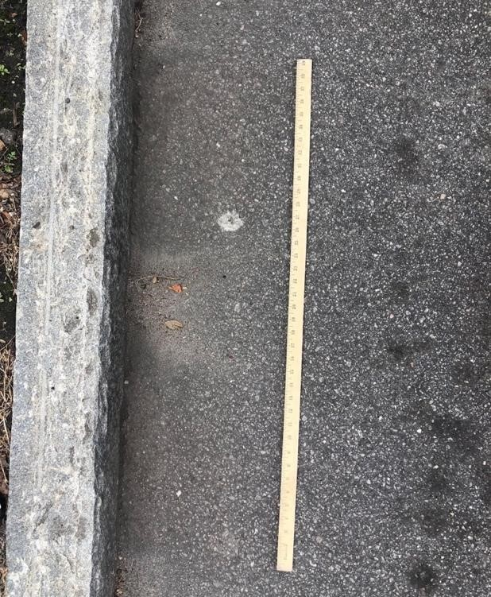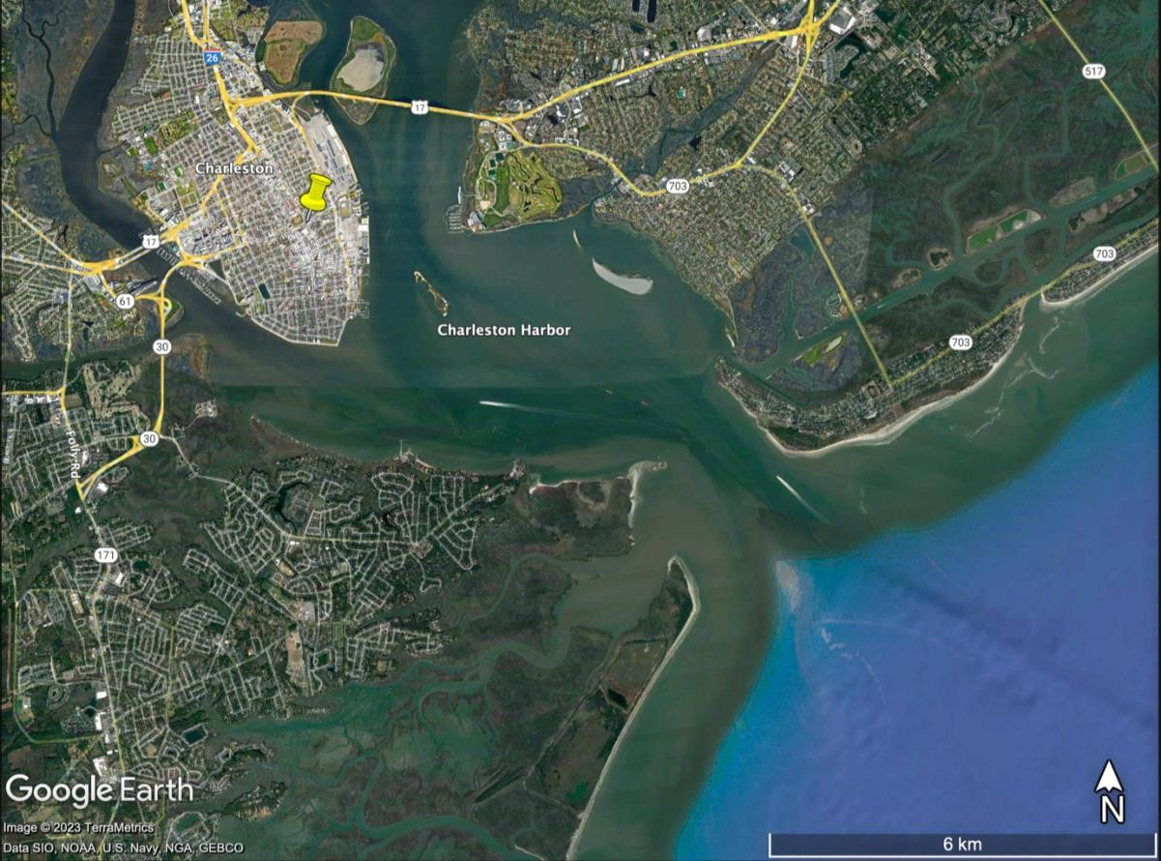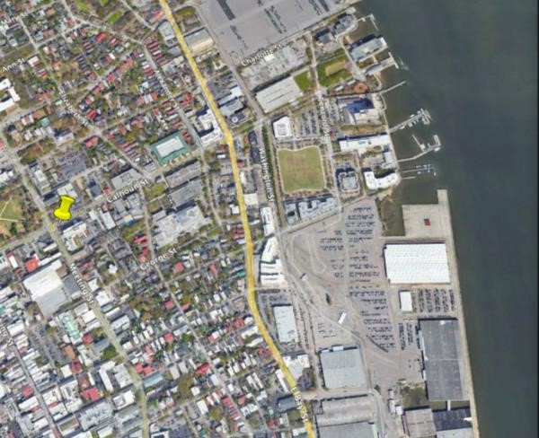
6 km

Figure 1.

Streetside collection of dust from Calhoun, St.
Collected by Bonnie Ertel.

cm
25

500 m

Atlantic Ocean

Charleston
Harbor

Charleston

Supplementary Figure 1. Satellite image showing Charleston, SC and the location of Calhoun St. (black pin) (Google Earth).



Supplementary
Figure
2
.

Streetside collection of dust
from Calhoun, St. Collected by Bonnie Ertel.

25 cm

Supplementary Table 1.
Calculations estimating the density of the mineral encrustation for HD and LD TRWP categories and the mean for both categories.
Mineral density |  | Equations | Avg TRWP Density = Tire Tread Dens(x) + Tot Mineral Dens(1-x)  x = amount of particle that is tire tread and 1-x = amount of tire that is min. encrust.  Tire Tread Dens = 1.1; Avg TRWP Dens = Avg LD, Avg HD, Avg LD+HD  Tot Min Dens = (Feld.Area*Feld.Dens) + (QuartzArea*QuartzDens) + (IronArea*IronDens)
2.62 | Feldspar
2.65 | Quartz
5.24 | Iron (hydr)oxide
Avg Density of HD TRWP | Mineral | EDX map area (um²) | Proportion of mineral phase to whole | Prop. Mineral area*Min Density
(1.429+1.6)/2 | feldspars | 937.71378 | 0.210366019 | 0.55115897
1.5145 | quartz | 2924.2769 | 0.656030127 | 1.73847984
 | iron (hydr)oxide | 595.54378 | 0.133603853 | 0.70008419
 | total area | 4457.5344 | total min density= | 2.989723
 | (x_tire part)*100= | 78.07% | rubber tread= | 1.1
 | ((1-x)_minencrust)*100= | 21.93% | tread-tot avg dens= | -1.889723
 |  |  | TRWP Dens Avg - tot min density= | -1.489723
Avg Density of LD TRWP | Mineral | EDX map area (um²) | Proportion of mineral phase to whole | Prop. Mineral area*Min Density
(1.079+1.179)/2 | feldspar | 126.17956 | 0.110127398 | 0.28853378
1.129 | quartz | 860.39467 | 0.750938024 | 1.98998576
 | iron (hydr)oxide | 159.18567 | 0.138934578 | 0.72801719
 | total area | 1145.7599
 | (x_tire part)*100= | 98.48% | total min density= | 3.00653674
 | ((1-x)_minencrust)*100= | 1.52% | rubber tread= | 1.1
 |  |  | tread-tot avg dens= | -1.9065367
 |  |  | TRWP Dens Avg - tot min density= | -1.8820367
LD+HD TRWP density Avg | Mineral | EDX map area (um²) | Proportion of mineral phase to whole | Prop. Mineral area*Min Density
(1.079+1.6)/2 | feldspar | 1063.8933 | 0.189869257 | 0.49745745
1.3395 | quartz | 3784.6716 | 0.675436865 | 1.78990769
 | Iron (hydr)oxide | 754.72944 | 0.134693878 | 0.70579592
 | total area | 5603.2943 | total min density= | 2.99316107
 |  |  | rubber tread= | 1.1
 | (x_tire part)*100= | 87.59% | tread-tot avg dens= | -1.8931611
 | ((1-x)_minencrust)*100= | 12.41% | TRWP Dens Avg - tot min density= | -1.6581611

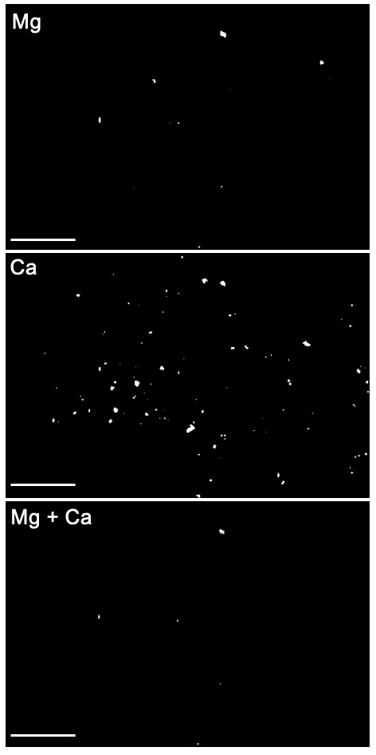
Supplementary Figure 3. Magnified section of a LD TRWP showing EDX individual elemental maps Mg and Ca (top and middle). The maps were overlaid using ImageJ to identify areas where both elements were detected (bottom). No other elements were observed where Mg and Ca were both detected in this section. Spots with only Ca are calcite. All scale bars are 50 µm.
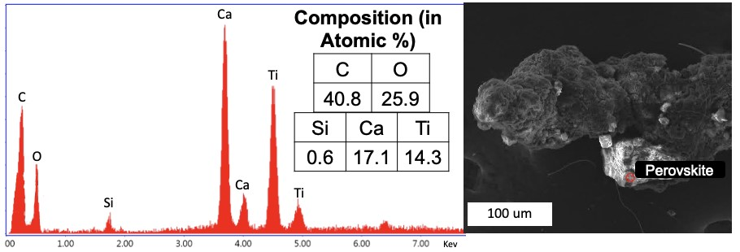 Supplementary Figure 4. EDX spectrum and chemical composition (in atomic %) of perovskite on a HD TRWP.

Equation 1.
Calculations for finding encrustation %mass of the TRWP using the density and volume estimations (section 2.7).

Since $Mass=Density × Volume$, by using the average density for the TRWP categories (HD and LD) and the calculated volume for the average TRWP we can find an estimate for the average mass of the TRWPs in the HD and LD categories.

HD Category
HD TRWP Average Density = 1.5145 g/cm³
HD TRWP Average Volume = 6203468.4709 µm³ = 6.203468 x 10⁻⁶ cm³
$$TRWP Mass=1.5145 {g/cm}^{3}× 6.2{03468e}^{-6}$$
$$TRWP Mass=9.4946e^{-6} g$$

Similarly, we can find the estimated mass of the encrustation using the calculated density and volume for solely the encrustation of the density categories analyzed (Section 2.7). The volumes calculated based on 10, 15, and 20 µm thicknesses were used.

HD TRWP Mineral Encrustation Density = 2.9897 g/cm³
HD TRWP Mineral Encrustation Volume (10 µm) = 320068 µm³ = 3.20068 x 10⁻⁷ cm³
$$TRWP Mass=2.9897 {g/cm}^{3}× 3.20068e^{-7}$$
$$TRWP Mass=9.4148e^{-7} g$$

HD TRWP Mineral Encrustation Density = 2.9897 g/cm³
HD TRWP Mineral Encrustation Volume (15 µm) = 480102 µm³ = 4.8 x 10⁻⁷ cm³
$$TRWP Mass=2.9897 {g/cm}^{3}× 4.8e^{-7}$$
$$TRWP Mass=1.4122e^{-7} g$$

HD TRWP Mineral Encrustation Density = 2.9897 g/cm³
HD TRWP Mineral Encrustation Volume (20 µm) = 640136 µm³ = 6.4 x 10⁻⁷ cm³
$$TRWP Mass=2.9897 {g/cm}^{3}× 6.4e^{-7}$$
$$TRWP Mass=1.88296e^{-7} g$$

LD Category
LD TRWP Average Density = 1.129 g/cm³
LD TRWP Average Volume = 14165881.1515 µm³ = 1.4165881 x 10⁻⁵ cm³
$$TRWP Mass=1.129 {g/cm}^{3}× 1.4165881e^{-5}$$
$$TRWP Mass=1.59933e^{-5} g$$

LD TRWP Mineral Encrustation Density = 3.0065 g/cm³
LD TRWP Mineral Encrustation Volume (10 µm) = 129290 µm³ = 1.29290 x 10⁻⁷ cm³
$$TRWP Mass=3.0065 {g/cm}^{3}× 1.29290e^{-7}$$
$$TRWP Mass=3.8871e^{-7} g$$

LD TRWP Mineral Encrustation Density = 3.0065 g/cm³
LD TRWP Mineral Encrustation Volume (15 µm) = 193934 µm³ = 1.93934 x 10⁻⁷ cm³
$$TRWP Mass=3.0065 {g/cm}^{3}× 1.93934e^{-7}$$
$$TRWP Mass=5.8306e^{-7} g$$

LD TRWP Mineral Encrustation Density = 3.0065 g/cm³
LD TRWP Mineral Encrustation Volume (20 µm) = 258579 µm³ = 2.58579 x 10⁻⁷ cm³
$$TRWP Mass=3.0065 {g/cm}^{3}× 2.58579e^{-7}$$
$$TRWP Mass=7.77418e^{-7} g$$

After finding the Mass TRWP and Mass Encrustation, we can calculate the Mass% Encrustation for the TRWP using the equation:

$$Mass\% Encrustation=\frac{Mass Encrustation}{Mass TRWP}$$

