Supplementary Materials
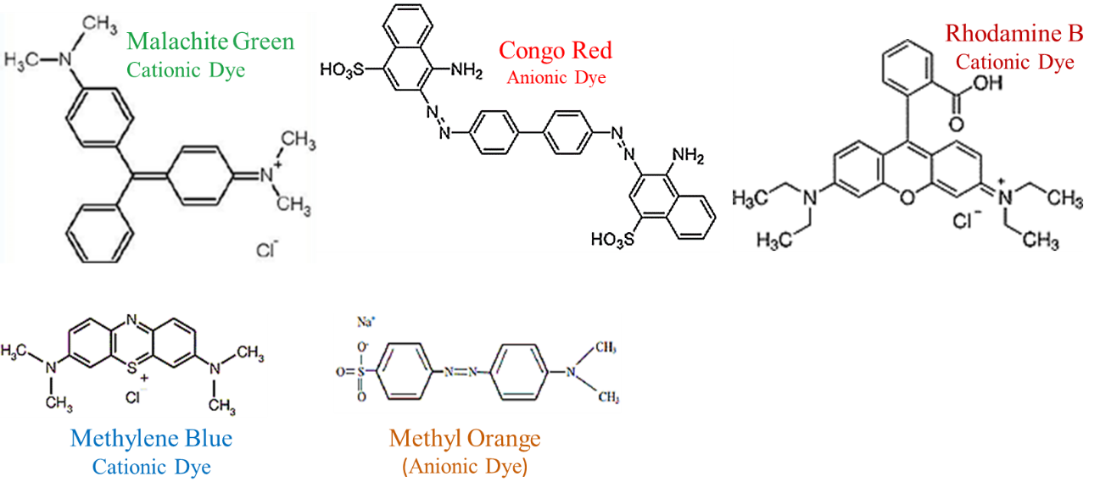
Figure 11. Structural formulas of organic dyes whose photocatalytic activity was investigated.

