Supplementary Figures

ORIGINAL ARTICLE

Establishment of conidial fusion in the asexual fungus Verticillium dahliae as a useful system for the study of non-sexual genetic interactions

Vasileios Vangalis¹ • Michael Knop^{2,3} • Milton A. Typas¹ • Ioannis A. Papaioannou^{2,*}

¹ Department of Genetics & Biotechnology, Faculty of Biology, National and Kapodistrian University of Athens, Greece
² Center for Molecular Biology of Heidelberg University (ZMBH), Heidelberg, Germany
³ German Cancer Research Center (DKFZ), DKFZ-ZMBH Alliance, Heidelberg, Germany

* To whom correspondence should be addressed: i.papaioannou@zmbh.uni-heidelberg.de

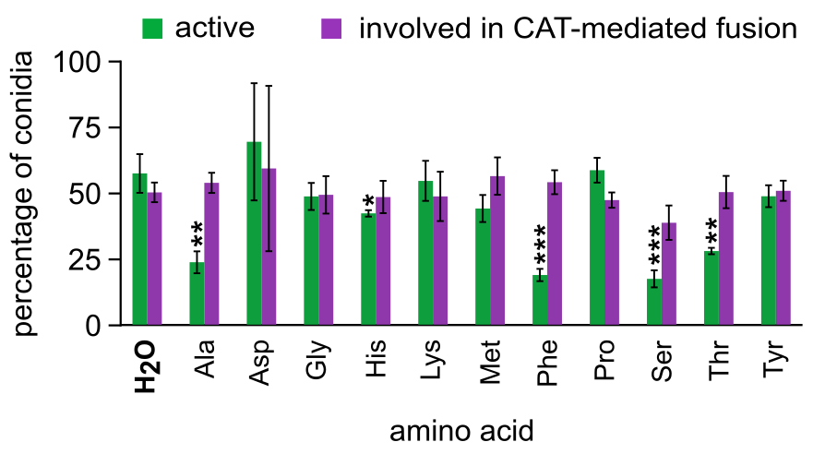

Fig. S1 Influence of various amino acids on the frequencies of active conidia and active conidia involved in CAT-mediated fusion (V. dahliae isolate 123V). Each amino acid was tested in triplicate, and 300 conidia were analyzed per replicate. Bars = SD. Statistical significance of differences from the control was determined by Student’s t-test (* p ≤ 0.05, ** p ≤ 0.01, *** p ≤ 0.001). The results from the remaining amino acids are presented in Fig. 2a.

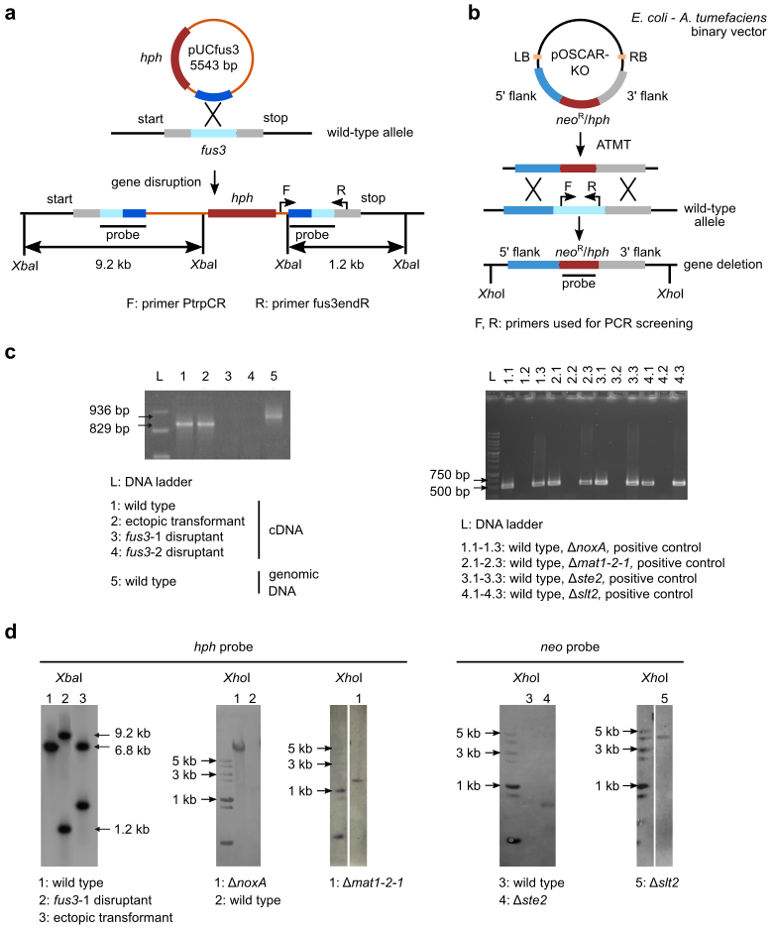

Fig. S2 Construction and validation of null mutants used in this study. a Schematic representation of the gene disruption strategy that was followed for knocking out the V. dahliae homolog of fus3, using protoplast transformation of V. dahliae 123V. b A double homologous recombination-based strategy using Agrobacterium tumefaciens-mediated transformation was used for the deletion of the V. dahliae 123V homologs of genes slt2, ste2, noxA and MAT1-2-1. c PCR screening using gene-specific primers for disruption (fus3) or deletion (slt2, ste2, noxA, MAT1-2-1) mutants. d Validation of mutants by Southern hybridization experiments.

