Supplementary figure S1: Secular trends in OA prevalence estimates
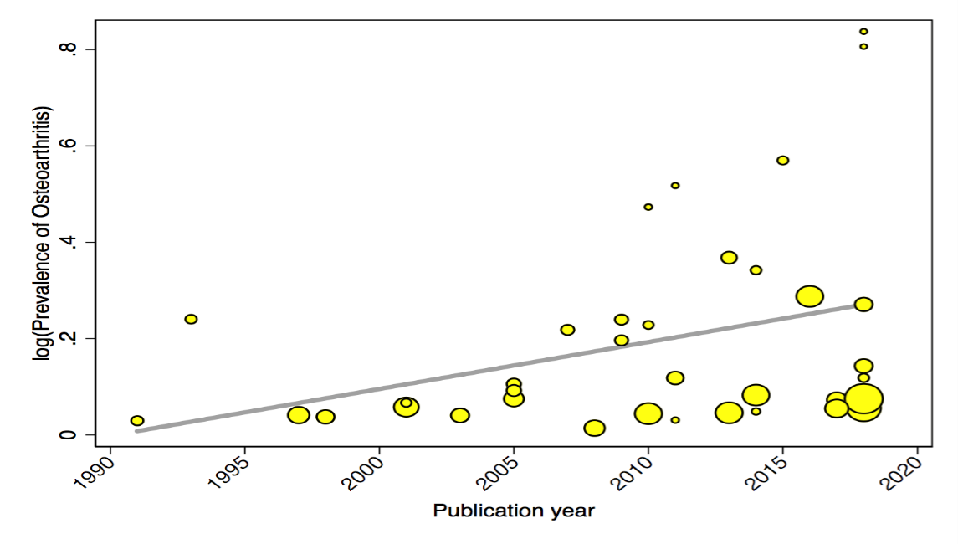

Supplementary figure S2: Association between sample size and prevalence estimates
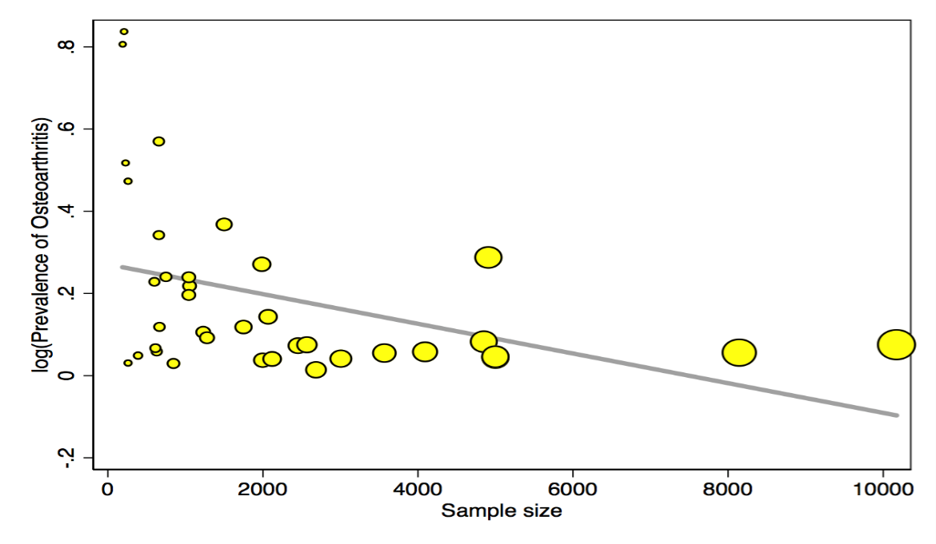

Supplementary figure S3: Association between quality and prevalence estimates
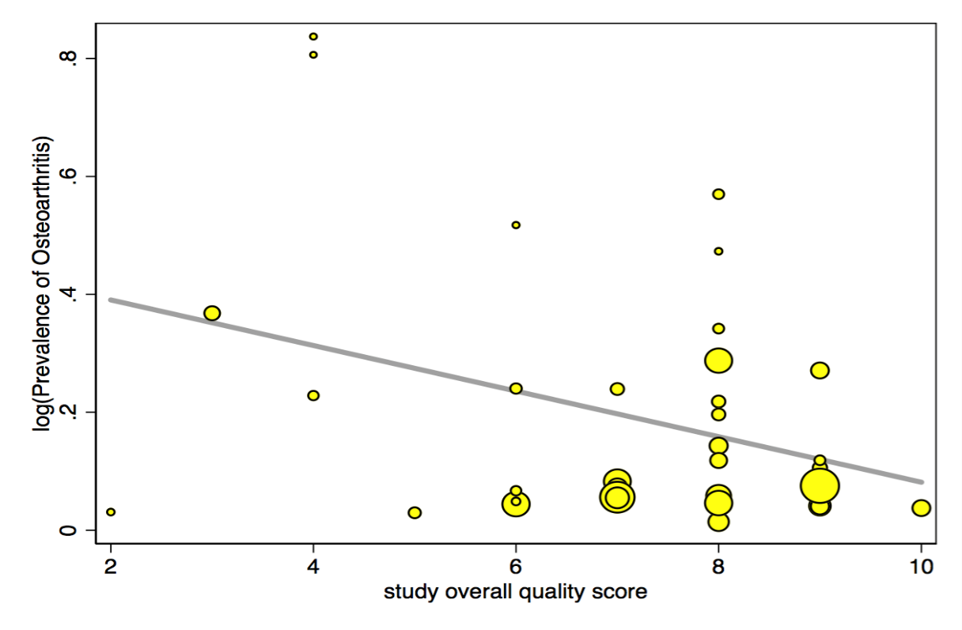

Supplementary figure S4: Association between percentage female and prevalence estimates
